Aaron Hollingsworth-Harris
Professor Goetz
Digital Media Foundations
5 February 2018
Brand Research: Spotify
When people think of a music streaming surface, one of the first images someone would probably think of would be Apple iTunes, given its reputation. However, other music streaming services exist that could give iTunes some heavily intense competition. One of those companies, which I plan to talk to you about, would be Spotify. However, music streaming service alone wasn't what helped Spotify to become the recognizable icon that it is today. It also had to go through a logo design process similar to iTunes that would give it an appearance that would appeal to consumers. This step started with the original designers of the logo.
The creative lead of the 2013 logo was Christian Wilsson. He was also responsible for the first logo design in 2006. He was working alongside Andreas Holmstrom, who was the lead designer for the new logo, in completing the project. The intention of this new design, according to Christian Wilsson, was to make the logo seem rounder and friendly. During the creation of the new logo, many methods were used in order to create what would be perceived as an appealing logo including the use of the Golden Ratio. However, Christian Wilsson mentioned that the use of the ratio only served to make the logo “look even more weird” (Ha). Despite these obstacles, the logo was launched and still flourished despite the controversy while also creating pressure for other services as well.
Spotify has influenced other streaming services to redesign themselves in order to keep up with Spotify’s level of appeal. One example of this would be the rebranding project the Fusion Radio went under in order to be currently known as Nexus Radio. During an interview made with the PR Newswire, a spokesperson mentioned how its rebranding was influenced by the challenge of competing with services such as Spotify or iTunes. The images and changes Spotify has made to its logo and marketing strategy are what allow for the pressure made on other services like Nexus Radio to become possible. One of the image changes made by Spotify would include the repositioning of its signature logo by moving the streaming waves above the "o" to the side and turning it into a more discrete logo. This gives Spotify the ability to use an emblem-like icon that people can recognize at a glance. It has also moved to using a customized Gotham font to portray a more streamlined image of itself. While it takes away from the playfulness that Spotify had in its older logo, it adds a new sense of gravity for a service that is steadily growing into a recognizable brand.
However, it had to have characteristics that stood out in order for the Spotify brand to be recognized as it is now. One of those changes was the Gotham font. This change to a sans serif font gives Spotify a friendlier appearance to its ideal audience, the millennials. This font is also customized so that the dot in the “i” fits this image as well by becoming a circle. Spotify has also made color changes from its original earthy green to a much brighter neon green so that it pops out at the audience. However, this change also created controversy and had many people debating over whether the change in color was a wise choice.
So as you can see, Spotify has gone through a remarkable amount of changes to its brand despite only existing for 12 years and competing with other streaming service giants like iTunes, especially in its design. Much hard work was contributed by essential personnel such as Christian Wilsson and these contributions have helped to influence the rebranding of other services as well. This goes to show the progressive change that Spotify has undergone has caused a great deal of change within itself and the world around it.

2006 – 2013
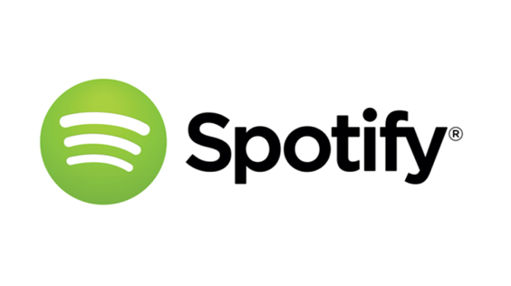
2013 – 2015
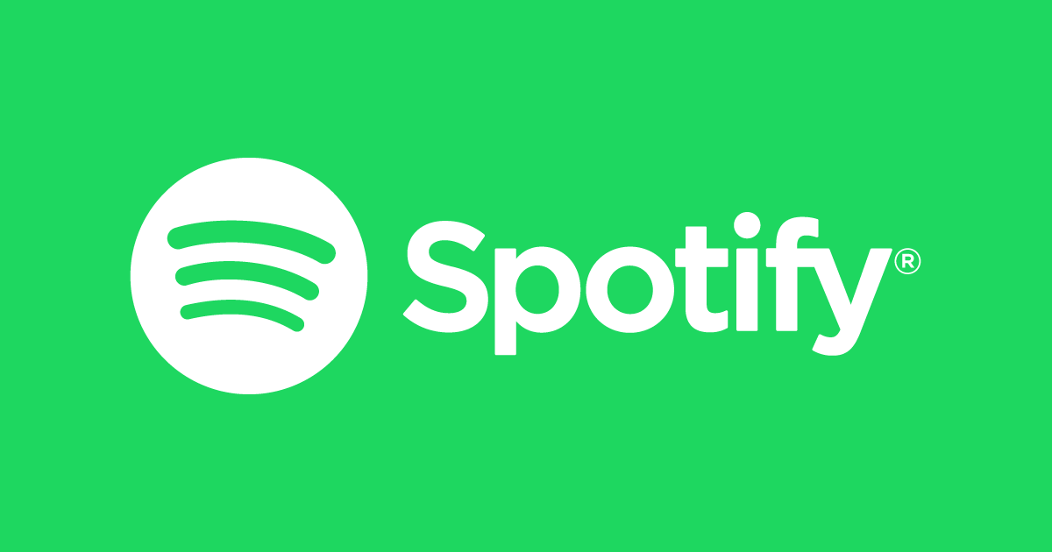
2015 – Present
Nexus Radio – 2015 Design

Bibliography
Ha, Peter. “How Spotify Got Itself a New Logo.” Gizmodo, Gizmodo.com, 19 Apr. 2013, gizmodo.com/5995060/how-spotify-got-itself-a-new-logo.
“Spotify Logo.” 1000 Logos The Famous Brands and Company Logos in the World, 1000logos.net/spotify-logo/.
Kastrenakes, Jacob. “Spotify Gets Serious with a New, Streamlined Logo.” The Verge, The Verge, 28 Mar. 2013, www.theverge.com/2013/3/28/4157210/spotify-debuts-new-logo-serious-redesign.
Lauretta Charlton Follow @laurettaland. “Spotify Says It Changed Its Green Logo for Branding Purposes, and Millennials.” Vulture, 26 June 2015, www.vulture.com/2015/06/spotify-green-logo-change.html.
Montgomery, Angus. "Design Week's 10 Biggest Stories of the Year." Design Week (Online Edition), 17 Dec. 2015, p. 5. EBSCOhost, citytech.ezproxy.cuny.edu:2048/login?url=http://search.ebscohost.com/login.aspx?direct=true&db=eue&AN=111804409&site=ehost-live&scope=site.
PR, Newswire. "Fusion Rebrands to Nexus Media with a New Marketing Plan to Compete with Apple, Spotify, Pandora." ["NEXUS-rebranding"]. PR Newswire US, 20 Aug. 2015. EBSCOhost, citytech.ezproxy.cuny.edu:2048/login?url=http://search.ebscohost.com/login.aspx?direct=true&db=bwh&AN=201508201517PR.NEWS.USPR.NY83919&site=ehost-live&scope=site.

