Superman 1978 and 2013
By Alexia Hernandez
Prepared for Dr. Adomaitis

Table of Contents
Abstract…………………………………………………………………………………. 3
Introduction…………………………………………………………………………....... 3
Superman 1978 Concept ………………………………………………………………… 3-4
Introduction of Garment: Christopher Reeve Superman suit ………………………… 4
Yvonne Blake: Costume Designer 1978 …………………………………………………. 4

Man of Steel 2013 Concept ……………………………………………………………….. 5
Introduction to Garment: Henry Cavill Man of Steel suit……………………………… 5

Michael Wilkinson and James Acheson: Costume Designer 2013 …………………….. 5-6

Construction of the 1978 Costume ………………………………………………………… 6-7
Construction of the 2013 Man of Steel Costume ………………………………………… 7-8
Man of Steel Costume Picture……………………………………………………………… 9
Mechanical Properties of Superman 1978 Costume………………………………………. 10
Mechanical Properties of Man of Steel 2013 Costume…………………………………….. 10
Conclusion……………………………………………………………………………………. 11
Reference………………………………………………………………………………………. 12

Abstract
In this project I will discuss the concept of Superman and describe the context of the movie. The garments that will be compared are the 1978 and 2013 costume. The fabric that was used to create the garments and the production will be stated. Yvonne Blake, who was the designer of the 1978 Superman costume, contributed to the iconic figure that we all know today. Other contributors to the Superman costume are costume designers for Man of Steel, Michael Wilkinson and James Acheson who made the remake for Superman in 2013. The construction of the two garments will be discussed and compared.
Introduction
Over the years film makers have made many versions of superhero movies and gave their versions a different touch when it comes to the superheroes character. The costume, hair and makeup changes over the years or depending on the direction the film wants to take. These changes can make an iconic image to pop culture. A great example for this statement is the one and only Superman. In this project we will discuss the Superman costume and compare the two suits of Superman (1978) and Man of Steel (2013).

Superman 1978 Concept

Superman started as a comic book in 1938 called Action Comics #1 created by Jerry Siegel as the writer and Joe Shuster has the artist, stated by Warner Bros (2015). According to CBS Interactive Inc, (2015)The concept of the Superman character is about a boy who was rocketed to earth as an infant from the planet Krypton, he was adopted by the Kent family and was known as Clark Kent. He used his powers to save mankind from evil. As an adult he becomes a reporter for the Daily Planet newspaper in order to hide his alias Superman. Over the years there have been many renditions of the Superman Movies and TV shows which have all kept the same concept of Superman, but in the 1978 installment of Superman played by Christopher Reeve retrieved from IMDb Inc (2015) the movie created a phenomenon due to Christopher Reeve costume. This new design paved the way for future costumes and became an iconic costume that had been admired by superhero fanatics over the years.

Introduction of Garment: Christopher Reeve Superman suit

In the 1978 Superman movie Christopher Reeve plays Clark Kent. Reeve's resemblance to superman made it seem like he was indeed meant for the role. According to Kucharski (2015), his hair was dyed black and styled with the front curl In order to enhance the look of Superman. Stated from the article in "Tyranny of style" by Kucharski (2015), in this movie the Superman costume consist of the iconic colors blue, yellow and red. The suit is mostly blue with the logo of a badge being yellow and a "s" on the center of the chest in red. A red cape was also part of the suit which had the "s" logo in the back, a yellow belt was another component and the belt was on top of red trunks. To finish off the suit tall red boots were added which had a deep "v" front (Kucharski, 2015).Though these properties of the costume consist in most of the Superman costume, the designer of the 1978 Superman suit contributed a different construction and brighter design than the earlier Superman costumes.

Yvonne Blake: Costume Designer 1978

The 1978 Superman costume is a famous suit that changed the idea of future Superman suits. The designer for this famous suit was Yvonne "Blake who is a British born Spanish costume designer (Dominguez, 2011). She was nominated for an a Saturn award for this movie, retrieved from Dominguez (2011). Yvonne Blake had a good and futuristic approach to the design of this costume with the help of Jerry Siegel and Joe Shuster who initiated the idea for Superman. She created a suit that looked silk or plastic by creating a "leotard in simmering two
way stretch, the cape was also made in a flowing fashion for resting and the boots were a glove leather with a small heel"( Bowers, 2015). Blake made one of the most memorable and famous suits in the world.

Man of Steel 2013 Concept

The Man of Steel movie is a modern take of the Superman superhero franchise. This installment which hit the screen in 2013 focuses on Superman who is also nicknamed the “The Man of Steel" due to his metallic sheen suit. The Man of Steel follows the same concept as the other superman movies. As stated on IMDb Inc (2015) this movie starts with Jor-El and his wife sending their son from a planet called Krypton to Earth. He lands in a farm where he is raised and becomes Clark Kent. As an adult he becomes a hero in order to save his loved ones with his special powers. In this movie Henry Cavill plays Superman, his costume brought much attention to a new and improved Superman who did not only look like a superhero but a godly figure of mythology.

Introduction to Garment: Henry Cavill Man of Steel suit

The Man of Steel costume is a representation of how costumes for superheroes are becoming technology advanced and improved. The older Superman costumes consisted of tights and rubber accessories. The Man of Steel costume definitely had more layers of creativity and technology. According to Crotty (2013) The Man of Steel costume was meant to be modern to the audience but grounded to the mythology of the story. The suit was consisted of a Hi-tech metallic sheen and dimensional texture to make the suit have more depth as stated by Crotty (2013). The suit in this movie almost looked like an armor than just an ordinary suit. The same red, blue and yellow colors were consisted but in metallic. As stated by Khouri (2013) The Man of Steel doesn't have red trunks and a yellow belt like previous Superman, instead his suit is one piece with no belt or trunks and it is skin tight to show off his abs and muscular body. To finish the costume the "s" on the chest is red and yellow like the traditional Superman.

Michael Wilkinson and James Acheson: Costume Designer 2013

The costume designer for the Man of Steel was Michael Wilkinson and James Acheson. Michael Wilkinson was born in Australia, and moved to the United States almost 16 years ago (Khouri, 2013). He won an Academy award for the 2013 movie American Hustle (IMDb Inc, 2015). He has always been passionate about films, clothes and characters. Although when they initially approached him to work on "Man of Steel" According to Khouri (2013) Wilkinson was committed to another project, which meant he had to put a pause on working with the Man of Steel, so in the meantime they started up with the legendary James Acheson. Acheson was also known for his work on other superhero movies like Spider-Man (2002) and Spider-Man 2 (2004), with the concept work and designs for the suit, then James Acheson was able to go on board (Khouri, 2013).
Construction of the 1978 Costume
The 1978 Superman costume was a very iconic suit that paved the way for future Superman costumes such as the 2013 Man of Steel; but what made this costume so iconic was how the garment was constructed. The 1978 costume is mostly made of Polyamide which is a nylon fabric as stated by Bower (2015). This fabric is a strong elastic synthetic fiber that is cellulosic and manufactured (Adomaitis, 2016). The suit was partially handmade and machine made. The "S" on the chest was sewn in and the yellow portion where the red "S" is actually inserted into the suit (Bowers, 2015). This iconic suit was the first time that synthetic high-shine fabric was used in the Superman movies (Kucharski, 2015). Polyester blends were also used in order to make the suit sleeker and give it a futuristic finish. The Polyester blends made the suit fit much tighter than previously accomplished (Kucharski, 2015). The color and dyes that were used for the suit played a big part for the effects of the suit and also for the Superman character (Bowers, 2015).
The 1978 suit was suppose to be a darker blue, but due to complications with the blue screen scenes it was required to have a lighter blue color; the suit almost looked turquoise (Kucharski, 2015). The blue color for the suit is called "steel blue" and was changed later for a moment in the movie where Superman turns evil into a grey blue color (Kucharski, 2015). "The cape was tucked into a tunic with a wider neck opening; it was also pleated to make the cape look fuller and more dramatic" as stated by Kucharski, (2015). There were different capes throughout the movie especially when he was flying, which were then made wider (Bowers, 2015). The belt and buckle were made of patent leather and plastic and the boot were made of very soft leather that fit like a glove (Bowers, 2015). The trunks were made of polyamide with a thick texture and the color was a metallic steel blue (Bowers, 2015). The suit had many mechanical properties that were used in order to preserve this iconic suit.
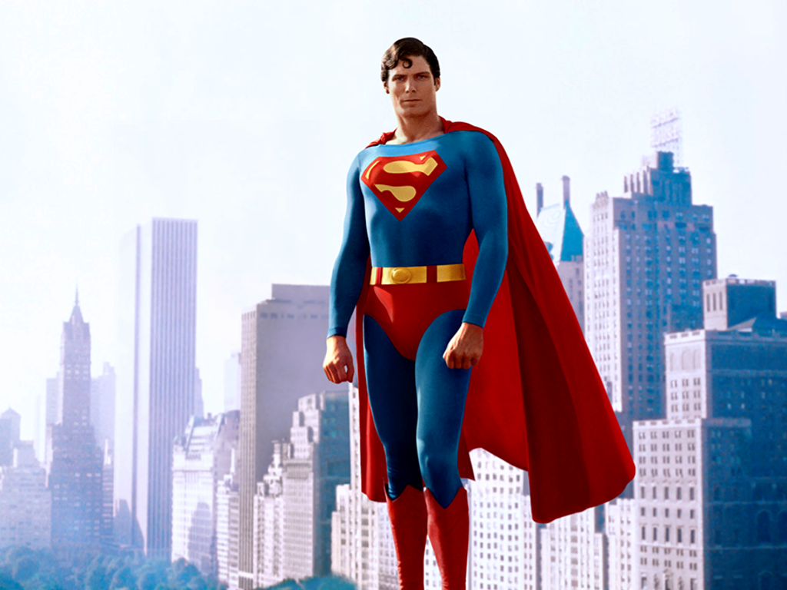 Figure 1. Christopher Reeve as Superman. This figure illustrates Superman and his iconic costume.
Construction of the 2013 Man of Steel Costume

The Man of Steel suit is made up of 3 separate layers. According to the article by Younis, 2013 the first layer was a fitted body suit with some sculpted shapes mounted on to the suit which was made of foam latex. The second layer was consisted of a thin stretched mesh over-suit that was also printed with dimensional chain-mail texture. Finally foam-latex elements are affixed at the ‘S’-glyph, the cuffs and the side-body details (Kucharski, 2015). The Man of Steel had a metallic finish with a unworldly quality, as though it’s an alien armor unfamiliar to those on earth. An a interview the costume designers said he wanted Superman to glow on screen and make him stand apart from the human race (Kucharski, 2015). To accomplish they created a realistic, gritty, contemporary tone for the film (Younis, 2013.
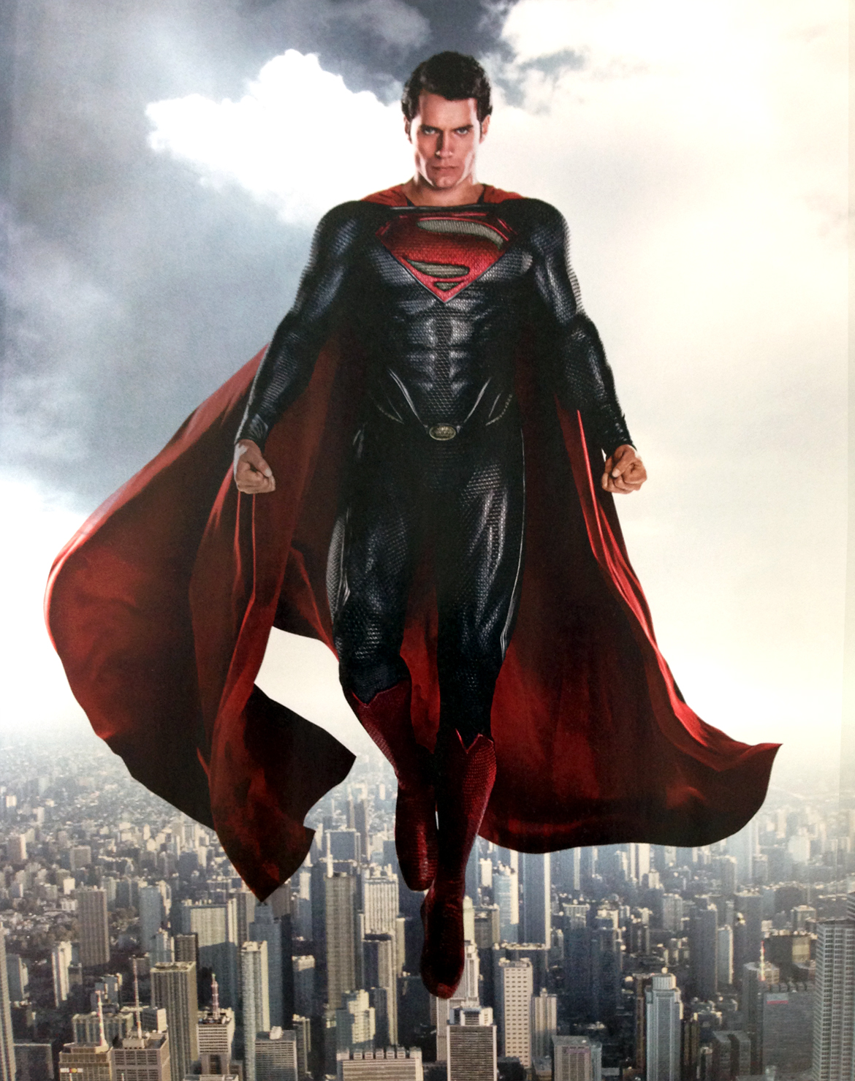
Figure 2. Henry Cavill as Man of Steel. This figure illustrates the Man of Steel flying over the city.
Mechanical Properties of Superman 1978 Costume
The suit had many mechanical properties that were used. The suit was made of polyamide (nylon) (Swatch Kit, 2016) which has flexibility, resiliency, and tenacity (Adomiatis, 2016, retrieved from Textiles PowerPoint). Polyamide is a strong elastic fiber which has great strength and tenacity, it doesn't wrinkle and it is very flexible (Adomiatis, 2016, retrieved from Textiles PowerPoint) this is great for a superhero who is constantly moving and fighting. The cape had a great drape that reached down below his knees (Kucharski, 2015). As for the leather red boots were actually prone to wrinkle and were actually stated by Reeve's that they "would wrinkle and crease from all the times they were being taken off and put back on" (Bowers, 2015). The properties of this suit are what made the 1978 Superman movie "remains the most famous depiction of Superman in live action entertainment" (Kucharski, 2015).
Mechanical Properties of Man of Steel 2013 Costume
In the Man of Steel costume mechanical properties were used in order to make the actor feel more comfortable and the costume durable when it comes to the action scenes. Much like in the 1978 Superman, the Man of Steel costume was also flexible, resilient and had great tenacity (Adomaitis, 2016, retrieved from Textiles PowerPoint). According to Younis (2013) The costume was entirely machine made nothing was hand- sewn. The sculpted foam shapes and a protected cup was the thing inserted to make muscles and texture to the suit according to (Kucharski, 2016). The suit was manly made of a stretch Lycra material that has a chain mail pattern screen printed on using high density gloss poly ink (Lunaman, 2013). The suit was also made of a thin rubber to make it flexible and durable (Lunaman, 2013). The over suit had a thin layer of stretched mesh to make the suit breathable (Swatch Kit, 2016). The cape like the 1978 movie had a great drape for a dramatic landing effect (Adomaitis, 2016, retrieved from Textiles PowerPoint). The Man of Steel costume had a lot of components in order to make this costume stand apart from the other Superman costumes. The ambiguous quality will make this costume be talked about for decades.
Conclusion
Superman is one of the most iconic superheroes of all time. Movies and TV shows are constantly being remade and one of the reasons for this is to shows new ideas for costume, visual and design. Over the years these designs have changed and new ideas have been brought to the idea of the Superman story. New fabrics are used in the latest Superman movies and the costumes have been more modern and impressive over the years. Thus is why the selection for this movie was made to compare two garments.
Christopher Reeve Superman suit and performance made superman an iconic figure. The 1978 movie paved a way for future directors and costume/ visual designers. This continued over the years and influenced the making of the Man of Steel costume that Henry Cavill wore. Superman is one of the most iconic superheroes of all time, he is a fictional superhero who appears in American comic books published by DC Comics, and is considered an American cultural icon. With the success of his adventures, Superman helped to create the superhero genre and establish its primacy within the American comic book. Most people in the world heard of Superman or have watched a Superman movie which explains the idea to choose a movie that most people are familiar with. Superman's appearance is distinctive and iconic; He usually wears a blue costume, red cape, and stylized red-and-yellow "S" shield on his chest (Kucharski, 2015) .This shield is used in a myriad of media to symbolize the character ( Khouri, 2013). He represents justice and hope, as well as saving mankind from evil. He is a hero, role model and truly an iconic figure.

Reference:

Adomaitis, A. (2016), Textile PowerPoint’s
A Warner Bros.(2015), Superman,
http://www.dccomics.com/characters/superman

Bowers, J. (2015), A Guide to Identifying an Authentic, Screen worn costume, ​​​ ​http://www.capedwonder.com/christopher-reeve-superman-costumes/
CBS Interactive Inc. (2015), Superman,

http://www.comicvine.com/superman/4005-1807/
Crotty, N. (2013), Man of Steel's costume designer was 'distracted by Henry Cavill's perfection

http://fashionista.com/2013/06/man-of-steels-costume-designer-was-distracted-by-henry-cavills-perfection
Dominguez, J. (2011), Yvonne Blake Medalla de oro, ​

http://www.jadominguez.com/2011/12/yvonne-blake-medalla-de-oro/
IMDb.com Inc.(2015), Superman
http://m.imdb.com/title/tt0078346/
IMDb.com Inc. (2015), Man of Steel
http://m.imdb.com/title/tt0770828/

Jones, N. (2015), Superman Costume Comparison,
​​​ ​http://www.supermanhomepage.com/movies/movies.php?topic=sr-costume-compare
Kucharski, J. (2015), Tyranny of Style,
http://tyrannyofstyle.com/christopher-reeve-superman- suits

Kucharski, J. (2015), Soaring into the 21st Century - Superman's Man of Steel Suit
http://tyrannyofstyle.com/superman-suit-man-of-steel-costume

Khouri, (2013), Comics Alliance,
http:// www.comicsalliance.com

Lunaman, (2013), Information of the Superman Man of Steel fabric
http://www.therpf.com/showthread.php?t=183688

Younis, S. (2013), My Thoughts on the "Man of Steel" Superman Costume,

http://www.supermanhomepage.com/movies/movies.php?topic=mos-costume

