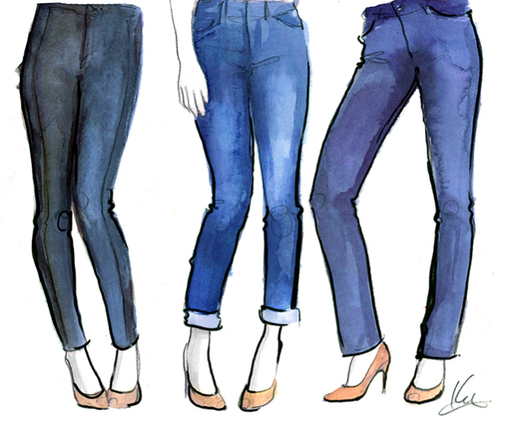

PERFIT
Product Development BUF 2400
Donavon Banton Alexia Hernandez Brianny Middleton
Shayina Dubusisson Naomi Cale

Product & Specifications
“The average U.S citizen owns 15 pieces of denim and up to three different denim brands” (Maria, 2015.) We know the women of America desire perfect fit denim that don't require them to travel 5-10 stores to get. We also know that women wants a denim that brings comfort but still remain stylish and trendy as well. With that being said, what we want is to provide women with a denim that is comfortable, trendy and most importantly, cost-efficient. Perfit denim offers denim for a lifetime. For instance, lyrca hybrid slimming mesh panel jean will be what all our consumers need and want. Lyrca mainly use the production of sports apparel, fabric is known to stretch up to more than 6 times its original length and can also be easily and quickly recovered (Maria, 2015). It is no secret that most women struggle with keeping the same weight over time, with the combination of blending lycra and denim we can create an revolutionary denim that can save many of women time and money.
We also decided to include a slimming mesh panel in the front and behind the pockets of all our jeans. This slimming mesh panel prevents women to keep any stomach weight under wraps and the back from showing any bagging or even the trouble of gapping out. Our denim will save women from the trouble of spending more on denim every time a pound or two is added on to their weight. We have all had that phase in life when our weight fluctuates, but Perfit will prevent women from the frequency trouble-some of shopping for new denim. Our jeans are also very accurate in sizing; we do intensive research and talk to women in order to provide the proper sizing to every shape. Our sizes will run from 0 to 20 and will provide for all heights short, regular and long.

PERFIT Social Responsibly
We are aware of the environmental causes producing denim leads too. We know producing denim involves a large amount of use of dying and water waste. PERFIT believes in our environment dearly and wants to move ethically when producing our products. It’s important we provide for the people but still keep in mind the importance of the world’s global issues. PERFIT works with greener fabrics to lower the impact of denim production. Our product will minimized the frequency of consumers purchasing dress very often because the longevity of our jeans.

Target Market
Perfit is a specialized denim brand that creates jeans for every type of sized women. We cater to sizing, sustainability, flexibility and of course style. Perfit is targeting women from the age of 18-30 who are conscious of the environment and who want to feel comfortable in their own bodies. This age group consist of millennial who are aware of the upcoming fashion trends and are mostly like to purchase a great constructed item as well as a stylish one. The jeans have built in technology fabrication that creates flexibility and can fit into any shape or size. We also cater to height, our jeans have three lengths Short, Regular, Tall. Our potential targeted customer is bold, conscious, confident, and stylish.
Trend Forecast
A lot of women worry about staying in style every season and making sure they are keeping up with trends, therefore we wanted our jeans to be very trendy and fashionable. We wanted to provide women with a wide variety selection of denim jeans which goes from classic basic jeans to trend setter jeans. This spring season is all about standing out and showing off bright metallic’s and bold colors (Alexander, 2018). We also wanted to give our jeans an edgy look so we decided to put two trends together to create an authentic denim look which is the black denim with the metallic’s gold/silver strips on both sides of the jeans and then we used the flare trend and flared out the bottom of jeans to create a chic look. Distressed jeans have stayed in style for many seasons and it became everyone's favorite throughout the years, we added a pair of distressed jeans for our consumers who still love the ripped jeans look (Nichols, 2018). We also wanted to fit the needs of women who carry a lot of things but don't have enough pockets to put them in. Utility jeans are the perfect jeans for women who desire a lot of pockets so they won’t lose their belongings, it is also trendy this season, so they will be able to suit their needs and stay trendy (Wasilak, 2018). These are some of the trends that we choose to follow to suit our target market needs and to keep them satisfied. We wanted our denim designs to be very unique and different, so women can have options and they can love what they wear. Having a woman feel comfortable and confident these designs will make them feel stylish and satisfied.

Price & Our Competitors
Perfit is a denim line delivering a design of superb quality but we also want our customers to receive our product at an ideal price. Like any other company we want to make a profit but we know our target market is the working class millennial so our general price range would be anywhere from $65 to $109.99 per denim depending on quality, cut, and ,style.
“PERFIT’S” competitors when it comes to denim that delivers style and comfortability would be brands like Madewell, Gap, Levi’s, and Parker Smith.

Madewell
The price of Madewell jeans range anywhere from $60 to $135. “I would like Madewell jeans to be the Levi’s of its generation,” the then-CEO of J. Crew Group told The New York Times in 2015.”(Laundry.Reviewed.com, 2018). Madewell jeans stand out to the consumer because their jeans are high rise. Which means curvy women with a large or protruding middle section have some coverage and feel some sense of comfort ability. Madewell high rise jeans can rise up to 10” to 11” inches from the waistline, many women said this makes outfit choices more flexible and they also feel more comfortable. This blueprint of high rise jeans is something we can take in to the manufacturing process of Perfit Designs.

Gap
The price of Gap denim for women can range anywhere between $30 to $80. They are known for their stretch and the comfort ability of their jeans close to that of a jegging but still giving you the durable fabric of denim. The fabric is soft and stretchy but is sort of like elastic; That when you put them on they form tightly to the curve and shape of your body; giving you a flattering and fitted look. We can incorporate this into the Perfit’s brand because all women have different body types. The stretch is great for women who are curvy and want fit into well fitted jeans. But this is also good for women who are less curvy, they can use our jeans to define and emphasize the body that they have.
Levi’s
The price of a Levi’s denim can cost you anywhere between $19 to $60. This is on the cheaper spectrum of the market but the durability and the last time of this brand of jeans puts them into competition with the higher end brands. Levi’s jeans is well known for their durability. Their denim will pass the washing machine test which most of our jeans don’t make it through. They take time on using the correct fabrics, stitching techniques, and technology to provide long lasting jeans. This is something I think we would consider in the Perfits brand providing durability, endurance, but also at a very reasonable cost.

Parker Smith
Parker Smith’s price range of denim can range anywhere from $75 to $250. Parker Smith is one of those brands you are paying for the A grade quality. You are getting a flattering curve, durability, comfortability but most important style and trend. This brand has a plethora of current styles where you don't have to sacrifice these elements no matter which trendy pair of denim you choose to buy. This is a brand Perfit needs to models our denim by we want to bring fashion and trend but also durability and comfort and the Parker Smith brand truly embodies that.

Methods Of Merchandising
L.A & N.Y Pop Up Shops
We will be holding events in two major cities where our product will be showcased. Our merchandising techniques to catch our consumer’s attention will be making sure the striking, unique, vibrant colored pieces will be showcased in the store front. Placement is very important, making sure that whether things are horizontally or vertically that it is at eye level, neatly placed, and accessibility to customer for to observe with the senses. Also having mirrors with well lit lighting at the customers convenience.

Perfit Online/Website
The online store is truly where the customers will be able purchase the finalized pieces. The latest technology plays a major role in the online purchasing process. We need technology that is going to analyze each individual consumer giving suggestions corresponding to pieces that they have recently clicked on. By sorting and organizing our technology data we will use it to make sure items are easily found for first time and returning customers to find. Also, we will involved crisp sharp pictures of the merchandise as well as 360 imaging that the consumer can have a visual of the merchandise from all angles. The website will contain pictures of fit models of different sizes wearing our denim, as well as videos where customers can visibly see our denim and how the model moves in it. The website will include a 10% off discount if the customer signs up for our newsletter which will include; emails from Perfit on any new collection arrivals, special offers and collaborations.

Brand Ambassador:
Our brand ambassador that will be introducing our product will be singer Rihanna. Rihanna is the perfect spokesperson for Perfit because our product is focusing on curves or body change. Rihanna has currently been getting some buzz for her weight gain but still embraces her body. Rihanna is known to be a confident and bold woman who is what Perfit is trying to influence every women through our denim collection.

Promotion/Advertising Campaign
We at Perfit would like to run a 12 month advertising campaign to showcase our clothing line in several major cities throughout the United States . It is important that our product becomes a part of women's everyday visuals from television to magazines to billboards to train ads. This way our future consumers can get more information on the products; as well as making our product apart of their lifestyle. Even though there is a rapid decline in print media we feel it is crucial that we use the top women's magazines such as Compositional, Elle,and Vogue because they have high circulation rates and also websites and apps that people are constantly using visiting. The billboards and train ads will capture the eyes of everyday commuters and our television advertisements will give us an opportunity to reach millions of viewers at a time. We also decided to hold two launch parties one in New York and LA. These launch parties will give us the opportunity to showcase our line and also help gain some celebrity clientele. Our website www.perfit.com will be linked to all of our social media pages. Through our website people will be able to purchase all of our denim and also get access to special discounts and deals we will be offering.

Website:Perfit.com
Facebook:facebook.com/perfit
Instagram:Perfit
Twitter: twitter.com/Perfit

References

Alexander, E. (2018, February 22). 10 spring/summer 2018 fashion trends to start wearing now. Retrieved from https://www.harpersbazaar.com/uk/fashion/shows-trends/g38445/spring-summer-2018-fashion-trends/

Bobila, M. (2015, November 16). 3 New Advances in the Denim Industry. Retrieved from https://fashionista.com/2015/11/new-denim-advances

Bauck, W. (2017, April 14). 3 Ways the Denim Industry Is Changing for the Better. Retrieved from https://fashionista.com/2017/04/advances-in-new-jeans-denim

Nichols, K. (2018, March 18). 3 Denim Trends to Try in 2018. Retrieved from http://www.whowhatwear.com/cool-denim-trends

Matt, S. (2018, March 01). I hated wearing pants-until I started wearing these jeans from Madewell. Retrieved from http://laundry.reviewed.com/features/i-hated-wearing-pants-until-i-started-wearing-these-jeans-from-madewell

Wasilak, S. (2018, April 26). 8 Pairs of Jeans You Don't Already Have but Should For the New Year. Retrieved from https://www.popsugar.com/fashion/Denim-Trends-2018-44440084

