Apple INC
By Alexia Hernandez
New York City College of Technology
Prepared for Dr. Tung
BUF 3300

History of Apple:
Apple was founded on April 1, 1976, by Steve Jobs, Steve Wozniak, and Ronald Wayne (Luo, 2013). These men were out to sell the Apple I a personal computer kit that was designed and built by Wozniak (The Sydney Morning Herald, 2006). The Apple I was sold as a motherboard, which has a CPU, RAM, and basic textual-video chips. The Apple I had less than what we considered a complete computer today (Leander, 2002). The Apple I went on sale for $666.66 in July 1976, which the price match today (2017) would equal to about 2,806.
On January 3rd, 1977 Apple was incorporated without Wayne, after he sold his share of the company for $800 (Luo, 2013). The company's revenue was increasing more and more over the next five years even doubling every four months. From 1977-1980 yearly sales grew from $775,000 to $118 million, which had an average annual growth of 533 % (McCracken, 2016). Soon after the Apple II was created on April 16, 1977 by Wozniak (Weyhrich, 2002). The design had more features and it was made for the business world since it had a spreadsheet program VisiCalc (Thomas, 2006). The updated version of the Apple II was able to take floppy disk drive and also had an interface called the Disk II (Weyhrich, 2002).
In 1980 the Apple III was introduced and was trying to compete with IBM and Microsoft (LEM, 2006). Jobs was already starting on Apple Lisa which would have a graphical user interface (GUI) because he was convinced future computers will have this feature. Though jobs started on Lisa he was pushed from the Lisa team and took over a revolutionary idea The Macintosh. The Lisa and Macintosh team were racing on who can put out and sell their item first and team Lisa won the race. Apple Lisa was a commercial failure due to its high price and limited software (Thomas, 2005).
In 1984, Apple launched the Macintosh which became the first personal computer to be sold without a programming language. The Macintosh initially had great sales but then went down due to the high price and limited software (Hormby, 2006). Apple then started to produce more and more items in the late 1980s-1990s like the; PowerBook, System 7 and Mac OS. Apple then started to experiment with a number of unsuccessful products like digital cameras, portable CD players, speakers, video consoles, TV appliances and eWorld online service.
Microsoft and Apple were competitors and always seem to compete with each other in who can have new and innovative ideas. Apple tried to sue Microsoft fur using GUI similar to the Apple Lisa (Hormby, 2006). The lawsuit dragged for many years but was later dismissed. Steve Jobs soon became making the product line for Apple and the line started to get more status. I'm 1997 Apple teamed up with Microsoft its top competitor to release new Microsoft office for the Macintosh (Harreld, 1997). The same year Apple finally introduced their online store (Harreld, 1997).
The iMac was introduced in 1998 it was a modern design that contained modern and unique technology (Apple Canada Inc, 1999). The iMac did pretty well selling about 800,000 units its first five months (Apple Canada Inc, 1999). In 2001 Apple opened their first retail stores in California and Virginia (Apple Stores 2001-2003, 2011). The same year Apple introduced their first iPod which was greatly successful selling more than 100 million units the first 6 months (Cantrell, 2006). In the 2000s Apple started to introduce a lot of innovated technology, devices and services that we use today for instance; in 2003 the iTunes Store was introduced for downloading music, in 2006 the MacBook Pro, in 2007 they announced for iPhones/iPod Touch and Apple TV, and the iPad in 2010 (Markoff, 2007).By 2008 Apple began to get really high market shares and even being the 3rd largest handset supplier in the world (Chen, 2008).
iPhones became a popular and successful over the years so far there has been 7 versions of the iPhone along with iPods and iPads. In June 6, 2016 Apple was ranked on Forbes list of revenue generation 3rd place with $233 billion in revenue and was on the top of the list as the top tech company (McBride, 2016).
Mission Statement:
Apple's current Mission Statement is:
"Apple designs macs, the best personal computers in the world, along with OS X, iLife, iWork and professional software. Apple leads the digital music revolution with its iPods and iTunes online store. Apple has reinvented the mobile phone with its revolutionary iPhone and App Store, and is defining the future of mobile media and computing devices with iPad (Investopedia, 2015)."
Steve Jobs Mission Statement:
"To make a contribution to the world by making tools for the mind that advance human kind (Investopedia, 2015)."

Merchandise Assortment:

Apple assortment in retail stores is usually set up by putting the Apple products such as iPhones, iPads and Macs out for display in order for customers to test or look at the products. The products usually come in different colors or different amount of memory, which are all displayed. Customers are always eager to touch and test the products so they can figure out exactly what they will like to purchase. The tables that the products are displayed on are charging tables which customers use in order to charge their personal phones or other devices. The products to purchase are usually kept in their stock room not out on display or for customers to see. A sales associate is usually the person who gets the products for the customer.

The Genius Bar is another feature in Apple stores. The Genius Bar is for customers who need any technical support or advice, as well as any help with repairs and service (Stanley, 2004). The Genius Bar provides service for customers with Mac OS software and other products that are not classified vintage (Stanley, 2004). The largest Genius Bar is in Amsterdam (Stanley, 2004). New stores have a feature called The Studio, where customers can meet with a "creative" employee and they can have assistance with projects such as: making a photo album, music composition and even film editing (Stanley, 2004).

Sales:
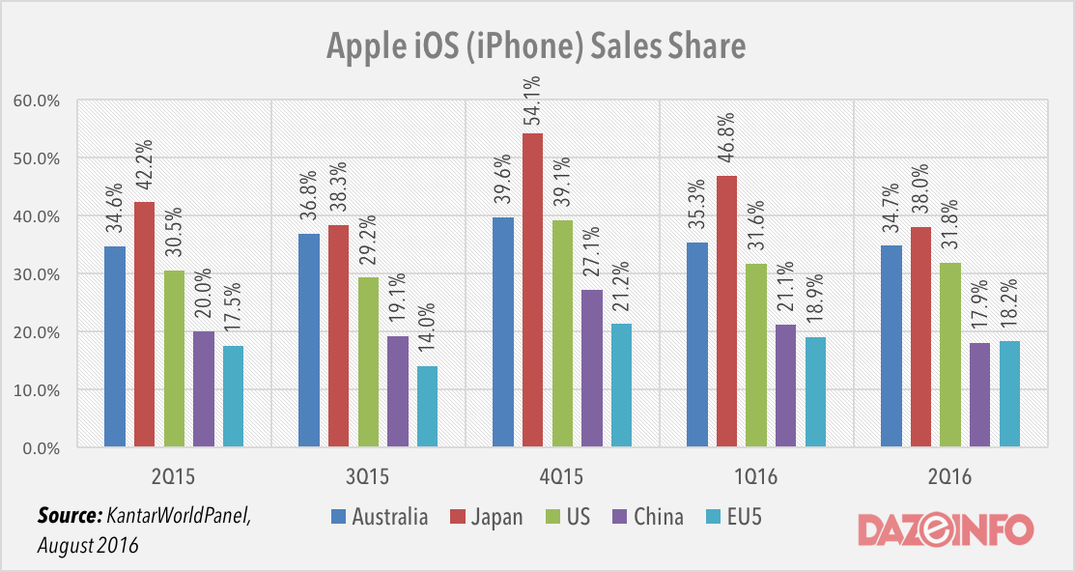

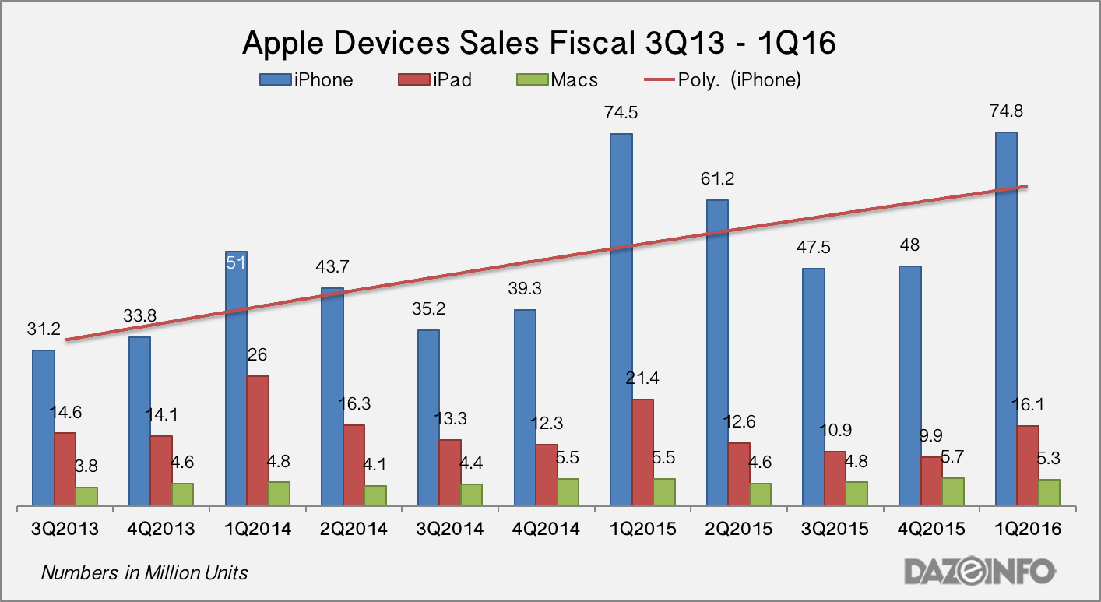
Store Count:
World: 490 stores in 20 countries
Countries | Store Count
United States | 269
China | 40
United Kingdom | 39
Canada | 29
Australia | 22
France | 21
Italy | 16
Germany | 14
Spain | 11
Japan | 8
Hong Kong | 6
Switzerland | 4
Netherlands | 3
Sweden | 3
Brazil | 2
Turkey | 2
United Arab Emirates | 2
Belgium | 1
Macau | 1
Mexico | 1

Strategies For Entering Countries:
An example of strategies that Apple does is seen in China with iPhones. iPhones in china are very expensive compared to the price in the United States. The phones are very popular in China and everyone wants to have their hands on an iPhone even if it's not the newest or latest iPhone. For example the iPhone 5s is priced at 5,288 RMB which is equivalent to $864 US, that figure is higher than a month salary in Beijing (Schiavenza, 2013). After Apple released the iPhone 5s in China they decided to lower the cost of their next product iPhone 5c. Apple made an affordable item for a popular item in China for millions of people (Schiavenza, 2013). Apple even coupled up with China mobile, the world's largest network of over 700 million subscribers (Schiavenza, 2013). The company put together an event in Beijing for the first time in history (Schiavenza, 2013).

Though the Chinese market was excited Apple didn't lower the cost by that much. The iPhone 5c cost 4,488 RMB, only 17 percent lower than the 5s (Schiavenza, 2013). This new price disappointed Chinese customers and even resulted in Apple having a drop in the stock price by almost 6 percent (Schiavenza, 2013). This new cheaper price didn't affect Apple drastically and even helped develop a strategy for China. Instead of lowering the cost on iPhones every year Apple will keep the cost the same. The Chinese market will buy an iPhone rather than an Android phone due to the brand name and the luxury essence it has. Offering an inexpensive iPhone will damage Apples most valuable asset and its brand identity. Luxury goods in China are so popular because it gives them a status. Owning an iPhone gives them that status that a cheaper phone wouldn't. Apple dropped the prices in order to test the brand loyalty in China. Apple learned that though there was a drop not only because of the market in china but because the 5c didn't do so well, China will continue buying iPhones because they are loyal to the brand.
Competition in Foreign Markets

In 2015 Apple ranked second place between brands Samsung and Huawei. Apple shipped 231.5 million in 2015 and Samsung 319.7. According to Strategy Analytics, Apple iPhones shipments are peaking and shifting its strategy around emerging markets such as India (Hall, 2016). The total global number of smart phones shipped in 2015 hit 1.4 billion units from 1.2 billion the previous year, which marked a 12 percent increase (Hall, 2016).
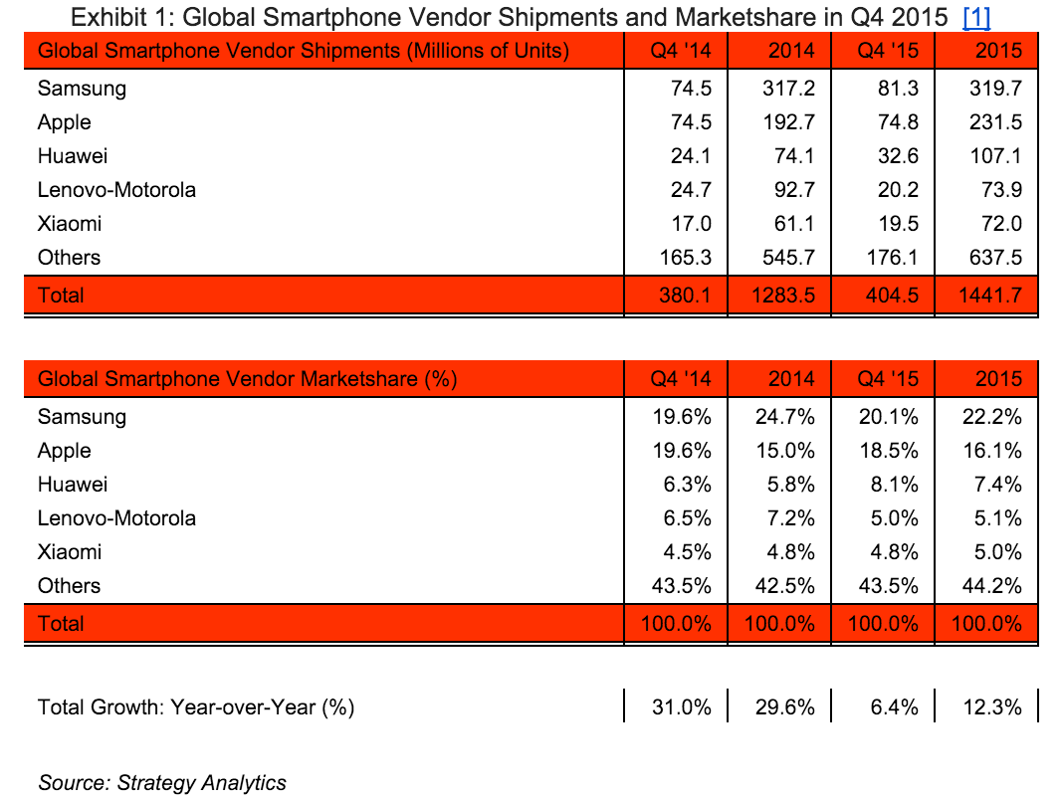

In this chart of 2014 and 2015 Apple climbed up 1.1 percent, moving from 15 percent to 16.1 percent (Hall, 2016). Samsung (which still remains at the top) dropped 2.5 percent from 24.7 percent to 22.2 percent (Hall, 2016). Samsung however regained market shares.

This suggests that the Apple company will need to look to emerging markets for new opportunities such as India (Hall, 2016). This is now one of the highest iPhone users after China and the United States. Huawei is slowly gained some steam and Samsung still remains at the top of the game (Hall, 2016).

Other competition that is seen is Apple having some competition with China inexpensive smart phones that markers appeal to consumers since it is homegrown. Chinese vendors are expanding their smart phones in order to provide a cheaper alternative than an iPhone. These vendors such as Gionee, Yulong, and Meizu are being launched in other countries like Russia, India, Taiwan, Southeast Asia and Latin American countries (Rapoza, 2013). This is bad news for Apple since this can decrease sales of Apples most loyal and buying customers.

Success and Failures:
Apple has had a lot of success with their iPhones and iPods, but the company also has a history of failures of products that didn't do so well due to the price or the limited software it contained.
Failures:
Apple Lisa (1983)
• Apple priced the Lisa computer as $9,995 which is the equivalent to 24,000 today (Heisler,2016).
•Never sold well and was often left for the original Mac.
Pippin (1995)
•Apples take on a game console.
•Inability to gain attention from gamers resulting in a flop.
•Expensive price at $559.
•Didn't have an ecosystem of games, there was less than 20 titles available.
•Sold only about 40,000 units
Newton (1993)
•Was made for the PDA market.
•Handwriting recognition didn't work very well as advertised.
Twentieth Anniversary Mac/ TAM (1997)
•TAM was over priced with a $7499 price tag.
•Internals were underwhelming relative to the cost of the product.
•Sales did explode so Apple slashed the price to $3,500 but it wasn't selling at that price so they put it down to 1,995 but the price didn't do anything for the sales or popularity.
Macintosh Portable (1989)
•Weighed 16 pounds, arguably considered portable
•Black and white LCD screen
•1M of RAM
• Heavy lead acid batteries
• Expensive, priced at 6,500 which is about $12,750 in 2016 dollars.
iMac Hockey Puck Mouse (1998)
•Customers complained it was frustrating and inefficient to use.
•Couldn't fit properly in most people's hand
•Circular design made it clumsy to hold and maneuver
•It was finally replaced in 2000 with the Apple Pro Mouse.
Success:
iMac (1988)
•Came after the unsuccessful Macintosh
• Was intended to make market shares for the company
•The "blue bubble" was eye catching and intrigued consumers.
• Intrigued consumers with a range of colors that was tag lined iCandy.
iPod (2001)
•First iPod in the market.
•First successful device of its kind.
•Evolved over the years to include a color screen and play video as well as shrinking in size and more storage capacity.
iPhone (2007)
•Groundbreaking device that revolutionized phones
•Has a touch screen user interface
•Apps that made the phone easier to navigate and use
•Has Face Time
•Sleek and easier to use
iPod Touch (2007)
•Borrowed some features from the iPhone
•Touch screen interface and apps
•More storage for music
•Thinner and lighter
•Remains successful today
iPad (2010)
•At first critics called it an oversized iPod touch but it soon began to catch attention.
•It revolutionized the tablet market, causing it to become a commercial success.
International Success and Failures:
Though Apple might not have failures in countries but rather in their products there was a risk for Apple to enter in China. Business in China can be difficult to do because of their government system, especially for technology companies because of the competition of local firms that are all trying to grow domestically (Nasr, 2015). Apple products in China became very popular over the ideas and it has become a status symbol that the Chinese want to obtain. It has become a premium western product that people are willing to pay for and even pay double on the black market (Nasr, 2015). The benefits of Apple products contribute to the success in China. Apple products such as iPhone and iPads because most people in China don't have TVs in their homes and the young Chinese use their mobile phones for everything (Nasr, 2015). Thus why the release of the iPhone 6 Plus was immensely popular due to the bigger size (Nasr, 2015).

Conclusion:
Apple is one of the most innovative and popular brands in history. It seems as everyone we know has some type of Apple product. Apple has a status that is undeniable it represents luxury. Apple products are very popular because it's easy to use, are always up to date with the newest technology features and the style is like nothing we've seen before. Apple will continue making innovated ideas that will keep increasing their capital. Over the years we have seen drastic changes in their products in order to give customers exactly what they need and want. Since the 1970's to now 2017, Apple is brands that keeps customers, analysts and technology innovate wonder what will Apple release next.

Work Cited:

Apple Canada Inc, 1999. "800,000 iMacs Sold in First 139 Days",
https://web.archive.org/web/20141108074139/http://www.ebooklyn.net/p/800000-imacs-sold-in-first-139-days.html
Cantrell, Amanda, 2006. Apple's remarkable comeback story,
http://money.cnn.com/2006/03/29/technology/apple_anniversary/?cnn=yes
Chen, Brian, 2008. "Jobs: Apple Is Third Largest Handset Supplier",
https://www.wired.com/2008/10/with-iphone-app/

Hall, Zac, 2016. Here’s how the iPhone is performing in global marketshare against the competition,

https://9to5mac.com/2016/01/28/iphone-global-shipments-marketshare/
Harreld, Heather, 1997."Apple gains tech, agency customers in Next deal",

https://web.archive.org/web/20081206061012/http://www.fcw.com/print/3_1/news/6441 2-1.html?type=pf
Hormby, Thomas, 2006. VisiCalc and the rise of the Apple I,
http://lowendmac.com/2006/visicalc-and-the-rise-of-the-apple-ii/
Hormby, Thomas, 2005. A history of Apple's Lisa, 1979–1986,
http://lowendmac.com/2005/history-of-apples-lisa/
IFO Apple Store, 2011. “Apple Stores 2001–2003",
https://web.archive.org/web/20110927210608/http://www.ifoapplestore.com/stores/chronology_2001-2003.html
Kahney, Leander, 2002. Rebuilding an Apple From the Past,
https://www.wired.com/2002/12/56426/
Luo, Benny, 2013. "Apple's Third Co-Founder Ron Wayne: On Forming the Company and Working with Steve Jobs",
http://nextshark.com/ronald-wayne-interview/
Markoff, John, 2007. "New Mobile Phone Signals Apple's Ambition",
http://www.nytimes.com/2007/01/09/technology/09cnd-iphone.html
McBride, Sarah, 2016."Apple leads Tech Industry in Fortune 500"
https://www.yahoo.com/tech/apple-top-tech-company-fortune-132100720.html
McCracken, Harry, 2016). "Apple's sales grew 150x between 1977-1980",
https://news.fastcompany.com/apples-sales-grew-150x-between-1977-1980-4001956

Nasr, Reem, 2015. Apple's success in China can teach US firms a lot,

http://www.cnbc.com/2015/01/29/apples-blowout-success-in-china-what-it-did-right-and what-us-companies-can-learn-from-it.html

Rapoza, Kenneth, 2013. Competition Getting Tougher In China For Apple iPhones,

https://www.forbes.com/sites/kenrapoza/2013/01/17/competition-getting-tougher-in-china-for-apples-iphones/#6926d0fe6926

Schiavenza, Matt, 2013. The Logic Behind Apple's Strategy in China,

https://www.theatlantic.com/china/archive/2013/09/the-logic-behind-apples-strategy-in-china/279569/
Sydney Morning Herald, 2006. "Apple co-founder tells his side of the story",
http://www.smh.com.au/news/laptops--desktops/wozniak-tells-his-side-of-the-story/2006/09/28/1159337270259.html
Weyhrich, Steven, 2002). "Apple II History Chapter 4"
http://apple2history.org/history/ah04/

