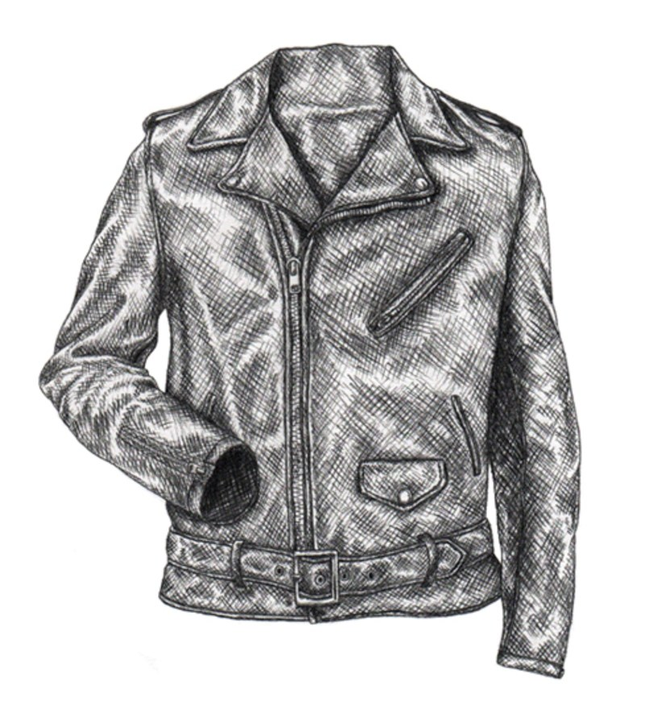

The Lex Reports:

Spring/Summer Men’s Leather Jacket

By Alexia Hernandez

New York City College of Technology

Trend Forecasting and Social Media

Prepared for Dr. Woods

**About the Author**

Alexia Hernandez is a Trend Forecaster for Elle magazine. She is from New York City and was born and raised in Upper Manhattan. She received her bachelor’s from New York City College of Technology and then her Masters in Journalism in Columbia University. Before becoming a trend forecaster, she has worked as a fashion consultant for several clients, Celebrities like Rihanna, Lady Gaga and Arianna Grande. Hernandez’s book State of the Undress was published in 2016 and talks about her relations to culture, religion and fashion and how it will shape the future. Hernandez now lives in the Upper West Side and enjoys her collection of music and fashion magazines. She will soon have her own show where she will interview upcoming designers on their adventures in the fashion industry.

**Table of Content:**

**To The Reader**……………………………………………………………………….

**Consumer Profile**…………………………………………………………………….

**History of the Leather Jacket**………………………………………………………

**Articles of Past Events**

Economic………………………………………………………………………

Political………………………………………………………………………..

Social………………………………………………………………………….

**Future predictions for 2020 spring**

Textiles………………………………………………………………………..

Cut…………………………………………………………………………….

**Trends for 2020**

1. **Knee Length Leather Jackets**…………………………………………………….

Textile…………………………………………………………………………

Cut & Fit………………………………………………………………………

Color…………………………………………………………………………..

2**. Leather Men’s Blazer**……………………………………………………………. Textile……………………………………………………………………….. Cut & Fit…………………………………………………………………….. Color………………………………………………………………………….

3. **Leather Motorcycle Jacket**……………………………………………………… Textile………………………………………………………………………… Cut & Fit……………………………………………………………………... Color………………………………………………………………………….

**Conclusion**……………………………………………………………………………

**Reference**…………………………………………………………………………….

**To the Reader**

The Fashion industry is taking a more sustainable and eco- friendly approach on how they creating textiles, yarns and finishes. The mindset of Go Green is making consumers more aware of what they are putting into and on their bodies. This creates in awareness of the environment and for consumers and designers to use only the best natural resources they can find. Recycled materials made into textiles are becoming a huge trend as well saving the planet earth at the same time. In spring/Summer 2020 there’s no exception. In this issue of the Lex Reports, you will get to see upcoming textiles, colors, cuts and fits trends for Men leather jackets.

The Leather Jacket is a classic that seems to never go out of style. This upcoming 2020 spring/summer we will notice a classic trend take sustainable and inventive path. We will look into the new upcoming trends for Men leather Jackets. The Leather Jacket will be having a more modern silhouette, a sleek and light composition as well. Advanced technology has had a huge impact in the fashion industry that would be incorporated in the 2020 leather jacket which will be incorporating cooling technology fabrics into the jacket in order for it to be worn in the spring and summer time. The length and cut will also be an interesting reflection to the times. Having a 3/4 Leather trench coat creating a futuristic look. The materials used in order to make the leather jacket will also reflect the economic, social and political happenings of the following years. Vegan leather will be greatly talked about and how designers are switching to vegan leather. These leathers will still have the resiliency and durability. Finally the Lex Reports will give you insight on the color palette that will trend for the spring/Summer 2020 season and how it will be incorporated in different styles of Jackets like the Motorcycle jacket, the knee length jacket and the classic blazer.

. 



**Consumer Profile**

The Target Market will consist of a man from the age of 25-35 who is willing to spend money on a good quality item. This man can be from any ethnic background or practice any religion. This man is also likely to have an education and even be a college graduate. Which is why he has a understanding of product development and the meaning behind true sustainability. This consumer is a classic man who is looking for a twist or inventive element in his clothing to awe his friends and family. He is most likely to be single or married depending on the age and is most likely to have a pet and prefers not to hurt or in danger animals due to his profound attachment to nature and the environment.

Due to his love of nature this man is aware of the environment and only wants the best from himself and the world. This man would do research on the item before buying, looking for how and where the materials were made, if it’s sustainable enough and if the product will last within the years. He is always aware of fashion trends and is willing to buy trendier items if it is made from a great and durable material or fabric.

This consumer would most likely live in the East coast, where weather changes fast and surprisingly. A person from the east coast especially in a place like New York City is known for always being on the go. This man is looking for a comfortable jacket where is resilient and durable and can pass any environmental factors. He also requires a jacket to have compartments for his phone, keys and wallet for easy and reliable access.

Some of the hobbies this target market will be into are jogging, outdoor adventures, photography and traveling with his family and friends around the world.

**History of the Leather Jacket**

Throughout the years the Leather Jacket has evolved and has become a classic and inventive piece. This jacket has many parts of many subcultures and reflects the spirit of the times. A leather jacket is jacket-length coat that is usually made from the tanned hide from various animals. The material is usually dyed black or different shades of brown, but throughout the years there has been a wide range of colors in leather Jackets. Raw materials like Antelope, lambskin, sheepskin, buckskin and cow hide are hides commonly used to make leather jackets (Mcnulty,2018). In order to make these jackets “the skin is removed from the animal then it is refrigerated, salted or packed into barrels of brine” (Mcnulty, 2018). After that it is sent to a tannery where the skin goes under multiple procedures in order to preserve and soften the hide (Mcnulty, 2018).

In the early 1900s aviators and military men wore leather flight jackets. During World War 2 the garment became known as the Bomber jacket and became very popular for their warmth and protection. The jacket was used to protect bomber pilots from exposure of high climate conditions found in high altitude (Trotsky, 2002). Sheepskin was also used which creates fleece and creates an even warmer insulation for the jacket. Russian Bolsheviks also wore leather jackets and became a staple uniform for commissars during the Russian Civil War (Trotsky, 2002). Many years later the Leather Jacket served protection for motor cyclers. Since the Leather is tough, heavy and thick it protects motor cyclers if they got into an accident. Some of the jackets were equipped with armor and also had weatherproof pockets and closure, high collars and are longer in the back than the front in order to protect the kidneys of the rider from the cold. Over the years the motorcycle jacket has gotten lighter and is not as heavy or tough as a older and traditional jacket. Theses jackets don’t serve much protection and are more to make a fashion statement.

In the 1920’s Irving Schott invented the motorcycle leather jacket which was sold only for $5.50 and was found in Harley Davidson (Medine, 2016). In the 1950’s Leather Jackets became very popular especially for the subculture of greasers. Actor Marlon Brando who played Johnny Strabler in the 1953 movie *The Wild One*was one of the first celebrities to make the motorcycle Leather Jacket to be popular (Medine, 2016), not only for pilots but for people to wear. Music Artist Elvis Presley was another celebrity who revolutionized the Leather Jacket. The Leather Jacket was associated with being a rebel or “badass” and subcultures like Greasers were known to be tough and caused havoc. The brown leather jacket has become a required part of wardrobe for the Hollywood adventurer; for example Harrison Ford in the Indiana Jones series (Medine, 2016).

Over the years the Leather Jacket became associated with “cool” in the 1970s punk bands such as the Ramones wore leather jackets and it soon became a staple in the punk subculture and even metal subculture (Mystique, 2018). In those subcultures chains and metal embroidery are incorporated into the jackets to have a distinctive look. In the 1986 the movie Top Gun with Actor Tom Cruise showed and popularized the aviator or pilot bomber jacket which also had a fleece collar, this garment has become iconic and remained fashionable for years (Medine, 2016). In pop culture over the years we see the Perfecto Leather Jacket in (1984) The Terminator and in (1999) the sci-fi action movie The Matrix where audiences see 3/4 length leather trench coats styled by the characters in the movie (Medine, 2016).

Today most modern leather jackets are made in China, Brazil, Mexico Italy, Russia, India, Pakistan, Canada and the United States (Via, 2018). Fabrics that look like leather such as polyurethane or PVC are used as alternatives for people who want to wear leather but don’t want to hurt animals and are pursuing a vegan lifestyle. Also synthetic fibers such as those materials tend to be less costly than real authentic leather.

**Timeline of Past Events**

**Economic**:

Article:

“Iyalode Lawson, president of the Nigerian Association of Chambers of Commerce, Industry Mines and Agriculture agrees. She believes with the right market conditions, Nigeria's leather industry could be worth $1bn annually by 2025.[The global leather industry has an estimated trade value of $100 billion every year](http://redirect.viglink.com/?u=https%3A%2F%2Fleatherpanel.org%2Fsites%2Fdefault%2Ffiles%2Fpublications-attachments%2Ffuture_trends_in_the_world_leather_and_leather_products_industry_and_trade.pdf&key=15785bf48552a1cdfab425661118986f), and Lawson hopes that Nigeria's long history with leather will count for something”.

“Because the oil boom is no longer there," she said, "We are now going back into all these areas of diversification whereby the economy will pick up and there will be more jobs."

“While cheap local leather products adorn market stalls in Lagos and Abuja, Nigeria's indigenous leather industry has been a sleeping giant of the country's north for over a century”.

“Nigeria has some of the oldest tanneries on the African continent, where young artisans still cure and treat animal hides in the same pits that their ancestors did” (Hayes & Akande,2018)

Review:

The Leather industry has been increasing due to the popularity of designer shoes, bags and belts. Over the years more consumers are buying designer goods that use authentic leathers and this contributes to harmful chemical and unethical practices. This article can relate to my forecast of designers in 2020 using more sustainability and clean materials and dyes because the growth of the leather industry and tanning factories can alert consumers and designers to use vegan leather or recycled fabrics in order to contribute to making the environment safer and cleaner. Since the Leather industry is booming in countries all around the world like Nigeria this can spark an awareness to decrease leather production, especially in 3rd world countries where the harmful fumes and dyes can harm the people by affecting their crops and water.

**Political**:

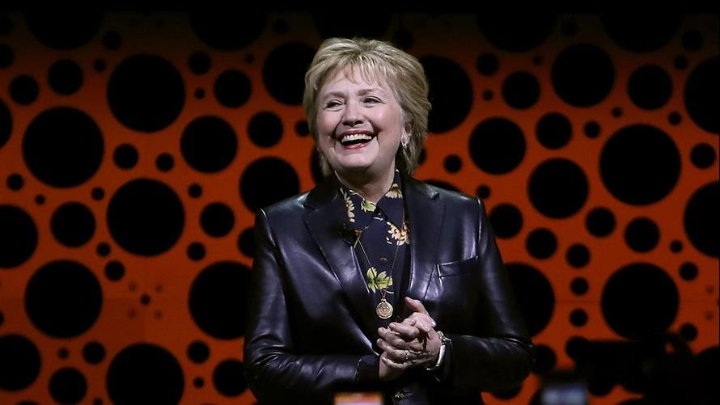

*Figure 1*: Hilary Clinton wearing a leather blazer. Reprinted from Market Watch (2017).

Article:

“A woman in the kind of leather jacket Hillary was wearing ... that black, structured, business-like bordering on military style, made her look tough,” agreed style expert Tom Fitzgerald, co publisher of the [TomandLorenzo.com](http://tomandlorenzo.com/) lifestyle blog with Lorenzo Marquez. “We joked that she looked like a detective in a '70s crime drama. She looks armored up and ready to fight.”

“Former President Barack Obama has been building his own fashion fan club since leaving the political limelight, especially with a slim brown leather jacket that he sported on his return trip from the Virgin Islands earlier this month” (Pesce, 2017).

Review:

Leather Jackets can make anyone feel cool and tough. The jacket creates a feeling of empowerment that we have seen over the years with Figures like Marlon Brando and Harrison Ford in Indiana Jones. Leather jackets and blazers are not usually seen worn by presidents or first ladies. Powerful figures such as Barrack Obama and Hillary Clinton wearing leather jackets is a huge fashion statement and can influence consumers who look up to these people to wear leather jackets. Women empowerment creates inspiration in all kind of sources especially fashion and this can be an example of that. This article relates to the forecast because the leather jacket is starting to be soon more not only in street wear but in political debates. Hilary Clinton leather jacket had a business style and military style that can probably be seen in the fashion industry in a few years and influence more women in power to wear them.

**Social**:

Article:

“The leather jacket became symbolic of the bad boy and rebel, and students would be banned from wearing them at schools across the US. That stigma was reinforced in the 1970s and '80s, when the Ramones wore Schott jackets as part of their signature punk look. Other bands copied them, and the jacket began to be associated with these metal acts”.

“As the era of punk and metal came to a close, modern stars have embraced the signature cool look of the Schott leather jacket. Rihanna, Kanye West, Matthew McConaughey, and Jay Z have all been photographed wearing a Schott brand jacket. Schott told us that the company never actively seeks these endorsements, but that the stars appreciate Schott for being a "cool underground brand." (Green, 2016)

Review:

The Leather Jacket has always been a symbol for rebels or bad boys. The Leather Jacket was a signature piece for greasers in the 1950s. Leather jackets have been incorporated into street wear fashion which is rising and is seen in many celebrities. It would be interesting to see celebrities supporting vegan leather and influence the youth culture to partake and research what is going to Leather and how it can affect the environment. With the introduction of new fibers, textiles and innovations; technology can now protect and enhance performance. This can intrigue consumers to purchase these jackets. Since the bad boy stigma of the Leather Jacket has decreased, more powerful fugues and celebrities can endorse the Leather Jacket in a sustained and eco-friendly path.

**Future Predictions for Spring/Summer 2020**

Textiles:

The 2020 Spring/Summer seasons will have a fresh and inventive style on classic items such as the trench coat, blazer and oversized jackets by adding vegan leather that is environmentally friendly, lightweight multi performance and sustainable (McCartney, 2018). The fabrics that will be use will be developed in a cleaner process that will not harm the environment. Recycle yarn and fabrics such as recycled polyester are going to continue to be popular (Ledru, 2018). Safer dyes that are innovative and that reduce the process of water and energy waste will be expected to dominate the fashion industry (Ledru, 2018).

Fabrics like organic cotton and vegetarian leather are becoming more popular due to people’s knowledge of how chemicals in leather can cause harm to factory workers and the environment. Fabrics aren’t the only item that are sustainable, but also trims such as zippers. Designers like Stella McCartney are avoiding using copper in their bags and jewelry due to copper not breaking down in the environment causing copper to be found in the ground and in the water (McCartney, 2018). Water pollution is a big problem in some countries and can cause many people to become sick, can kill plants and animal life (McCartney, 2018). Instead of using copper Stella McCartney uses stainless steel and aluminum alternative (McCartney, 2018).

The use of recycled materials and waste will influence more designers to create products and garments from these resources. Resources such as recycled nylon and polyester will be regenerated (Ledru, 2018). For nylon there will be a textile called ECONYL, which takes “waste such as industrial plastic, waste fabric and fishing nets from oceans is recycled and regenerated into a new nylon yarn that is exactly the same quality as virgin nylon”(McCartney, 2018). Recycled polyester is also a textile that designers are using such as Stella McCartney, and it is mostly made from recycled plastic water bottles (McCartney, 2018).

Many consumers today are into lounge wear or products that are durable enough for any activity such as work, leisure, and travel. With the duality and durability of these products consumers feel like they are getting more for their money (Ledru, 2018). These products are made by using intelligent fabrics that can also protect the consumers from environmental harm such as UV, wind or water (Ledru, 2018). In spring/summer 2020 we will see more cooling technologies especially in items that can be very warm like the leather jacket. Leather and linings of leather jackets can be very warm and doesn’t allow consumers to wear them in warmer spring days or in the summer. With these cool technology fabrics consumers will have the courage to. Other fabrics that will be trendy are: quick dry textiles, UV protection yarns and fabrics, windproof and waterproof membranes, water repellent yarns and finishes, micro fleece and anti-odor yarns and finishes (Ledru, 2018). These innovative textiles are great components for leather jackets and will encourage customers to purchase these items in the spring and summer.

The sustainability for spring/Summer 2020 will stronger therefore creating a trend of using natural resources and the use of bio-synthetics. Many of the materials that will be utilized tap into the Trans seasonal trend and leisure trend (Ledru, 2018). Designers will be playing with these innovations in fabrics such as merino wool, cotton and silk and will be using new cellulosic fibers such as seaweed to elevate their product with a creative and luxurious feel. With the trend of sustainable materials the innovations in textiles will increase and impact the world in a whole new way.

Color & Patterns:

Colors will always have a huge impact on trends and could also reflect or predict where the fashion industry or even the world is going. The colors for Spring/Summer 2020 will be a mix of vivid oranges, golden yellows, pure blues, deeper purples and red, eggshell whites, platinum grays, and neo mint (Morris, 2018). Neo mint will the trendiest color for 2020 and will start the year with an optimistic approach due to new innovations in technology and advances in sciences (Morris, 2018). The Optimistic nature of this hue pinpoints the hype of new technologies like AI( Artificial Intelligence) which will be joining the Olympics games and helping judges to give scores as accurate as possible and the NASA Mars 2020 Rover that will begin its mission to see if Mars can support microbial life (Leavitt, 2018). A combination of vivid oranges and soft oranges will be seen in 2020. In the previous seasons we saw a bright orange but for spring/Summer 2020 one will see a milky, subdued tone which can appeal more to a consumer (Morris, 2018). Golden yellows will hit the mass market; this color has a deeper tone than its predecessor which in 2019 which was more of a bright sunny glow yellow (Trendstop, 2018). Many campaigns throughout the years have been incorporating yellows. A theory for this could be due what the color represents which is positive energy, and relieves negativity, anxiety, mental and bodily tiredness (Trendstop, 2018). Yellow will uplift people and this can resonate with them.

Cassis is a mix of a deep purple and pink that creates a deeper fusion apart from the deeper purple and bright sweet tone pinks saw in 2019 (Morris, 2018). This color creates a sense of tranquility. Crimson red and bright red will also be trendy along with softer blues like purist blues (Morris, 2018). Blues are usually core colors that most people have in their closet or go to. Purist blue has a softer and relaxing feel that can easily transition its way to a fashion color (Morris, 2018). Eggshell whites and platinum gray creates a sense of minimal and natural colors. These colors have been a huge focus in previous years because it can be seen as gender-neutral (Trendstop, 2018). These shades are calming, cool and reserved and also give off a futuristic vibe.

Graphic prints and patterns will also be prevalent. Vivid digital prints, multi colored abstract prints, textured 3D jacquard, mélange and space dyed prints in knits, and halo-graphic trims are some of the features that will be soon in garments in Spring/Summer 2020 (Ledru, 2018). This adds to the innovation elements and influences we see in the colors that will be trending like Neo-mint. The prints and patterns will reflect on new technologies and other sciences advances that are giving a new direction to the fashion industry and the world.

1**. Knee- Length Jackets**

Style:

The Alex Knee-Length Jacket is a trend Lex Reports is predicting for Spring/Summer 2020. The style of the jacket is different takes on types of jackets such as the Trench jacket and oversize cocoon jacket. The leather trench jacket was featured in the Alexander McQueen spring/summer 2019 fashion show. The trench jacket had a leather exterior with a long belt; the jacket in this collection also had slits on the side of the sleeves for easier mobility. According to Vogue Magazine pockets will be popular in 2019. Lex report predicts that will be seen in 2020 because Smartphone’s and newer laptops will be introduced because of the advancement of technologies this requires men to want more storage space (Yotka, 2018). Oversize jackets and blazers with contrast elements of fabrics and colors will be trendy to create a unique and creative touch (Yotka, 2018).

Textile:

Knee-length jackets are usually seen in many different types of fabrics such as wool, cotton, polyester, and tweed but in 2020 Lex Reports are predicting a leather trend in knee length jackets. The fabrics that would be used are vegetarian-leather that would become more due to the sustainability and environmental friendly properties (Ledru, 2018). Ethical practices are becoming very popular with consumers where they are doing research on where their products are made of or where they are coming from. Vegan leather will have less harm to the environment. Stella McCartney created a buzz when she re-released her products to be vegan leather. In 2013 she started to use alter-Napa which is material made from polyester and polyurethane and has a recycled polyester backing (McCartney, 2018). This breakthrough material is influencing designers to incorporate faux or vegan leather to their brands. Petroleum can be a dangerous chemical that greatly affect the environment as well as polyurethane. Stella McCartney is also using water-Bourne or solvent-free polyurethane (McCartney, 2018). By using these types of solvent it creates a safer environment for workers that have to deal with those chemicals.

Organic cotton is also going to be seen in the knee length jackets. Organic cotton is also a safer and environmentally friendly fabric to use. Incorporating organic cotton eliminates toxic chemicals being used, as well as soil health and the conservation of water (McCartney, 2018). This contributes not only the health for farmers but people all around the world that are being affected by toxins in the air. Organic cotton is seen in many brands such as Everlane, Todd Shelton and Patagonia (The Good Trade, 2018). Not only is cotton a better option for the environment but it is also a breathable fabric and the best fabric for spring/summer 2019. The environment has been very unpredictable lately due to issues like global warming. This causes for summers to be very hot and for consumers to look for the best fabrics that can cool them down. In this trend organic cotton will be mixed with vegan leather. The mixing of fabrics is seen in the Alexander McQueen Spring/Summer 2019 fashion show, where he mixes fabrics like polyester with silk in his jackets. Lex Reports is predicting this will become popular into 2020.

Cut & Fit:

Long Knee Length jackets is huge trend and it is seen in many 2019 spring/summer fashion shows such as Alexander McQueen, Raf Simmons and Versace (Yotka, 2018). The oversized blazer or pea coat is seen on the runway for the Spring/Summer 2019 shows. The oversized jackets have a relaxed feel which can contradict the times due to a lot of political issues and ideas. In 2020 the United States will elect a president and that could be a serious time for the country. Consumers are looking for a way to escape from these issues and are looking for a fun and easy going product. The trench jacket can be seen as a professional statement jacket. The Knee length trench coat will have slits on the sides for easier mobility like seen in the Alexander McQueen fashion show.  There will be a pendulum swing from crop jackets that we saw in the previous seasons to longer jackets and coats that we will see in 2020. The trench coat was used by army officers during the First World War but has been reinvented for more casual and sophisticated looks. Since street wear has become more popular and trendy. We will see the trench coat have a casual feel, which can affect the cut and fit by making the jacket longer or oversized (Yotka, 2018).

Color:

The Colors that Lex Report predicts will be trendy spring/ summer 2020 will be vivid orange, jet black, eggshell, Spanish grey, and mint green. These colors give a feeling and sense of tranquility, neutrality, and futuristic vibes (Trendstop, 2018). The vivid orange creates a fun and optimistic approach that people can resonate with. The jet black has a hint of gray that can make the color look muted and cool. The eggshell will be a trendy color that can resemble the color white and grey. These colors can create a sense of comfort and neutrality that emphasis more on gender and free gender connotations (Trendstop, 2018). The cool industrial tones are quiet and reserved and adopt many different guises from the futuristic to the functional (Trendstop, 2018). The mint green is a play on what ISPO predicts will be the color of 2020, Neo-Mint. This green is a subdued mint green and it is milkier and softer. This color can also represent sustainability and the Go Green mindset that many people are influenced and are partaking.

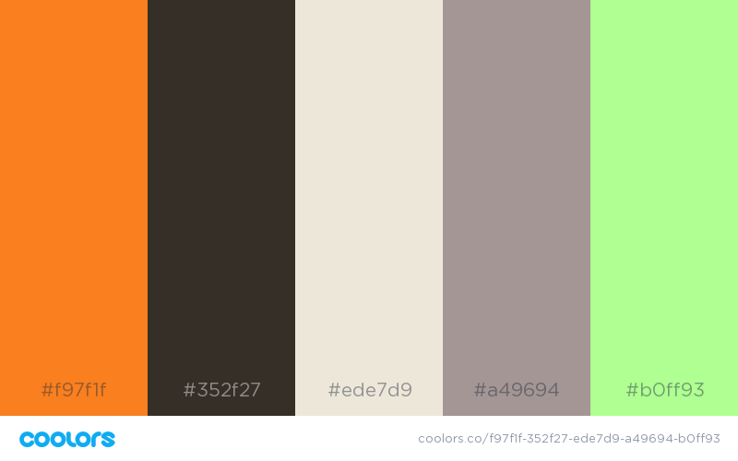

**2. Men’s Leather Blazer**

Textile:

The men’s Blazer has always been a classic piece in every man’s closet and it dates back to Cambridge and Oxford with boat rowers (Dangremond, 2015). The blazer was meant to act as a wind breaker and was made to keep rowers warm in colder training day’s sessions (Dangremond, 2015). Blazers were also embellished with very colorful patterns or stripes in designs unique to each rowing club, this helped spectators on distant shores to identify which crew was which (Dangremond, 2015). The term blazer didn’t come into play until 1952 in an article that referred to the red jacket worn by Cambridge's Lady Margaret Boat Club as blazing red, hence the blazer (Dangremond, 2015).

In spring 2020 the blazer jacket will incorporate leather into this classic piece creating an incentive but still timeless style. Wool and serge is usually used for blazers (Centeno, 2018), but designers are started to use recycled polyester and wools in order to protect the environment from harmful fumes that these textiles can create. Since blazers are mostly seen worn at work in school, moisture management and cool touch and quick dry will be innovations added to the jacket in order to create a cooler environment for warm spring and summer days (Ledru, 2018). UV protection textiles constructions can also help on hot days and can protect the consumer’s skin (Ledru, 2018). Clean technology features are strongly influence to reduce water, waste and energy this can contribute to effect dye solutions for appealing finishes (Ledru, 2018). Micro light fibers will also be very popular for easier movement and performance and Water repellant yarns and finishes that are useful for unpredictable weather which is a major issue in some parts of the United States due to global warming (Ledru, 2018). These elements can really help maintain the consumer dry and protected.

To maintain durability and sustainably fibers that can be used for this trend if BCI cotton, vegan leather, recycled polyester and wools (Ledru, 2018). For finishes Seaweed Aramid fibers, Nettles, iridescent yarns, mineral embedded yarns and spider silk (Ledru, 2018). Fabrics that will be used for linings are Bemberg silk and rayon which can range from the expensive to the cheaper spectrum, but both can be very breathable fabrics and perfect for the spring and summer seasons (Centeno, 2018).

Cut & Fit:

The blazer has always had a sharp and clean look; it has been changing over the years from sophisticated and classic looks to a more casual look that can be worn with t-shirts and denim jeans. Since street fashion is rising, Lex Report predicts that that length of the blazer jacket will increase and consumers will be more into long-line blazers. In spring/summer 2019 fashion shows we saw designers like Raf Simons and Dior have oversized double breasted blazers and was a refreshing and casual take on a classic piece (Yotka, 2018). In the Alexander McQueen spring/summer 2019 fashion show we saw a new take on the fit and cut of the blazer. The blazer had a longer and sleeker fit but was also fitted on the sides to create a sautés silhouette. The blazers also had a double effect where the front of the blazer appeared like there was two jackets or a vest underneath (Yotka, 2018). I believe that this cut and style will be seen in 2020 since double sided knits and garments will be popular as well as contrast in fabrics colors and yarns (Ledru, 2018).

Color:

The colors that will be used for this spring/summer 2020 trend is a Deeper Tangerine, Rosewood, Citron, Rich Black, and Forest Green (Coolorsco, 2018). Thesse colors are a play on the trend colors that will be seen in 2020 but with a deeper and masculine feel. These sophistcated colors can also be transseasonal and can be incorparted in the work place as well as hang out with friends and family. The hues can also give off a nature asthetic which can resonate with people who enviromentally concious.

The color deep tangerine is a muted and deeper then previous brighter orange that was in trend in 2019 (Morris, 2018). Rosewood is warm and bold take on the color Cassis, it has a muted red hue mixed with purple (Morris, 2018). Citron can resemble a golden yellow but has a subdued light green element that can make it more sophicated and mature. The light green can transition into a darker green like Forest Green. Forest Green has an earthy and neautral appeal with a sense of masculanity. This goes for the Rich Black which is a sleek and classic color that is seen in a lot of blazers or blazer linings.

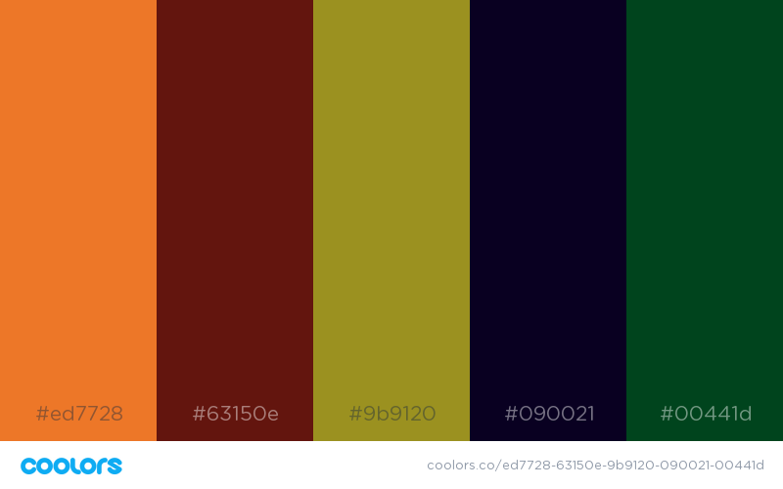

**3. Motorcycle Jacket**

Textile:

The motorcycle jacket has always had a bad boy or rebel stigma that has never truly gone away. Before the 1970s the people were banned from wearing leather jackets to school in the U.S (Green, 2016). During the 1970s the brand Schott was the leading brand for leather jackets and was worn by subcultures like punk and metal heads (Green, 2016). The classic Leather Jacket In spring/summer 2020 will now have a more inventive aspect by incorporating innovative textiles and protection. Many consumers will like to wear leather jackets in the spring and summer time but cannot because leather jackets can be very warm.

Innovators are now creating smart fabrics that can help protect you from the heat.  Cooling technologies and moisture management are helpful ways in which consumers can wear these jackets (Ledru, 2018). Innovations in UV protection yarn finishes and textile construction, quick dry fabrics, and wind proof and water proof membranes are going to be helpful and be seen for these jackets in spring/summer 2020. With the popularity of vegan leather increasing consumer only want the best of the best textiles and will want protection. Aramid fibers for high tenacity and anti-rip will enhance the longevity of the product and will change luxury leather brands (Ledru, 2018). Matte Touch spacer fabrics will be very popular and will have quilted embossed surfaces to create a lightweight protection (Ledru, 2018). The elimination of stitching will also create a very unique look. Many designers will be into clean technology features that can reduce water, waste and energy as well as efficient dye solutions for optically appealing finishes in synthetics (Ledru, 2018). This can pair very well with synthetic fabrics such faux leather.

Lex Report is also predicting super lightweight and natural touch which can enhance performance. Since people are traveling more or wearing leather jackets to work, these lightweight fabrics can create a high level of performance. The finish of the products will have a glossy and lacquered look for a heavy metal feel (Ledru, 2018). For trims there will be a trend of halo-graphics, lamination and plastics. Zipper will also have an exaggerated molded look.

Cut & Fit:

The Motorcycle leather jacket length will be longer in spring/summer 2020. In previous fashion shows such as the Alexander McQueen spring/summer 2019 we saw a cropped motorcycle jacket and in the Alexander Wang spring/summer 2019 fashion show there was also a combination of cropped and jacket- length motorcycle jackets (Yotka, 2018). Lex reports predict that motorcycle jackets will only get longer to create a futuristic effect due to new innovations in sciences and technologies (Leavit, 2018). In the movie *The Matrix*, the audience sees characters in the movie like Neo and Trinity wear ankle-length leather coats to show an element of the future. These long leather coats do create a futuristic feel and 2020 will be the start of a new decade.

Color:

The colors for this spring/summer 2020 trend are Olivine, Raisin Black, Antique Ruby, Dark Gunmetal, and Granite Gray (Coolurs.co, 2018). This color palate has more of a masculine tone and includes deeper hues then the previous trends. These colors are also a take on the colors that will trend in 2020. Olivine is a take on Neo Mint but has more of an earthy tone that can create a mineral-based element. Raisin Black is mix of brown and black and will look beautiful on a leather motorcycle jacket. Antique Ruby looks similar to the color Rosewood and has a subdued red and purple combination that creates a vintage feel. This color can also be genders neutral because many women will wear this color, but also will a man. Dark Gunmetal is almost like a black-navy that was seen and popular in 2018 (Trendstop, 2018). This color can pair very nicely with Raisin Black and also give off a bad boy vibe when it is incorporated in a leather motorcycle jacket. Finally, the last color is Granite Gray which is a play on the previous shades of gray that I have talked about in the previous trends, it’s a functional color that pairs well with anything and can have a minimal and clean aesthetic.

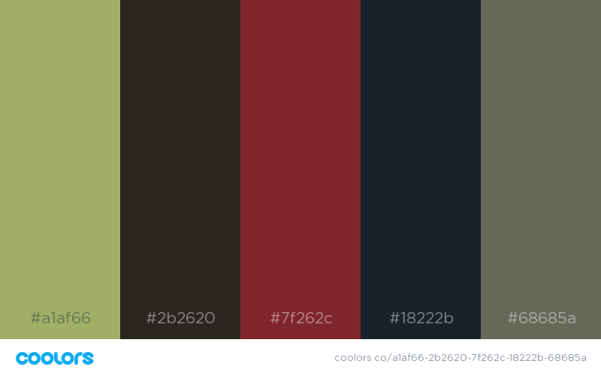

**References:**

Akande, S., & Hayes, T, B. (2018) Will leather be a part of Nigeria’s economic rebirth?. Cnn.com. Retrieved from:

<https://www.cnn.com/2018/10/02/africa/nigeria-leather-economy/index.html>

Bondi, L. (May 21, 2018). Faux Leather Pieces That Look And Feel Like The Real Thing. Healthyway.com. Retrieved from:

<https://www.healthyway.com/content/faux-leather-pieces-that-look-and-feel-like-the-real-thing/>

Centeno, A. (2018). Men’s Suit Jacket Linings| Understanding The Lining & The Interior Of Men’s Suit. Realmenrealstyle.com. Retrieved from:

<https://www.realmenrealstyle.com/mens-suit-jacket-linings/>

Coolors.co. (2018). Color generator. Coolors.co.

Dangremond, S. (June 17, 2015). How the Blazer Got Its Name: A history of the preppy fashion staple. Townandcountrymag.com. Retrieved from:

<https://www.townandcountrymag.com/style/fashion-trends/a3314/the-history-of-the-blazer/>

Green, D. (2016). How the leather jacket became a cultural icon, according to the company that invented it. Businessinsider.com. Retrieved from:

<https://www.businessinsider.com/how-the-leather-jacket-became-iconic-2016-1>

Leavitt, E. (July, 15, 2018). People Are Already Predicting Color Trends for 2020. Domino.com. Retrieved from:

<https://www.domino.com/content/wgsn-color-trend-report-2020/>

Ledru, S. (2018). Color palette spring/summer 2020. Ispo.com. Retrieved from:

<https://www.ispo.com/en/awards/textrends/color-palette-spring/summer-2020>

Ledru, S. (2018). 5 textiles trends for spring/summer 2020. Ispo.com. Retrieved from:

[https://wwwispo.com/en/awards/textrends/trends/textiles-trends-2020](https://www.ispo.com/en/awards/textrends/trends/textiles-trends-2020)

Ledru, S. (2017). 5 textiles trends for spring/summer 2019. Ispo.com. retrieved from:

<https://www.ispo.com/en/awards/textrends/textiles-trends-spring-summer2019>

McCartney, S. (2018). Recycled nylon and polyester. Stellamccartney.com. Retrieved from:

<https://www.stellamccartney.com/experience/us/sustainability/materials-and-innovation/recycled-nylon-polyester/>

McCartney, S. (2018). Organic cotton. Stellamccartney.com. Retrieved from:

<https://www.stellamccartney.com/experience/us/sustainability/materials-and-innovation/organic-cotton/>

Mccartney, S. (2018). Metals. Stellamccartney.com. Retrieved from:

<https://www.stellamccartney.com/experience/us/sustainability/materials-and-innovation/metals/>

McCartney, S. (2018). Vegetarian leather. Stellamccartney.com. Retrieved from:

<https://www.stellamccartney.com/experience/us/sustainability/materials-and-innovation/vegetarian-leather/>

Mcnulty, M.(2018). Leather Jackets. [Madehow.com](http://madehow.com/). Retrieved from:

<http://www.madehow.com/Volume-2/Leather-Jacket.html>

Medine, L. (2016) A History of the Leather Jacket: How’d It Get So Cool? [Manrepeller.com](http://manrepeller.com/). Retrieved from:

<https://www.manrepeller.com/?p=86959>

Meyers, S. (2015). Where Does Leather Come From? Leather Manufacturers Tell The History Of Leather. [Makersrow.com](http://makersrow.com/). Retrieved from:

<https://makersrow.com/blog/2015/03/where-does-leather-come-from-leather-manufacturers-tell-the-history-of-leather/>

Morris, A. (May 11, 2018). “Neo mint” will be the colour of 2020 says forecaster WGSN. Dezeen.com. Retrieved from:

<https://www.dezeen.com/2018/05/11/neo-mint-colour-2020-wgsn-trends-design/>

Mystique, A. (2018). A TIMELINE OF THE HISTORY OF THE LEATHER JACKET. [Americanmystique.com](http://americanmystique.com/). Retrieved from:

<https://www.americanmystique.com/blog/a-timeline-of-the-history-of-the-leather-jacket/>

Pesce, N, L. (2017). Here’s why Hilary Clinton and Barrack Obama are wearing leather jackets. Marketwatch.com. Retrieved from:

<https://www.marketwatch.com/story/heres-why-hillary-clinton-and-barack-obama-are-wearing-leather-jackets-2017-03-29-1288654>

Smith, L. (2018). ISPO Textrends launches color palette for Spring/Summer 2020. Ispo.com. Retrieved from:

<https://www.ispo.com/en/trends/ispo-textrends-launches-color-palette-spring/summer-2020>

The Good Trade, (2018). 35 Fair Trade & Ethical Clothing Brands Betting Against Fast Fashion. Thegoodtrade.com. Retrieved from:

<https://www.thegoodtrade.com/features/fair-trade-clothing>

Trendstop. (2018).Pantone Color of the Year 2018 Conversation. Blog.trendstop.com. Retrieved from:

<https://blog.trendstop.com/2017/12/pantone-color-of-the-year-2018-prediction/>

Trotsky, L. (March 13, 1925). “Jacob Sverdlov”. Marxist.org. Retrieved from:

<https://www.marxists.org/archive/trotsky/1925/03/sverdlov.htm>

Via, A. (2018). Which Countries Produce Leather The Most ?.[Buffalojackson.com](http://buffalojackson.com/). Retrieved from:

<https://buffalojackson.com/blogs/insight/which-countries-produce-the-most-leather>

Yotka, S. (2018). The Spring 2019 Men’s Trend Report. Vogue.com. Retrieved from:

<https://www.vogue.com/article/spring-2019-mens-trend-report>