Cinderella: The Movie Costume Comparison of 1950s & 2015

Professor Kelly Valladares

BUF 2246 Textiles

By: Amber Alicea & Arielle Gustave

4 December 2020

TABLE OF CONTENTS

- Introduction & Movie Synopsis………………………………………………………… 3

- Garment 1 with Image…………………………………………………………………… 4

- Garment 2 with Image…………………………………………………………………… 5

- Comparison & Conclusion……………………………………………………………… 6

- Bibliography………………………………………………………………………………7

Cinderella the movie 1950

In the Cinderella movie produced in the 1950s, a young girl's life quickly turns upside down after her mother’s death and father decides to remarry a cold, evil woman. Her new life consisted of an evil stepmother and two ugly stepsisters who keeps her enslaved and dressed in rags. As time went on, her father passed away and her stepmother quickly turned her into a servant in her own home. They always kept Cinderella home cleaning and cooking at all cost. The evil stepmother and ugly stepsisters would have hated to see her look good, succeed, and/or be happy; they rather see her cater to them and miserable. However, this quickly changes when Cinderella's fairy godmother appears and magically transforms her reality of going to the Prince’s ball one night into a dream come true. Cinderella enchants the handsome Prince Charming at the ball, dressed in a beautiful blue princess gown. The catch is that she must face the wrath of her enraged stepmother and sisters when the spell wears off at midnight. – Amber
The cartoon original Cinderella movie from the 1950 has been remade in real life movies, plays, and also adaptations over the past years till present day. A key detail of the movie, whether it was the original or a remake, was the significance of Cinderella’s appearance and how that differed from her stepsisters. While her stepsisters were dressed in the latest gowns and accessories, Cinderella was wearing housework clothing. Therefore, it is portrayed that she is not as beautiful since she also wears the same clothing every day. Once the princess blue dress was put on Cinderella, only one word everyone thought when they seen her, including her stepsisters and stepmother, was beautiful. Although the princess gown debuted before the 1950s, the style is more popular today due to the Cinderella movie and celebrities wearing that same style. It is also used today in many different fabrics, colors, and occasions. People today have the luxury to feel like a Cinderella on any given day! – Arielle
Garment #1: The Ball Gown

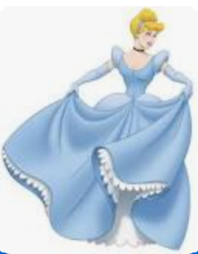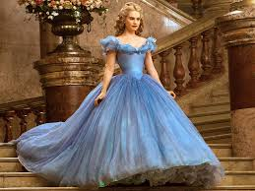

The first garment we chose to compare was Cinderella's dress worn to the Royal ball. In the image on the left from Cinderella in 1950 she is shown wearing the ball gown designed by costume designer Ellen Mirojnick. The gown is shown combining baby blue and white details with scalloped trimmings for an overall dainty magical look. Her look is very Victorian and reflective of the 50s fashion and silhouette. – Amber

Garment #2

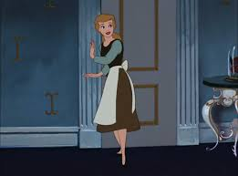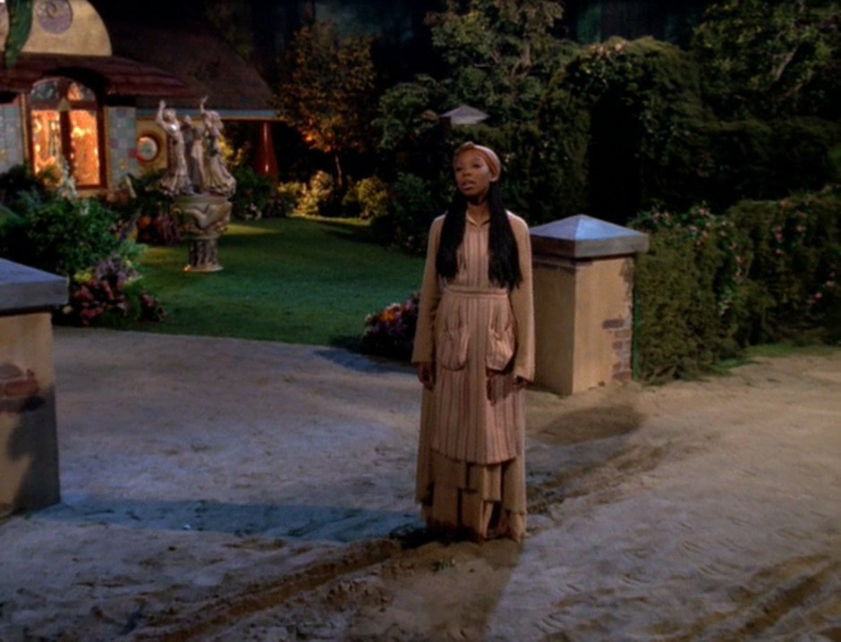

Cinderella 1950 - Arielle
Cinderella’s housework attire was known as rags. It was a cotton four-piece outfit she wore to clean the house, cook, and to run errands. The outfit included a midi brown skirt, teal long sleeve shirt with a chocolate brown vest over it, and a white skirt apron that tired around her waist. This look has changed over the years and houseworkers now are also known as maids wearing black and white collard dresses with the same symbolic white tie around waist apron.
Cinderella 1997 – Arielle
In the 1997 version where Brandy plays Cinderella, the housework costume has the same look but was adapted to the times. This version had Cinderella in linen housework outfit. Her apron was for the full body and had two square pockets. The apron was also in a beige color with red stipes going vertically. She wears a brown silk scarf wrapped on her head as well. Silk is a material that works well with your hair because it protects the health of hair as far as it being breathable, which helps the hair not to dry out and/or frizz. The linen brown dress she wears for housework and happens to be the most durable fabric. This makes sense to have as a housework outfit because it also always the body to breathe. Cinderella was doing multiple things at once that could have caused her body temperature to overheat but since she was wearing linen she was able to regulate her body heat without even realizing.

Bibliography

“Brandy Norwood in Cinderella (1997).” IMBD, 1997, www.imdb.com/title/tt0128996/mediaviewer/rm2409926657/.
Cinderella. (2005). Retrieved December 04, 2020, from https://www.imdb.com/title/tt0042332/plotsummary
https://sandandscarf.com/blogs/sand-and-scarf/why-you-should-be-wearing-a-silk-scarf-to-bed

