The Who You Are T-Shirt

I am Arielle Alethea Gustave. I identify as a woman who is single at the moment but believes in a social status with marriage and children. I am a daughter, an older sister, and a friend. Also, proudly, I am a future Spring 2021 graduate of New York City College of Technology. My major is Business and Technology of Fashion with a concentration in Global Fashion. This fashion major defines me not as a designer but more of the business/stylist aspect.

Dress defines me as effortless, meaningful, and extravagant. My t-shirt does not capture the full essence of this, yet it still depicts bits and pieces of it. For starters, on the front of my shirt is a handstitched Jordan sneaker lanyard in the letter M using a with blue thread. The M stands for Myles Morales who was my best friend that died 18 January 2020. The blue thread was used because it was Myles favorite color which signifies feelings of calmness, serenity, intensity, and inspiring. It’s often described as peaceful, tranquil, secure, and orderly (Morin, 2020). Furthermore, making the letter “M” out of the sneaker lanyard also symbolized Myles and I first conversation over a pair of blue Jordans we both were wearing. One of my future goals Myles and I always dreamed about was opening our own sneaker store which I will do in his honor. Myles embodied everything the color blue signified, and he is forever a part of me.

Above the letter M that is handstitched with blue thread from a Jordan sneaker lanyard, there is an iron on patch of a journal that says Time for A New Adventure. It is made with the colors blue also and beige. The color blue describes the patch as sincere, calming, inspiring, and intense; however, the color beige is overall for aesthetic purposes. These colors make up how I write as well. I am a writer who loves great presentation. I write when things get hard. I write when I am happy. From the time I could start writing, I always had a story to tell. The slogan on the patch resonated with me because I am always writing about my new adventures. My next new adventure after graduating will be joining the Air Force.

On the back of the t-shirt, it reads Arielle the Great in pink varsity letters with green stitching. Pink evokes a range of responses (Cherry, 2020). A response can be influenced based upon personal and cultural factors according to Kendra Cherry from verywellmind. Pink can be used as a calming effect but give off feminine, vibrant, refreshing, and euphoric energy. The color green gives more of a natural personality which is defines how natural I am as a person from my personality flow to the body I have. Green is thought to relive stress and help heal (Cherry, 2020). The two e’s in Arielle are in green and stitched in pink to emphasize my name being important to me and my excitement but refreshing future of my name. The pink and green can be described as nurture vs. nature coming together which depicts the type of person I am today. Furthermore, Arielle the Great comes from a quote which resonated with me since high school; I am the greatest and I just don’t know it yet. In between Arielle and the, there is a basketball in the center with green hand stitching as well. Coinciding with the varsity letters, the basketball was significant because it played a huge part in my life. When I got to Howard, I volunteered as the Men’s Basketball team manager for three years. I traveled all over the United States with them and even went to Hawaii. That experience gained me older brothers that I have always wanted for a lifetime. Basketball also allowed Myles and I to have a bond on the court. Everything on the shirt, from the front and back to the stitching, goes hand in hand with describing areas of my life.
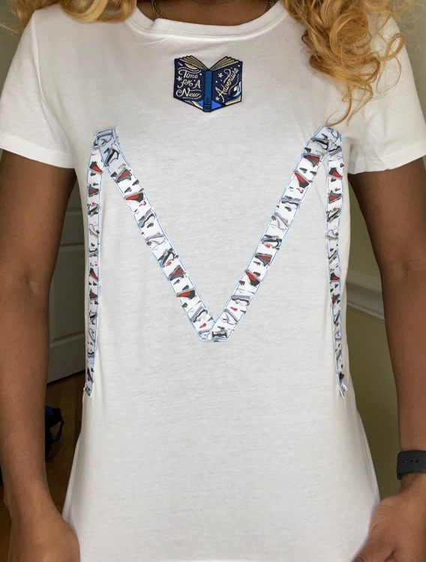
Front of shirt
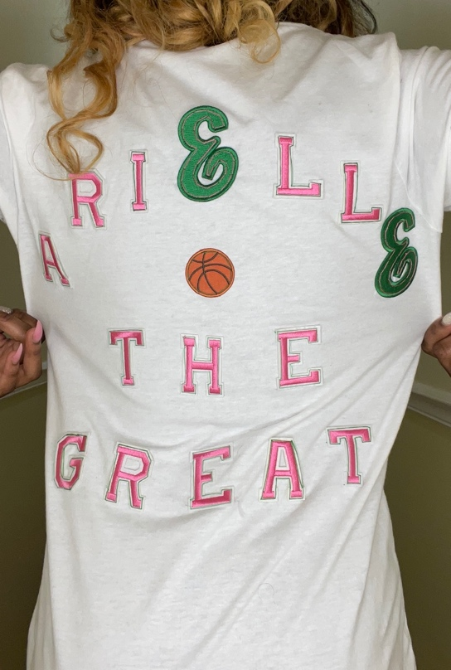
Back of shirt

Reference

Beige color meaning - psychology & personality. (2021, February 16). Retrieved May 09, 2021, from https://colorpsychologymeaning.com/color-beige/
Cherry, K. (2020, December 21). The color psychology of pink. Retrieved May 09, 2021, from https://www.verywellmind.com/the-color-psychology-of-pink-2795819
Cherry, K. (2020, February 22). How the color blue impacts moods, feelings, and behaviors. Retrieved May 09, 2021, from https://www.verywellmind.com/the-color-psychology-of-blue-2795815
Cherry, K. (2020, January 24). How does the color green impact mood and behavior? Retrieved May 09, 2021, from https://www.verywellmind.com/color-psychology-green-2795817

