PRESENTS

I HAVE NO IDEA WHAT TO WEAR

Written and Illustrated by Arielle Alethea Gustave

**Prologue**

Fashion can get complicated especially when getting a new wardrobe. I never knew what to wear after graduating high school! That is when I realized that my style of dress was changing. I was not into looking like a basketball player anymore (yes, I played). The sweats, basketball shorts, sneakers, and warmup tops has become my past life and I am ready for my future. Little did I expect that my future consisted of *body modifications* such as *transformations* to the hair, nails, teeth, etc. My style of dress had developed tremendously since my basketball days in high school. Now, I wear dresses, sandals, and heels and I even apply makeup at times. With a whole new style, I thought it would get easier finding something to wear but it did nor resulting in me not knowing what to wear on a daily basis. I had ups and downs with making sure I wore the right outfit to the right events. My friends tell me all time that if I had to take the easy way out, it would result in me wearing a pair of designer sneakers and sweats like I did when playing basketball. Sneakers has always been the key to my heart and are still with me on my journey today. I would overall describe my type of dress as versatile but then again, I never know what to wear!

**Foreword**

Arielle Alethea Gustave is the most self-less person I know. She knows where she has been, she knows where she is, and the best part is that she knows where she is going. I am grateful to call her my mentor because she is one of my favorite respectable women. Fashion has always been a part of her brand and there is no denying it. I am proud that she is following her dreams and completing a fashion degree. Arielle, I thank you for being the greatest

* BSharp

**Table of Contents**

Prologue 2

Foreword 3

A Highschool Great Gatsby Prom 6

A Freshman Pageant 8

A Howard Homecoming 10

An All-Black Annual Party 12

Another Howard Homecoming – orange off 14

A Howard Charter Day – gold skirt 16

A 21st Birthday Brunch – red 18

A Teyana Taylor Tribute – kani 20

A Friend’s 21st Birthday – silver bape 22

LOS ANGELAS, California 24

About the Author 26

**Acknowledgements**

I dedicate these short stories about my life and dress to the people that were there:

my mother,

my brothers,

my abuelo,

Myles Morales

2015 May 25

**A Highschool Great Gatsby Prom**

I was attending my SENIOR prom! There is an emphasis on senior because I was graduating high school as a junior. Ask me how I did it and I would not be able to tell one, but I knew I made it! I attended Middletown High School in Middletown, New York (upstate). The theme of that 2015 prom was the *Great Gatsby* and was located in the Orange County area. I tried searching and even tried calling the school to get the exact address but came up empty. However, I could not forget the details, my mother driving up to the circular driveway with a fountain in the middle. Also, I do not believe it was a hotel, but the front of the event space had an area for pictures and unloading the cars. Inside the space, it was decorated as a wonderland combined with 1920s squeak easy bars. There was a dinning place for us to sit down and eat but also a dance floor. I did not have a date to the dance but when I got there, I spent the night with my best friends, Justin and Sebastian. They had come with their dates, but everyone wandered off to their own groups after they ate. Growing up, I never went to events like this so the loud music, dimmed lights, and everyone being extremely carefree was something I wanted to see more of in my future.

My mom and I wanted to execute the *Great Gatsby* theme for the prom. Therefore, I found a dress website which had the perfect dress for the occasion. I wore a white high low dress that had a trail. The top half of the dress was made from bridal satin but had embroidered stones throughout the front bust area. The bottom half of the dress, including the trail was made from chiffon. To make the dress pop, my shoes were red suede Christian Louboutin 100mm heels. My mom brought them as a gift for my accomplishment on graduating early. Matching the shoes, I had a red clutch and *transformed* my face with natural makeup consisting of red lipstick. I accessorized with silver fashion jewelry which consisted of a ring, bracelet, and necklace. My ears were *mutilated* with silver earrings that dangled from my ear.Also, my mom found a head piece which laid over my start hair as the flappers did. All the pieces looked vintage and fit perfectly with the theme.

This was special to me because throughout high school, I was in an abusive relationship and my mom didn’t know at the time. My mother and I’s relationship was not the best, there were to many ups and downs. However, in the moments of her helping me get ready for prom and dropping me off, I knew I made her proud because I was officially graduating a year early from high school. Also, she made me feel seen and proud of who I was becoming. Dress brought my mom and I closer when I really needed it. All the pieces of the outfit and the different moments fit well together. The red Christian Louboutin heels were my favorite because red represented my high school life in one, love, fear, anger, and courage. In addition, I suffered with acene throughout my high school career so being able to put on makeup and not look like my everyday self really made me feel great. I felt safe. Also, because Justin and Sebastian were there also made my experience better. I did not have to be scared here. Prom helped me realize I am not alone. I did not think mentally I was going to make it to prom, but I am glad I did to have that radiance again!

2016 October 2

**A Freshman Pageant**

Today was the day I introduced myself to Howard University as Arielle the Great! It was my first year at Howard University, in Washington, DC, and I stumbled upon a pageant that crowns a “Mr. and Mrs. Freshman.” The pageant consisted of twelve contestants, four males and eight females. We practiced Monday through Friday nights for about four weeks until the big day! The pageant took place in the Blackburn Center on campus with a DJ and thrust stage. The theme of the pageant was *African Royalty* and we held ourselves to that standard.

There were several different outfit changes through the pageant, but only one dress stuck with the *African Royalty* theme for me. It was a red and black ball gown that was made of bridal satin. The top half of the gown was black and had short sleeves with a deep v neck. The bottom half of the gown was red, consisted of hidden pockets, and laid at my feet; one could not see my shoes. I clipped a necklace that had my name on it that my mother had given me when I was ten. My face was *transformed* with natural makeup and red lipstick (my go to). My hair was designed as a braided weave mohawk; split or hair in three ponytail buns vertically, then take a pack of braided hair to wrap it around and through the ponytail buns with pins to hold the style. The look came together and became special to me.

This particular look was for a segment of the pageant where shared who I am, and I did not know what to say prior. Once I seen how the look came together and the feedback I received from the crowd, I decided it was time to speak my truth of being a domestic violence survivor. At the end, my peers told me they thought they were alone, and they thanked me for speaking up. In that moment, I realized dress made me connect with others and change their lives in a positive manner. Thank you, the red/black dress, the braided weave mohawk, and Howard University!

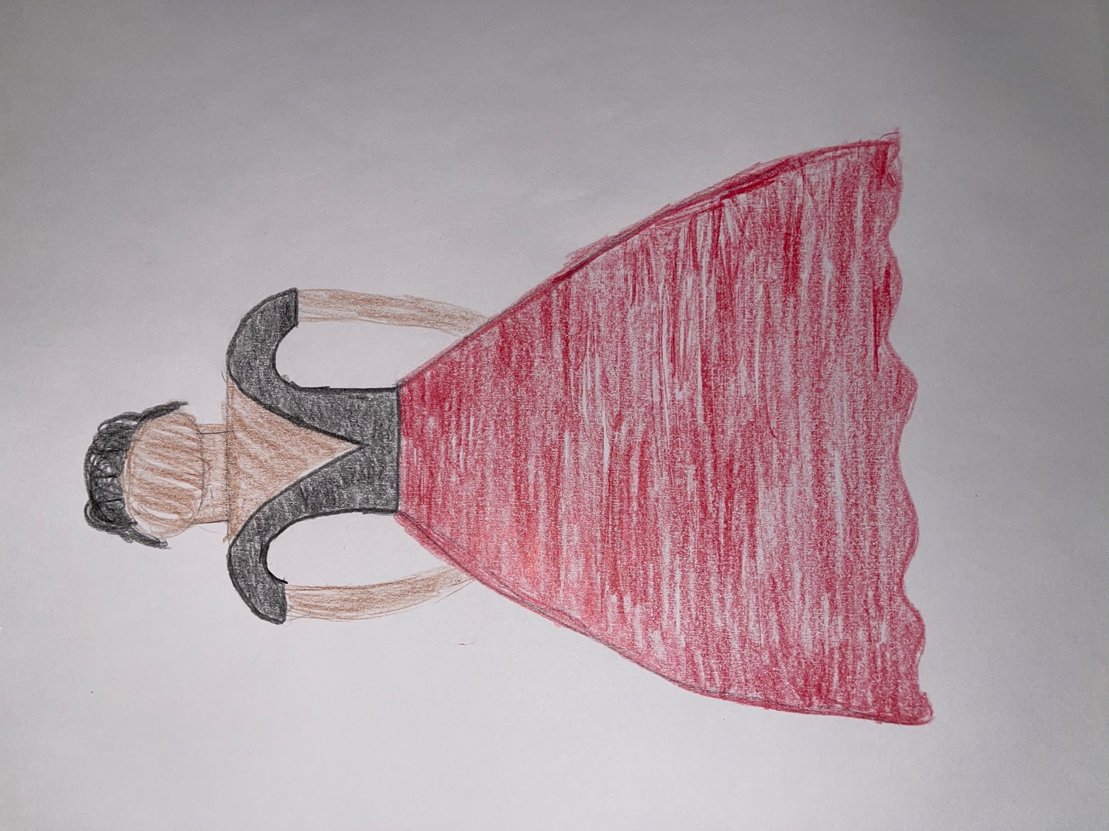

October 20th, 2017

**A Howard Homecoming**

My hair has always been thick, long, curly, and black for as long as I can remember! At this point in time, I had started my second year at Howard University, and I needed a change for myself. Homecoming happens a weekend in October, every year, where everyone comes to look their best or present their new self. This year, I wanted to present my new self, but I could not imagine what it would be. The weather was in the 60s and I needed my look to stand out for every event; Yardfest (concert on the yard), parties, and brunch. My mom told me, “Arielle, do something that will make you happy in the moment, but you would not regret it later on.” It had to be my HAIR which meant I needed a reveal outfit as well!

The modifications on my hair were a tough decision because I had many different options to pick from. I chose to cut it and dye it. I went to a salon and the hairdresser cut my hair into about a 10 – inch bob. My roots and the back half of my hair was colored a golden brown. The top half of my hair was a golden blonde. I debuted the look wearing an orange, black, and white knitted polyester Black Pyramid hockey jersey with embroidered numbers, lettering, and symbols. My shoes were these PrettyLittleThing polyester black peep toe thigh high boots which were water-resistant. My homecoming look was a statement hair piece that came out perfect.

Modifying my hair was something I never thought I could do but I did it and fell in love! The blonde color made me feel feminine beauty since I was bullied for being a tomboy growing up. The cut made me feel as though I was taking control of my new life, I wanted to live, putting pain behind me. My hair decision came about due to me feeling as though I lost myself and I had to get me back. Furthermore, I was able to find me but defined a new version of myself and debuted her at Howard University during Homecoming weekend! My hair did that for me.

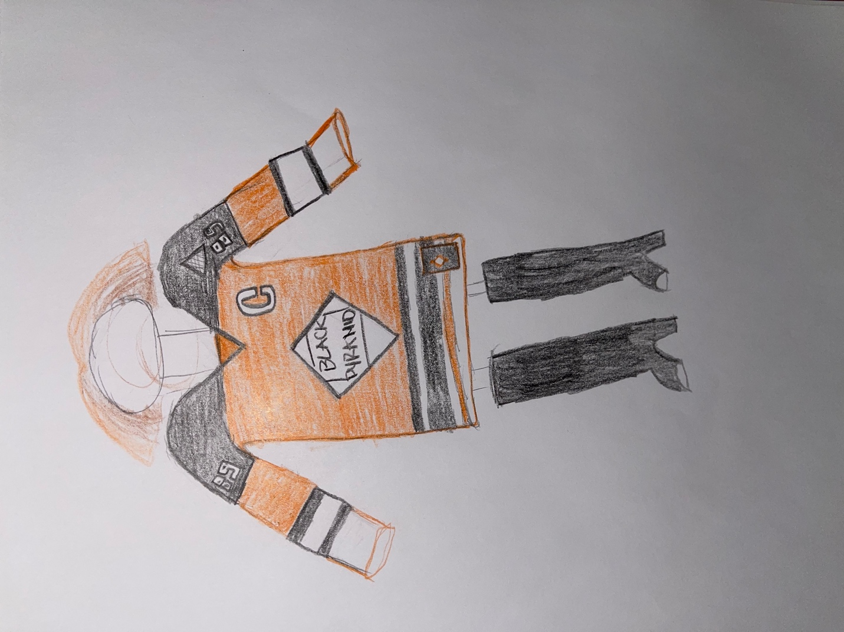

January 17th, 2018

**An All-Black Annual Party**

Fashion has always been a part of me. I never really knew which route in fashion I wanted to take but I could you it was not a designer. Being at Howard University I watched how people just threw together outfits and called it fashion. Most styles were a hit, but others were a definitely miss. With that in mind, I was attending an all-black party and did not know what to wear but I know I wanted to stand out. I had a V-neck long sleeve mid black dress from H&M, black thigh high boots, and a multicolor coat. The party was taking place at Bliss Nightclub at 2122 24th Pl NE Washington, DC 20018. I needed to make sure I was looking my best but stand out.

Once the day of the party I came, I had it all figured out. I put on my black cotton long sleeve dress then *attached* a black nylon corset/waist trainer over it which *pre-shaped* my waist and *modified my body.* My hair was already *transformed* due to it being bleached blonde, so I slicked it up into a mohawk with *clipped* pins to hold it up. I then put on black latex block heeled thigh high boots with a faux fur black/white/beige jacket. I also finished the look with *transforming* my skin using makeup and *attached* eyelashes.

Being that I hate designing clothes, I really enjoyed styling myself and putting things together. This was one of the first outfits I allowed myself to take a risk on putting different pieces together to create a new look. I am really content with how I executed the look, simple but still was able to pop.

October 28th, 2018

**Another Howard Homecoming**

Each homecoming I try different looks that will pop. I did not know what to wear until the week before and it hit me. Furthermore, on Howard’s campus, there are students that have brands that they hand make or get manufactured.

I went to donate at a thrift shop called Redz Trading in the Georgetown part of DC where I found an orange cotton J. Crew trench coat. I personally never show my body, but this girl makes two pieces, and I purchased a brown bra let with biker shorts.

2019 March 3

**A Howard Charter Day**

Charter Day for Howard University is March 3 and holds a black-tie event every year at the Washington Hilton Hotel in Washington, DC. The night consists of guest speakers, a three-course meal, a photo booth, and a dance party to end the night. This will actually be my second time attending so I wanted to wear something that would outdo the first time. I had one day to get something together after being told by my mentor, Loick St. Louis, that I would be going. So, from Buffalo Exchange too my closet, I was determined to find something that would make me feel great. The event didn’t take place till 6pm the next day so I had a little time.

At Buffalo Exchange that day, I didn’t think that I would find anything that would scream black tie event. However, I had a new H&M beige polyester three quarter sleeve blouse so all I needed was a skirt. I ended up finding an ankle length A-line skirt that had gold glitter embellishments all over with a gold thick trimming at the top and zipper on its side. The skirt was made of organza and a silk layer underneath. At the time, I had *inserted* faux locs that *modified* my hair which allowed me to look as though I had dreadlocks. With this style, it is normally not considered a black tie or professional look but because of how I styled it, with how I dressed, and *transformed* my face with makeup, it came out the way it needed to aesthetically.

I often doubt myself when it comes to having nontraditional hairstyles and attending professional settings because I don’t want to come across as any stereotype. However, giving this challenge with my hair I know I executed the look perfectly. I never really understood what it meant to look the part since growing up I often was always in a basketball setting as a basketball player. So, this was one of the challenges that I had to face that allowed me to really test what I can do with fashion. This was also one of the first times in a thrift store so thinking outside the box and not going to a traditional department store really allowed me to see another side through vintage clothing as well. In the end,

I learned that my mentor knew I possibly would’ve been uncomfortable with going to an event like this, but he also knew that I would execute the challenge perfectly.

2019 March 31

**A 21st Birthday Brunch**

My birthday is March 31st, and I am an Aries. I never do anything for my birthday but this year I was turning 21. I was planning a brunch for the day of my birthday, so I knew whatever I put together had to be bold but elegant. I started looking for dresses, shoes, hairstyles, and nail designs about two months prior so I would not have to be overwhelmed at the last minute. During my search, I came across a variety of looks but still couldn’t find the best look for me. After gathering possible contending outfits, I decided to send it to the person that knows me best since I was born, my mom. She quickly gave me her feedback and picked out exactly the look I was going for.

One thing I already knew for sure was that I was going to modify my face by applying natural make-up and eyelashes. But when it came to my outfit, with my mom’s recommendations from my list of contending outfits, I ended up purchasing a red silk and tulle two-piece dress from a black designer brand, Oyemwen. The top half of the dress was a red silk leotard with tulle short sleeves and the bottom half was a skirt with a silk red slip underneath the organza tulle. Furthermore, I *transformed* my nails by *adhering* extra-long stiletto acrylic nails that were pink and glittery. I also, modified my look by adhering a toned honey blonde wig to fulfill the look I was going for. The bold and elegant look I was going for, ended up coming together a week before my birthday very seamlessly.

This outfit was very important to me because it was the first birthday I really celebrated as an adult. I executed my bold and elegant look after hearing my friends say I treated my birthday as the MET Gala. At first, I felt as if I was to extra but then I realized I had every right to be because it was my day. Time and time again I prove to myself why I love fashion because I enjoy taking the time out to brainstorm, plan, and execute to a T. It felt great that other people could see the vision I executed.

2019 April 5

**A Teyana Taylor Tribute**

Growing up, I never seen someone in the fashion industry that I can look up to that looked exactly like me, style and all. Then, in 2006, on MTV, I found the perfect person. I was in my room and My Super Sweet 16 came on. On that episode, it was Teyana Taylor turning 16

September 28th, 2019

March 31st, 2021

About the Author

Arielle Alethea Gustave was born and raised in Brooklyn, New York but is currently living in Queens, NY. She graduated Middletown High School a year early in 2015 then attended SUNY Rockland Community College Fall 2015 for a year. In Fall 2016, she attended Howard University for two years, took off a couple semesters, and then transferred to a college back home to Brooklyn, New York in the Fall of 2019. Arielle is now a senior at New York City College of Technology majoring in Business and Technology of Fashion with a concentration in Global Fashion. She will be completing her Bachelor of Science degree Spring 2021. After graduation, Arielle be enlisting active duty into the Air Force with rank. She still intends to further her education in the Air Force by either earning her master’s degree, PhD, or both as well as becoming an entrepreneur.