ARIELLE A. GUSTAVE
160-31 121st Ave Jamaica, NY 11434 | Arielle.gustave@mail.citytech.cuny.edu | (917) 246-0471

April 2021

To Whom It May Concern:

Hello, my name is Arielle A. Gustave. I am a future Bachelor of Science Spring 2021 graduate of New York City College of Technology. My major is Business and Technology of Fashion with a concentration in Global Fashion. I am writing this letter to highlight my interest in the event coordinator position at Saks 5th Ave in New York.

I am looking to leverage my volunteer and luxury coordinating experience toward a position within an industry I truly care about: event planning. Recently, I completed an internship with Louis Vuitton, where I worked as a client advisor and operations intern. In this position, I worked on pre and post event communication, owned creating waitlists for new collections, and was support for the team. I believe that this internship allowed me to see the day-to-day coordinating and communication that take place in house.

This past semester I took a Marketing – Entrepreneurship course that I feel will be helpful if offered this position. It allowed me to learn the business side of fashion from leading to managing budgets and tracking sales. I also understand that COVID-19 has heightened the importance of communications internally and externally. With my recent internship being in-person and managing virtual events, I believe I would be able to handle this position and all tasks given. My skill sets include excel, PowerPoint, google suite, managing events, organization, public relations and story writing, event planning, social media, and more. These skills will allow me to be a great asset to the company. As I will not only bring my skill set, but my passion to learn, ability to multitask and work under pressure in a fast-paced environment.

It is important that from this position, I am able to develop new skills and network for a senior level event coordinating or special events job. I would like to ultimately be a head event planner, teach event planning and crisis communications course, and open my own nonprofit. This position is a great opportunity for me to develop new skill sets and enhance the skill sets I already have so that I will be able to accomplish my goals down the line.

I have enclosed my resume for review. Determined by the understanding of the responsibilities expected of me, in addition to my previous internship experience and related coursework, I believe that I am more than qualified for the position. I look forward to speaking and meeting with whom this letter may concern and other members of the company. If you have any further questions or concerns, please do not hesitate to contact me via phone at (917) 246-0471 or email at arielle.gustave@mail.citytech.cuny.edu.

Sincerely,

Arielle A. Gustave
Job Listing:
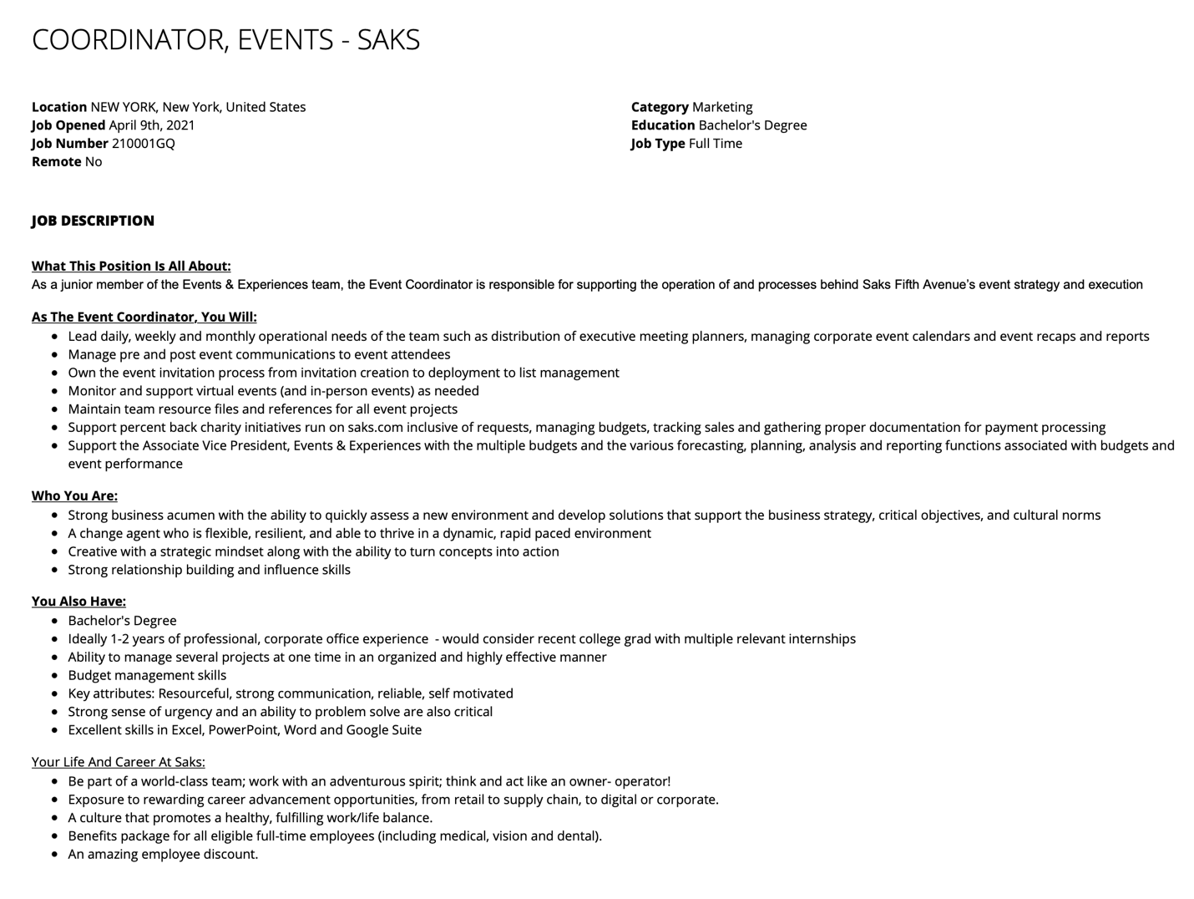

ARIELLE A. GUSTAVE
160-31 121st Ave Jamaica, New York 11434
ariellealethea@gmail.com | (917) 246-0471 | https://www.linkedin.com/in/arielle-gustave/

ACADEMIC/PROFESSIONAL BACKGROUND:
Degree Year University Major
B.S. 2021 New York City College of Technology Business & Technology of
Magna Cum Laude Fashion
Module: Global Fashion

Cont. Edu 2019 Prince Georges Community College Business

Cont. Edu 2018 Howard University Public Relations

Cont. Edu 2016 Rockland County Community College Communications in Media

Diploma 2015 Middletown High School Communications

HONORS AND AWARDS:

2021 Spring Semester, New York City College of Technology, Magna Cum Laude
2020 Spring Semester, New York City College of Technology, Dean’s List

RELEVANT PROFESSIONAL EXPERIENCE:
Louis Vuitton – Saks 5th Ave, NY Hybrid Support (Seasonal) Nov. 2020 – May 2021
- Appointments: In-person and virtually connect with clients to show new product
- Online Processing: Processing online orders to send to customer
- Customer service: Providing exquisite customer service to every customer that comes in

Nordstrom – New York, NY Logistics Assistant (Seasonal) Sept. 2019 – Jan.2020
- Delivery: 1) consolidate, quality check, and use system to pack and ship packages to consumers 2) track and locate packages for consumers
- Fulfillment: Pick items that are in store to fulfill online orders or buy online pick up in store orders

Apple – Arlington, VA Product Zone Specialist March 2019 – August 2019
- Specialist: creating promoters, executing Apple Steps of Service, contributing to the Business team
- Runner: bringing product to product zone members, genius bar members, and/or customers; restocking
- Counter: scanning product that need to be counted for inventory purposes
- Visuals: Cabling and standardizing product; changing floor sets of Apple and 3rd party products
Louis Vuitton – McLean, VA Hybrid Support (Seasonal) Nov. 2018 – Dec. 2018
- Shipment: Unpacking and stocking new merchandise
- Online Processing: Processing online orders to send to customer
- Customer service: Providing exquisite customer service to every customer that comes in

DSW – Hyattsville, MD Sales Associate May 2018 – Oct. 2018
- Shipment: Unpacking and stocking new merchandise
- Online Processing: Processing online orders to send to customer
- Customer service: Providing exquisite customer service to every customer that comes in

J. Crew Men’s Shop – Washington, DC Stylist Sept. 2017 – March 2018
- Reinforcing Clientele: Connects with customers by asking open-ended questions to assess customer needs
- Wardrobe Assistant: Prepare a wardrobe for customers while providing noble customer service
- Merchandising: Unpacking and stocking new shipment while familiarizing myself with the new product

Best Buy – Middletown, NY Customer Service Sept. 2015 – August 2016
- Customer service: Providing exquisite customer service to every customer that comes in
- Product Knowledge: answering all questions about what is new in the store and all products/services we sell
- Cash Handling: Provide friendly, fast, and accurate processing for all customer transactions lanes

INTERNSHIP:

Howard University – Washington, DC Men’s Basketball Manager Sept. 2016 – May 2019
- Practice: set up drills before practice start, distribute practice gear, ensure players are hydrated
- Away/Home Game: set up for pregame meal, distribute game gear, ensure players are hydrated, prepare bench for players and coaches, distribute stat sheets to coaches
- Clerical: create expense reports using Concur, create month calendars on paper and on team app

135th Street Agency – Washington, DC Intern March 2017
- Production: Assisted with the construction and execution of the screening for FOX’s show Shots Fired in the Newseum
- Hosts: Manage and escort reserved seats for FOX VIP guests and celebrity guest
- Interviewer: Interviewed audience members and stars of the show

HU Fashion Show – Washington, DC Positive Energy Coord. March 2017 & Oct. 2018
- Stylist: style models for their looks before they walk
- Model Hosts: get to know models to make sure they had everything needed to walk
- Supervisor: overseen each department to make sure they were running smoothly

FYI Brand Group – New York, NY Public Relations Intern May 2017 – August 2018
- Research: Media kits, gaining contacts, creating excel documents with contact list
- Press: Creating press clippings for clients
- Social Media: Curating Instagram post and captions for business page

OTHER WORK EXPERIENCE:

FoodKick – Brooklyn, NY Inbound Shopper April 2020 to August 2020
- Delivery: consolidate, quality check, and use system to pack consumers orders
- Fulfillment: Pick items that are in warehouse to fulfill online order

WORKSHOPS for PROFESSIONAL DEVELOPMENT:

- Attended, Professional Development Orientation, City University of New York College of Technology, ZOOM Registration Link, Monday, March 8th, 2021, 3:30pm – 4:30pm
- Attended, Cushman and Wakefield Career Informational, City University of New York College of Technology, Microsoft Teams meeting Link, Friday, March 19th, 2021, 1pm – 2pm
- Attended, Wix – Build Your Online Presence – Portfolio Webinar, City University of New York College of Technology, ZOOM Registration Link, Thursday, March 25th, 2021, 5pm – 6pm
- Attended, COOP Careers Information Session, City University of New York College of Technology, ZOOM Registration Link, Friday, April 2nd, 2021, 11am – 12:45pm
- Attended, COOP Careers – Intro to Digital Careers, City University of New York College of Technology, ZOOM Registration Link, Friday, April 22nd, 2021, 5pm – 6pm
- Attended, COOP Careers – Effective Communication, City University of New York College of Technology, ZOOM Registration Link, Thursday, May 6th, 2021, 5pm – 6pm

SOCIAL MEDIA & TECHNOLOGY SKILLS:

Instagram Microsoft Office
Facebook Google Drive
LinkedIn iWork

