Arielle A. Gustave

Professor Jessica Appelstein

BUF 3310: Contemp. Designers

March 2021

**The Bathing Suit Competition**

The bathing suit competition, also known as the swimsuit competition, is one of the earliest competitions in the history of America. The competition was used to determine Miss America as the beauty pageants had a particular way of dressing in swimsuits during the competition (Riverol, 2020). The use of the swimsuits in the event was however abolished recently after it was decided that the winner of the competition would not be decided on their physical appearance but rather on their intelligence. There were swimsuits for both male and female contestants during the event. The event would be organized annually and the beauty pageants would be dressed in different swimsuits and display their physicality before the judges (Watson, & Martin, 2018). The swimsuits were the best outfits that properly expressed the physicality of the pageants, which was the criteria for deciding the winner of the competition. For a long time, beauty pageants wore swimsuits of different kinds to assist them become fit for the Miss America competition. This would also hinder the confidence of others who wanted to join due to the swimsuit portion. Not everyone was confident about their shape and size.

In the past, displays of beauty was one of the ways of appreciating culture in America. The simple way of looking at culture through the beauty pageants was a common practice in the United States as it would involve beautiful women paraded in a competition. The competition would aim at identifying the most beautiful woman. The young women would be lined up in a competition used to search for the *Queen of Beauty* (Slapak, 2019). The practice started many years ago, in the 19th Century, and the century after. It was practiced remembering the past days of the event. As it kept advancing, the common thing during the event was the use of the bathing suits, referred to as swimsuits later. The various types of swimsuits had the capability of displaying different features in women. Whether it was showing their bust area, their glutes, or their abs, women and men were able to display their best attributes in swimsuits without realizing. The pageants have persisted and may continue existing for many years to come because they have been critical for the prosperity of the society (Riverol, 2020). The illustration below is one of the remaining pictures of the beauty pageant contenders lining up for Miss America in swimsuits, which remains a bigger event today;

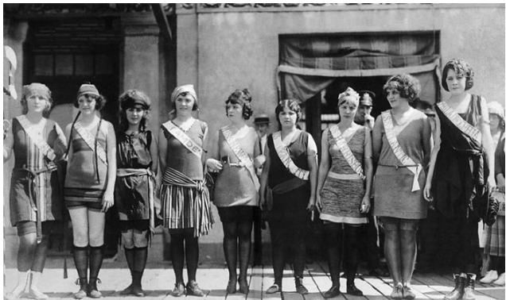(Riverol, 2020)

The Miss America competition was previously referred to as the beauty pageant and was created through a boardwalk in Atlantic City. It was through a boardwalk amidst the prohibition era. The very first contest of Miss America occurred in 1921 (Riverol, 2020). It was the first time in the history of America where young girls would be lined up side by side to compete while dressed in bathing costumes. The young girls lined up for the competition for the first time were aged 16 to 25 years old. The bathing suits used then would not be used today as swimming costumes because they have been outdated. The winner of the competition was Margaret Gorman, a sixteen year old and she was awarded a golden mermaid statue (Riverol, 2020). Furthermore, in 2019, the Miss America Pageant actually eliminated the swimsuit competition. The initial appearance of the competitors in Miss America competition were dressed like in the following figure,

(Riverol, 2020)

The event became global in 1951 after a group of young women were lined up, half dressed in the United Kingdom for the first international beauty pageant. The events in the United Kingdom led to an event that would later be referred to as Miss World (Watson, & Martin, 2018). The event began like a bikini contest in a festival but evolved into a way of appreciating the new models of swimsuits. The advanced swimsuits were displayed through women who played a critical responsibility of representing the beauty pageants. The impressive experiences from the event led to the creativity in creating more advanced bikini and swimming costumes that would not only be used during competitions but also for other purposes (Riverol, 2020). The swimsuits became famous and would be used for more competitions including those for the children and people of color.

The event advanced to various parts of the world where it was considered a basic international practice not only for displaying the swimsuits and the beauty of the young ladies across the world but also as a way of expressing some of the advancements in the world like creativity (Slapak, 2019). The various designs of the swimsuits and other creations that were realized as the beauty pageants were considered a critical part of the society and a way of entertainment made the world become a better place in many ways. Until the time that the use of swimsuits was abolished from the beauty contests recently, beauty pageants have been critical in changing the lives of people especially the young ladies taking part in the event (Riverol, 2020). The event was meaningful and helped in showing some of the ways that beauty was harnessed in the past.

All in all, the bathing suits used by beauty pageants in the Miss America tournament. Since then, the beauty pageants have been in existence through history despite the ban on bathing and swimsuits from use in the beauty contest for Miss America. After it was decided that the wisdom and intelligence of the contestants would be considered and not their physical appearance, there was no need to use the swimsuits in the competition. After the contest became universal, it was apparent that the beauty pageants and the swimsuits would go down the history as the initial steps in the creation of a universal contest where young women would line to compete over who would be more beautiful. The annual competition is currently one of the best and the rewards availed for the young women makes it more attractive.

References

Riverol, A. (2020). *Live from Atlantic City: the history of the Miss America pageant before, after and in spite of television*. Popular Press.

Slapak, G. (2019). Sink or Swim: Deciding the Fate of the Miss America Swimsuit Competition. *Women Leading Change: Case Studies on Women, Gender, and Feminism*, *4*(1).

Watson, E., & Martin, D. (2018). The Miss America pageant: Pluralism, femininity, and Cinderella all in one. *The Journal of Popular Culture*, *34*(1), 105-126.