Artem Gubenko
Prof. Shriky
Digital Media Foundations
Date

Starbucks History
Starbucks, a multinational corporation based in Seattle, is renowned for its coffee beverages, coffee beans, food, and drinks, which it sells at its retail stores and also supplies wholesale to other outlets. It is widely recognized as the world's largest coffeehouse chain. In the early 1970s, when Starbucks first opened its store near Pike Place Market, most American coffee drinkers consumed cheap, low-quality coffee, which was weakly brewed and came from a can. However, Starbucks's founders - Jerry Baldwin, Gordon Bowker, and Zev Siegl - were passionate about quality and worked hard to change the public's perception of coffee. Initially, Starbucks only sold coffee beans roasted by Peet's, a gourmet coffee company in Berkeley, California. They later began roasting their own beans, which proved to be popular and profitable. The company did not start selling brewed coffee until 1982, after a decade of selling only beans. In 1984, Starbucks opened its first espresso bar, at the suggestion of Howard Schultz, who was hired later that year. In 1987, Baldwin and Bowker (Siegl having sold his shares in 1980) sold the company to a group of investors led by Schultz.

Starbucks commenced its operations in 1971 by vending coffee beans at Pike Place Market in Seattle. The original logo was black and white and featured a mermaid, highlighting the fact that Starbucks offered more than just coffee. The initial rendition of the Starbucks siren depicted a topless mermaid with a fully visible double fish tail. The company's founders originally christened the business Pequod, after the whaling ship in Herman Melville's novel Moby-Dick. However, they shortly realized the name was not appealing and instead chose the name Starbuck, after the ship's chief mate.
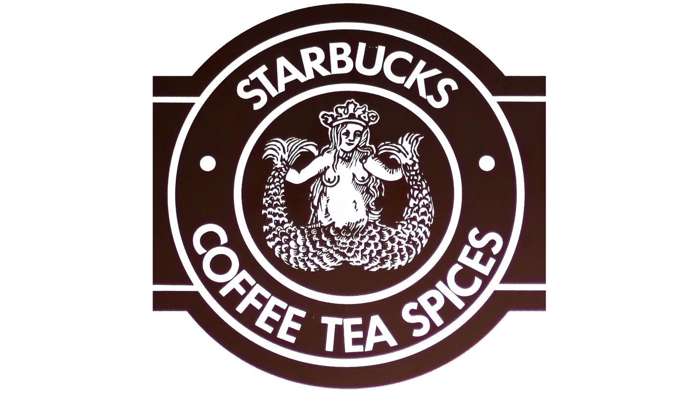
Starbucks’ logo from 1971-1987
Howard Schultz purchased the company during this period and promptly reworked the logo, marking the first instance of the Starbucks logo evolving. The logo was altered in 1987, making the Siren's image more stylish in response to complaints from Seattle's Puritan residents. At that time, Starbucks had a widespread network of cafes, cups with the company logo, and branded vehicles for coffee delivery. After adding handcrafted espresso drinks and merging the two companies, Starbucks introduced a sleeker and more polished image.
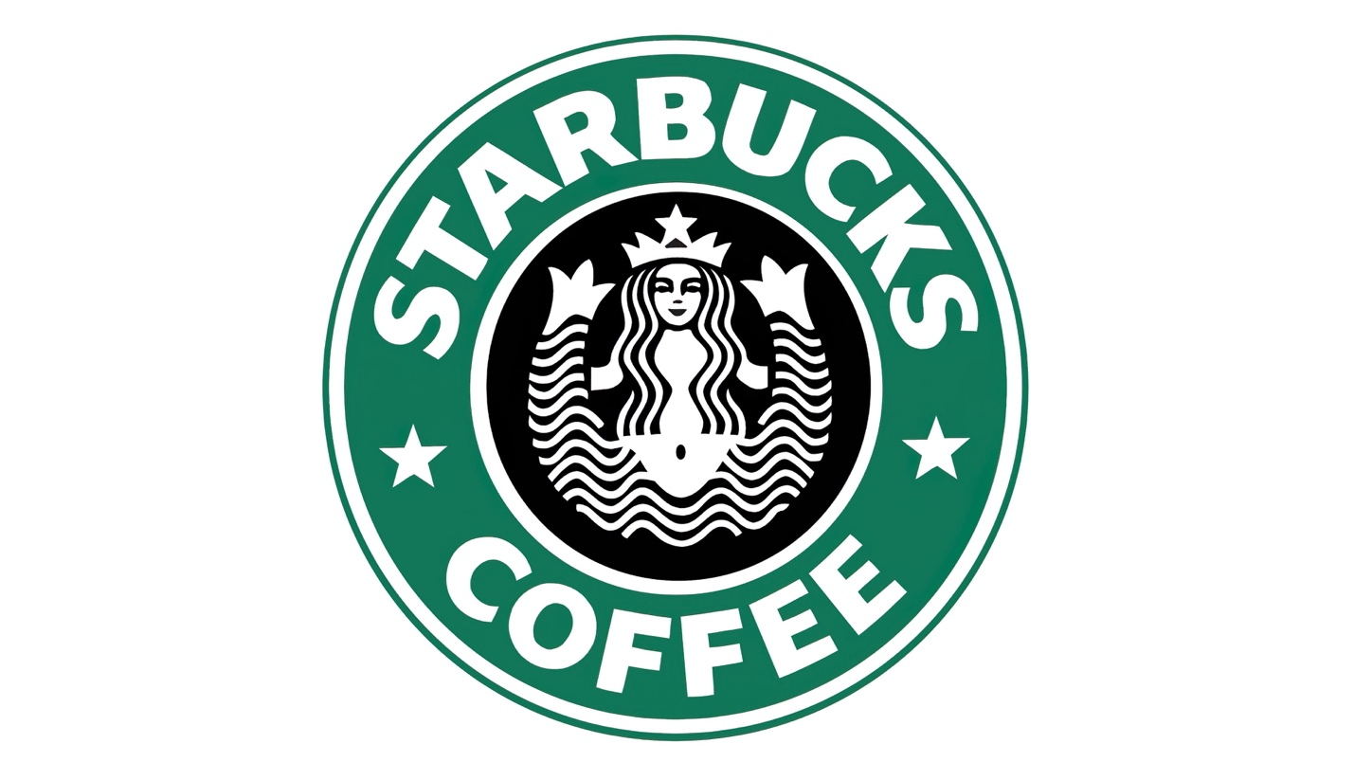
Starbucks’ logo from 1987-1992

Starbucks underwent its third logo redesign in 1992. This time, the focus was on the mermaid, with the logo featuring a more intimate and up-close view of the creature. Her naval was no longer visible, and only a small part of her tail was shown. Once again, the coffee company's logo was modified due to societal pressure, as conservative citizens felt uneasy about the mermaid's bare midriff(diaphragm and pelvic area). As a result, the lower half of the mermaid was removed, and the remaining image was enlarged. Additionally, Starbucks switched the black outer strip of its logo to green, marking the beginning of a shift towards a predominantly green color palette. The color green is commonly associated with growth and peace, aligning with Starbucks' mission statement to "inspire and nurture the human spirit." During this redesign, the logo, font, and text underwent significant changes as well.
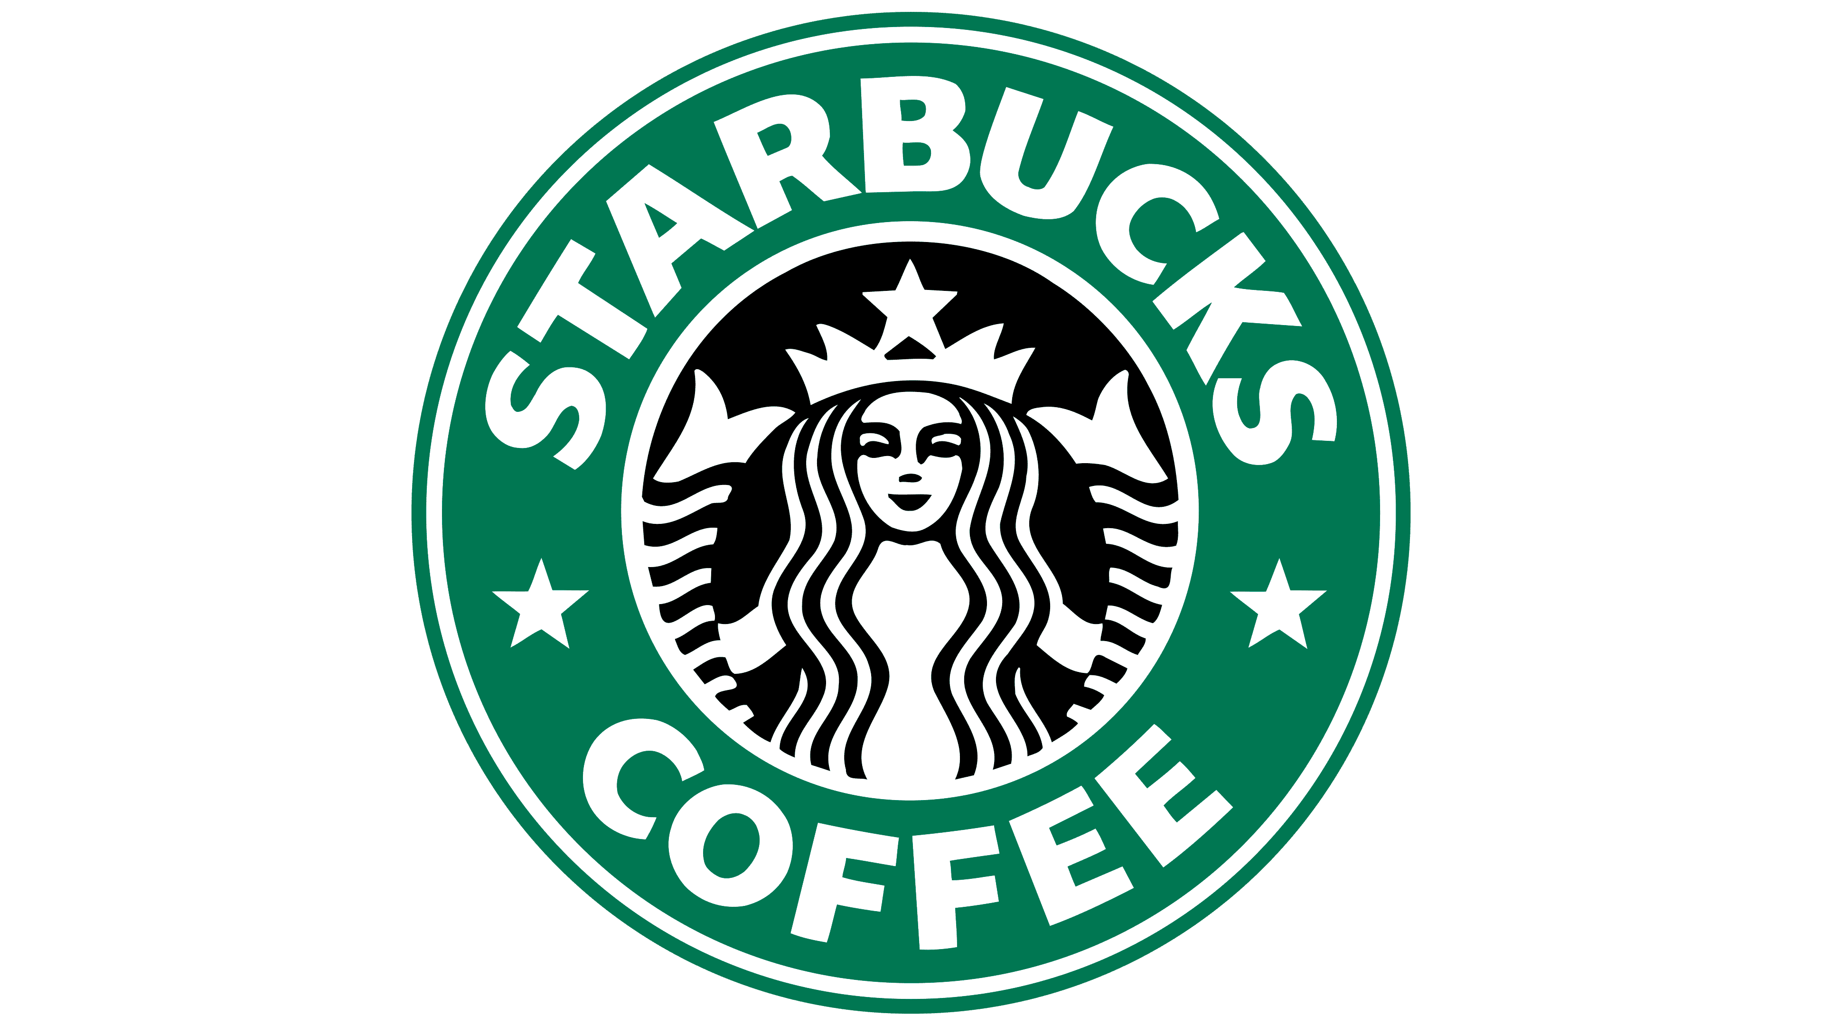
Starbucks’ logo from 1992-2011

To commemorate its 40th year in operation, the corporation made an effort to rebrand itself, but unfortunately, the attempt has not been deemed a success. Rather than propelling itself forward, Starbucks ended up regressing. One of their inexplicable decisions was to attempt a redesign of the original 1971 logo, perhaps in an effort to attract the new popular trend at the time which featured “hipster” culture on the rise. This rebranding effort was met with disapproval from both graphic designers and the general public. The familiar green logo, cups, and branding had become deeply entrenched in the public consciousness, making a significant change like this destined to fail from the outset.
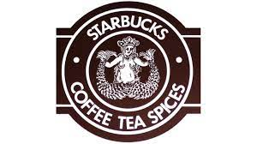

By 2011, the brand had gained global recognition, prompting the company's management to consider streamlining its design. As a result, they eliminated unnecessary elements by removing the outer circle and inscriptions, leaving only the beautiful mermaid on a green background. This move aligned with the current trend of simplifying ECO-logos to reduce the use of ink and preserve natural and ecological spaces. The company's new logo and packaging now emphasize the Starbucks siren and feature a bright green color scheme, while playing with the size and placement of the logo. For example, merchandise and bags may have the logo applied off-center to add some variety to the overall clean and sharp design.

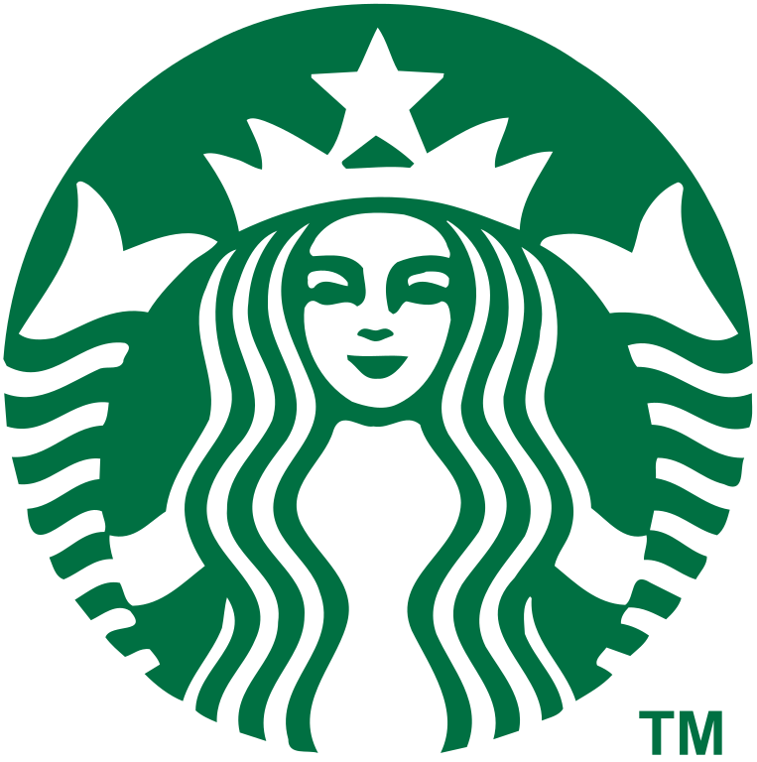

Starbucks’ logo from 2011-present

In recent years, Starbucks has established itself as a marketing and advertising visionary, expanding its brand and influence even further. The company's green color scheme, Starbucks siren, and branding have been consistently applied to their website, online branding, stores, gifts, and all other packaging. Using a logo that features multiple distinct colors can be expensive, but relying on the green color provides an eye-catching and colorful option without the disarray of multiple colors. When a green and white logo is enough to achieve instant recognition, it's clear that successful packaging has been created. The evolution of the Starbucks logo provides many valuable lessons. By having a unique and recognizable mascot, the company was able to establish a strong brand presence not only in America but also around the world. From the very beginning, the Starbucks logo was closely tied to its brand, and the two were inseparable. The Starbucks logo serves as a prime example of how effective logo design can work in tandem with identity and branding efforts.
Work Cited
Wikipedia contributors. “Starbucks.” Wikipedia, The Free Encyclopedia. Wikipedia, The Free Encyclopedia, 26 May 2022.
https://en.wikipedia.org/wiki/Starbucks#Logo
“Starbucks Logo.” Logos-World, 26 May 2022.
https://logos-world.net/starbucks-logo/
Goldring, Kira. “A history of the Starbucks Logo.”, 2022.
https://www.tailorbrands.com/blog/starbucks-logo
Bondarenko, Peter. “Starbucks American company.” Oct 02, 2015. 09 Sep 2021.
https://www.britannica.com/topic/Starbucks
Farr, Sheila. “Starbucks: The Early Years.” 15 Feb 2017.
https://www.historylink.org/file/20292
Cannon, Matt. “Brand Stories: The Evolution of Starbucks.” 24 February 2015
http://www.worksdesigngroup.com/brand-redesign-evolution-starbucks/

