Artem Gubenko
Thelma Bauer
Digital Media Foundations
Date

Starbucks History
Seattle-based Starbucks is a multi-national corporation that sells coffee drinks, coffee beans, food, and beverages at its retail stores as well as wholesale to other outlets. The American company often considers to be the largest coffeehouse chain in the world. When the first Starbucks store opened near the Pike Place Market in 1971, most American coffee drinkers percolated inexpensive low-grade coffee, scooped out of a can and weakly brewed. The passionate, quality-driven approach of Starbucks's three founders -- Jerry Baldwin (b. 1942), Gordon Bowker (b. 1942) and Zev Siegl (b. 1942) -- helped change public perception of what a cup of coffee could be and set the stage for the company's development. They started by selling coffee beans roasted by Peet's, a gourmet coffee company in Berkeley, California, then began roasting their own. For a decade, the few Starbucks stores sold just beans and not coffee drinks, but those gourmet beans were popular and profitable. The first Starbucks to sell brewed coffee opened in 1982. Howard Schultz (b. 1953) was hired later that year, and at his urging Starbucks opened its first espresso bar in 1984. In 1987 Baldwin and Bowker (Siegl had sold his shares in 1980) sold Starbucks to a group of investors led by Schultz.

In 1971, Starbucks began selling coffee beans in Seattle’s Pike Place Market. The original black and white logo focused on the mermaid and the fact that Starbucks sells more than coffee. In the first version, the Starbucks siren was topless and had a fully visible double fish tail. The original founders first named their company Pequod, after the whaling ship in the story of Moby-Dick. They quickly realized this wasn’t a catchy name and switched it to Starbuck, who was the ship’s chief mate.
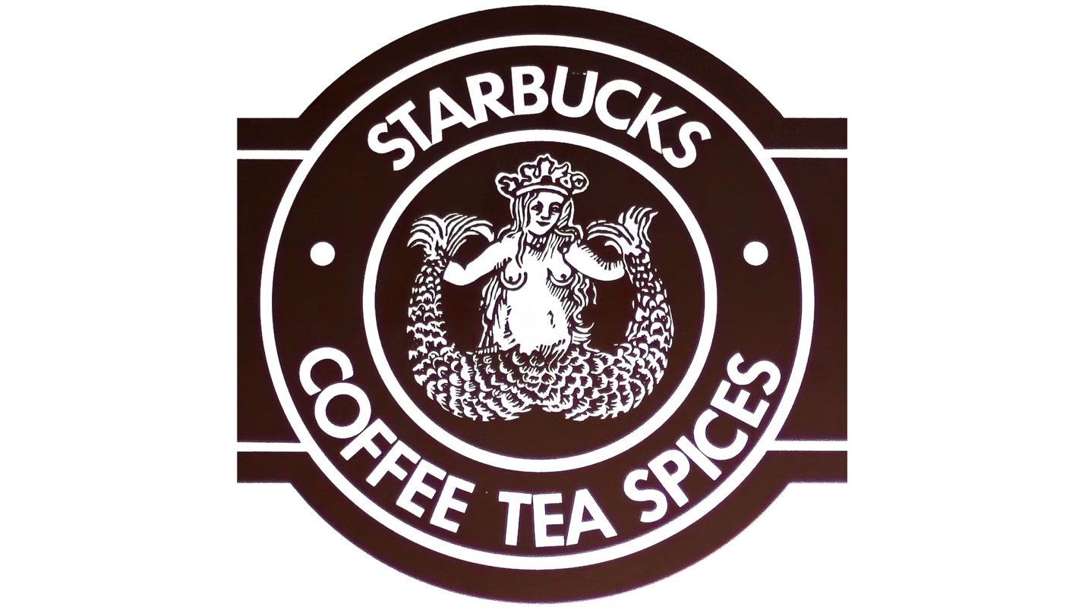
Starbucks’ logo from 1971-1987
During this time, the company was bought by Howard Schultz, who wasted no time redesigning the logo. This would be the first evolution of the Starbucks logo. The emblem was changed in 1987, the Siren’s image was made more stylized due to the strong outrage of the Puritan citizens of Seattle. By then, Starbucks had a large chain of cafes, branded cardboard cups, and branded coffee delivery vehicles. With the addition of handcrafted espresso beverages and melding of the two companies, Starbucks unveiled a cleaner, crisper image.
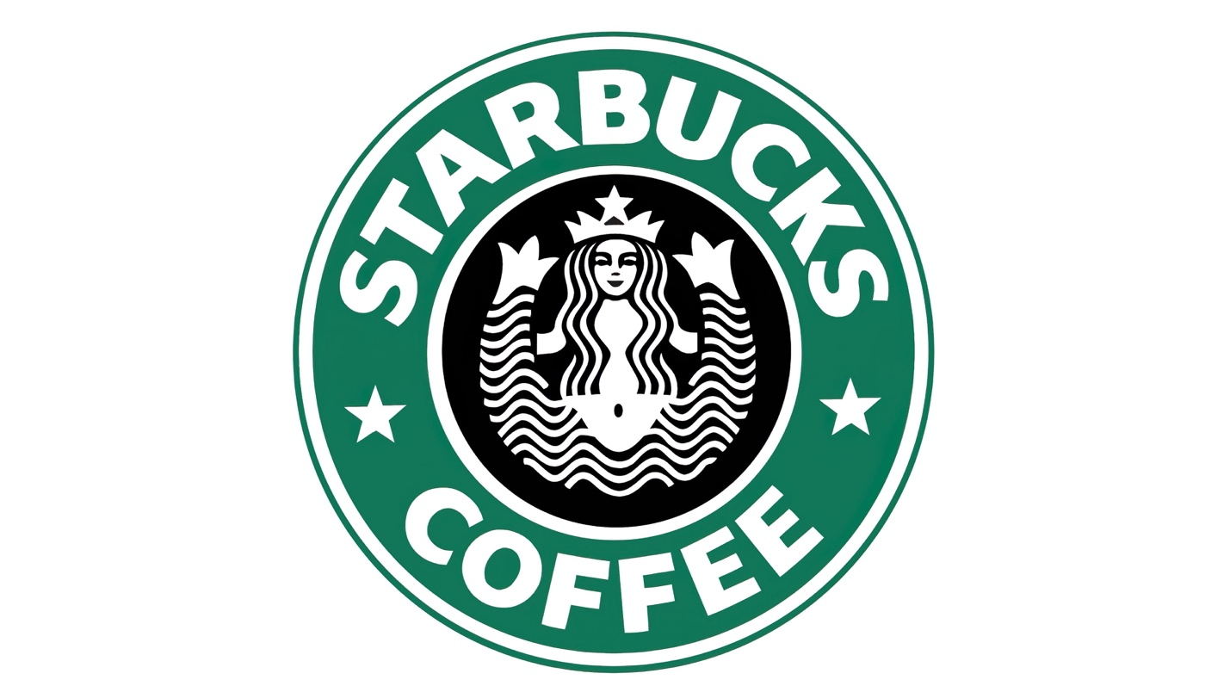
Starbucks’ logo from 1987-1992

In 1992, Starbucks went through its third logo design change. The logo zoomed in on the mermaid, creating a more intimate, close-up view. Her naval was no longer visible, and only some of her tail could be seen. The owners of thriving coffee houses were again forced to change the emblem’s design under pressure from society – respectable conservative citizens were embarrassed by the naked navel of a mermaid. This was done and radically – the lower part of the Sirena was cut off, the rest of the picture was enlarged. Starbucks decided to change the black outer strip of their logo to a green one, which began the change to a purely green color scheme. The green color is most commonly associated with growth and peace which emphasizes Starbuck’s mission statement to “inspire and nurture the human spirit.” At this time, the text, font, and logo were also drastically changed.
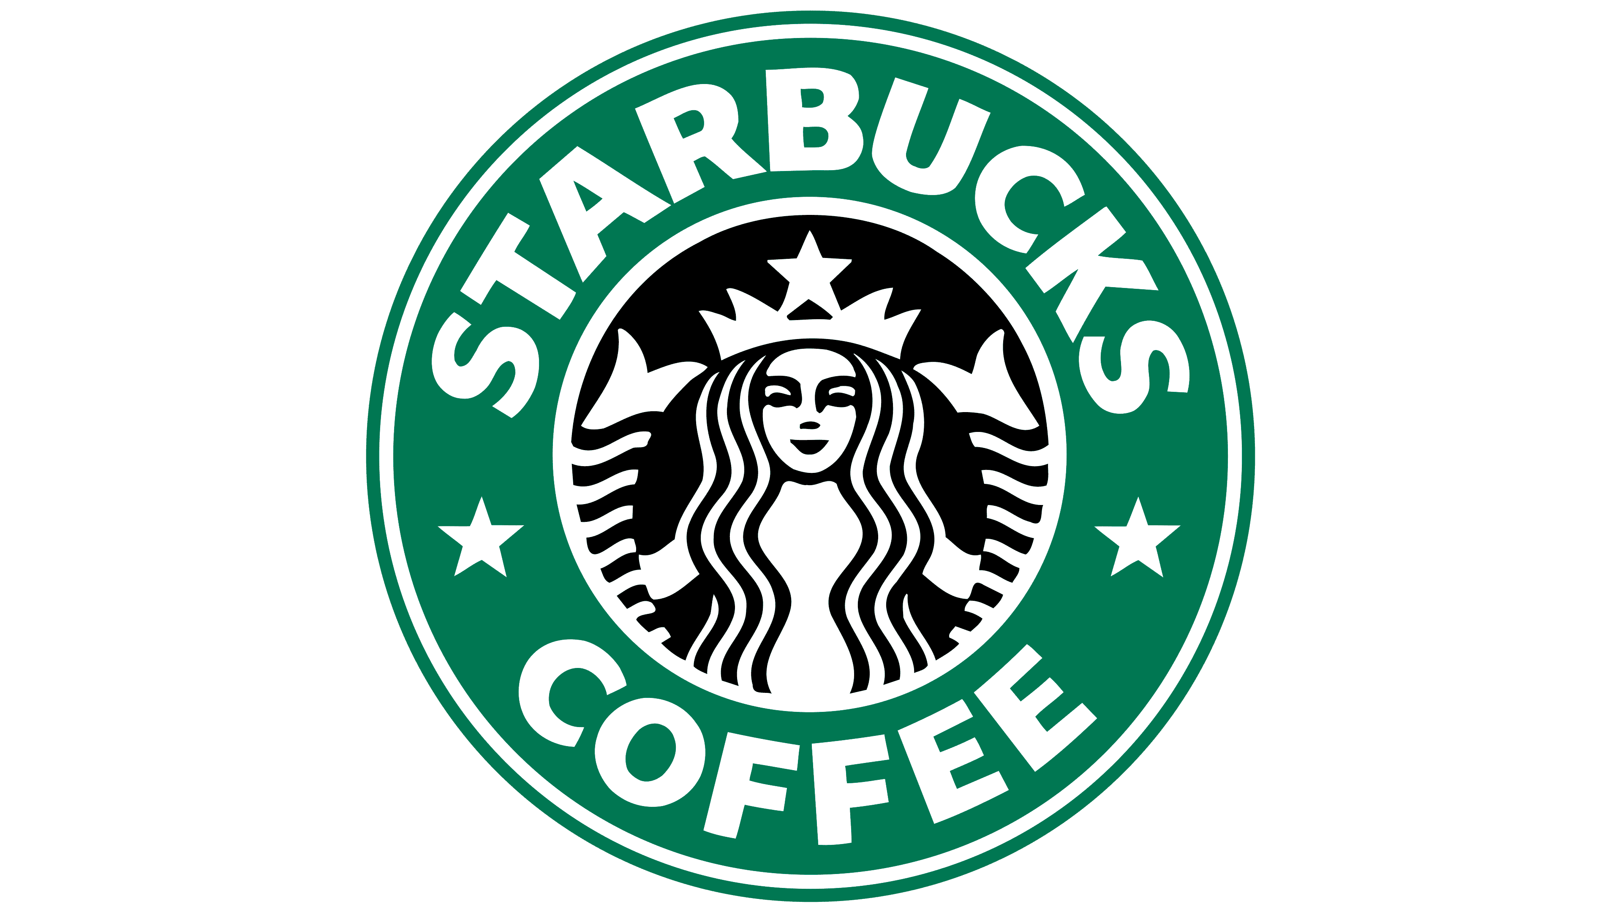
Starbucks’ logo from 1992-2011
Celebrating its 40th annivdersary, the company decided to attempt a considerable rebranding effort. Starbucks attempted to take a leap into the future, but instead, fell further into the past. They inexplicably attempted to reimagine the original 1971 logo, possibly to appeal to the new hipster movement. The rebrand attempt failed with both designers and the public at large. The green logo, cups, and branding had become so familiar to the public that attempting a large, significant change like this was doomed from the start.

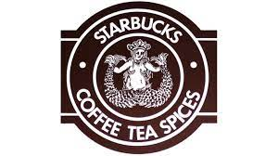
In 2011, the brand became recognizable worldwide, and the company’s management concluded that it was possible to remove unnecessary design elements – they cut the entire outer circle with inscriptions. Only a beautiful mermaid on a green background remained. Such changes were also made in the current trend of ECO-logo – simplification of the design and the amount of paint on the logo to preserve the nature and ecology of space. The new logo and packaging focuses instead on the Starbucks siren, bright green color palette, and playing with the size and location of the logo. For instance, the bags and merchandise often feature off-center application of the logo to mix up the otherwise clean, crisp packaging. 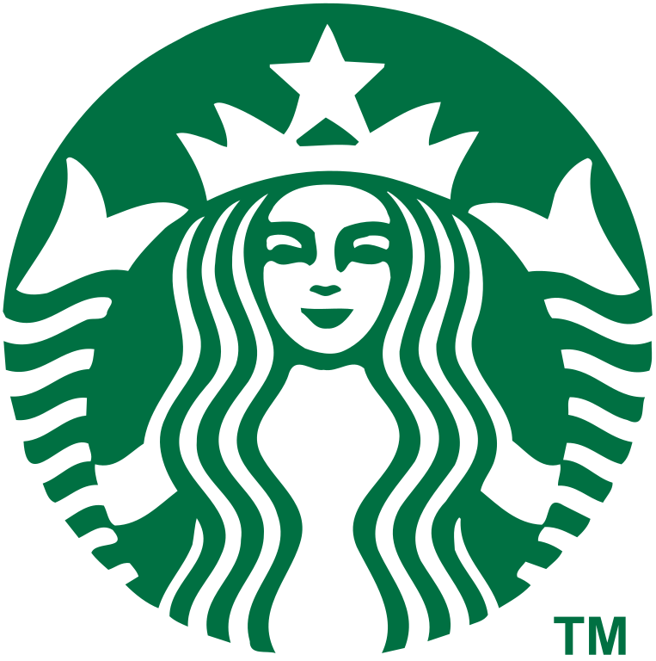

Starbucks’ logo from 2011-present

Over the years, Starbucks has continually refreshed their logos and packaging design without losing their core image. The green color scheme, Starbucks siren, and branding have also carried over to their stores, website, online branding, gifts, and all other packaging. Maintaining a logo that features many distinct colors can be costly. Relying on green instead can still provide an eye-catching, colorful option without the clutter of various distinct colors. When a green and white logo is all you need to become instantly recognizable, you know you’ve created successful packaging. There’s so much we can learn from the evolution of the Starbucks logo. Having a unique and recognizable mascot helped them create a strong brand presence, not just in America but also in countries all around the world. From the very beginning, their logo was connected to their brand in the strongest possible way. There was no Starbucks coffee without the logo. The Starbucks logo is a perfect example of how effective logo design goes hand-in-hand with its identity and branding efforts.
Work Cited
Wikipedia contributors. “Starbucks.” Wikipedia, The Free Encyclopedia. Wikipedia, The Free Encyclopedia, 26 May 2022.
https://en.wikipedia.org/wiki/Starbucks#Logo
“Starbucks Logo.” Logos-World, 26 May 2022.
https://logos-world.net/starbucks-logo/
Goldring, Kira. “A history of the Starbucks Logo.”, 2022.
https://www.tailorbrands.com/blog/starbucks-logo
Bondarenko, Peter. “Starbucks American company.” Oct 02, 2015. 09 Sep 2021.
https://www.britannica.com/topic/Starbucks
Farr, Sheila. “Starbucks: The Early Years.” 15 Feb 2017.
https://www.historylink.org/file/20292
Cannon, Matt. “Brand Stories: The Evolution of Starbucks.” 24 February 2015
http://www.worksdesigngroup.com/brand-redesign-evolution-starbucks/

