Argeny Garcia
PHYS 1118
12/4/12

Our Solar System Formation

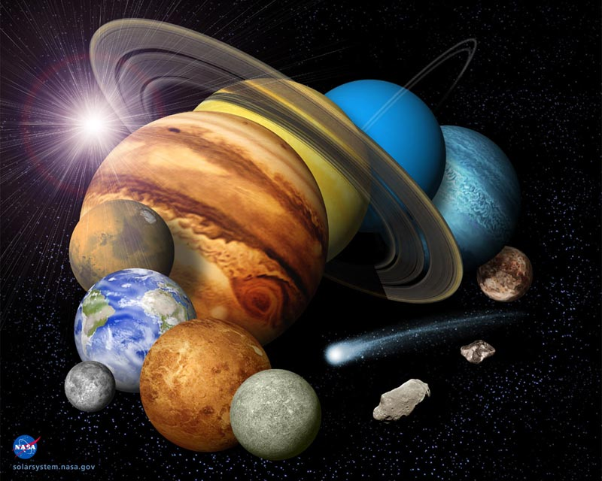

About 4.6 billion years ago, the solar system in which we live in, started to form. Our solar system lies in one of the arms of the Milky Way Galaxy. It consists of one star called the Sun and 8 planets, Mercury, Venus, Earth, Mars, Neptune, Jupiter, Uranus, and Saturn. All 8 planets and anything else that resides in our solar system orbits the sun, which controls everything and provides necessary heat for us to exist. Our solar system began as a giant cloud of dust and gas, mostly composed of hydrogen gas, in the empty cold void of space. It took about 700 million years for our solar system to form into what we see today.
The entire universe is driven by an invisible force called gravity. Gravity is the force that pulls everything together to form every object in existence. The formation of our solar system was driven by gravity from the start. In the beginning, the cloud in which the solar system formed from was floating inanimately in space with no activity. Scientist believe that in order for the cloud to start becoming active a near by super nova might have exploded and sent a shock wave through the cloud, which triggered it to start collapsing on itself. Large masses in space have a natural spin. As a result of the cloud collapsing on its self, its rotational speed increases because of conservation of angular momentum. The increase in speed causes the cloud to flatten out into a disk like shape, which makes a solar system circular. The cause of the flattening is because of the imbalance of the clouds mass. Having more mass on one side will stretch a malleable object out when spun fast enough. As the cloud was crushed more and more by gravity, the center of the cloud became denser with higher temperatures in the millions of Kelvin. Over millions of years, the center of the cloud became so hot that it started fusing Hydrogen, in a process called nuclear fusion and became the star we know as the Sun.
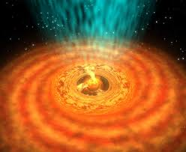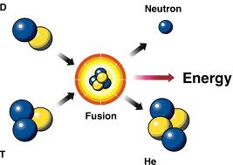
When the collapse of the massive cloud finally creates a star, planets are now able to form from the left over material, left by the creation of the star. The material that was left over now orbits the star at different distances from the star. The distance and the concentration of the type of material in a certain area determine the kind, size, and composition of a planet that will form. Anything in areas extremely close to the sun will be vaporized because of the suns high temperature. The area where rocky planets like the earth and mars form is called the “Rock Line” because it is cool enough for rock to solidify and starts at about 5 million miles away from the sun, and gas planets like Jupiter and Neptune form much further out where there is a higher concentration of gas molecules.
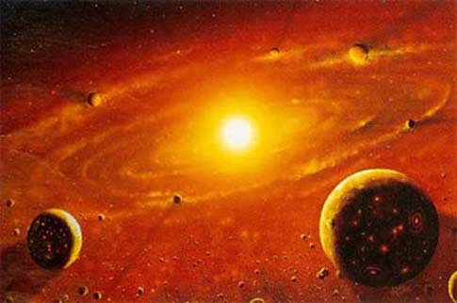
A planet forming around a star is a pretty random process. A rock planet is made by random collisions of rock orbiting in the rock line. Rock and dust create friction when colliding, creating static electricity which sticks them together. Once enough material has been accreted, the mass then becomes a Planetesimals which is a rock big enough to have sufficient gravity to start attracting enough mass to become a planet. Planetesimals then turn into proto planets after collecting more mass and are now comparable to the size of the moon. Many proto planets are formed and will eventually collide and fuse with one another to make a planet. Gas giants are made roughly the same way, they simply become much bigger because there was much more material in the areas where they form compared to the rock planets. Where gas giants are formed there is rocky solid material and much more gas. The rocky material first accretes solid material to become planetesimals and then with its gravity it will collect the gasses around making them a giant like Jupiter.
At the beginning of our solar system there where many more than 8 planets orbiting our sun. Over time these planets crashed into each other with explosive force, some were completely destroyed on impact but some were hit by smaller masses and just fused into a bigger planet. The earth was no exception. It too went through a massive collision with another about 4.5 billion years ago with a mars size planet called Theia. The Earth barely survived this impact but because of the angle that Theia hit the Earth, it was able to hold together and not break apart. The debris thrown out into space from the impact orbited Earth and eventually clumped together with the same process planets were formed and created the Moon.
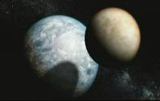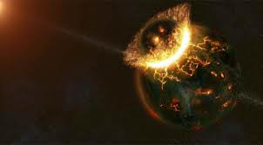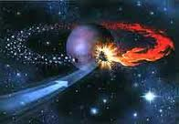
After the completion of our solar system, there was left over rock that was not used by either of the planets. These rocks are called asteroids and orbit in 2 different regions of the solar system. One is the asteroid belt, which is located between the orbit of mars and Jupiter and contains thousands of asteroids. The second is called the Kuiper belt, which is way beyond the orbit of Neptune in the outer reaches of the solar system 30 to 50AU away from the sun. Today everything in the solar system orbits the sun in a stable circular like motion and will continue to until the death of the sun.

- http://www.windows2universe.org/our_solar_system/formation.html
- http://en.wikipedia.org/wiki/Formation_and_evolution_of_the_Solar_System
- http://www.bbc.co.uk/science/earth/earth_timeline/earth_formed

