Anthony Delbrun Professor Bauer

CDMG 1112 12/12/18

**Field Trip Report**

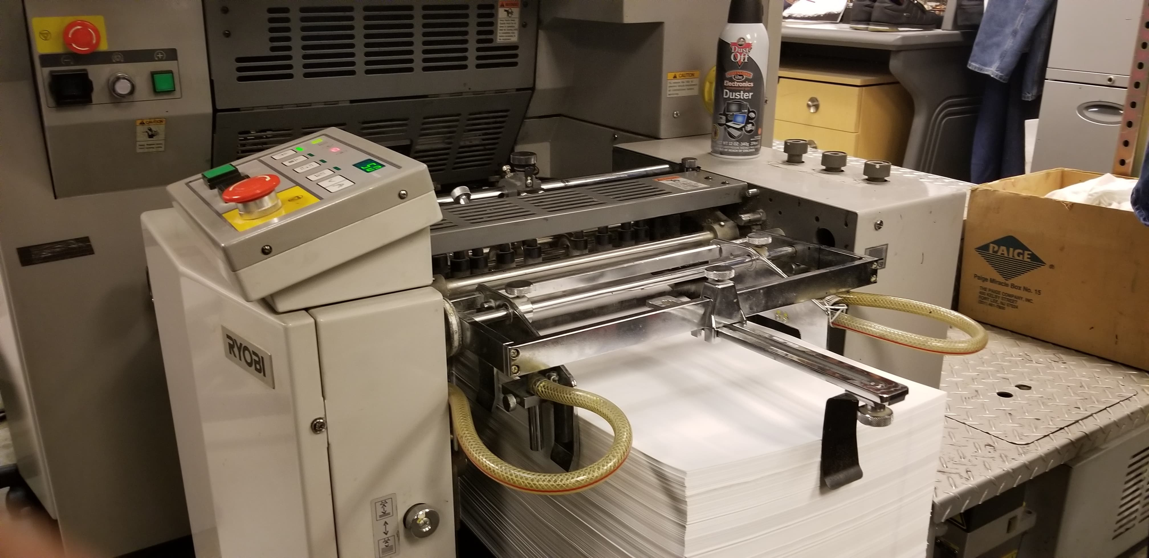

My time at the UFT Printing Facility at Broadway, Manhattan, New York was an outstanding one indeed. The purpose of this trip was to get a close-up look into the world of a print shop, and to learn about the different kinds of machines, paper, ink, and etc. that are used there. The reason this part of advertising/graphic design is useful to know about is because it can greatly assist in cost and time reduction of printing. Furthermore, it will keep you ahead of the game if you are previously informed to the kinds of printing available to you. There were many machines I saw at the facility but 3 of them peaked my interest. The first machine I liked was a poster-sized one that can only print documents with minimum measurements of “11x17” in color and/or black and white. The next machine I liked was a machine used to print newspaper-type articles with the option of front and back. This machine used oil-based ink and produces a medium-quality picture. The third machine which was my favorite was the Custom Printed T-Shirts machine. That machine can print out any picture/image of your choosing onto a T-Shirt. Once that's finished they take the finished T-shirt and put it on a machine that dries up the ink for 25 seconds. After that's done with your custom T-shirt is all yours. I got two for myself. Overall, this place isn't half bad and I will definitely comeback again!

Video: <https://photos.app.goo.gl/BGcrd3hVfD4eB34E7>