Madera Cuban Grill Restaurant

Afiya Charles-Cunningham

New York City College of Technology
Dr. Adomatis
Latin cuisine is one of my favorite dishes to dine. Although I enjoy Latin cuisine, I am not too familiar with Cuban cuisine. For this multicultural experience, I wanted to explore the different types of dishes and spices associated with Cuba. While walking around a strip in Long island City Queens, New York, I stumbled on Madera Cuban Grill Restaurant. I visited the website to look up the history of the establishment as well as to get a better understanding of the kinds of cuisine offered by the restaurant. Although the founders are unknown, Madera listed 34 years of restaurant experience on their website. Madera offers a full variety of Cuban dishes, drinks and desserts popular with Cuban and Latin American culture.
As I looked around the restaurant, an outdoor dining area was setup decorated with synthetic fern plants, a red cabana covering a row of four tables and two additional tables under a red table umbrella. Each of the tables was decorated with red synthetic flowers and a white tealight candle. The hostess, Ana, dressed in a white polo embroidered with the restaurant logo and khaki pants, asked me if I was dining in or taking out. I expressed I was dining in and she responded she has a table readily available. As I followed the hostess to the table, I watched the other guests interact and dine at their tables. I glanced over at a few plates to get an idea of the visual appeal of the dishes. When I was seated, the host directed me to the QR code for the digital menu located on the table as shown in figure 1. I scanned the code and started scrolling through the menu to decide on which dishes I would try. As I sat on the table and observed my surroundings, I noticed the restaurant décor was aesthetically decorated with the Cuban flags and beautiful oil paintings of Cuban artists such as Cecilia Cruz and places and cars in Cuba. I can hear the upbeat tempo of drums and trumpets coming from the speakers from the var of the restaurant. I can smell the aroma of Latin spices such as cumin, bay leaf and a blend of peppers. While I was making my decision, the waiter Carlos walked over with a wire basket dressed in a red nylon handkerchief filled with sourdough bread. I picked the bread up to taste and the touch and feel was rough to the touch. The bread was crunchy biting into but was fresh and satisfying as the little pieces moved around my tastebuds. The dining experience at Madera was a unique experience to traditional American dining because it the décor was designed to mirror that of Cuban culture and the Caribbean music made the atmosphere feel as though you were in another country. Usually when I am dining in an American restaurant, there is a TV screen with American sports or tv shows in the background for the guests to enjoy in the background and soft pop music. The dining experience is mostly inclusive of American culture.
Figure 1
QR code
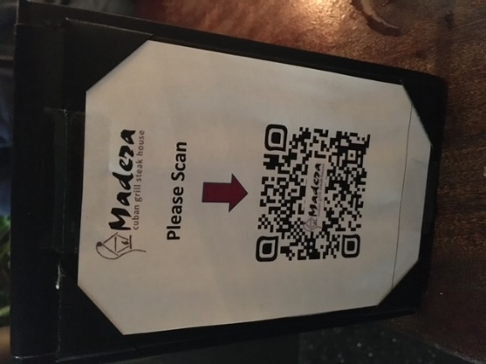
Retrieved from Madera Restaurant
I continued to scroll through the menu, and I noticed a wide range of meats, seafood and poultry. Food items included: Porter House steak, served with saffron rice and broccoli, salmon and corn salsa, Cuban steak sandwiches and sauteed pork chunks. The menu was mostly in English, however, there are some items that are traditionally Spanish dishes that were labeled in Spanish. These dishes included: maduros which is fried sweet plantains, Moro (rice cooked with black beans and pork) and tostonos, fried green plantains. These menu items were listed in Spanish but were described in English beside them. For all other items on the menu there was a description of the items below or besides them letting the guests know what is accompanied with their dishes. I finally decided on the items I wanted to try off the menu. I first started with a coconut shrimp appetizer. The coconut shrimp came with a mango mint sauce which complimented the taste of the coconut shrimp. The texture of the shrimp was crunch of the outside but moist on the inside. For my main dish, I decided on the Madera Salmon. The salmon dish was flavored with lemon, wine and mixed spices. The salmon was topped with chopped mango, cilantro, crushed red pepper and radish salsita and a side of sweet plantains shown in figure 2. Taking a first bite of the dish was a beautiful explosion of flavor. All the spices and flavors were a wonderful pairing to one another. The salmon was moist and fell apart in the fork as I scooped up the rice and black beans. I washed down every bite with a sip of my red sangria. I ended my dinner with tres leche for dessert as shown in figure 3. Tres leche is a Spanish vanilla cake soaked in condensed milk and frosted with a whipped vanilla frosting. The tres leche was delicious and the aroma of vanilla was strong with every bite. Most of the dishes I noticed on the menu from my previous dining experiences at other Spanish restaurants. The only unusual dish I was unfamiliar with was the Moro rice. Moro is made with black beans resulting in the rice turning black and pork chunks is also mixed in to add flavor.
Figure 2 Salmon Dinner Figure 3 Tres Leche
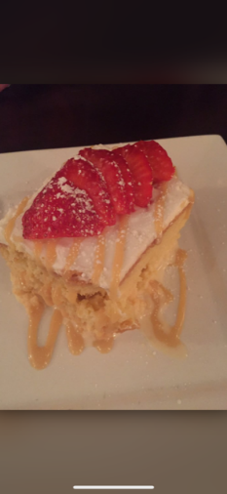
Retrieved from Madera Restaurant Retrieved from Madera Restaurant

Madera’s salad selection offered a variety of salads, breads and desserts on the menu. Few of the salads were traditional and others were traditional of Cuban culture. Although I did not have any of the salad, the options offered were a mixed green house salad, Madera salad with a Cuban twist of avocado, pineapple and watercress. The citrus Madera Heart of Palm salad which included marinated citrus, heart of palm, over lettuce leaves. Lastly a tropical salad with papaya, mango, mandarin oranges, mixed greens and toasted almonds. Besides the sourdough bread bought to me by Carlos, the other bread options were tortilla chips, sweet bread, French baguette for the Cuban pressed sandwiches and hamburger bread. The dessert menu featured and short list of items consisting of flan, tres leche and ice cream.
Aside from the food menu items, there was a variety of wines and spirits such as Pina Colada, mojitos, passion Cuban cocktail, Bellini, beers and sangria, white, red and sparkling. I tried the sangria and it was deliciously satisfying. The sangria was sweet and not too overpowering. I could still taste the undertones of citrus and the crunch of the diced apples. Presidentes, a foreign brand beer is one item I noticed was not as typical in an American beer selection that I have seen. I typically see Coronas, and Bud Light. Presidente is a Dominican beer brand and is widely popular throughout Caribbean islands.
Steak, red meat and pork is geographically popular in Cuba because of the large land mass and the ability for cows and pigs to graze. There was a wide variety of food reflective of the cultural geography such as pulled pork sandwiches and steak. Seafood is also popularly incorporated in Spanish dishes since Cuba is surrounded by water. Seafood Paella is a common dish in Cuba. Paella is a rice dish with mussels, calamari, shrimp and a blend of cumin, sofrito and saffron and yellow rice. Other geographically dishes displayed on the menu were beans and plantains very popular among Latin America.
The hostess Ana’s hair was adorned with a red sparkly headband matching the letters of the restaurant logo on her white polo shirt. Her makeup was light with minimal eyeshadow and light penciled black eyeliner. Her gold bracelets made clinging noises as she guided me to my seat. I could smell the faint smell of flower-scented perfume permeating from her body. When my waiter Carlos came to my table to drop off the glass of water, I could smell the strong scent of men’s cologne as he leaned over. Carlos also wore a white polo shirt with khakis. As Carlos walked back and forth from the table to bringing the food, I could hear the sound of his rubber sole shoes on the makeshift wooden ramp thar separated the sidewalk to the outdoor street dining area.
Dining at Madera was a pleasurable dining experience. Overall, I would rate my experience a B. The taste of the salmon was great, but I noticed the corn salsa was made with canned corn instead of fresh corn. The decor was aesthetically pleasing, and it appeared the restaurant put effort into creating an atmosphere that brings the Cuban experience to the customers from the palm trees and paintings. The restaurant also ensured they were constantly cleaning tables and offered plastic cutlery for their guests. I was impressed with this gesture as I could imagine supplying this could be expensive, but it also shows they keep their consumers in mind during these times. The prices on the menu was affordable for the quality of taste and portion of the food. the service from Carlos was impeccable, he was inviting, gave great suggestions and he constantly checked in on the table to ensure everything was good and I had everything I needed. Overall, I would recommend this restaurant to anyone who is in the Long Island City area and enjoys Cuban cuisine. I will certainly be returning.
I usually dine in restaurants based on how well the menu items grab my attention. This multicultural dining experience gave me the opportunity to sit back and really observe everything about the experience from start to finish as I had to use all five of my senses. Our five senses are used involuntarily without thought every day, but I was voluntarily using my senses and it heightened the experience. I used my sight to observe and really experience as close as possible to their culture. Being aware of the kind of spices I was tasting allowed me to enjoy the food much more. Hearing the Latin music forced me to use my imagination as if I was presently in Cuba and picturing how the Cuban native might have danced or sang along to the lyrics. Touching the décor added visual appreciation for the restaurant. All these factors elevated the experience and changed the way I will dine in restaurants moving forward.
Figure 4
Madera Receipt
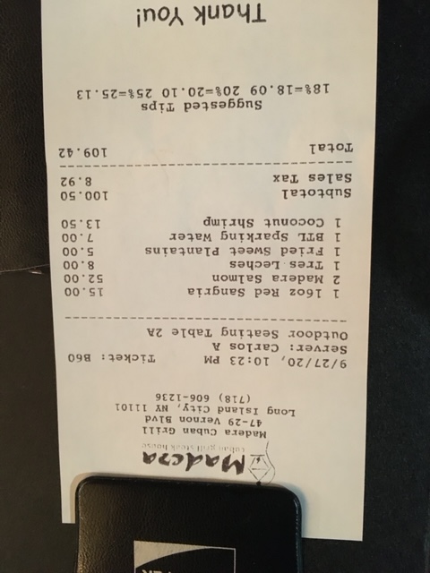
Retrieved from Madera Restaurant

