Accessibility Training on Blackboard

Enroll in the Accessibility Course

- Log in to Blackboard
- Select “Accessibility Training” on the main menu
- Enroll in the “Blackboard Accessibility Course” by clicking on the course link.

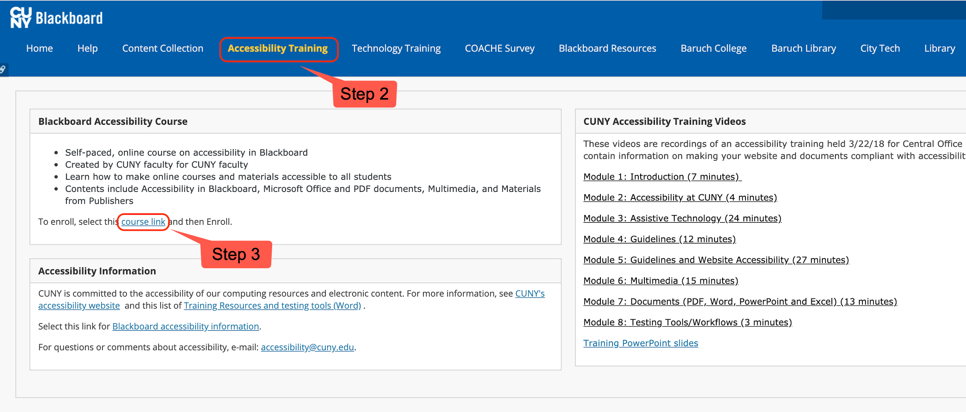

You will be redirected to a page that looks like this:
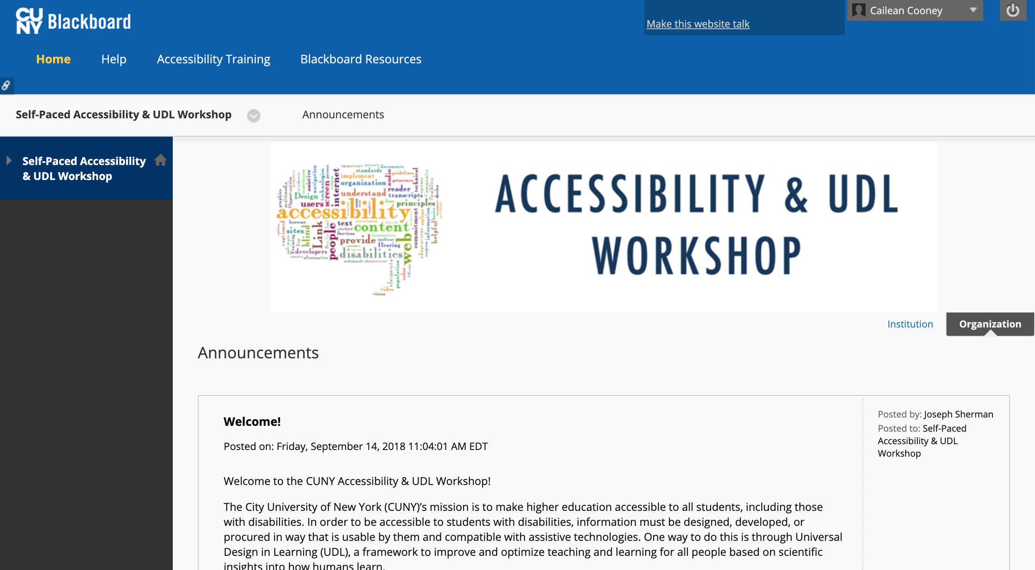

Completing the Course
- Click Self-Paced Accessibility & UDL Workshop to expand and view the following units:

- UDL & Your Teaching
- Blackboard Accessibility
- Word Documents
- Excel Documents
- PDF Documents
- PowerPoint Documents
- Multimedia
Optional: Materials from Publishers
Discussions / Q&A
Workshop Certificate

- Read through the welcome message and workshop outline.
- Click on a topic title (e.g. UDL & Your Teaching) to access the materials and activities, and lesson quiz.
- Click Lesson Activities to access the resources for a topic. There will be files to read online and/or download, as well as videos that you can watch on the topic page.
- Once you’re finished reviewing these, click Lesson Quiz to take the quiz. Click Begin to start. To receive credit for the course, you must take the quiz for each topic and score at least 80%. You can retake a quiz if necessary.

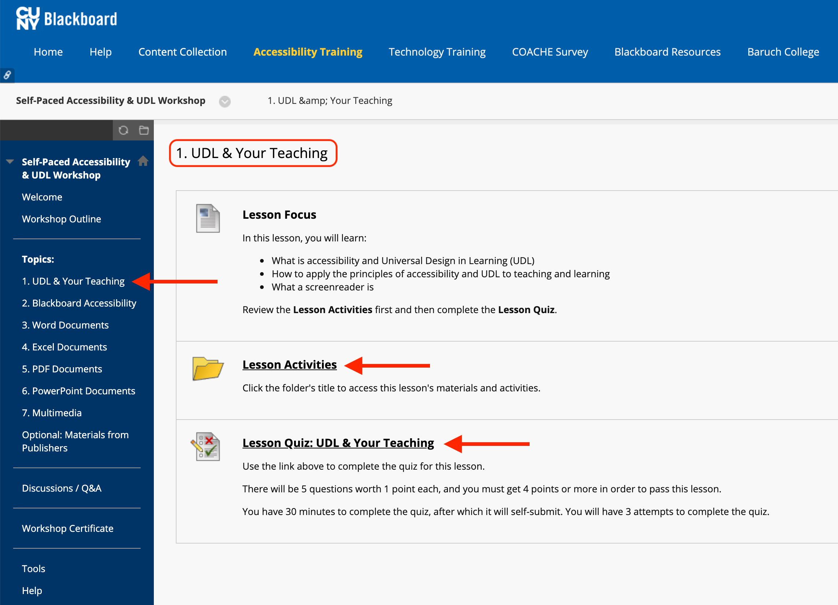

Lesson Activities example:
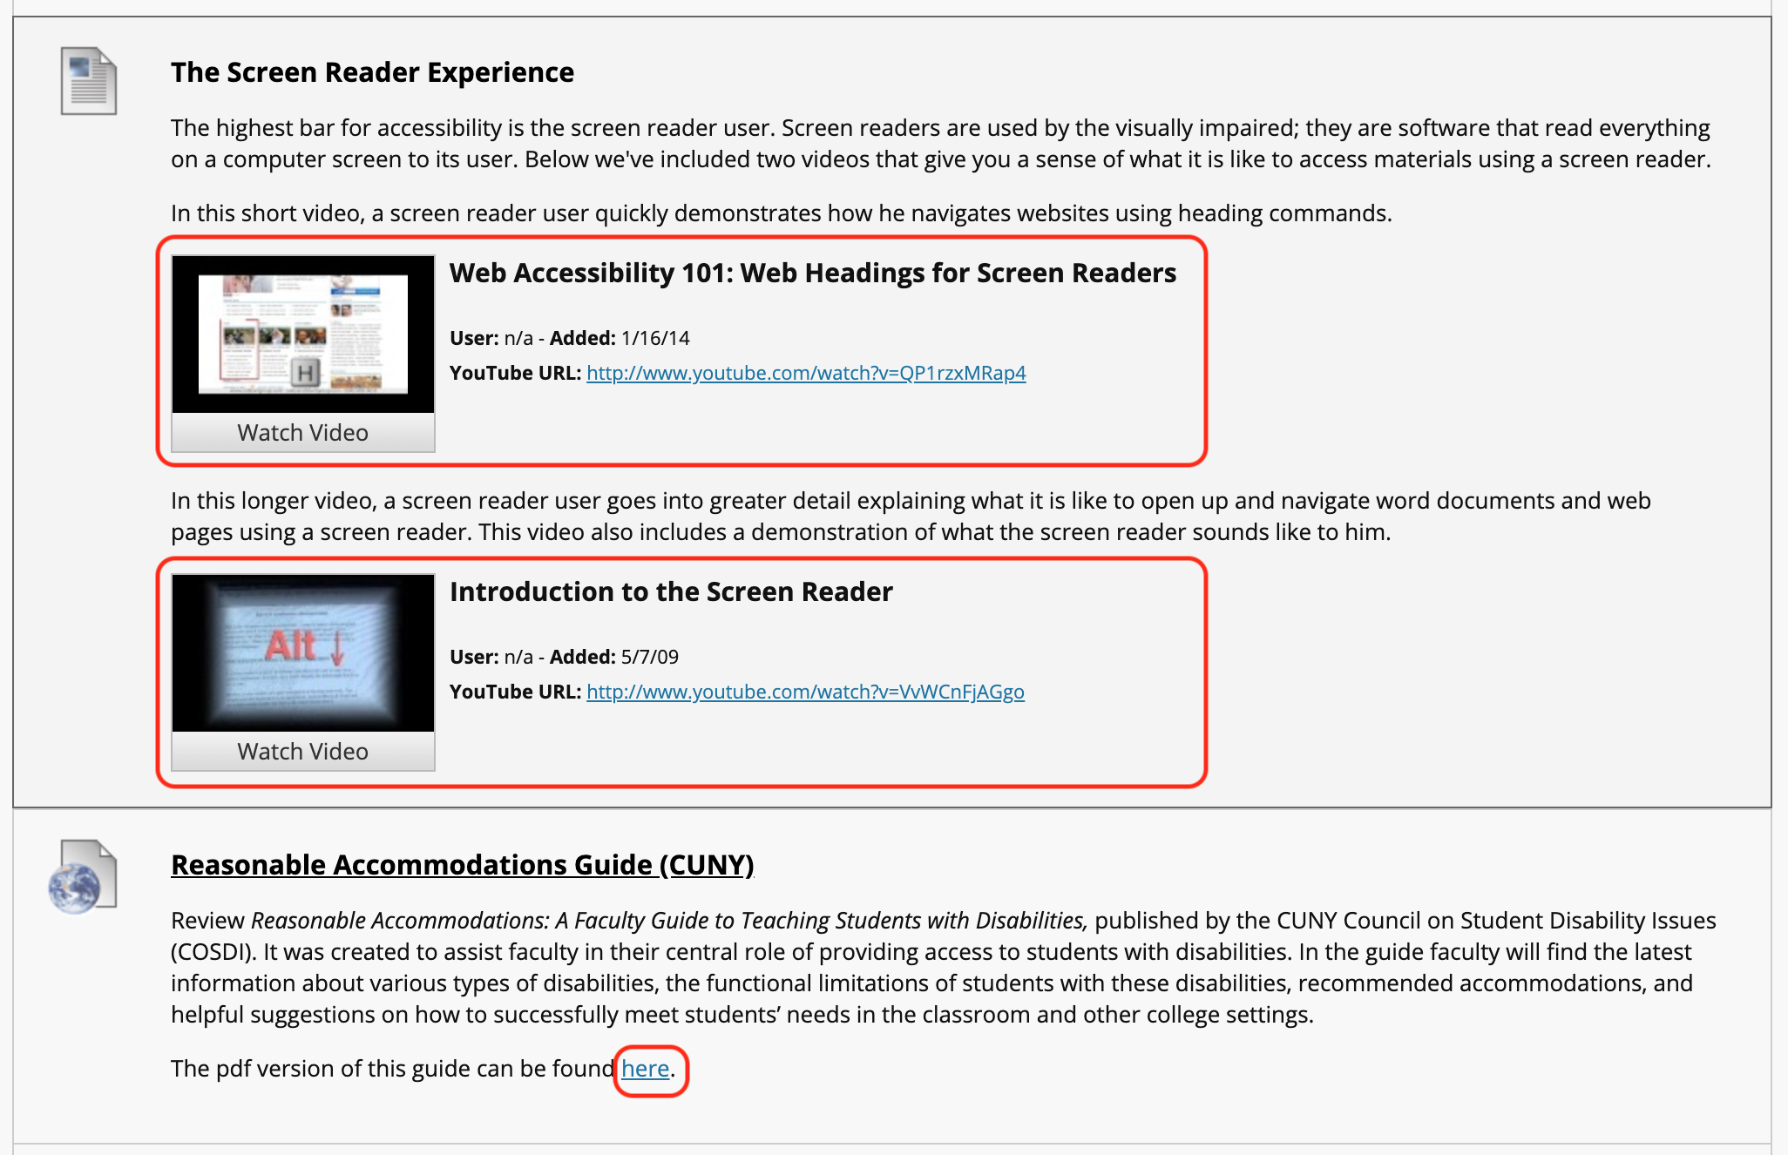

Lesson Quiz example:

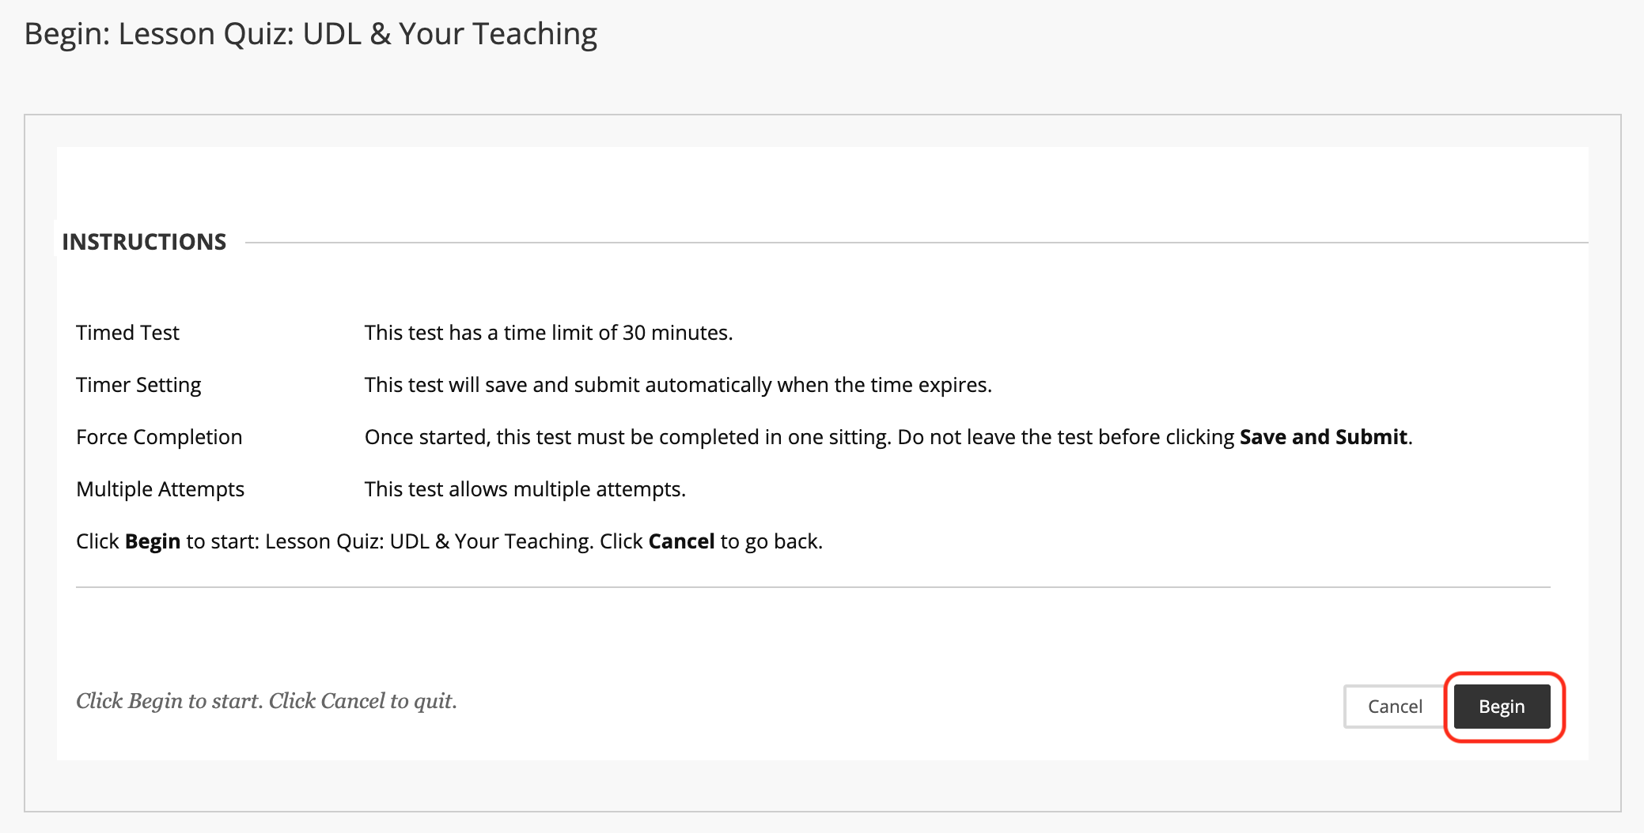

Receiving and verifying your certificate
You will automatically receive a certificate once you’ve finished, and scored at least 80% on the quizzes for each of the seven topics.

- To view your certification, click Workshop Certificate in the left-hand menu.
- Click Certificate of Completion to view the My Achievements page, where you will see the certificate listed beneath your name.

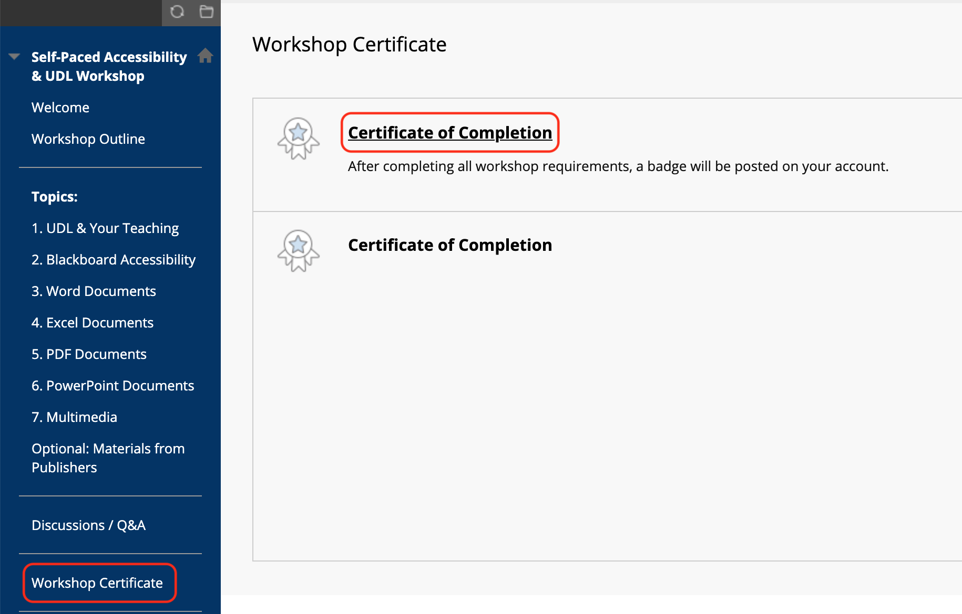

- On the right side of the Certificate of Completion, there are three icons. Click the bottom icon to print the certificate.

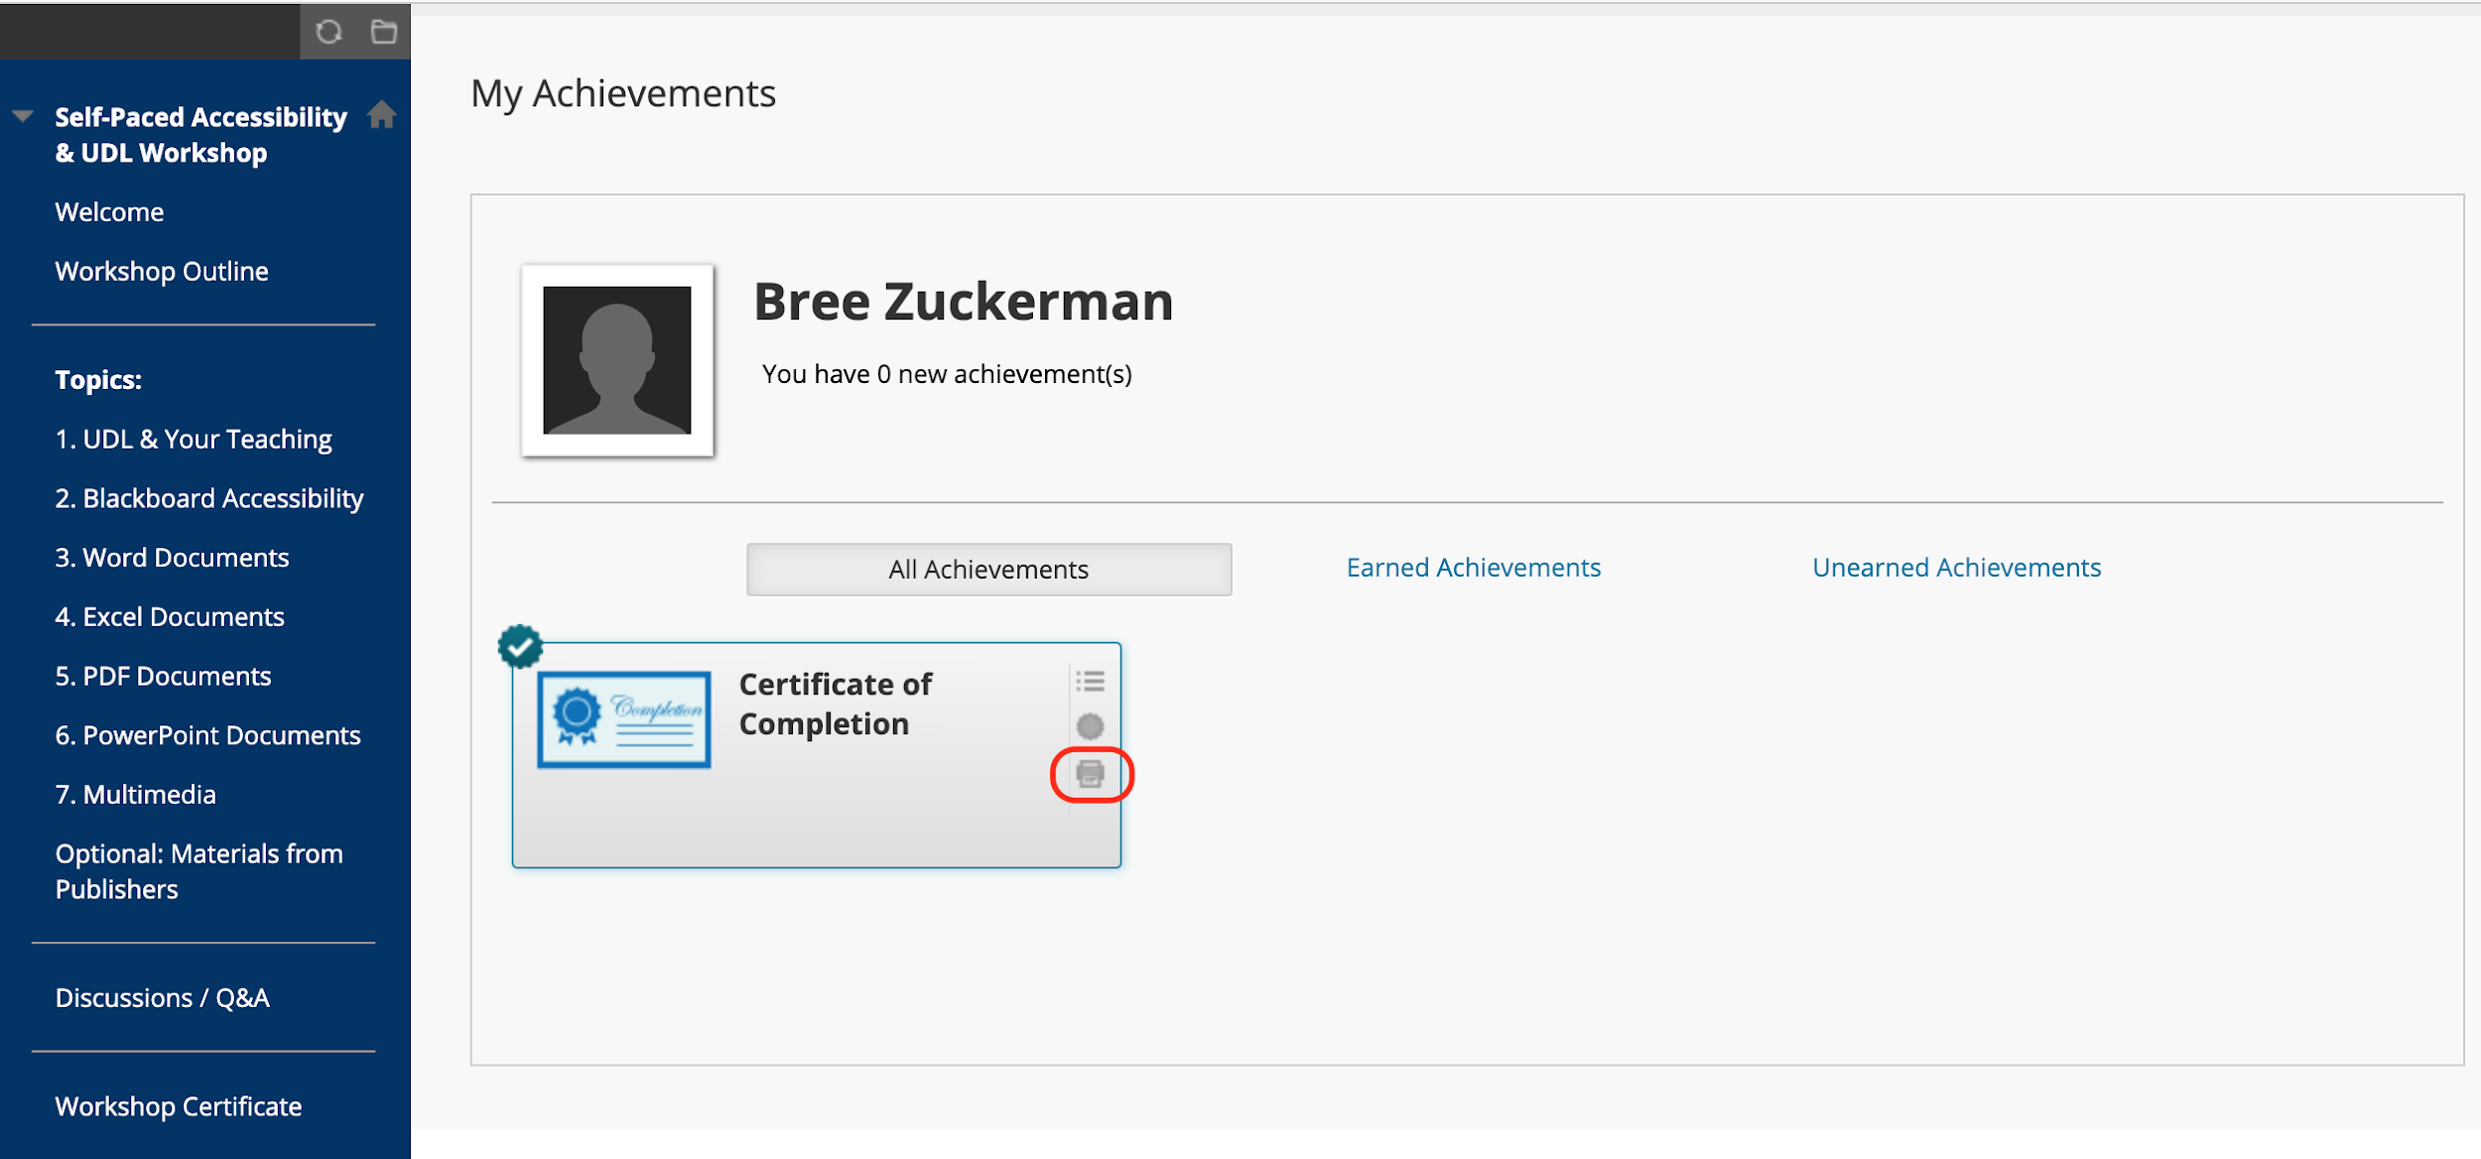

- Options for verifying your certificate could be sending either of the following via email to Cailean:
  - Take a screenshot of the print certificate window
  - On the print certificate window, click Print Certificate and save as PDF
