Abenezer Bereket COMD 1112

Mars

Words are symbols, their meaning is affected by time. A word might mean something today but after sometime it can represent something else entirely. Sometimes the meaning of a word changes based on location.
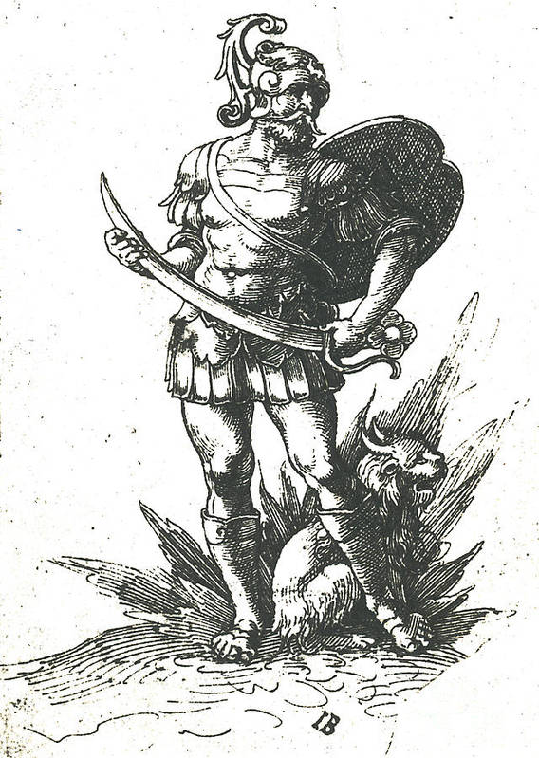
The word I chose was Mars. During the ancient roman era, in 250 AD, Mars was a warship as the god of war. The most revered god and comes in second only to Jupiter in the Roman pantheon. The month march is named after Mars and during march and october in ancient Rome, a giant festival thrown During Augustus rule he was the most worshiped military god.

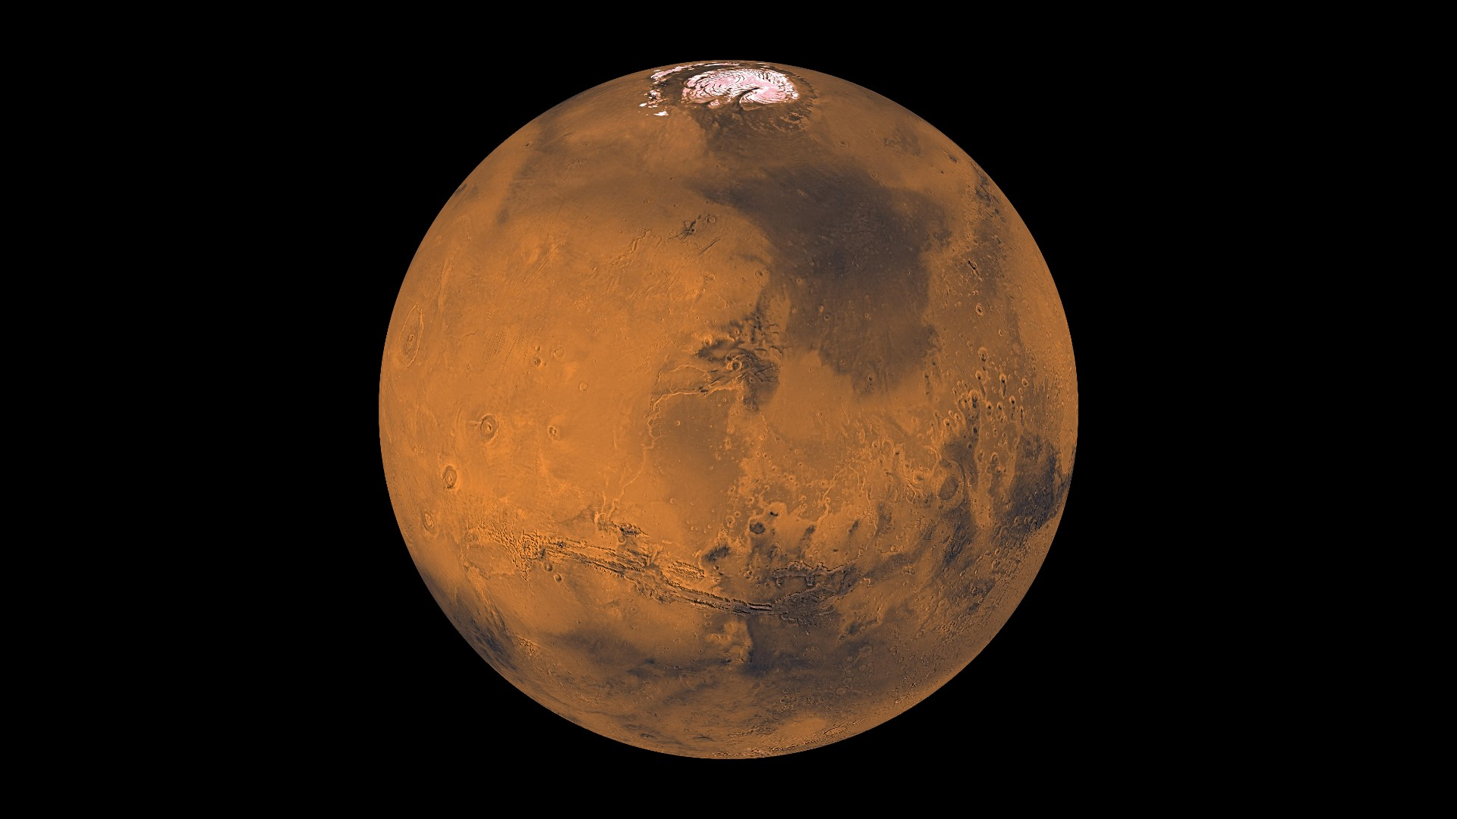

The planet Mars was documented more than 4000 thousand years ago, no one can really be credited for the planet's discovery. The ancient Romans gave the planet its name after their god of war because the reddish color of the planet resembles blood. The first person to see Mars through a telescope was Galileo Galilei in 1609. Since Galileo’s time the interest in astronomy has grown much higher than the interest in Roman theology. The word Mars is now mainly associated with the planet more than the deity. If you ask anyone from the 20th century what Mars is, most would say it is a planet.

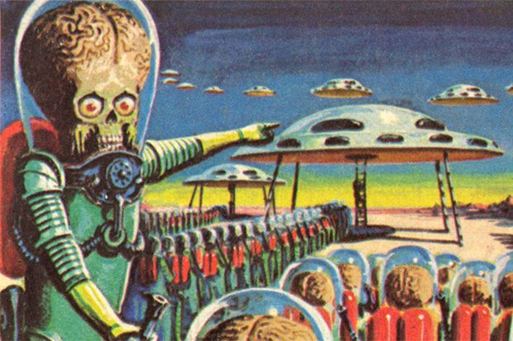

Many people believe in the possibility that there is life on Mars. Countless books, movies and tv shows have been made about aliens from Mars, like the book A Princess Of Mars or War Of The Worlds. After the successes of H.G. Wells' novel, War Of The Worlds, Mars for a long time was as accosted with aliens. Mars is the most explored planet, yet there still much we don’t know about it yet. What we do know is that it is possible for life to exist on mars.

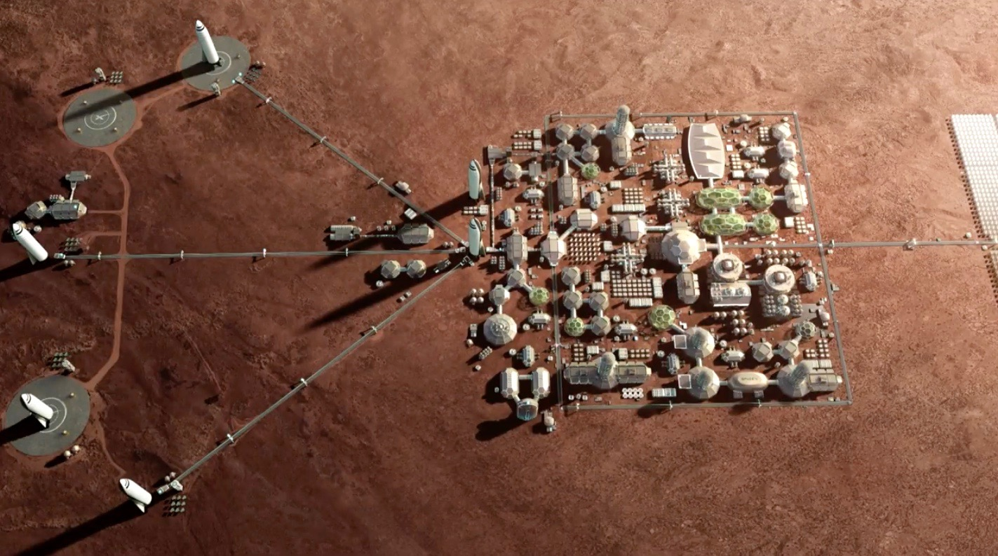

The future of humanity on Mars has become very likely to happen. Private companies like Spacex and government organizations like N.A.S.A are preparing to one day send people to colonize Mars. According to people Space.com Two hundred thousand people have submitted applications to be candidates for the Mars colony. Today when people think of Mars, they think of a future home for mankind.

Through the passage of time the word mars has evolved from a god of war to a future home for mankind. It shows how the meaning a word has isn’t definite, all things change including words.

