Arnora Balidemaj
BUF 2246
Professor Munroe
Final Research Paper

History of the Trading of Silk

Silk is known as the most zealously guarded secret in history. The Chinese kept the secret of silk altogether to themselves and for almost two thousand years no one knew exactly what it was, how it was made, what it was used for and how valuable it actually is. The history and origin of silk is very unique and interesting. The production of silk originated in China during the Neolithic period and eventually became extremely desired in many wealthy ancient empires. It is a natural protein fiber that is produced by several insects, some more commonly used than others. It spread across the world on a famous route which became known as and was named the Silk Road. This road connected China to Europe, Africa and India.
Sericulture is known as the producing of silk and the rearing of silkworms for that specific purpose. Bombyx mori is one of the many species of silkworms and it is the most common used. According to Chinese myth, wife of the mythical Yellow Emperor, Lady Hsi-Ling-Shih, is credited with introducing sericulture and inventing the loom for weaving silk. She began to teach other women to weave the silk and later became much more advanced with special embroidery and designs that increased the worth of the fabric.
During the Han dynasty, the quality of silk improved and became more sophisticated and the demand of silk also increased. The quality of silk improved in terms of strength and durability and more designs and colors were incorporated. This was possible due to the advancement of technology and skills. Weavers were usually women, and it was also their responsibility to make sure the silk worms were well fed on their favourite diet of chopped mulberry leaves and that they were sufficiently warm enough to spin thread for their cocoons. (Cartwright 1) The cultivation of the silk worms themselves also became more sophisticated from the 1st century CE with techniques used to speed up or slow their growth by adjusting the temperature of their environment. Different breeds were used, and these were crossed to create silk worms capable of producing threads with different qualities useful to the weavers (Cartwright 1).
Throughout centuries, silk has been used for many different things such as clothing and accessories and home furnishing. It traveled through many different ancient empires through the Silk Road. There are many different types of silk, some more popular and commonly used than others, and some older than others.
The extremely popular silk would not have been as popular at the time if it was not for the Silk Road that was created for and that made the trading possible. The famous trade route played a huge and very important role in Chinas economy. It connected China to the Middle east that exported goods through middlemen that arranged business deals. Silk in either the form of thread, woven cloth and/or finished products were exported to not only the close neighboring states but also very wealthy and known kingdoms that include Persia, Egypt, Greece and Rome. These kingdoms desired the silk because it was a clear symbol that showed their status in the social class. If you were able to afford the rich embroiled and designed silk, you were of the upper class.
Silk is a fabric that shows elegance and wealth. This has been the case for many centuries. In China, where silk originated approximately 8,500 years ago, silk was used as currency and a reward. Silk was meant for the Emperors of China for their own personal uses and a factory was even made to make silk to gift to other wealthy nobles in different empires. It played a very important role in Chinas economy being that it was considered a luxury that was desired all over the world. Then and today, the Chinese used silk to make special occasion and traditional clothing such as robes, gowns and jackets with decorative and special embroidery. The silk robes with decorative embroidery was a clear representation of what social class you belonged to, that being the upper class. It distinguished royalty from people of the lower class who wore plain silk. Silk was also used in home furnishing such as wall hangings, screens or hand fans.
Silk has a long history in India as well. India is the second largest producer and the largest consumer of silk in the world, China being the first. However, many historians argue that silk was indigenous to this country. Almost all of the raw mulberry silk is found to come from Indian states including some others like the muga and the tassar. Like in China, silk symbolizes royalty and wealth and has for many centuries. They are mainly used for beautiful and a very well known traditional costume for a bride on her wedding day, also known as a “sarree.” One very popular silk in India is the Tussar Silk, which is used for the sarrees. It is known and valued for its gold color and rich appearance and finish.
Chinese trade in the roman empire for silk began in the first century BC. The Chinese silk arrived to the Roman Empire as fabric rolls or threads. These were then used to create clothing for males and females. The garments were then dyed into vibrant colors which became the most
expensive clothing in the ancient empires. This was very different than a typical outfit in the ancient period because they were not made of animal or plant like most clothing before silk came along. They were brighter, more comfortable and of better quality than the typical clothing during the time. The rich usually wore nothing but silk and the demand and worth increased as centuries passed.
As China sent out silk, other commodities such as culture were brought through the Silk Road into China. Different languages and writings were brought in through the routes from traders, diplomats, travelers and monks. Different and unfamiliar religions such as Buddhism was also brought in from India and then passed on to Korea and Japan. Explorers such as Marco Polo used the route, as did Christian missionaries from the west to enter China for the first time (Cartwright 1). New foodstuffs were introduced into China and then cultivated there such as walnuts, pomegranates, sesame, and coriander (Cartwright 1). Silk, which lead to the creation of the Silk Road was a huge advancement for China in many different aspects. It played a huge role and grew Chinas economy, brought in new ideas and connected China to the worlds wealthiest empires.

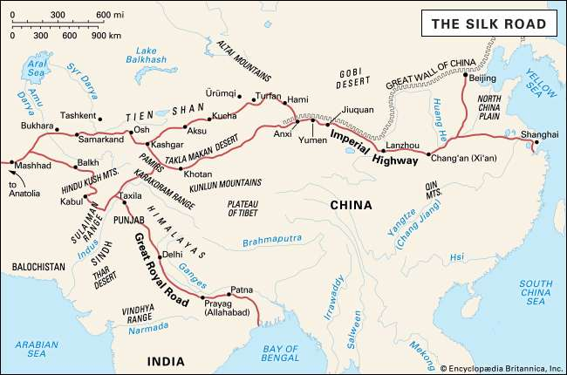
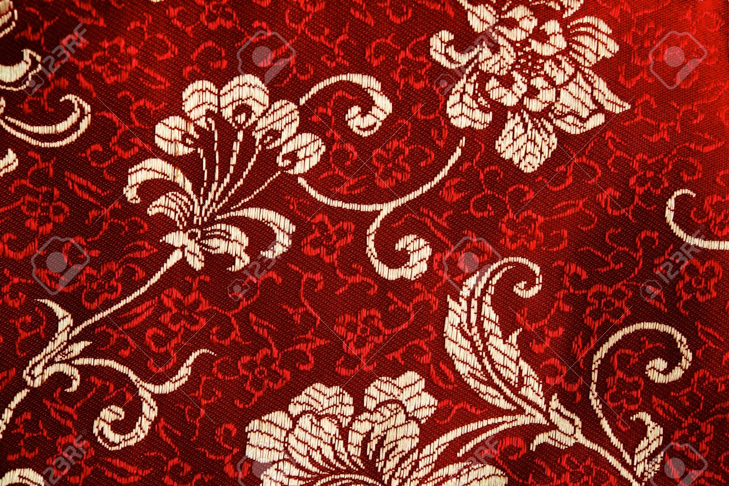
https://www.britannica.com/topic/Silk-Road-trade-route

https://www.123rf.com/photo_17185061_traditional-chinese-silk-clothing-sample-with-flora-pattern-.html

References

Cartwright, M. (2017, July 28). Silk in Antiquity. Ancient History Encyclopedia. Retrieved from https://www.ancient.eu/Silk/

Varadarajan, L. (1988). Silk in Northeastern and Eastern India: The Indigenous Tradition. Modern Asian Studies, 22(3), 561-570.

Mclaughlin, R. (2016). The Roman Empire and the Silk Routes : The Ancient World Economy & the Empires of Parthia, Central Asia & Han China. Havertown: Pen & Sword Books.

Liu, X. (2010). The Silk Road in world history (New Oxford world history). Oxford ; New York: Oxford University Press.

SILK ROADS Dialogue, Diversity & Development. (n.d.).
Retrieved from https://en.unesco.org/silkroad/about-silk-road

Britannica, T. E. (2019, January 30). Silk Road.
Retrieved from https://www.britannica.com/topic/Silk-Road-trade-route

