Executive Summary

Nora’s Spa Suite is a small family owned business established in 2025 by business owner Nora Balidemaj at 46 Pondfield Road in Bronxville, New York.

Company Summary

Her business gives spas a whole new meaning with fun, new and improved services. Her broad experience in business management and graphic design gives the business an advantage financially and aesthetically.

I am very pleased to enclose my business plan for Nora’s Spa Suite. You’ll find a great amount of information regarding my business inside the plan. I have included a thorough evaluation of opportunities in the market place and how I plan to overcome and succeed them, in great detail.

- At the spa, we take pride in treating clients with great respect and making sure they leave the spa well groomed, beautiful and happier than when they entered.

Funding Request

- The Company requests a total loan of $30,000.00 for the start up and will be paid back within two years of the business running. The funding proceeds will be use for the following purposes:
- Advanced equipment for facial services
- Lease and renovations

- We expect to break even within a year time period following the introduction of our service.

Company Objectives

- To achieve 100% customer satisfaction.
- Have repeat customers and gain new ones year after year.
- Build a clientele that depends on us for all of their beauty needs and concerns.
- To break even in year one and make smart investments in the business that only benefit the business rather than hurt.
- Begin to make a significant net profit starting year two.

Company Mission Statement

Our goal is to provide a high class spa experience for our guests; a place where beauty, comfort, knowledge, and personalized individual attention is our first priority.

- We want to give our clients a totally memorable and rejuvenating experience.
- We want our clients to know that looking and feeling young, beautiful and fresh is possible through our procedures that we offer at Nora’s Spa Suite.

Personal Experience and Knowledge

- I, the owner am going to be in charge of all services being given.

- I am a licensed esthetician and am properly trained and legally certified in conducing the procedures offered.
- I am also a certified and licensed hair and makeup artist.

- I have graduated with a bachelors degree in the Business and Technology of Fashion at The New York City College of Technology and my masters in Entrepreneurship from Baruch College.

- I have experience in the managerial field:

-I have worked as an operations manager at Avra Madison, an upscale Mediterranean restaurant in Manhattan.

- I also have also taken courses in graphic design and worked for a firm. At this firm I learned a great deal and believe that I can use these skills to my own benefit in my business for any websites, logos, business cards or designing in general.

Business Summary

- No equity partners are needed.

- The Company affirms that its promoters have acquired all legally required trademarks and patents.

- I have a great banking relationship with J.P Morgan Chase.

- I have both a savings and checking account with them for over 12 years.
- I have $45,000 dollars saved up for lease/rent and renovations and any other expenses required to run the business and function specifically only for this business. I have other funds to the side for personal use and living necessities, the $45,000 is specifically for this business.

- That being said, 100% of the start up costs will go to asset creation and expenses necessary. Start up costs will be financed and done through a combination of my own investments and the investor.

- Expenses include:
- Monthly lease which is $3,322 per month.
- General and Administrative (electricity, water, gas bills)
- Stationary supplies and equipment for procedures
- Insurance
- Payroll Taxes

Service Description

Nora’s Spa Suite sells treatment services such as

- Massages, facials and makeup application, electrolysis, spa manicures and pedicures, body treatments like exfoliation, wraps and packs, aromatherapy, and hair services like cutting, styling and coloring.
- Along with the treatment services listed above, there are also products that are in relation to the services and treatments we conduct that are available for purchase and/or ordering with the spa.

First rate service is intended to be the focus of the company and a cornerstone of the brand’s success. All clients will receive one on one timely service. This is expected to create a loyal brand following and return business.

Product Description

The products for sale include:

- Hair products such as hair masks, shampoos, conditioners, and leave in treatments along with hair tools like flattening irons, curling irons, wands etc.
- There will be facial products like masks, moisturizers, eye creams, serums, oils for any skin concern the customer might have.
- There will also be nail products such as polish, polish remover, and nail tools.
- These products are for sale at the salon so that customers can maintain any treatment they received at our salon at home and help make the service last longer.
- If for any reason we do not have the product in the salon, we can order it and ship it to the customers house and keep a subscription tab to reship whenever there is a need.

Digital Services

- There are no plans of an online store because it is not necessary in the Spa business.
- However, there will be a website for the spas general services such as location, numbers, social media platforms, and what we offer as a business in terms of services and products.
- Customers are able to also check prices on our website.
- Also, there is gift card purchasing service available that sends digital gift cards which make a great gift.
- The website is linked on all social media accounts to bring awareness to the website for those that do not know.
- This will be of little to no cost since I have worked in media and know how to build business websites.

Management and Employee Summary

- Nora’s Spa Suite will begin as a small family business run and managed by me and my significant other, with occasional help from my sister.
- As the owner, I will manage, run and conduct all procedures for the customers in the salons with proper appointing and scheduling of clients.
- Once the business begins to grow and if needed, I plan to hire one to two estheticians to help and do part time work.
-Estheticians will only work 20 to 25 hours a week maximum and will have a starting salary of $25.00 per hour, but as stated above, this is a back up plan in case I myself cannot do it.

Transaction Overview

- There will be a credit card taken upon appointment being made in case a client does not honor his or her appointment.
-We ask that clients call 2-3 days to respectfully cancel their appointment. Failure to call ahead of time results in a half charge of the service they booked.
- We accept all credit cards and/or cash to pay for the services and a customer is charged after the service to ensure that he/or has had a pleasant experience at Nora’s Spa Suite.

Competitive Advantage

There are no other spas that offer all the services Nora’s Spa Suite offers in the town of Bronxville, or any other surrounding towns in Westchester County. It is more convenient than any other nail salon, hair salon, or regular spa because we offer all treatments under one roof. The location is extremely convenient, right off of two major highways, the Sprain Brook and the Bronx River Parkway. Also, Nora’s Spa Suite is right in the center of Bronxville and surrounded by the Metro North, Coffee Shops, Restaurant, Delis, Dry Cleaning, Parks, Grocery, Boutique Retail Shops, Drug Stores, Banks, etc. It is extremely convenient for someone to notice the salon when running errands such as shopping or grabbing lunch or dinner.

Main Competitors

Our main competitors are Suzanna’s Spa, Simply Skin Laser Medispa, and Welcome to Golden Glow.

- Suzanna’s Spa is located in Mount Kisco, New York which is much further up North and in an inconvenient location.
- Simply Skin Laser Medispa is located in Yonkers, New York which is more of a convenient location but does not have a parking garage and street parking is not available which means people need to park far away and walk. This is not ideal under certain weather conditions.
- Welcome to Golden Glow is located in Mahopac, New York, also in a very inconvenient location.

All three competitors also do not offer the services and products Nora’s Spa Suite offers and do not have convenient locations which puts us at a very important and good competitive advantage.

Promotional Strategy

Being a millennial who has grown with technology, I am able to use social media to advertise. Social media has become one of the best ways to advertise a brand or company. It gives great exposure to the public and is cost friendly. Having friends, family and neighbors promote the brand to their followers can grab exposure from thousands of people who are viewing the brands social media pages such as:

-Instagram
-Facebook
-Twitter
-Google Ads
These platforms are methods that will promote the companies sales.

The graph below shows sale improvements based on the length of social media investment.
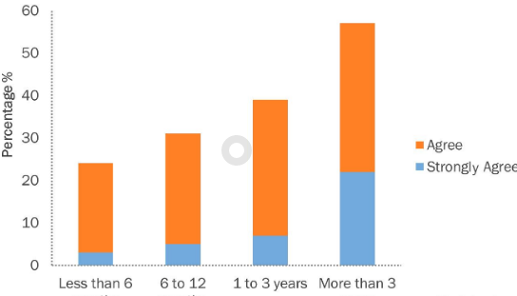

SWOT Analysis

Strengths

- New, advanced and improved technology and equipment that no other spa in the area uses.
- Convenient location
- No spending on payroll

Weakness

- The space in the spa is very small
- Only one person working (me)
- We can only take so many client a day

Opportunities

- Business expansion
- New clients who are open to trying new equipment
- Hiring employees if there is a need

Threats

- Other spas in the neighborhood who already have most of the clientele
- Clients afraid to try the new equipment and sticking to what they are familiar with

Logo

- The logo will be in a bold, large, white font to catch the attention and be visible as people walk or drive by. It will be on the front window of the store. We do not want the logo to be too obnoxious or childish looking but not too hidden either. We want to fit the mood of the rest of the town.
- I will use my graphic design experience to create the logo, needing little to no money to make it.

Industry Overview

- People are constantly influenced by celebrities and social media influencers on how to remain looking young and following new hair and makeup trends.
- Getting facials and hair and makeup done is a cheaper and less permanent alternative than getting plastic surgery and fillers.
- In conclusion, the beauty industry is growing and is continuing to grow and become more relevant in society.

Beauty industry growth shown below

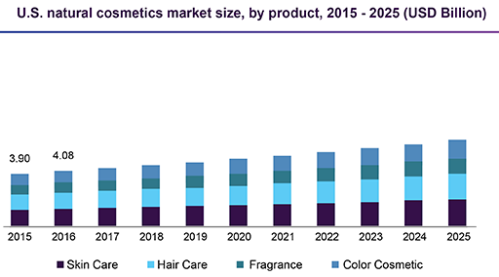

Marketing Summary

In todays society people will do anything to keep up with the idea of beauty and looking young and there has been a bigger hype around it all mainly from social media influencers and celebrities. Receiving a facial cleanses, exfoliates, and nourishes the skin, promoting a clear, well hydrated complexion and can help your skin look younger. The ones part taking in this would typically be women from the ages of 20 and older. Young women are learning what it means to take care of your skin from a young age so that it can be preserved for as long as possible with no plastic surgery needed.

Market Segmentation/Mix

Our market segmentation consists of typically women and men from ages 20 and older. This is a huge gap because there is no age limit or shame in gender when it comes to taking care of ones self. It can be broken up into:

- Younger adults who are learning how to take care of their skin, hair and nails and are having fun with experiencing with what works for them.

- Women and men from ages 35 to 50 years who have a good idea with what works for them, what they like or dislike and are still preserving their skin but are noticing to see a difference.

- Our main customers will typically be those from ages 20–45 years old
- Ages 20-35 will be the biggest age range.

- Women and men from ages 50 and older who still are trying to take care of themselves and feel and look as young as they possibly could.
- This will be our smallest age range of customers.

Below is a pie graph to visualize the market segmentation explained above.

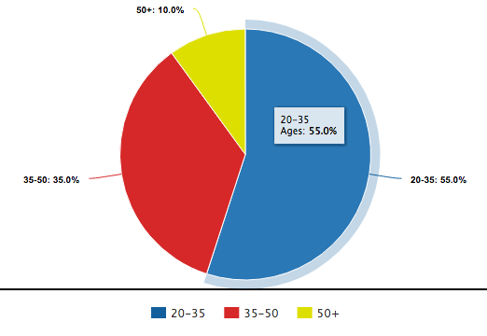

Marketing Summary

- Marketing will be done through social media and word of mouth being that it is a small town business and all towns Westchester County are very accessible.
- We will use our social media platforms to advertise
-Discounts and sales on products and services
-New products and services
-Free trials for products
- We will provide great customer service and a friendly atmosphere by offering 100% customer satisfaction or:
-A money back guarantee if customer is unhappy
-A re-do service if customer is unhappy
-Drinks and snacks available upon arrival

- Marketing will be of little to no cost since it is done by myself, the owner of the business and there are no external sources included but instead all internal.

Pricing Strategy

- The company has completed a thorough analysis of its competitors’ pricing. Keeping in mind our competitions pricing and the costs of customer acquisition, we have decided that we will not exceed those prices but instead offer better deals and promotions while still attempting to be profitable for the business.

Goals and Exit Strategy

- My goal is to keep it a small family run business
- I plan to run the business by myself, with the help of my significant other, in terms of support, while conducting procedures on my own and being available at all times and devoting all time and energy to it.
- At the moment, I do not plan to expand and open more stores but am aware that it could be a great and profitable opportunity.
- In 5 years, or earlier if necessary, I plan to hire at least one employee to help me run the spa.

Below is the 5 year income statement

 | Year 1 | Year 2 | Year 3 | Year 4 | Year 5
Revenues
Products | 9,800 | 12,050 | 13,200 | 14,400 | 19,900
Services | 93,000 | 105,150 | 111,000 | 117,850 | 128,500
Other | 3100 | 3,320 | 3,900 | 4,130 | 5,000
Total Revenue: | $105,900 | $120,520 | $128,100 | $136,380 | $153,400
Operating and Expenses
General and Administrative | 675 | 775 | 780 | 810 | 825
Insurance | 700 | 750 | 750 | 800 | 800
Payroll taxes | 700 | 730 | 730 | 750 | 1350
Lease | 39,864 | 39,864 | 39,864 | 39,864 | 39,864
Stationary Supplies | 250 | 330 | 330 | 350 | 375
NET PROFIT | $63,771 | $78,071 | $85,646 | $93,806 | $110,186
 | 0.602 | 0.647 | 0.668 | 0.687 | 0.718
x10 | 60.2% | 64.7% | 66.8% | 68.7% | 71.8%

