Module 4:
The Smart Tie

Arnora Balidemaj
Business and Technology of Fashion, The New York City College of Technology
BUF 4700: Contemporary Issues in the Fashion Industry
Dr. Nazanin Munroe
May 13th, 2020

Abstract

The Smart Tie is an active user controlled mens necktie that changes color and pattern when controlled by an app or remote. The app and/or remote offer a variety of colors and patterns for the user to choose from making day by day dressing much easier and more affordable. An exclusive partnership with ChroMorphous has made this all possible. ChroMorphous is responsible for the technical aspect of the tie and their researchers at the University of Central Florida have discovered a heat modifying method that could alter the pigment of a fabric. In addition to the creation, the team at Smart Tie is responsible for the designing aspect of the tie and creating a method to make this product eco-friendly and unique in the marketplace. With positive exposure using great advertising and marketing the product is expected to be in high demand, hit the market and be sold within wholesale retailers. A SWOT analysis and marketing plan is included to show how the brand expects to function and develop, and marketing techniques to help better promote the brand and product. Photos are also shown to demonstrate a visual idea of the product and what the end result looks like.

Great technological advancements in the textile industry and an increase of awareness in sustainable fashion has given the fashion industry the opportunity to progress in practicing sustainability while still remaining trendy. Consumers are learning what it means to be sustainable and how important it is to our environment. Smart textile fabrics are being created from citrus fruits, heating and cooling clothing including smart textiles, and color and pattern changing fabrics, inspiring designers and scientists to become more creative and combine their ideas and knowledge. These new advancements help the fashion industry rapidly progress all while helping our environment. The Smart Necktie is a new product that could change the future of men’s formal wear for the better. The Smart Necktie will play a major role in how people shop and dress for their everyday work attire or special occasion attire.
The creation of The Smart Necktie has become possible with a partnership with The College of Optics and Photonics (CREOL) at the University of Central Florida in Orlando, Florida. The scientists from this group are those to be credited for developing ChroMorphous. The group is constantly working to better develop the technology and fabric so that it is either more functional, more comfortable and visibly better by testing and experimenting on the fabric. The partnership with ChroMorphous and The Smart Necktie is completely exclusive and cannot be purchased by individuals who would like to create their own tie.
Materials and Methods
The color changing tie would function with a remote control, and/or by downloading the brands app on any smartphone, whichever the customers prefer and are more comfortable with. The remote and app both are available and come with the tie and would include a variety of colors and/or patterns to choose from with just the click of a button. The technology used to make and design the tie would definitely be considered as more advanced, active and very smart. The technological facet of the tie includes ChroMorphous, which includes a technology that will gradually change the color or pattern of a fabric when it is being controlled by the user. This is all possible with a smart fiber that is thin and woven into a traditional fiber. The smart fiber is not visible or distinctive. This wire is not harmful to a wearers body and feels like denim at touch.
When the user is attempting to change the color or pattern, there is a temperature modification of the thread smart thread taking place. The stream of electricity in the thread is changing in temperature and getting warmer, thus changing the color and pigment of the thread. A small computerized chip is found and connected on the back side of the tie with one only one connected wire and is not visible from the front side of the tie. The wire is what is sending the message from the users app to the smart fiber. When the tie is fully functioning with either a color change or pattern change, the whole tie will also change in temperature and become slightly warm, but not to a point of discomfort for the wearer.
The Smart Tie brand will attempt to better develop CREOL’s ChroMorphous technology, by making it more sustainable and eco-friendly. The threads used in their current product, their color changing bag, are made from synthetic polymer. Synthetic polymers are a human made polymer taken from petroleum oil and remade to imitate a natural fiber. Instead, the Smart Tie will use a natural fiber that is not toxic or harmful. For instance, silk which is a natural animal fiber that is soft, lightweight and smooth. (see figure 3) This would make the product biodegradable and will not hurt the environment in the long run like synthetic materials do.
When purchasing or ordering, there is an option to choose five of your preferred colors or patterns. The colors available would be red, green, yellow, sky blue, navy blue, orange, yellow, pink and purple. The patterns available are vertical or horizontal stripes, polka dots, regular small dots and a diamond print. With the app or remote, the user could choose a color, then the print on top of it, with the color of preference for the print as well. For instance, a red tie, with green vertical stripes. Or, a green tie with blue polka dots. The available colors for the pattern are the same as the ones for the tie. (see figures 1 and 2 for examples of what the fabric could look like) So in total, one can choose between ten colors, five for the tie and five for the patterns. This gives the wearer a lot of flexibility and variety in the type of tie that they want to wear and differentiates it from any other product currently on the market. When the user chooses their combination of color and pattern, the tie will instantaneously change into the chosen colors and within a few moments the tie is visibly changed to those exact colors.
The necktie itself is not harder to maintain than any other regular tie. The tie can handle any minor spilling of liquid as long as it does not affect the chip and wire on the backside of the tie. After removing the easily detachable computerized chip and wire, it can be machine washed regularly without tarnishing the actual tie. When the tie is in its neutral state, meaning there is no color modification and the user has turned off the chip, the tie is white. This is how the user will know the product is off and can either be put to wash or be put away.
The Smart Tie has many benefits to one’s lifestyle. It can be used time after time saving the wearer money, could match any suit or dress shirt giving the wearer flexibility in their options, it saves time in the morning dressing before work, and makes a great gift for any occasion. Many people might be opposed to this product for different reasons. The cost might be a factor, one’s priority might not be changing their tie so often, but people will mostly question the product itself and how functional it really is. However, there are similar products consisting of the same technology that is being used in the tie as well created with ChroMorphous. The other product is a purse and a scarf that has been developed and tested at the University of Central Florida by scientists. (see figures 1 and 2) The Color Changing Smart Necktie’s partnership with The College of Optics and Photonics (CREOL) in Orlando, Florida and creates of ChroMorphous, are constantly working to better develop the technology and fabric and produce it for wide scale market adoption. This will eventually be able to be integrated into not just clothing and accessories but also into home furniture and decor.
Analysis
SWOT Analysis
Strengths - A major strength is that The Smart Tie is one of a kind. There is no other product on the market like it and it is the first to be created. This necktie is a chance for the men’s fashion industry to grow and turn into a different and more sustainable direction, one tie that can be used over and over again. It can play a role in the advertising of sustainable products and show people how effective it really is and how it is actually completely functional.
Weaknesses - A weakness would be all the competition in the marketplace. A trouble the Smart Tie will face is getting people to purchase and try the product and to get wholesale retailers to want to sell the product within their stores. Since this is a product and concept that has never been heard of and would be new to the marketplace, people will have a hard time trusting and believing that it is completely functional like it is said to be. The main and major competitors would be Macy’s, Neiman Marcus, Bloomingdale’s and JC Penny who already have a huge collection of ties and many people depend on them to shop for ties. The product would need great advertisement to get word around and bring positive attention to it.
Opportunities - The biggest opportunity The Smart Tie has is the opportunity to grow. If the tie does good and sells like it is expected to, the brand can also grow. There could be a whole collection of suits and dress shirts made to go along with the tie using the same smart textile technology.
Threats - A threat would be ensuring that every single piece of technology that is integrated works and functions correctly and making the proper and correct attempts to make this product sustainable. With a new product and technology, it is very possible for defects and issues to occur within the technology. The product needs to be tested over and over and ensured complete functionality. Another threat would be similar technology being created and creating competition for the brand. With that being said, The Smart Tie brand would need to build a strong relationship with its potential consumer audience by creating a product that has very few issues so that consumers would not lean towards trying another product that offers almost the same features. With great advertising and marketing skills the weaknesses and threats are expected to become insignificant.
Marketing Plan
Business Summary. The Smart Necktie has an exclusive partnership with ChroMorphous who is completely credited for creating the technical idea of the product. The Smart Necktie is responsible for the sustainable and artistic aspect, creating design patterns and colors for the tie.
Brand Objective. The brand’s objective is to achieve 100% customer satisfaction by creating a product that practices what they preach while selling a product that is functional and safe. A customer is given a money back guarantee if they are unhappy with the tie.
Target Market. The target market for this product would be men in the business field, professors, lawyers and men shopping for a special occasion where a tie is expected to be worn. Many times, men who are in the business or hospitality field need to wear neckties as their everyday work attire or uniform, and for those who like to change it up often or buy better quality ties, it can get expensive and even space consuming. Higher end neckties that are typically made of silk can be purchased from stores like Neiman Marcus start at $200 and range into $1000. More affordable neckties usually made from synthetic fibers can be found at stores like JCPenny starting at $20 and range to $50. Regardless, both can put a dent in one’s pocket when there is a constant need in having to change it everyday and keep purchasing more. Also, the purchasing and eventual tossing of a tie made from synthetic fibers hurts our environment. With a color and pattern changing necktie that is sustainable and is user activated and controlled, one tie could be worn repeatedly and the design could change as and when the wearer pleases.
Promotional Strategy. Promotional strategies will include digital marketing using social media, brand websites and paid advertisements on Google. Social Media plays a big part in advertising and can gain exposure quickly and can target consumers more precisely based on views and searches.
The collaboration of fashion, dress and design with technology is a concept that most would find incompatible. Researchers and scientists are developing a future of both being combined into one, making smart fashion functional and trendy. Researchers at CREOL have created a technology that could help change the fashion industry forever and the Smart Tie will take the role in making it a sustainable product with an addition of biodegradable fibers rather than synthetic. Wearers will be able to interact with their attire and control what their clothing looks like, based on color, design and pattern.

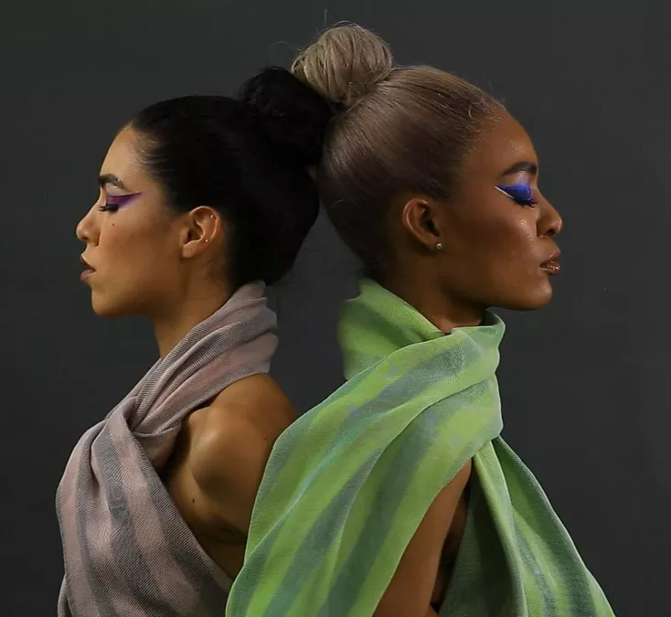
Images

Figures 1 and 2:
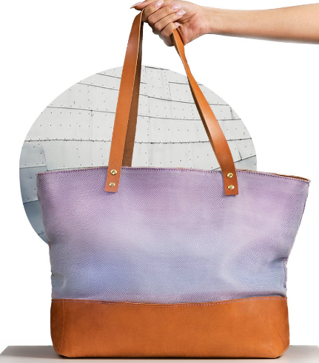
These images represent CREOL’s color changing scarf and purse which are prototypes that both use ChroMorphous, the same technology as the Smart Tie. Both products give a good visual of what the color pigments and patterns are expected to look like. As shown in the images, the color modification does not look unnatural and as if theres an incorportaion of a LED light.

A New Fabric Experience. (n.d.). Retrieved May 16, 2020, from http://www.chromorphous.com/

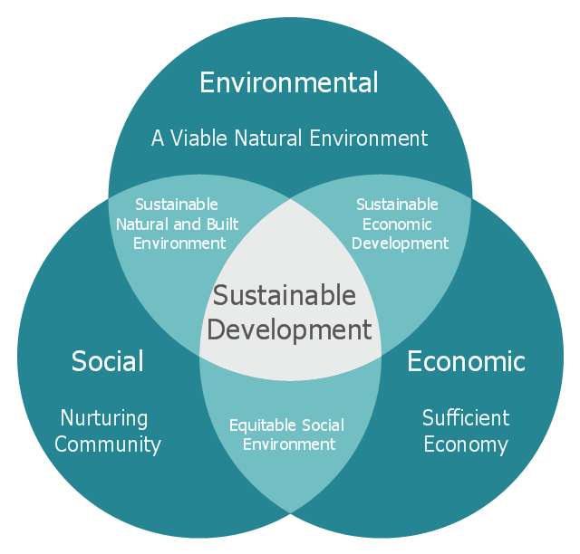
Figure 3:
Sustainabity is an important part of life and is often overlooked. Many do not realize how practicing it can benefit the economy and enviorment along with our social lives.

Venn diagram - Path to sustainable development: Sustainable development - Venn diagram: Venn diagram - Path to sustainable development: Venn Diagram For Sustainable Development. (n.d.). Retrieved May 16, 2020, from https://www.conceptdraw.com/examples/venn-diagram-for-sustainable-development
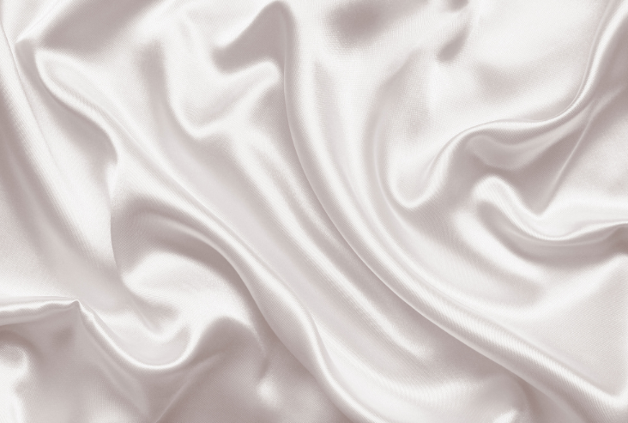

Figure 4:
The fabric shown in the photo is known as Silk, a natural fiber that is biodegrabale that Smart Tie plans to use to make their ties and make their product sustainable.

"HeiQ Real Silk" finish brings a touch of luxury to everyone. (2016, December 06). Retrieved May 16, 2020, from https://heiq.com/2016/03/09/heiq-real-silk-finish-brings-a-touch-of-luxury-to-everyone/
Refrences
Takahashi, D. (2018, May 16). This amazing fabric can change its color on demand. Retrieved May 16, 2020, from https://venturebeat.com/2018/05/15/this-amazing-fabric-can-change-its-color-on-demand/

Carey, B. (2018, May 15). This smart fabric changes colors when you tell it to. Retrieved May 16, 2020, from https://www.cnet.com/news/color-changing-smart-clothes-smart-fabrics-purse-ucf-chromorphous/

Cao, Y., &amp; Wang, B. (2009, March 31). Biodegradation of silk biomaterials. Retrieved May 16, 2020, from https://www.ncbi.nlm.nih.gov/pmc/articles/PMC2680630/

Www.fibre2fashion.com. (2018, May 29). CREOL produces user-controlled colour-changing fabric. Retrieved May 16, 2020, from https://www.technicaltextile.net/news/creol-produces-user-controlled-colour-changing-fabric-242476.html

Stolyar, B. (2018, May 15). Research Scientists Debut ChroMorphous, A Color-Changing Technology. Retrieved May 16, 2020, from https://www.digitaltrends.com/mobile/chromorphous-color-changing-technology/

Active, User-Controlled Color-Changing Fabric. (2018). Retrieved May 16, 2020, from https://www2.creol.ucf.edu/NewsEvents/NewsDetail.aspx?NewsID=798

A New Fabric Experience. (n.d.). Retrieved May 16, 2020, from http://www.chromorphous.com/

Men's Ties. (n.d.). Retrieved May 16, 2020, from https://www.jcpenney.com/g/men/view-all-accessories-for-men?item_type=ties

Designer Ties. (n.d.). Retrieved May 16, 2020, from https://www.neimanmarcus.com/c/mens-accessories-ties-pocket-squares-cat40450753?ecid=NMPT__XX

Venn diagram - Path to sustainable development: Sustainable development - Venn diagram: Venn diagram - Path to sustainable development: Venn Diagram For Sustainable Development. (n.d.). Retrieved May 16, 2020, from https://www.conceptdraw.com/examples/venn-diagram-for-sustainable-development

"HeiQ Real Silk" finish brings a touch of luxury to everyone. (2016, December 06). Retrieved May 16, 2020, from https://heiq.com/2016/03/09/heiq-real-silk-finish-brings-a-touch-of-luxury-to-everyone/

