Alona Abdullaieva
DEN 2315 Pharmacology
Fall, 2019
Ginkgo biloba
Ginko biloba – the botanical generic name is ginkgo. The name Ginkgo biloba was first given to the tree by Linnaeus in his Mantissa Plantarum Altera.¹ Another common name for Ginkgo biloba is maidenhair tree.² The extract from Ginkgo leaf has been utilized in many fields such as food, biochemistry, as well as in pharmacology, showing high antioxidant activity, antibacterial effect, and physiological activity in therapies for diseases. The active constituents of the Ginkgo leaf are flavonoids.³
Pharmacologic classification is very similar to platelet aggregation inhibitor.
Ginkgo is available as tea, powder, tablet, tincture, suspension and cream (cosmetic).
Ginkgo tea is rich in antioxidants that act specifically on mitochondria and have a positive effect in vascular regulation. The research has proven that Ginkgo and green tea may decrease the intraocular pressure in patients with glaucoma.⁴
Ginkgo is used in cosmetic products. The formulation of anti-wrinkle cream from herbal flavonoids like Ginkgo is an efficient natural anti-wrinkle solution.⁵ According to the literature Gingko seeds are effective in treating asthma, enuresis, pyogenic skin infections and intestinal tract worm infections.⁶ Most of the Gingko biloba products’ labels state that it can improve memory and cognitive function. This natural pharmaceutical increases blood circulation and improves myocardial function, vision, premenstrual syndrome, schizophrenia, a movement disorder called tardive dyskinesia.⁷ No off-label use is indicated. Product source is the extract from the tree that native to China. After the discovery of Gingko biloba in China it was planted in many different regions of the planet, such as Europe and United States. Many clinical studies have shown the efficacy of Ginkgo for the treatment of neuropsychiatric disorders. According to the literature taking a 240-mg daily dose of Ginkgo biloba extract is effective in the treatment of dementia.⁸ Medical and dental professionals should be aware of spontaneous bleeding side effect. The medication dictionary states that possible reactions include headache, dizziness, heart palpitations, and GI and dermatologic reactions. Absolute contraindications have not been established. However, Ginkgo may affect the metabolism of various drugs.⁹ Gingko biloba has no oral manifestations. In comparison with the most common drug for dementia Namenda (Memantine Hydrochloride) Ginkgo does not have as much reported side effects. Also, Gingko can be compared to Plavix (Clopidogrel) because of its antiplatelet functions. The side effects and mechanism of actions are very similar. It is advertised as natural product and available OTC in many forms. Consumers may be attracted by the fact that its organic and assume that the product will have less side effects than a prescription drug. The consumer may purchase the product online or OTC. Information on the product is available in books, magazines and on line. The best way to verify the information on the product is to check an updated drug book. As a health educator my knowledge should be very extensive about the natural products because of the potency and interaction with other medications. I have to be very comfortable discussing possible interactions and side effects of Gingko. It’s of upmost importance to educate a patient in order for them to be treated safely. Since the drug book states “spontaneous bleeding” I would get a medical clearance for this patient before starting the treatment. I would ask the patient to stop taking Gingko 2-3 weeks before the dental cleaning.¹⁰

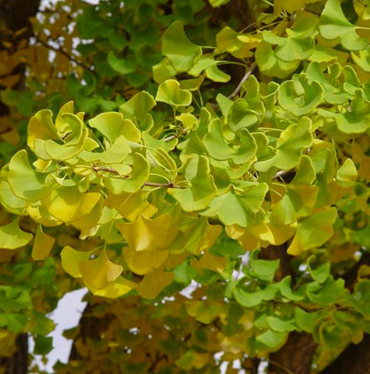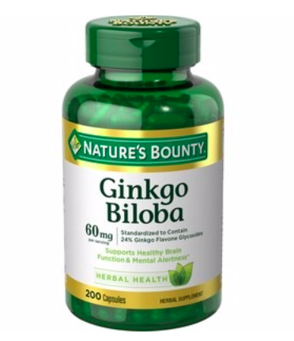

References:
- Moule, M.C. The Name Ginkgo Biloba and Other Names of the Tree. T’oung Pao. Second Series, Vol. 33, Livr, Pp. 193-219. https://onesearch.cuny.edu/primo-explore/fulldisplay
- PLANTS Database. USDA. Ginkgo bloba. Natural Resources Conservation Service. January 19, 2016. http://en.wikipedia.org/wiki/Ginkgo_biloba
- Zhang, Xianglun, et. Al. Effect of Ginkgo biloba Leaf Powder on Growth Performance, Meat Quality and Antioxidant Activity of Muscle in Growing-Finishing Pigs. Pakistan Journal of Zoology, vol. 48, no. 5, 2016, p. 1555. Gale Academic.
- Reed, Kimberly K. Complementary and alternative therapy for glaucoma: green tea and ginko biloba for glaucoma? Sleeping upright to bring the IOP? Learn what your patients may be using to treat their glaucoma. Review of Optometry, April 15, 2010, p. 63. Gale Health and Wellness.
- 2010 Society of Cosmetic Scientists and the Société Francaise de Cosmétologie. 106 International Journal of Cosmetic Science, 32, p. 99-106. Gale Academic.
- The main active constitutes and detoxification process of Ginkgo biloba seeds and their potential use in functional health foods. Journal of Food Composition and Analysis. Volume 83, October 2019. Gale Academic.
- Reviewed by Charles Patrick Davis, MD, PhD. Ginkgo. RxList. August 8, 2018. https://www.rxlist.com/ginkgo/supplements.htm
- Masayuki Hashiguchi, Yuriko Ohta, Mikiko Shimizu, Junya Maruyama, Mayumi Mochizuki. Meta-analysis of the efficacy and safety of Ginkgo biloba extract for the treatment of dementia. Journal of Pharmaceutical Health Care Science. April 10, 2015. https://www.ncbi.nlm.nih.gov/pmc/articles/PMC4729005/
- Richard L. Wynn, Timothy F. Meiller, Harold L. Crossley. Drug Information Handbook for Dentestry. 24th Edition. 2018.
- Reviwed by Steven D, Ehrlich, NMD. Penn State Hershey. Milton S. Hershey Medical Center. Ginkgo biloba. June 22, 2015. http://pennstatehershey.adam.com/content.aspx?productId=107&pid=33&gid=000247

