Cross between Sordaria wild-type and mutant strains
Asma Akam
Lab report #2
New York City College of Technology

Abstract
Sordaria fungus was used in lab to understand genetic recombination and how offspring become genetically different from their parents. Sordaria produces eight haploid ascospore, with a specific color pattern indicating recombination.
Introduction
Sordaria fimicola is an Ascomycota fungus that reproduces sexually and asexually to produce eight haploid ascospores, which are held inside an ascus (Olive, 1956). First a diploid zygote undergoes meiosis producing four haploid nuclei, then mitosis producing eight haploid ascospores. Crossing over occurs during meiosis, in which an exchange of genetic material between two chromosomes leads to genetic recombination. In lab a cross between gray mutant strain vs. wild- type and a tan mutant strain vs. wild-type. A wild-type spore color is dark, while a mutant spore varies in tan or gray. The goal was to understand genetic recombination and meiosis and how it can lead to genetically different offspring from their parents.
Methods
In this lab, one petri dish was used to cross a wild-type Sordaria with a mutant tan strain and the other dish crossed a wild-type Sordaria with a mutant gray strain. A sharpie was used to draw four equal quadrants on the back of two petri dishes, labeling the Quadrants with either two T and two WT or two G and two WT. We used a sterile wooden splint to cut 0.5 cm cubes of the Sordaria agar cultures, which were already prepared and inverted them in the center-designated spot making sure hyphae were faced down. After the dishes were incubated a week later we examined the spores under a light microscope. A wet mount was made from the perithecia near the junction of the two strains. Gently press on the perithecia until they rupture and release asci. We observed it under low magnification then high to see if the ascospores have a 2:2:2:2 or 2:4:2 or 4:4 color pattern and filled in the table based on what was observed.
Results
A cross between wild-type vs. tan mutant strain and wild-type between gray mutant strain was created. The genes controlling ascospores demonstrate if recombination has occurred during crossing over. If recombination occurs the expected outcome is 2:2:2:2 or 2:4:2 and if no recombination occurs it will be ordered 4:4 of mutant and wild-type spore color. Figure 1 illustrates a cross between wild-type vs. gray mutant strain, and figure 2 illustrates a cross between wild-type vs. tan mutant strain. Table 1, demonstrates the distribution if the strains crossed had recombination or not. If recombination exists between the wild-type and mutant strain a 2:2:2:2 or 2:4:2 color pattern will be seen and if recombination doesn’t happen a 4:4 color pattern will be seen. The total asci observed was 20 for each, which was supposed to be 200. While observing the asci for wild-type vs. gray mutant we discovered equal amounts of non-recombination and recombination. We observed wild-type vs. tan mutant and found slightly more recombination in the asci.
Discussion/ Conclusion
Sordaria is a fungus that produces eight haploid ascospores, through meiosis. During meiosis crossing over occurs, in which an exchange in genetic material between chromosomes leads to genetic recombination. Our sample size was unfortunately small, because it was hard to make out the color patterns and observe the asci under the microscope. We were unable to accurately determine if more recombination occurs in wild-type vs. tan than in wild-type vs. gray mutant, due to a large sampling error. We determined both recombination and non-recombination occur during meiosis for the Sordaria, which some offspring resemble their parents while others are genetically different.
Figure 1 Wild-type vs. gray mutant strain

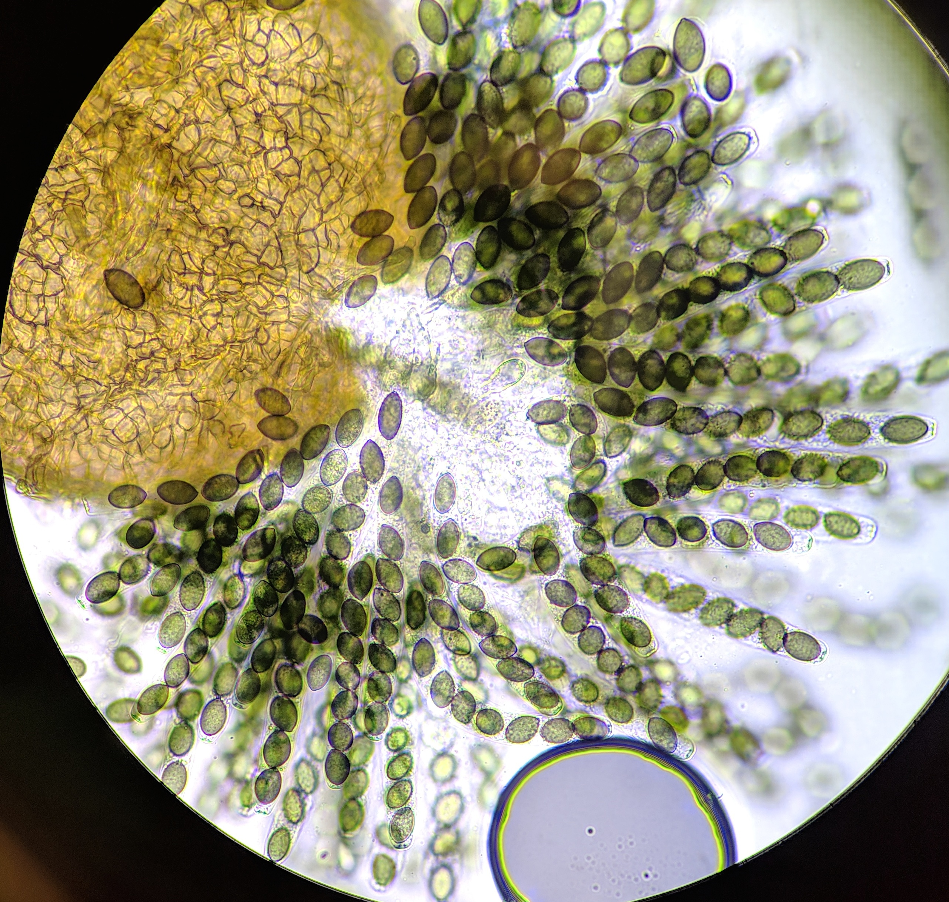

Figure 2 Wild-type vs. Tan mutant strain

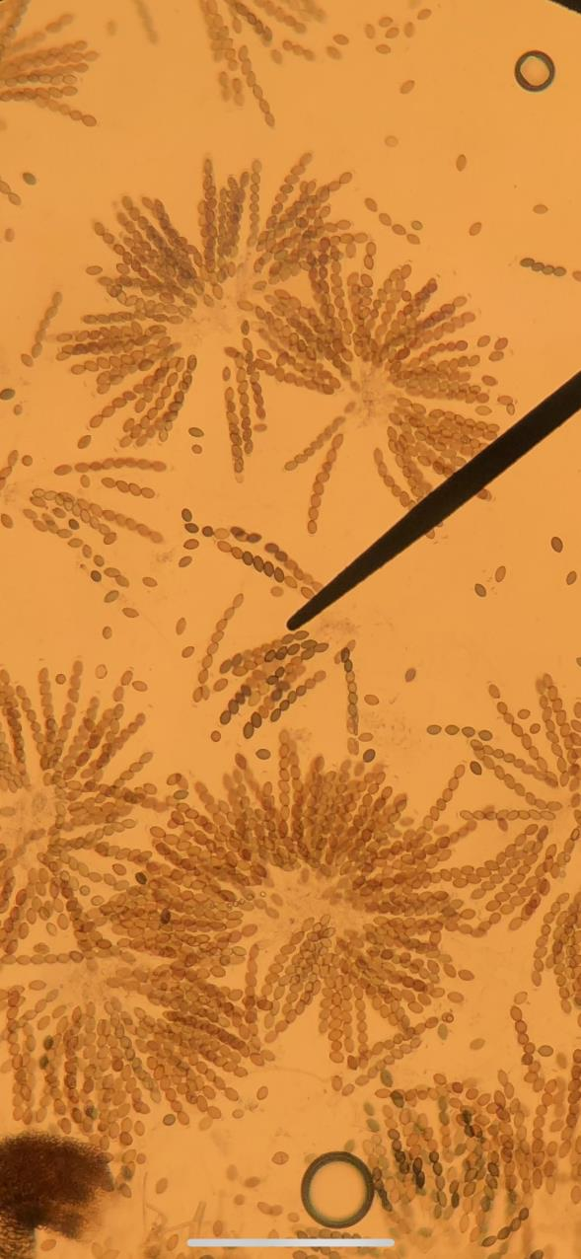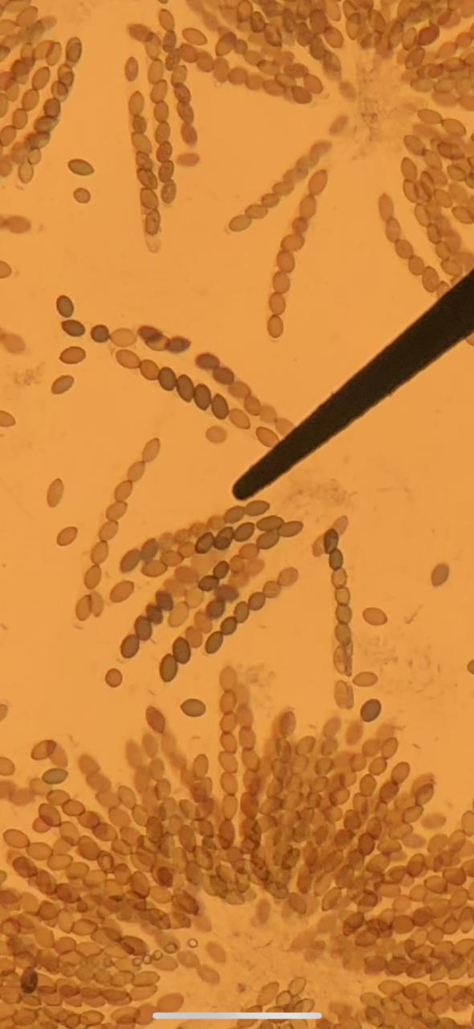

Table 1: Crosses between wild-type vs. mutant type and amount of recombination present.

Strains Crossed | # Non- recombinant asci | # Recombinant asci | Total asci | % Recombinant | Map Units (% Recombinant/2)
Wild-type x gray | 10 | 10 | 20 | 50% |  | 25
Wild-type x tan | 8 | 12 | 20 | 60% |  | 30

Reference

Olive, L. (1956). Genetics of Sordaria fimicola. I. Ascospore Color Mutants. American Journal of Botany, 43(2), 97-107. Retrieved from http://www.jstor.org/stable/2438817

