Human Karyotyping to Diagnose Abnormalities in Fetuses
Asma Akam
Lab report #1
New York City College of Technology

Abstract
A karyotype is used to diagnose and understand chromosomal deviations and defects. In this lab a karyotype was used to examine a fetus of a 37-year-old woman, who showed higher risks for birth defects. After analyzing the karyotype of the fetus a trisomy for chromosome 21 was discovered. A fetus with a trisomy 21 has three copies of chromosome 21, illustrating the child will have Down syndrome. A genetic disorder associated with intellectual disability and developmental delays.

Introduction
Geneticists use karyotypes to diagnose different abnormalities and defects in humans. A normal human somatic cell contains 46 chromosomes and 23 pairs. Down syndrome is a gene defect expressed in genes located on chromosome 21, which is associated with clinical phenotypes such as craniofacial dimorphism, cognitive deficits, neurological defects and more. (Schnabel, Smogavec, Funke, Pauli, Burfeind & Bartels, 2018). In Case Study B, amniotic fluid was extracted from around a fetus and the chromosomes were stained and observed under a microscope. The chromosomes were represented on a karyotype for Marie’s an eighteen-week pregnant woman. The karyotype was illustrated female fetus with a trisomy for chromosome 21, indicating the child will have Down syndrome.

Methods
In this lab, a chromo scan was used with a specific case study indicating a karyotype of a fetus. A cytogenetic report was filled out and chromosome stickers were used to pair each chromosome in the karyotype. After each chromosome was paired the karyotype was analyzed for any irregularities and defects.

Results
In case study B, amniocytes were extracted from the amniotic fluid surrounding Marie’s fetus. After the cells were cultured and stained a karyotype was created. In figure 1, the fetus’s karyotype revealed it has trisomy 21, which means three copies of the 21 chromosomes, indicates the child will have Down syndrome. A human somatic cell has 46 chromosomes in this case study B; the fetus has a total count of 47 chromosomes.

Discussion
Trisomy 21 is a genetic condition caused by an extra chromosome in chromosome 21. Genotype-phenotype studies on trisomies reveal that genes producing Down syndrome cluster in tiny sections in chromosome bands, depending on the genes location it will distort the balance of gene products (Schnabel, Smogavec, Funke, Pauli, Burfeind & Bartels, 2018). A karyotype is used to detect any defects in chromosomes, in this case Marie’s fetus, which has trisomy 21.

Conclusion
In summary, a karyotype for case study B was used to analyze a fetus for a 37-year-old woman named Marie. The karyotype demonstrates an extra chromosome in 21, illustrating that the fetus will have a genetic disorder called Down syndrome. Down syndrome is triggered by an irregular cell division after fertilization. In Marie’s case after the chromosomes were paired using the chromo scan an extra chromosome was found, having a total of 47 chromosomes rather than the normal chromosome count for human somatic cells 46.
Figure 1: Karyotype of case study B

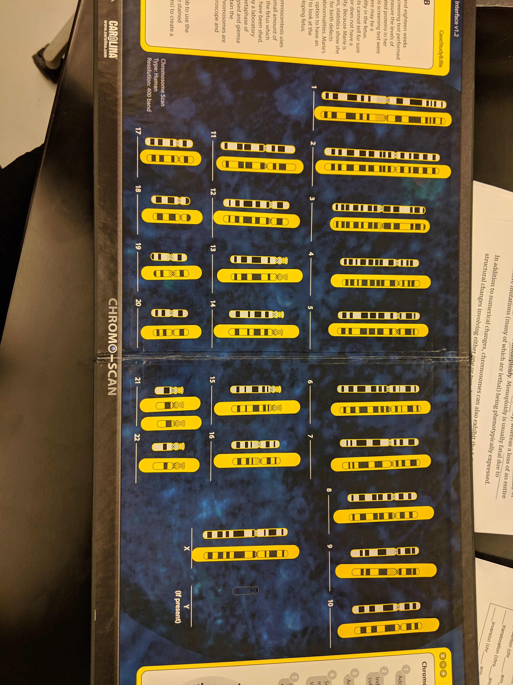

Reference

Schnabel, F., Smogavec, M., Funke, R., Pauli, S., Burfeind, P., & Bartels, I. (2018). Down syndrome phenotype in a boy with a mosaic microduplication of chromosome 21q22. Molecular Cytogenetics, 11(1). doi:10.1186/s13039-018-0410-4

