Where I’m from
By: Victor Aguilar
Inspired by Willie Pedomo
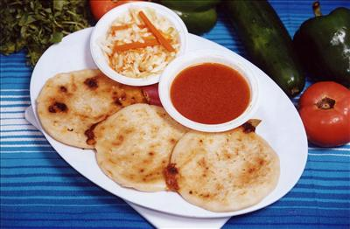

If I said I was from a beautiful country in Central America, where every day is a festival, where all the women get together and make the best meals you ever imagine and the men lay back grab a beer and talk about the good old days. Where the traditional dish is pupusa. Would you know where I’m from?
Where I’m from we love eating pupasa. It’s a typical Salvadorian dish made of handmade tortilla and is usually filled with cheese, cooked pork meat or refried beans. Pupusas are typically served with curtido (cabbage slaw with red chilies and vinegar) and tomato salsa. The best way to eat this is with your family, the best pupusa I ever had is when my mom and my aunts come together and make it. Where I’m from the best meals is with your family and what better meal to have then the best Salvadorian dish.

