May 10, 2009

BOWERY

A Living Museum of Sad Stories
By GREGORY BEYER
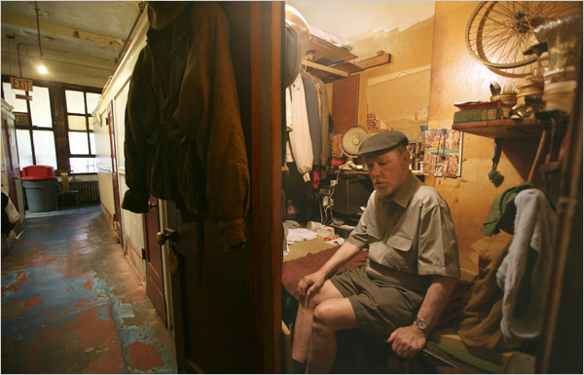
DEPENDING on its occupants, the lobby of the White House Hotel, a 92-year-old single-room-occupancy building on the Bowery near Bond Street, can have the feel of a sanitarium, minus the institutional obsession with cleanliness.
Residents sit hunched over cans of soda or cups of coffee, eyes closed or staring, lost in silence. A man in a wheelchair whose left leg ends in a stump below the knee can often be found there, listening to music on earphones. After a time, he laboriously wheels himself across the lobby, through another door and down the hall toward his room.
One formerly homeless man refuses to leave the building, according to fellow residents. He looks out the window, but as far as anyone knows, he has never ventured out on the street.
The White House is a four-story red-brick building at 338 Bowery, the last of the dozens of flophouses that once largely defined the city’s Skid Row. Lately, the White House has been the site of a standoff of sorts, the center of a slow-moving drama involving real estate interests, matters of historical preservation and the lives of a handful of poor, essentially helpless men.
The 18 current residents pay rents ranging from $7.16 to $9.61 a night and live in the hotel permanently. As was the case years ago, when the White House and the other flophouses were filled with men who signed up for daily or weekly stays, many of the residents struggle with mental illness and addiction.
Most tenants owe at least two months’ rent, according to Patrick Jones, a lawyer for Metro Sixteen Hotel LLC, the company, affiliated with the hotelier Sam Chang, that bought the building in 2007. Some have not paid rent at all since that date, Mr. Jones said.
Metro Sixteen’s plan was to redevelop the property into a proper hotel, Mr. Jones said. But after the purchase, the building was included in an extension of the NoHo Historic District, severely hampering the developer’s plans.
“It was a surprise,” Mr. Jones said. “If there was an inkling that this was going to be placed in a historic district, the owners wouldn’t have purchased it.”
Metro Sixteen has applied to the city’s Landmarks Preservation Commission for permission to develop the site, asking to be considered under the commission’s hardship provision. The city has not yet ruled on the request. But if it is granted, the developer could demolish the hotel and rebuild on the site, effectively bulldozing one of the last remnants of the Bowery’s flophouse past.
A man named Euzebius Ghelardi opened the White House in 1917 as a lodging house, and about a decade ago the hotel also began operating as a hostel frequented by backpackers and students. Foreign tourists, often equipped with cameras and camcorders to document their travels, provide most of the revenue.
The flophouse regulars and the tourists sometimes mingle in the spare lobby that is furnished with a few tables, chairs and vending machines. Some residents delight in offering advice on local attractions. For others, the presence of transient guests yields what one longtime resident described as “the feeling of animals being on display.”
Meyer Muschel, the White House’s manager, estimated that every year a handful of journalists, filmmakers or students stopped by to write about or to film the place.
Was he weary of these periodic attempts to document life at the White House? Mr. Muschel, a brash former corporate lawyer who also serves as president of Congregation Ohab Zedek, an Upper West Side synagogue, said that he was.
Some tenants, he added, resent the fact that the White House is regarded as a repository of “human interest” stories. At the same time, the convenient concentration of so much human frailty has transformed the hotel into a living museum of sad stories.
The White House’s living quarters are cubicles four feet long by six feet wide. They line long, narrow hallways in a way that suggests horse stables. Since only so many belongings can be stuffed into the cubicles, there is much overflow into the hallways. Personal effects collect on available ledges; clothes pile up on free surfaces and dangle from hooks.
THE sight of a frail man like George Buchanan, 73, seated on his small bed is unsettling and claustrophobic, even with the door open. Mr. Buchanan, whose gray mustache is stained dark brown at the midpoint of his upper lip, has lived in the White House for 26 years. His slow gait, he said, is the result of congestive heart failure.
Once he went up to the second floor, but he won’t again. He used to enjoy reading, but his failing eyesight has prevented it in recent years. “I’m at a loss now for how to pass the time,” he said.
There are artists, too. Lee Wells, for example, is the author of “Escape From Mississippi: Diary of a Black Boy Growing Up Down South,” a self-published book with a loose approach to spelling and punctuation.
In the past few months, three White House residents have accepted buyouts, an option available to the men who remain. But Brandon Kielbasa, an organizer with the Cooper Square Committee, a tenants rights group, said that even a windfall of cash would not necessarily help them find homes. Most have no family, few friends, and sporadic, if any, income, he said, and as a result they are content to cling to what they know.
As one longtime resident put it, in spite of his hard feelings for the White House, “This is the Alamo.”

