Interference Archive Reflection

We visited the Interference archive in Gowanus for our class. It’s in the place where you can’t expect to have archive, because around the archive there are houses and some commercial place. So when you go there you might be lost because they didn’t put any big sign or anything to make the archive pop up for people. We meet Mike Clemow who runs his own podcast and which was the purpose of our visit because we are doing podcast project for our class. He told us many things but our concern was podcast and radio station and difficulties running both of them. He was having difficulties starting the radio station because of things like copy right. But he started the radio station. working on it 24/7 was a big issue. He mentions that producing a podcast is not a very easy job sometimes it takes weeks to complete 20-minute podcast.

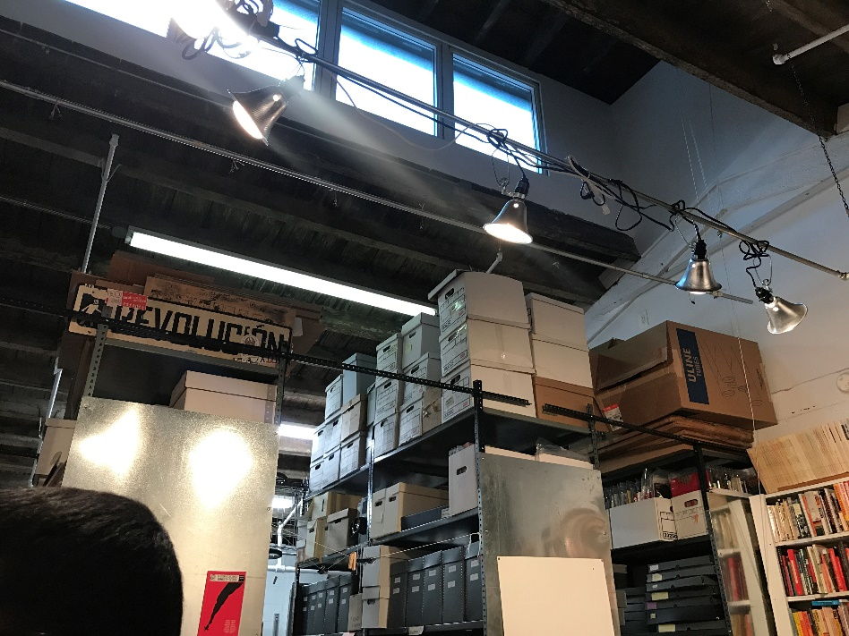 The thing that catches my attention was the building they are putting archive in. it was not a fancy building. I was expecting more fancy building as I heard the name interference archive because archive have values, so seeing a building which not suits the archives was surprising.

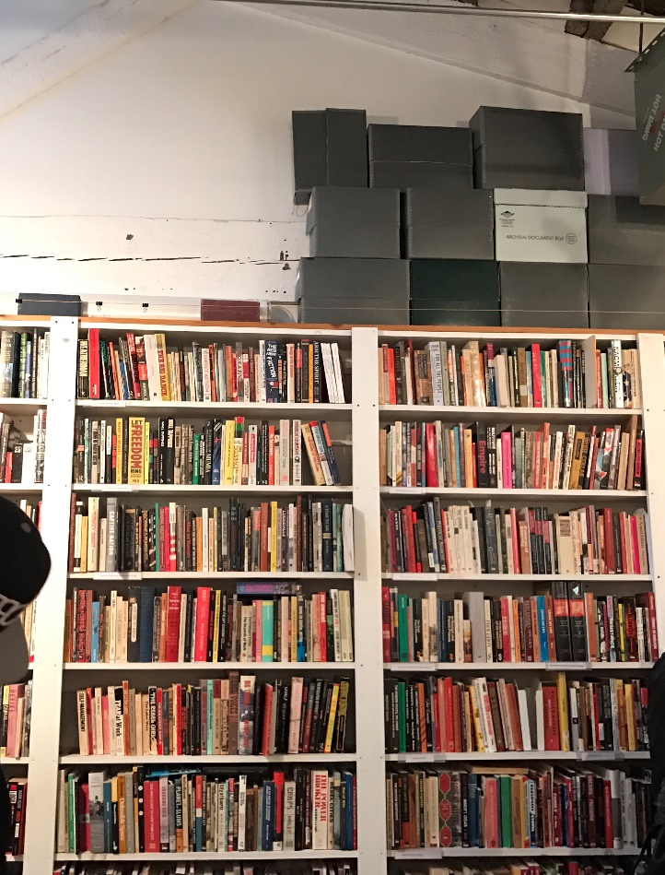 The other thing that catches my attention was the books they have in there. I was not excepting so many things in there by the look of the building but they have enough books to read. And they organized the books very well by the topics and evets.so people can easily find the book they want to read.

Questions
- Why Mike produced only few podcast?

- Why the interference archive building is so damaged and in the area that people will barely pay attention?

