Archive Response #2 – NYPL
Source #1
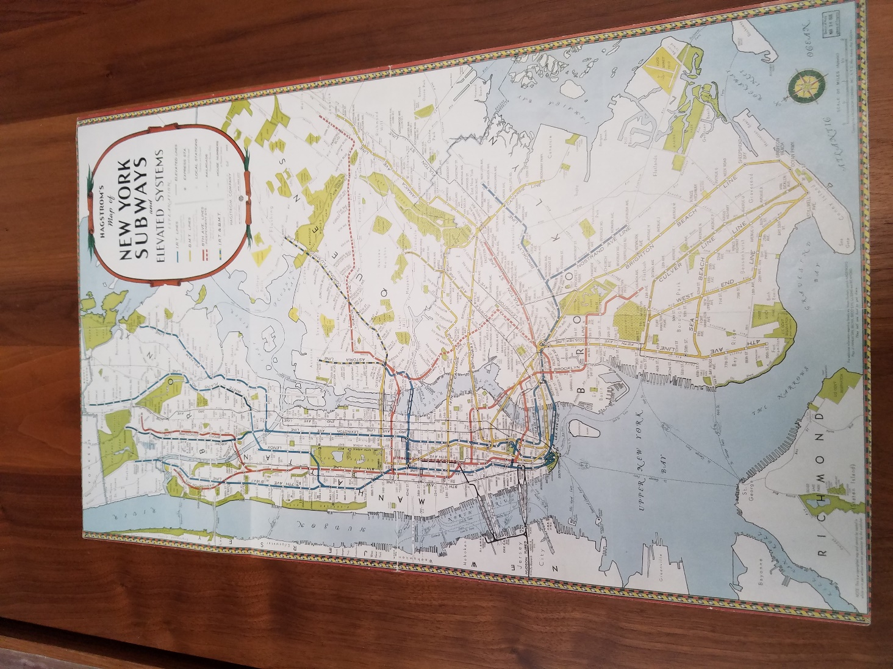
Title: ​Hagstorm’s map of New York subways and elevated systems
Published by: ​ Hagstorm Company Inc.
Date: ​ 1936
Source: ​ Primary Source; Map
This map is of the subways and elevated trains in New York around 1936. It is significant because you can see the major changes that have occurred in subways since then. Some if not all of these lines are still being used today. Another thing I noticed is how simplistic this map looks and colorful which also reminds me of the maps we use today. It’s remarkable how many trains they actually already had in place at that time. We’ve been talking about grand central terminal and the rail road system in New York all semester so that’s why I found this relevant.
Source #2
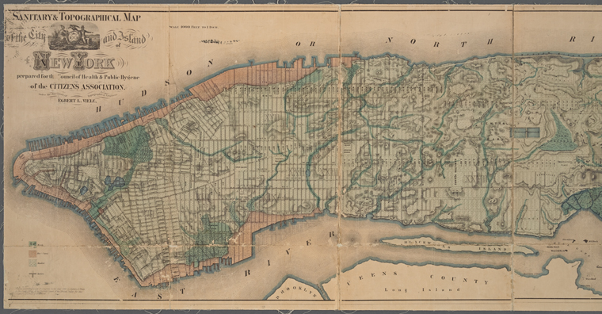

Title: ​ Sanitary and topographical map of the City and Island of New York; prepared for the Council of Hygiene and Public Health of the Citizens Association under the direction of Egbert L. Viele, Topographical Engineer.
Published by: ​Council of Hygiene and Public Health of the Citizens Association
Date: ​ 1865
Source: ​ The New York Public Library. (1865). ​Sanitary and topographical map of the City and Island of New York; prepared for the Council of Hygeine and Public Health of the Citizens Association under the direction of Egbert L. Viele, Topographical Engineer.
​ Retrieved from http://digitalcollections.nypl.org/items/1db24760-f3a2-0130-031a-58d385a7b928

This map was of the island of Manhattan in 1865. The purpose of this map was to get a better understanding of the island and what used to be there before colonization. This was important at the time because people were falling ill and they couldn’t find the source, so people started to demand that they check to see if there were any channels or streams throughout the island. As this could be the source of the spreading of illness at the time. It was interesting to see the change in how the island looked before the big buildings and many piers started coming. It came to a surprise that there were a couple of underground channels and streams in Manhattan that I would have never guessed. This is relevant to the course because of how the way people protested, reminded me of the protests that were made to save grand central.
Questions:
- What changes were made when the mta took over management of the subway system?
- Without the available technology for land survey we have now, how were these measurements taken to map out the island?

