Archive Report-New York Public Library
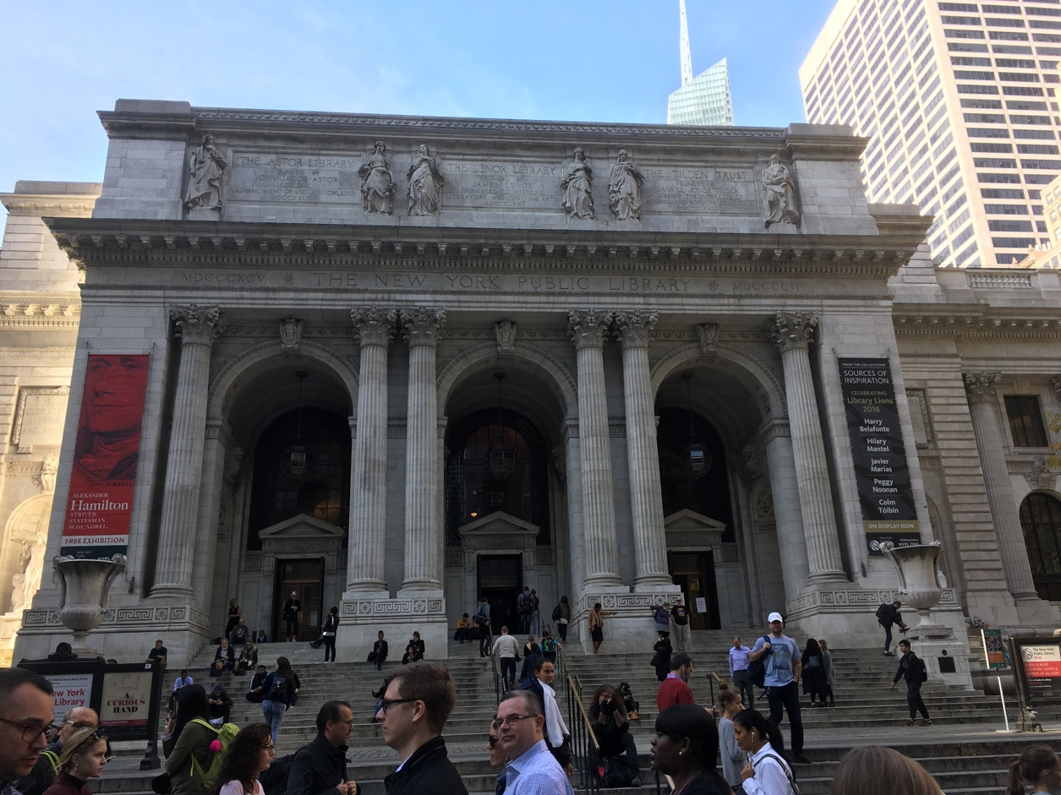
The New York Public Library is a contemporary building from the late 1890s. It belongs to the neo-classic architectural style. It is the largest public library in New York City.

Victor Ramirez
11.07.2016

Introduction

In this archive report I have included a historical map that was displayed on a table for us during our visit to the New York Public Library. This document is a primary source from the 1930s subway system in New York City.

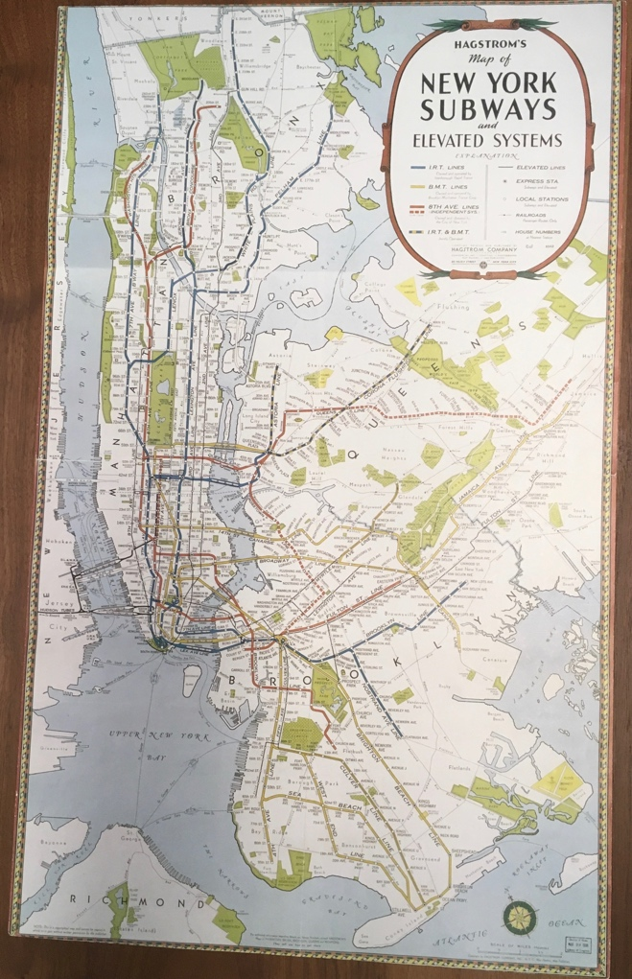

I chose this informative map from the NYPL Collection. It shows an old subway map of the city.
It contains all the necessary information in order to read a typical map. For instance, it has an orientation (North arrow), scale and legend. It contains a title and a grid that are used to describe the subways routes in the city.

Author: Hagstrom Company, Inc.
Publisher: Hagstrom Company, Inc.
Place of Publication: New York
Date: Date Issue: 1936
Audience: General public
Origin: The map was published in 1936 to inform the citizens of New York. My assumption is that many copies were printed.
Context: The map describes the active subway lines of the Interborough Rapid Transit (IRT), Brooklyn- Manhattan Transit (BMT) and their stations. Today, the Metropolitan Transportation Authority (MTA) runs those subways lines illustrated on the map.

Citation
Hagstrom's Map of New York Subway and Elevated Systems [Map]. (1936).
The New York Public Library. Manhattan, NY: Hagstrom Company.

http://historymatters.gmu.edu/mse

