Learning Places Fall 2016
SITE REPORT #1

Grand Central Terminal Site Visit
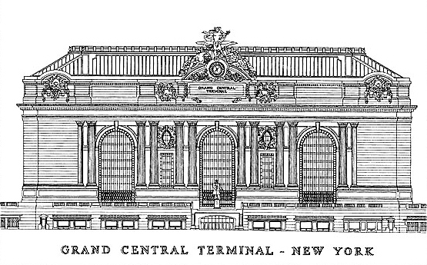

Sotir Zhupa
10.06.2016
INTRODUCTION
This site report is an expansion of site report #1 on Grand Central Terminal. We visited Grand Central Terminal for a second time on the 28th of September but this time around we had a tour guide that works in the building who gave us important new information about Grand Central. Also the tour guide showed us some secrets that are hidden inside the terminal. This second tour was extremely insightful and helped me to better understand what made Grand Central such a historical building that has survived for so long.

SITE DOCUMENTATION (photos)

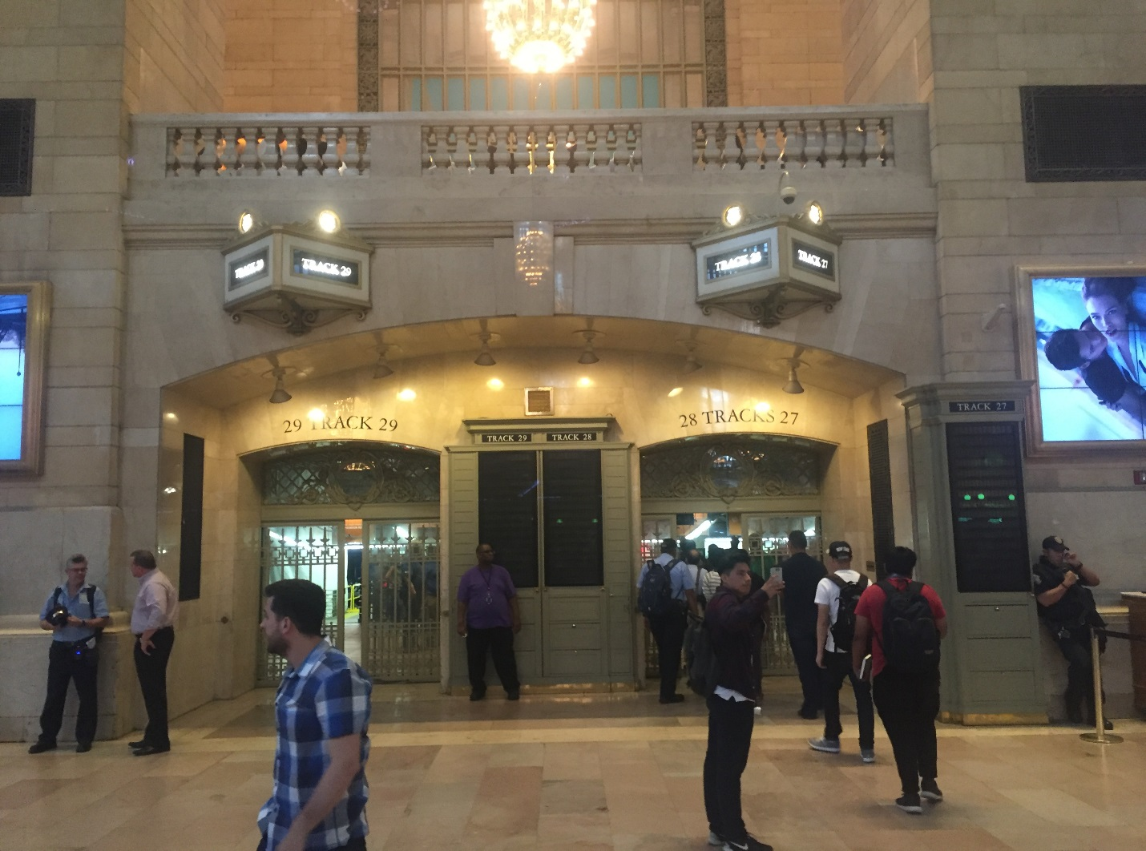This is a photo of one of the many entrances to the train tracks where you can find the train you’ll need to take so you can reach your destination. This is an important picture to point out because these entrances can, quite easily , lead people to the train track they would like to go, whether it be track 1, 2, 29 etc. As you can see in the photo above there are many signs that say the track numbers and they are also very well-lit making them easy to locate.

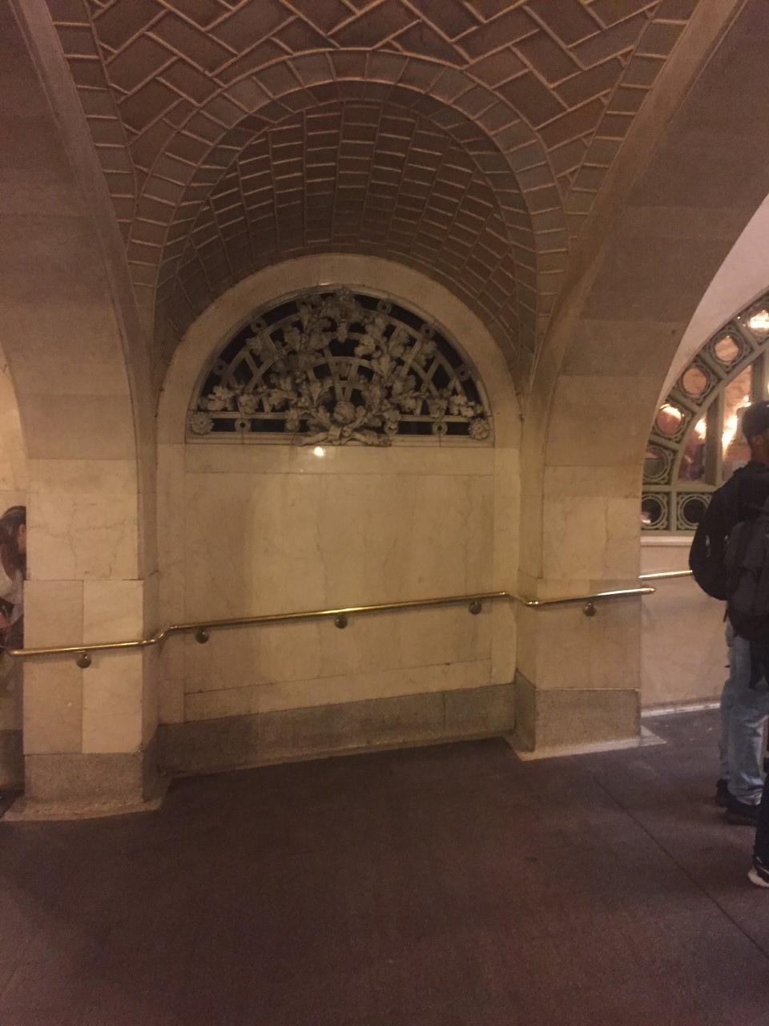

This is a photo of the whispering gallery, a hall in Grand Central Terminal, where you can go to one corner of the room and have a friend at the opposite corner and he can hear what you are whispering. I found this place extremely fascinating and that is why I chose it to include it in my site report.
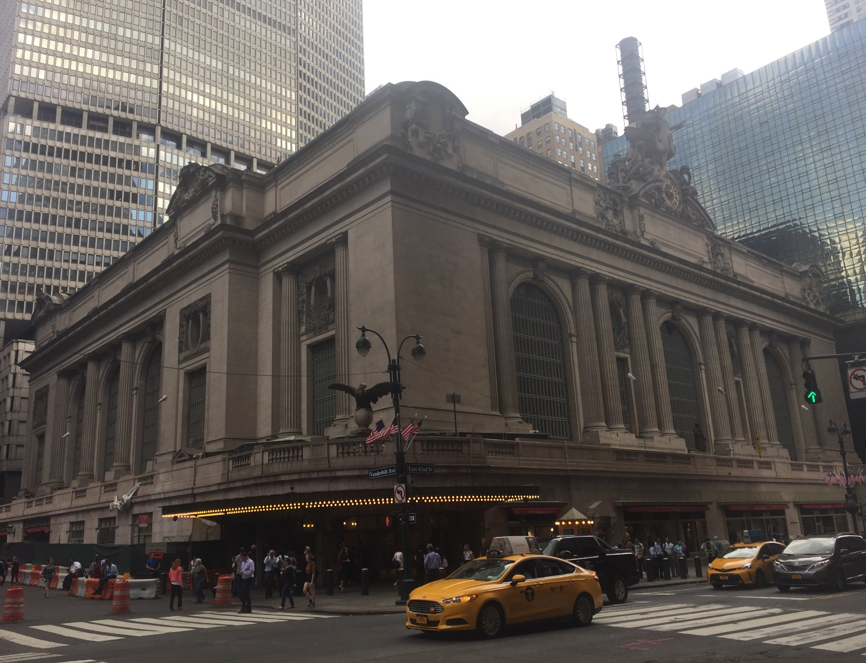
This is a picture of one of the many entrances to Grand Central Terminal, at the corner of 42nd and Vanderbilt Ave, and is one of the most recognized entrance to the Terminal. This is important because it is recognized all over the world and is a big tourist attraction in New York City.

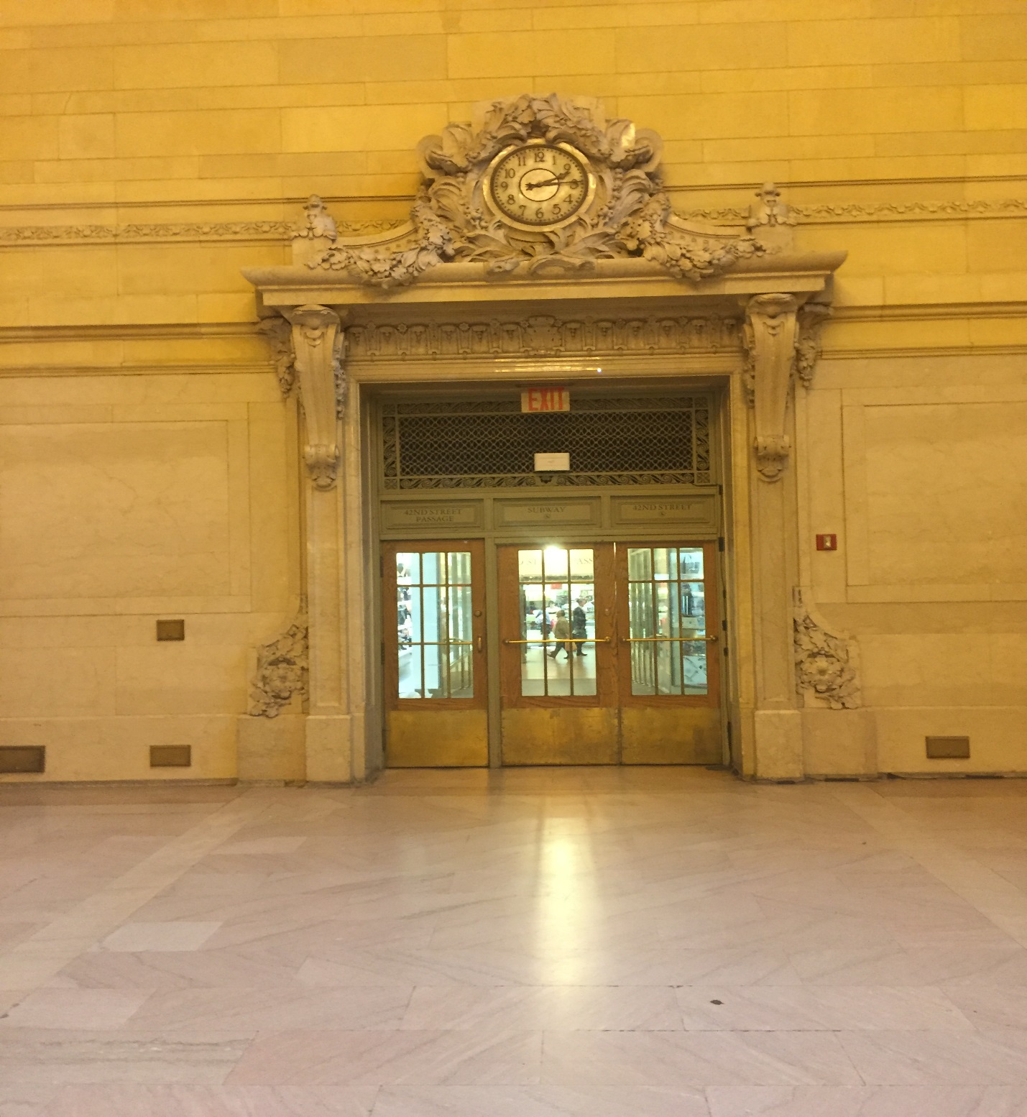
This is a picture of an exit, or entrance depending on how look at it, inside Vanderbilt Hall. I chose this as one of my pictures because of the pathways beauty and inviting nature. You can see around the doorway the patterns of acorn and oak leaf clusters. Also, as I mentioned, the inviting nature of the doorway which isn’t intimidating at all. This is because of the glass on the doors that allows you to see exactly what is happening on the other side.
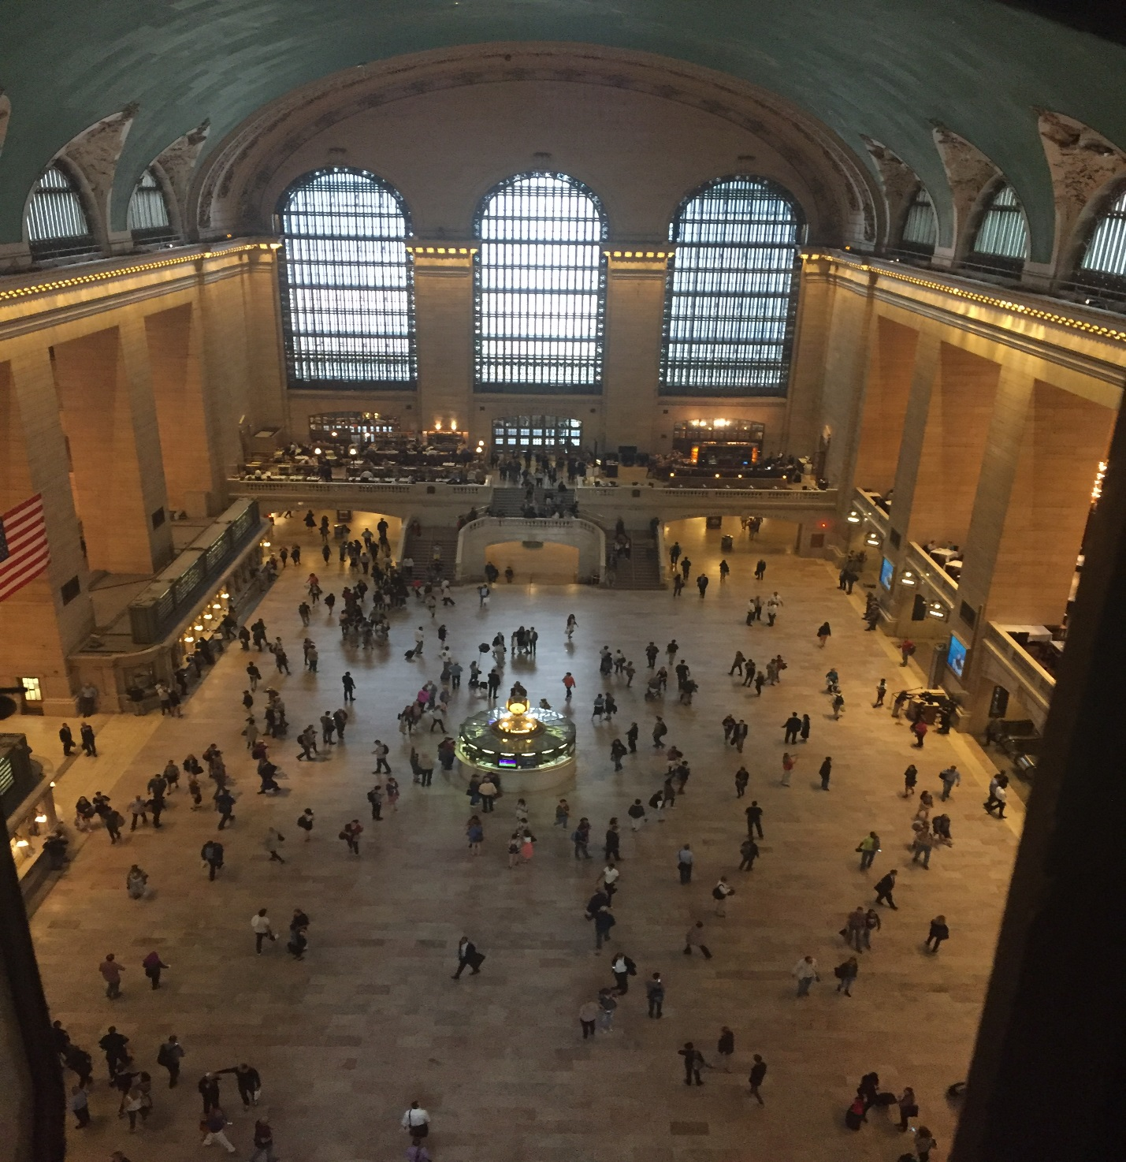This picture is one of the most impressive that I’ve had from all my site visits because of my placement in the building. This view is from the catwalk that is about 110 feet above the main concourse, it shows almost all of the concourse from the entrance and giant windows above it and the information desk in the middle of the room. This was an important picture to add because it is not every day that you are able to go up there and see this amazing view. It was a special experience that I felt needed to be displayed.
SITE DOCUMENTATION (sketches) 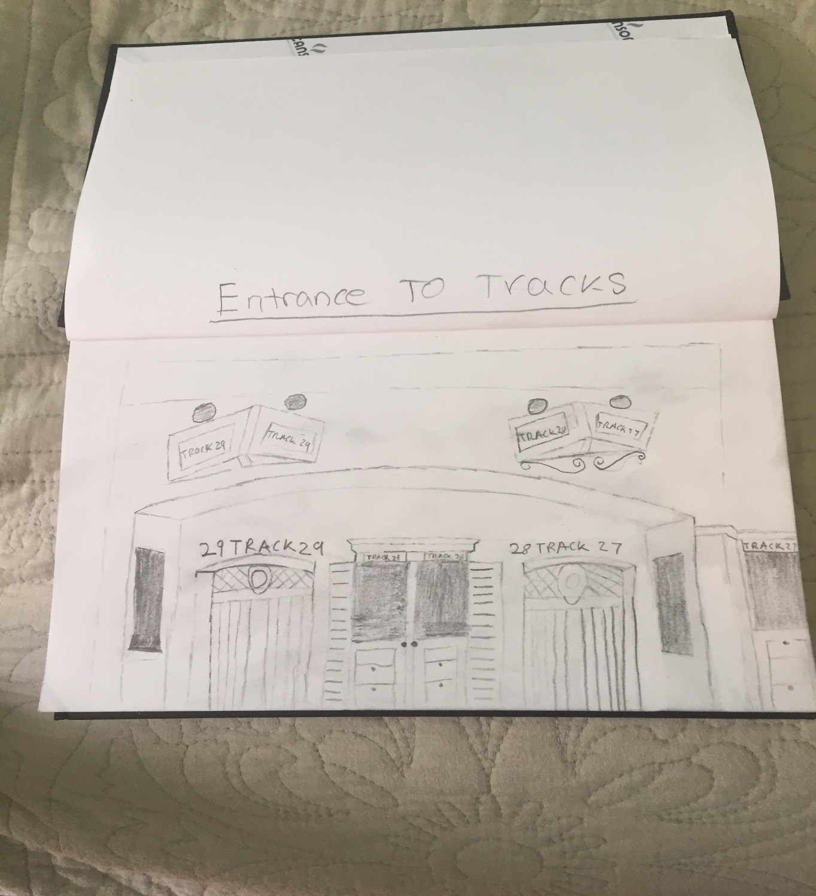
This is a sketch of the picture I took above of the train track entrances, I thought it was important to sketch this picture do the viewer could recognize what is in the sketch.

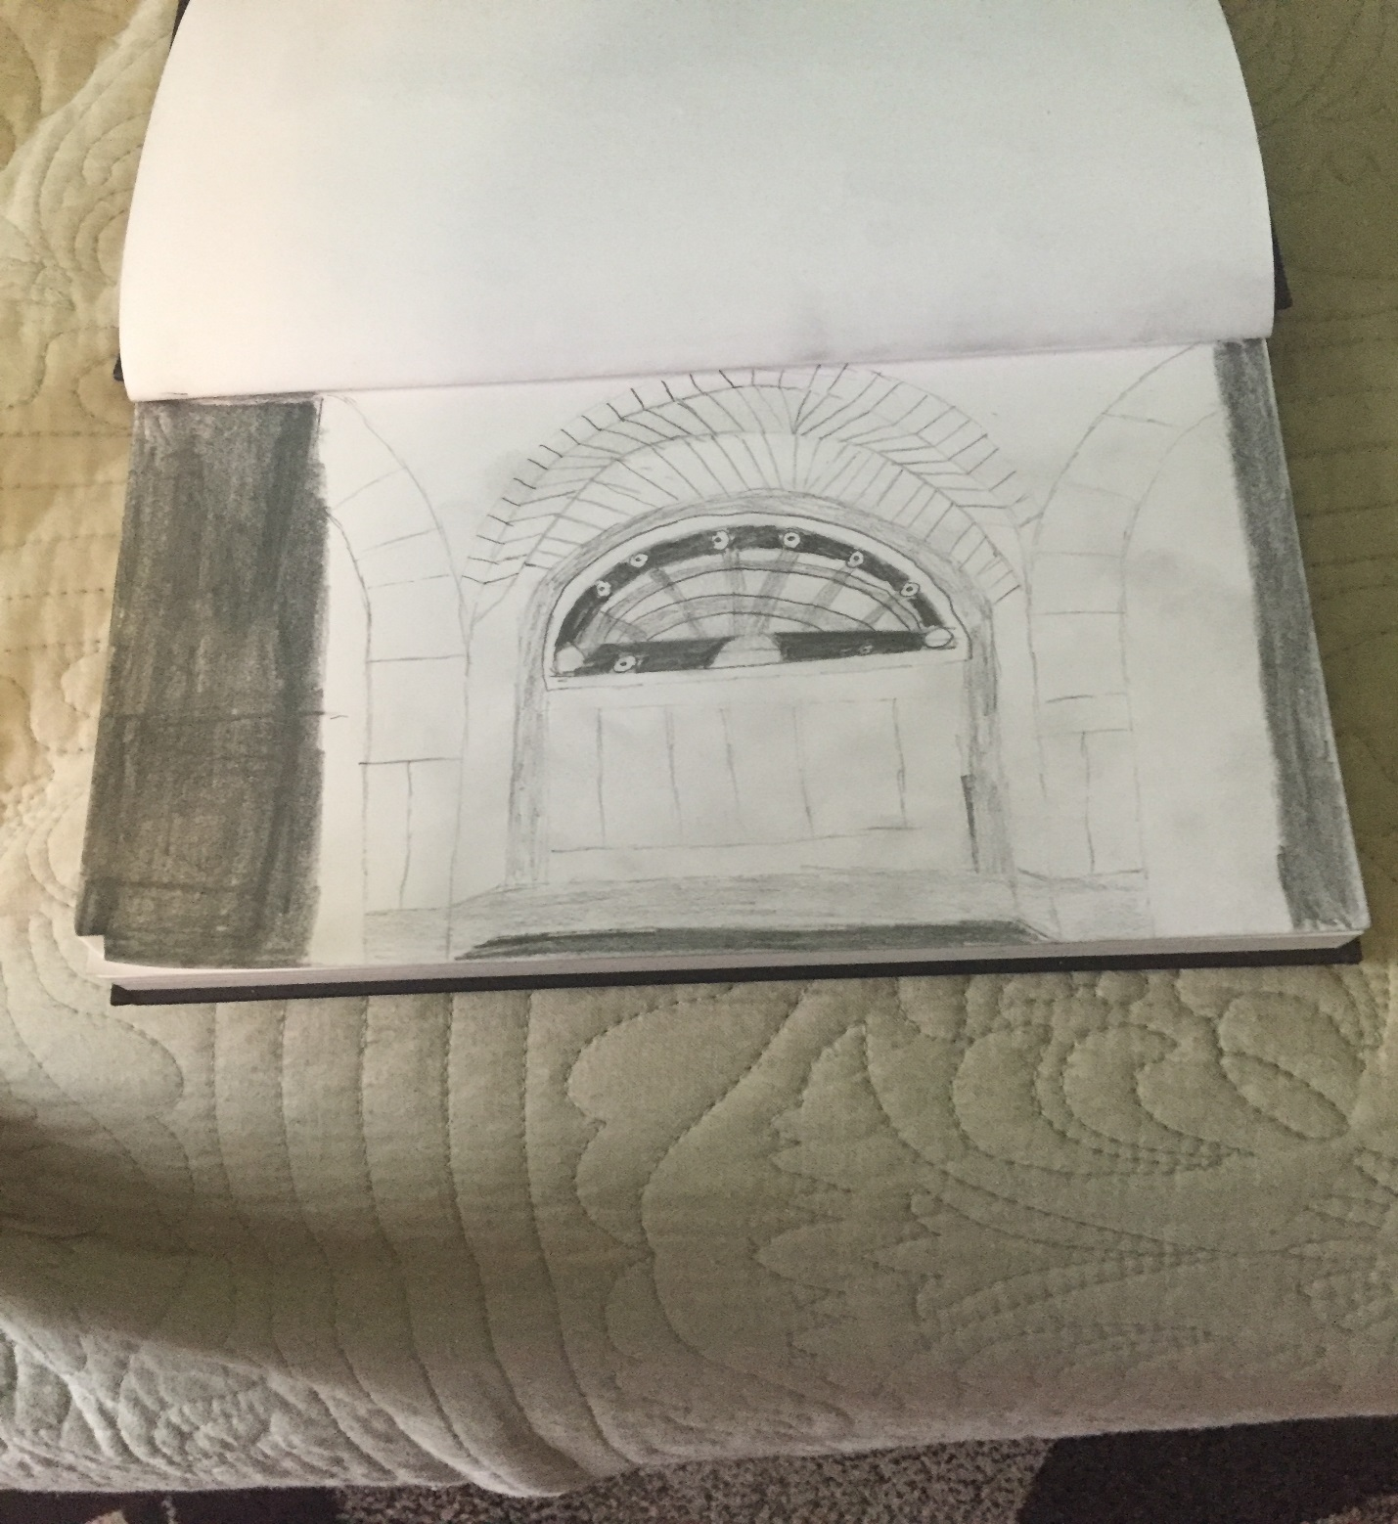
I did the same thing here as I did in my previous sketch, I drew a picture that I took and I shared both in the site report you I could show the viewer what I was drawing.

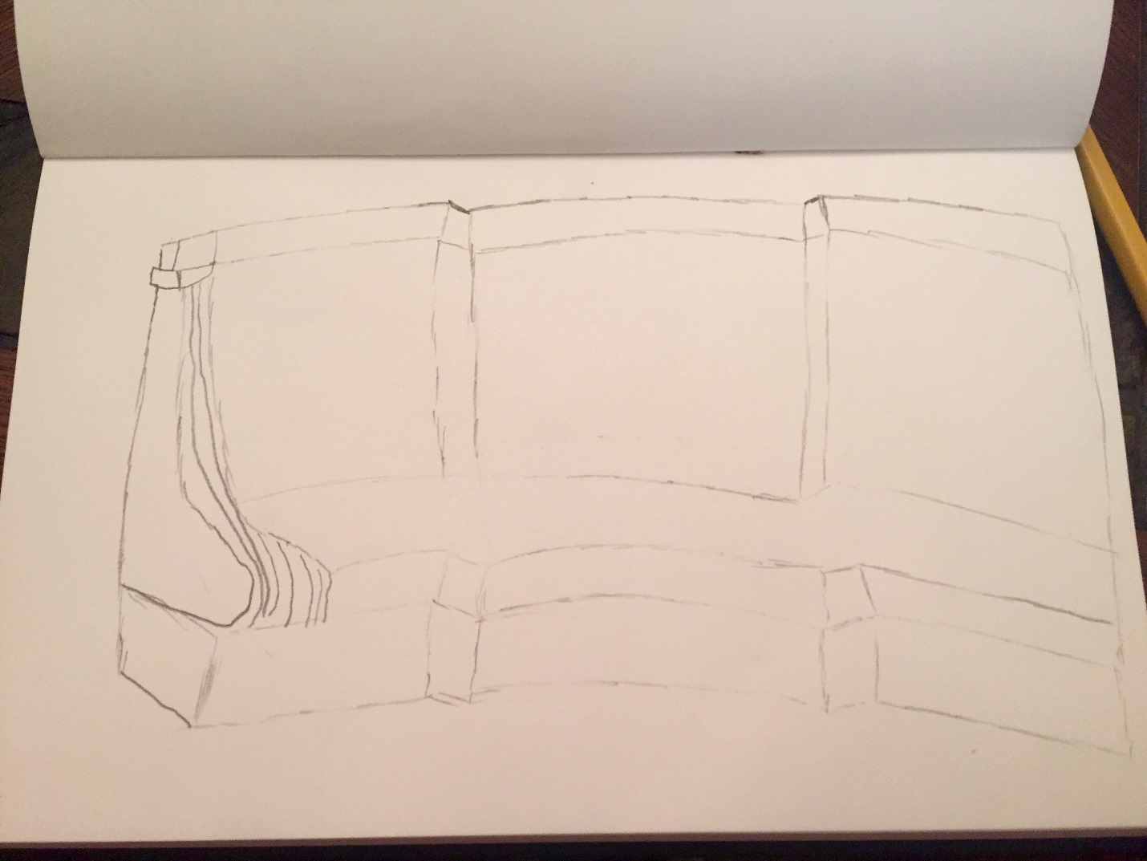

Although it might be difficult to tell, this is a sketch of the benches in Vanderbilt Hall, the only ones left on the far right corner of the room. It was important for me to sketch these because they are the only benches remaining in these huge room which, as the tour guide explained, was once full of them. These benches not only held people waiting for trains but also for a period of time help the homeless.

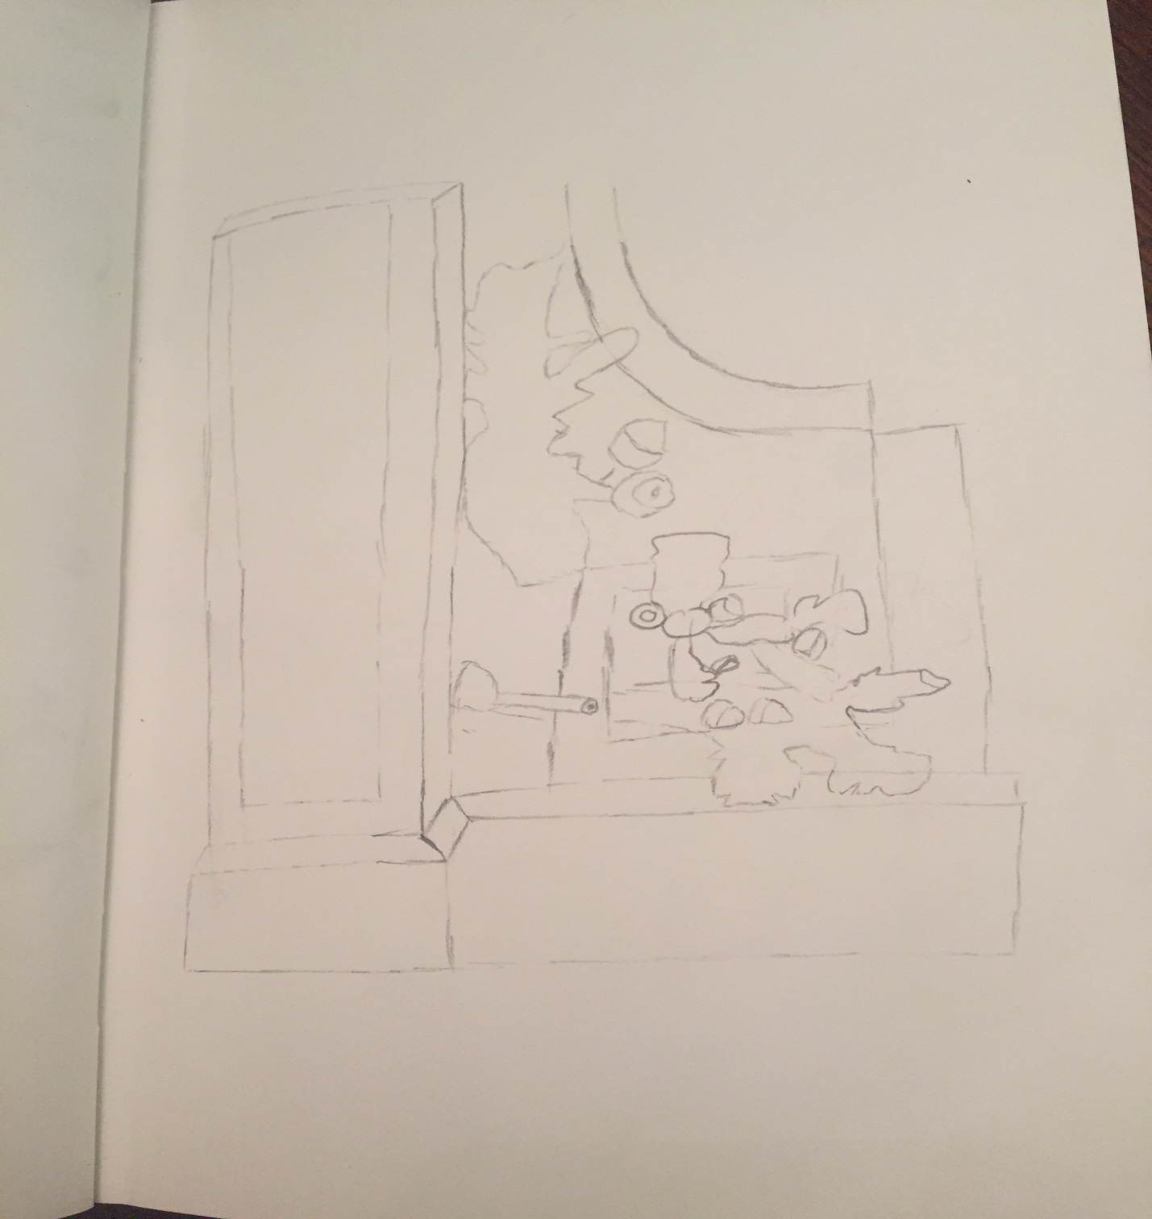

This is a sketch of the acorn and oak leaf cluster that is engraved throughout Grand Central Terminal, on doorways, clocks and other places. This is a symbol that is associated with the Vanderbilt family that funded the construction of this building. I found it important to sketch this because it is in so many places in the terminal and it has such big symbolic meaning.

GENERAL NOTES:
- Grand Central Terminal was finished in 1913.
- The building is styled in a neo-classical way with steel frames running through it.
- Vanderbilt hall is no longer open to the public and rather is used sparingly for art exhibits and events.
- Over 750,000 people go through Grand Central each day.
- From 1996-1998 Grand Central Terminal was repainted and cleaned because of the large amount of smoke damage that had happened.
- In 1967 the terminal was in danger of being torn down like Penn Station was.
- Grand Central Terminal had a big design flaw, the ceiling in the main concourse is upside down.
- There is a secret staircase inside the Information booth.

INSIGHTS/DISCOVERIES
This second site visit was made even better than the first one for a couple of reasons, we were able to go up to the catwalk, which wouldn’t be normally possible, and were told that the cat walks are used for both maintenance and for people to from one office building to the other. Also the tour guide made it extremely interesting by teaching us things that most people wouldn’t know. Some of my personal insights and things that I found fascinating are the multiple secrets that the tour guide told us about. Like the secret staircase inside the information booth or the fact that there is a secret train track that was built only for FDR who had polio. This track lead him straight to his hotel and would only be used when the president was in town. Also the huge flaw that was made when building Grand Central, the ceiling being backwards but I think, what will be the most helpful comment that the guide said, if I ever take a train at Grand Central, is that the times on the departure board are wrong. All the trains leave one minute ahead of what the board says. This is no accident, it is done so people won’t rush to the train and potentially get hurt. All these things together made me so much more knowledgeable in Grand Central.

KEYWORDS/VOCABULARY & DEFINITIONS
Tripartite: in terms of architecture this is used when a building or a part of a building is divided into three parts.
Meridian Line: this was a term introduced by the tour guide when explaining the ceiling in the main concourse, it means the imaginary line that surrounds the earth, can also be thought of as the equator.
Panoramic Shot: is a picture that is taken horizontally.

QUESTIONS for Further RESEARCH
- Was the whispering gallery an accident or made on purpose?
- How many reconstructions took place after the building was completed in 1913?
- How big is Grand Central Terminal compared to Grand Central Depot?
- Is the secret train track that was used for FDR still functional or even exist?
- Why was the black circle and rectangle not painted like the rest of the ceiling?
- How is Grand Central so efficient with their trains, having a 98% on time record?

