Learning Places Fall 2016
SITE REPORT #1

Grand Central Terminal Site Visit
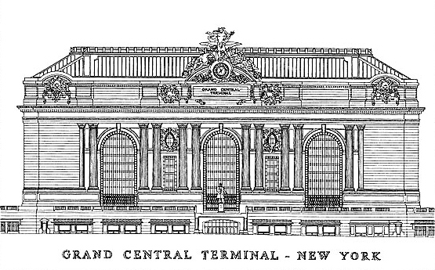

Sotir Zhupa
09.17.2016

INTRODUCTION
On Monday September 12th we visited the historical Grand Central Terminal. This was a trip intended to teach us not only about the history and the beauty of this magnificent building but also to capture the idea behind what kind of architecture and style was used to build it. As we walked around the terminal you can tell the precision and detail that was used in almost every part of the structure and I believe that is why it is so unique.

SITE DOCUMENTATION (photos)

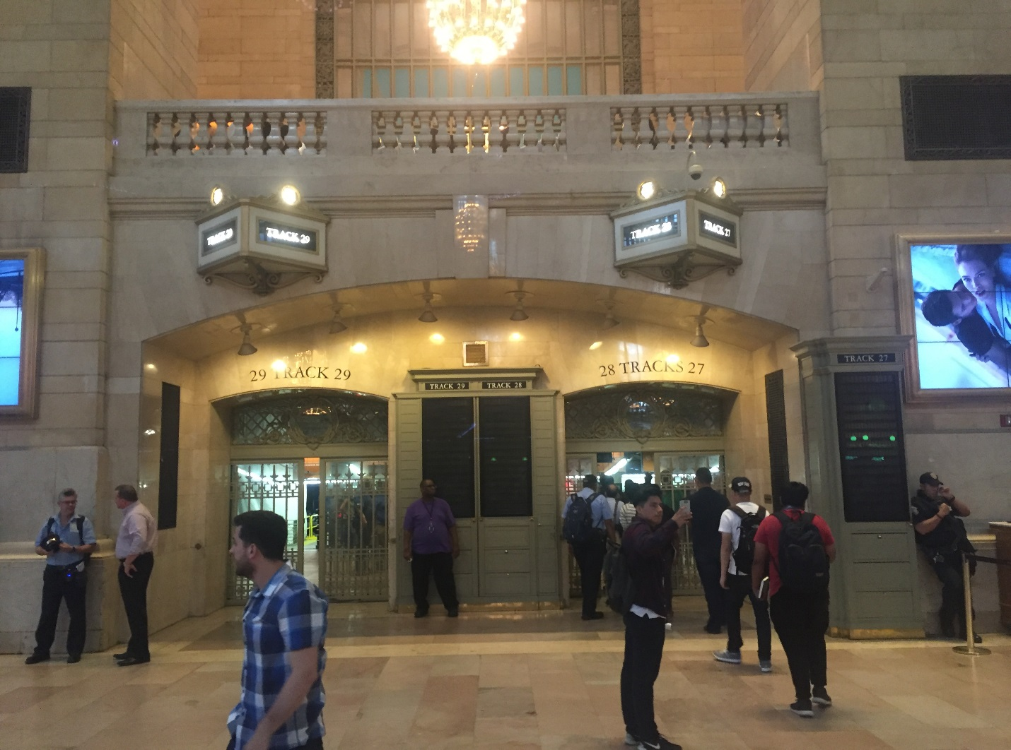

This is a photo of one of the many entrances to the tracks where you would be able to find the train so you can commute. This is an important picture because it can very clearly lead people to the track they would like to go whether it be track 1, 2, 29 etc. As you can see in the photo above there are many signs that say the track numbers and they are also very well lite making them easy to locate.

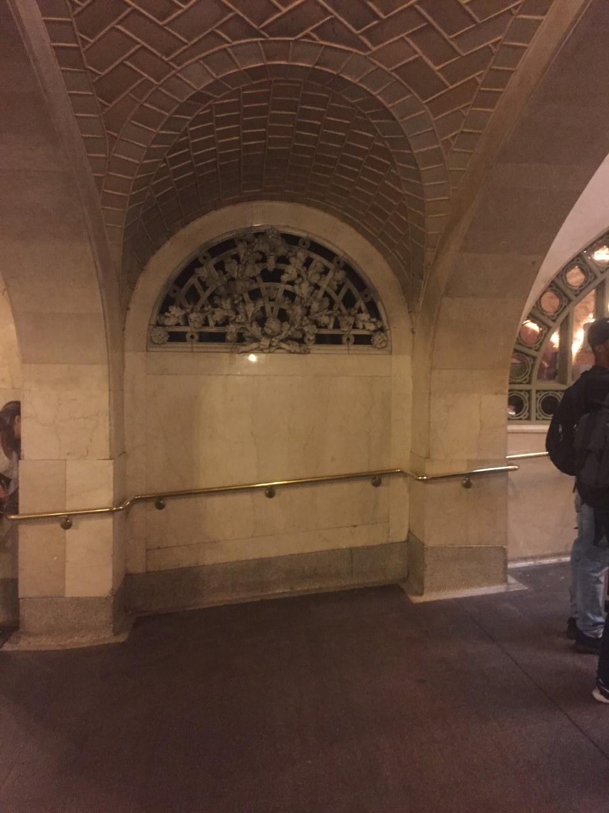

This is a photo of the whispering gallery, a hall in Grand Central Terminal, where you can go to one corner of the room and have a friend at the opposite corner and he can hear what you are whispering. I found this place extremely fascinating and that is why I chose it to include it in my site report.
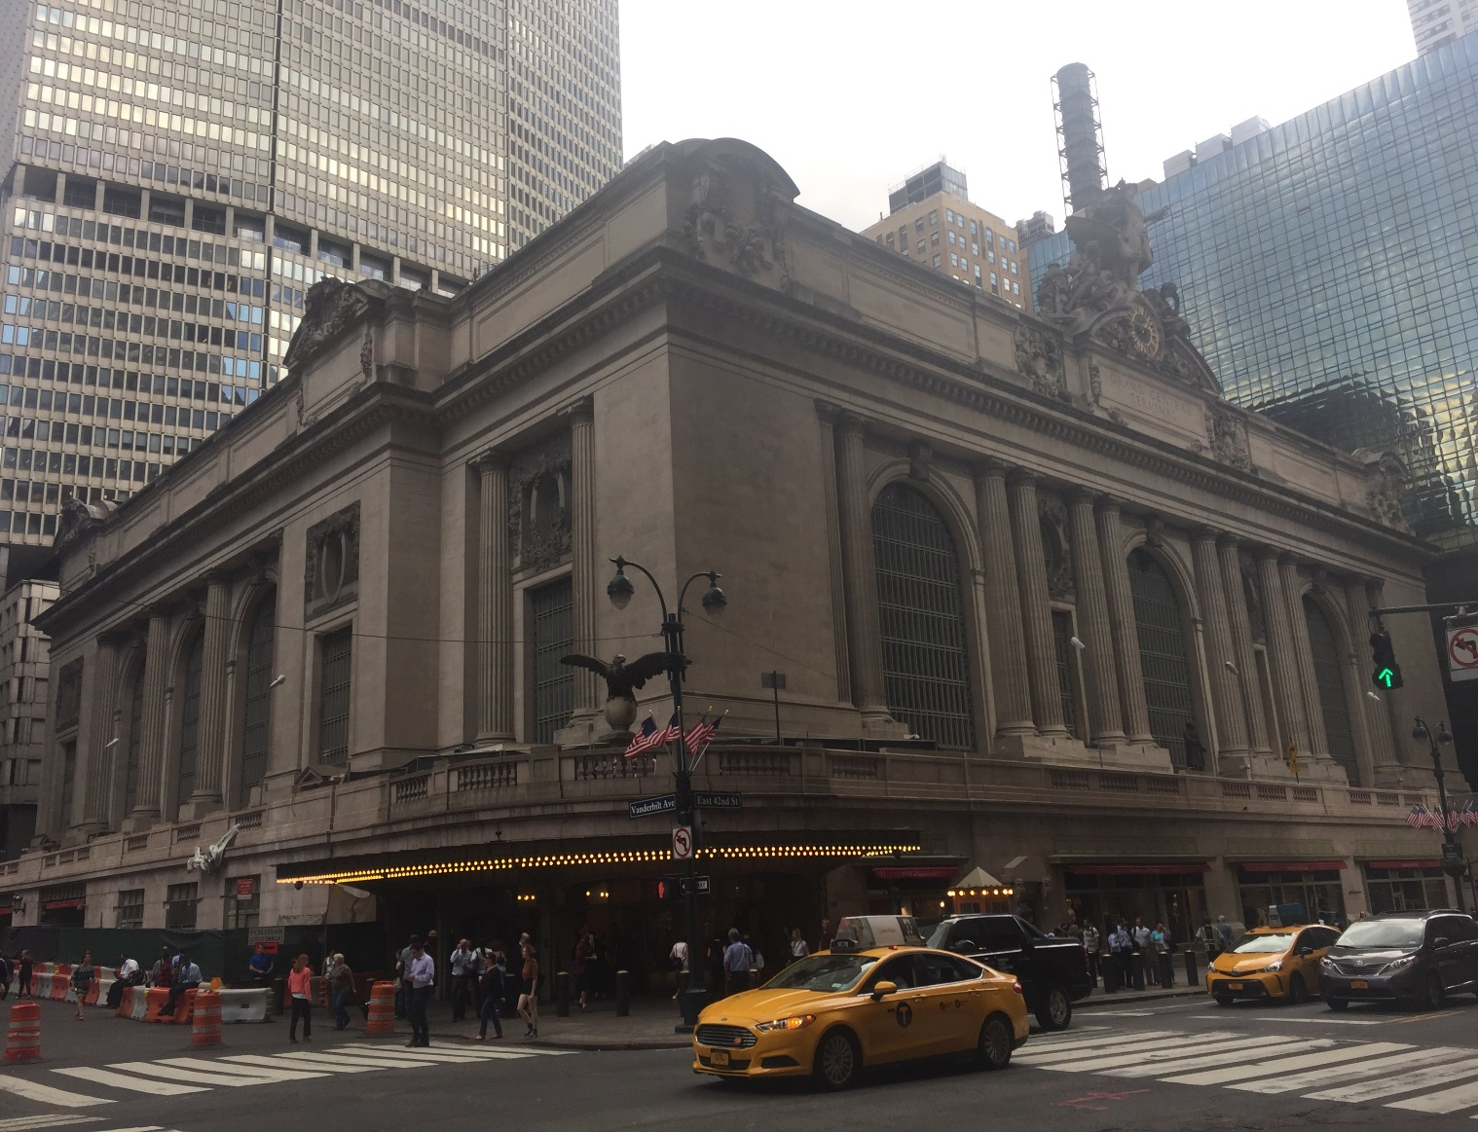

This is a picture of one of the many entrances to Grand Central Terminal, at the corner of 42nd and Vanderbilt Ave, and is one of the most recognized entrance to the Terminal. This is important because it is recognized all over the world and is a big tourist attraction in New York City.

SITE DOCUMENTATION (sketches) 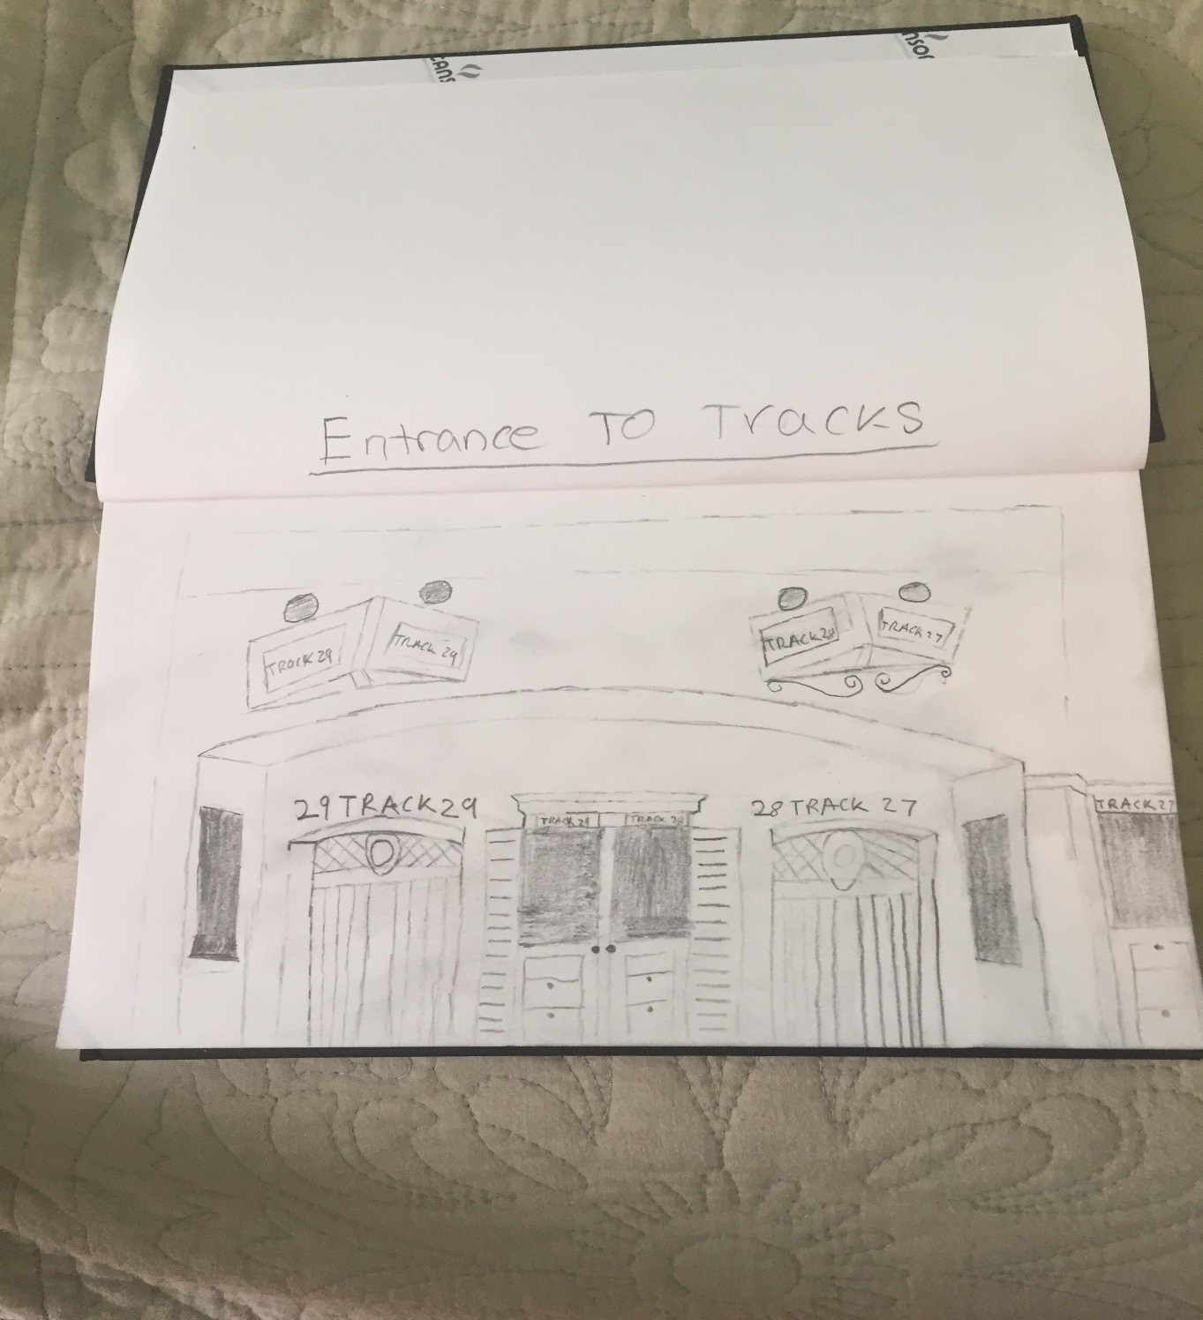
This is a sketch of the picture I took above of the track entrances, I thought it was important to sketch a picture that I thought was fairly easy and you could recognize what I was drawing.

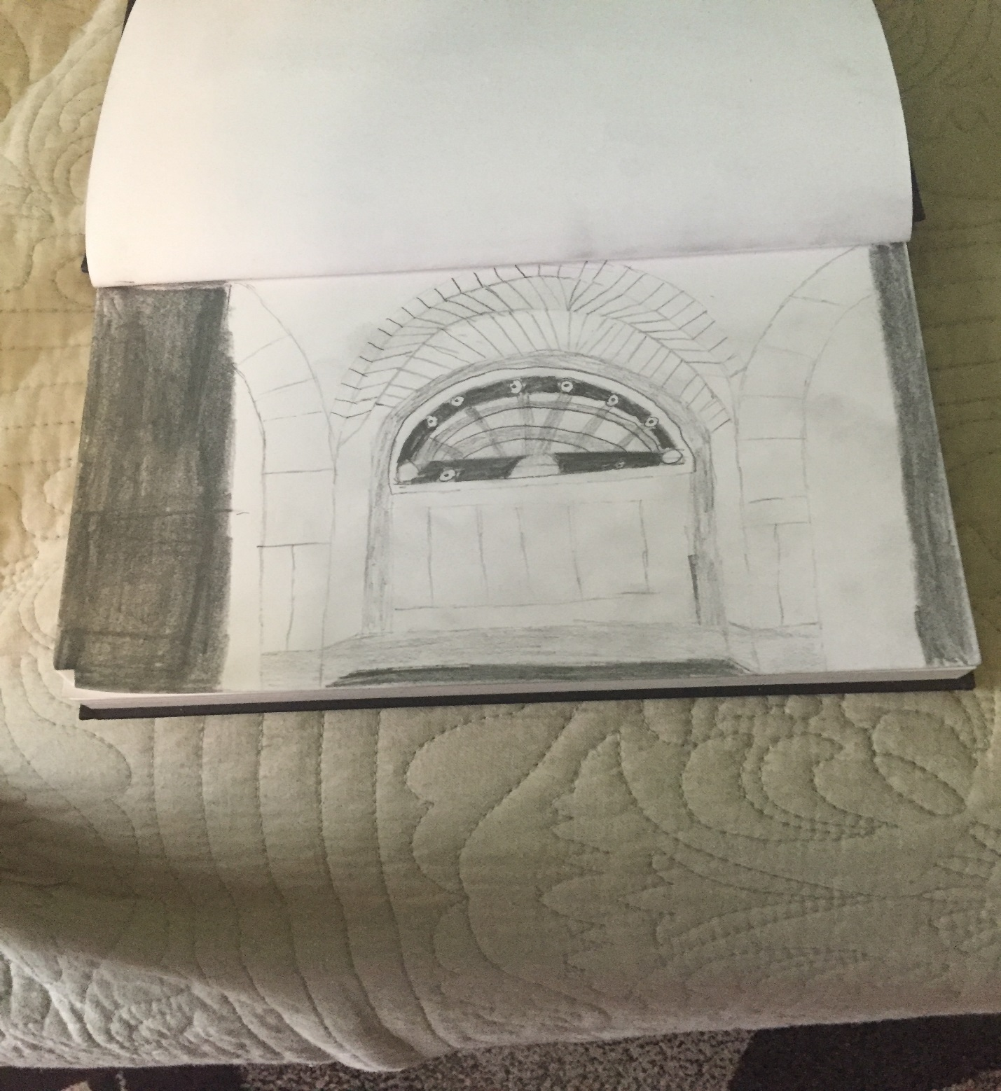
I did the same thing here as I did in my previous sketch, I drew a picture that I took and I shared both in the site report you I could show the viewer what I was drawing.

GENERAL NOTES:
- Grand Central Terminal was finished in 1913.
- The building is styled in a neo-classical way with steel frames running through it.
- Vanderbilt hall is no longer open to the public and rather is used sparingly for art exhibits and events.

INSIGHTS/DISCOVERIES
Some of the things I learned about during this site visit, and my first time at Grand Central Terminal, is how beautifully the building is laid out making different parts easily found and accessed. As opposed to its predecessor which was very cluttered this is much more spread out making commute easier for people. Also what impressed me when we were in the main concourse is how well lite, by natural light, it was because of the huge windows. I felt that even without electricity you would be able to see fairly well. One of my favorite parts of the building was the whispering gallery.

KEYWORDS/VOCABULARY & DEFINITIONS
Tripartite: in terms of architecture this is used when a building or a part of a building is divided into three parts.

QUESTIONS for Further RESEARCH
- Was the whispering gallery an accident or made on purpose?
- How many reconstructions took place after the building was completed in 1913?
- How big is Grand Central Terminal compared to Grand Central Depot?

