MAT D628-2071
Introduction to Proofs and Logic
Professor Reitz
Silvana, Danping, Jessie, and Franklin
Final Draft Group Paper
December 4, 2018

We were provided a puzzle in class, similar to a maze, that challenged us to find a solution by visiting all destinations (points). However, we were only allowed to cross each bridge once using the Bridges of Konigsberg. The problem was discovered by mathematician Leonhard Euler. He was wondering if there was a way to pass the Seven Bridges of Konigsberg only once. This is how the Seven Bridges of Konigsberg challenge came to be. When there was no solution to the Bridges of Konigsberg problem, he came up with a theory called the graph theory and explained why it was impossible to pass each bridge only once. There are four areas of the town; the river separates the areas and are connected by bridges.

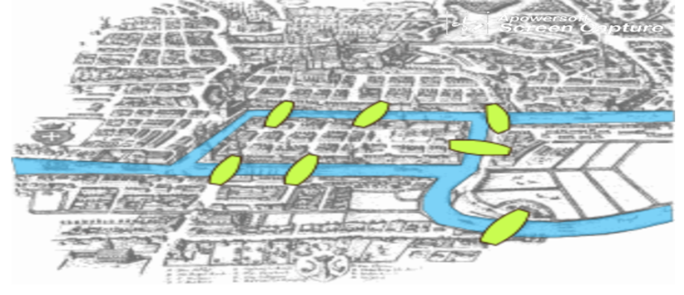

At first this puzzle looked fairly simple and not like a challenge at all. We tried many ways, like beginning from different points, to solve this puzzle. With all our tries and combinations, we found out that it was impossible to solve this puzzle. None of us were able to find a solution. This was frustrating because it felt as if we were making a mistake or somehow missing a step. However, although it was frustrating, it was also very interesting. It was interesting because it was impossible to pass through the bridges more than once. This allowed for us to open our minds and think of different possibilities. Then we came across some questions like, why is there no way in which one can walk through the city by crossing the bridge more than once? Before we can understand why there is no solution to the Bridges of Konigsberg problem, we have to understand Graph theory by constructing different walking tours.

We can simply think about each land mass as points (A, B, C, and D), and the bridges as continuous lines connecting the points. Some bridges pass through more than one point.

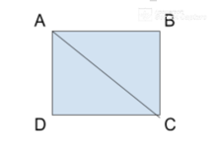
We created many different walking tours (puzzles), some with a solution and some without a solution. For the puzzles that have a solution, we noticed that if there were two points connected with three bridges and the other points are connected with even number of bridges, then the puzzle can be solved. From this, we formed a conjecture: For any puzzle, if there are only two points connected (to the rest of puzzle) with an odd number of bridges and the remaining points are connected with an even number of bridges, then the puzzle can be solved.

Our conjecture is a universal conditional statement. It guarantees any puzzle that satisfies the condition, then it must have at least one solution. There’s no constraint to the number of points and the number of bridges. However, we know it’s a fact that every puzzle must have at least two points and one bridge. Otherwise, there would be no walking tour!
Every point in a puzzle is connected with either an even or odd number of bridges. For example; in figure 1, point A and C are connected with 3 bridges (odd number). Points B and D are connected to the puzzle with only two bridges (even number).

In figure two, we can see that all the points are connected with 3 bridges (odd number). Our conjecture states only two points can be connected with an odd number of bridges for the puzzle to be solved. Also, in figure two, four points are connected with three bridges. Therefore, it does not fit the condition of our conjecture. Our conjecture cannot determine if it can be solved or not. Figure 1 only has two points connected to other points with odd number of bridges (3 bridges). Thus, figure 1 fits our conjecture perfectly. Then if our conjecture is true, we can find a solution for it. In fact, we did find a solution.
We first tried to use our conjecture to test some puzzles and see if we can find a counterexample to disprove it. In Open Lab #4, all of us can find a solution for G1-G3 puzzles but couldn’t find a solution for G4. So, we test those puzzles with our conjecture. G1 and G2 satisfies our condition, and they all can be solved. 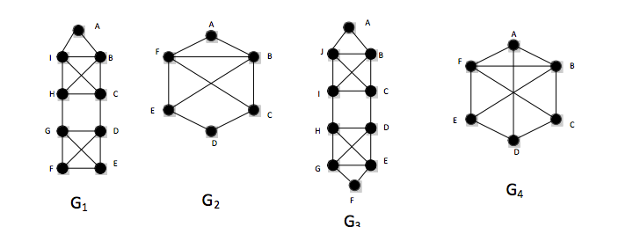

While trying to experiment with the conjectures conditions, Jessie came up with a complex puzzle. She started by building up from a simple puzzle, which had fit the conjecture. She was able to create multiple puzzles with the conditions of having only two points connected with odd bridges. After numerous successful attempts in solving the puzzles that fit the conjecture she believed the conjecture was true. Then she wanted to show that as long as the specifications of the conjecture were present, no matter how intricate the puzzle got, it can be solved. So, she created the puzzle below. When she initially presented the puzzle to the group, she thought she was able to disprove the conjecture since she couldn’t solve it herself. However, Danping was able to discover a solution after several attempts.
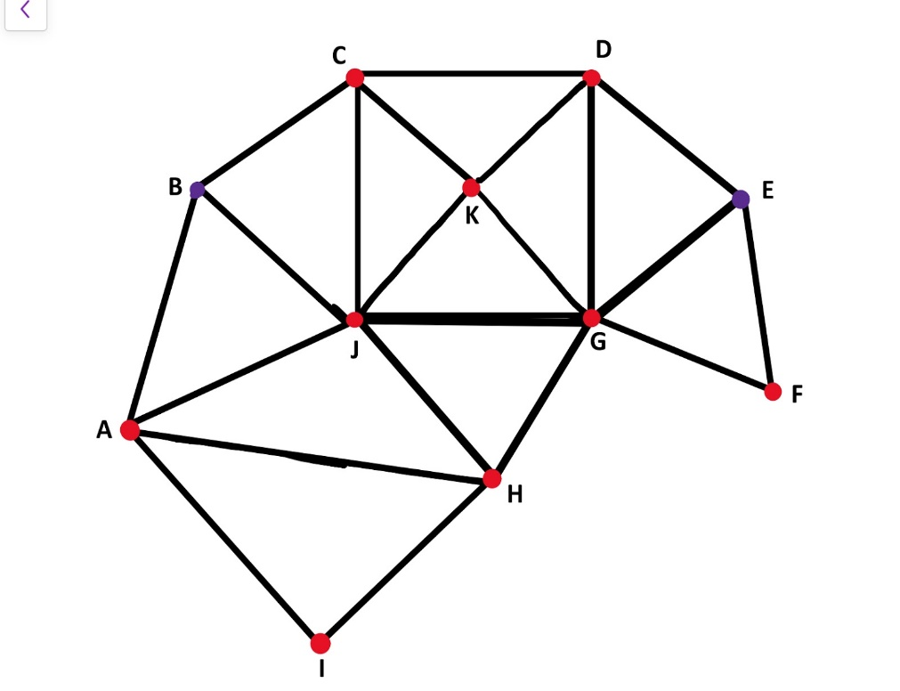
Solution: B-A-I-H-G-F-E-G-J-H-A-J-B-C-J-K-C-D-K-G-D-E
Then we tried to use the methods that we learned in class to prove it. Some methods that we learned in class for proofs are: direct proof, contrapositive proof, contradiction proof, and induction proof. Since the contrapositive of our conjecture is: If a puzzle has no solution, then there is one point, or more than two points connected to other points with odd number of bridges. It makes our conjecture much more difficult to prove, because “more than two points” can be infinitely many points, which is hard to prove. So we don’t think it’s a good idea to use the contrapositive method. After we thought about using induction proof. Since induction is used to prove natural numbers, we thought we could prove our conjecture, which works for a two-point puzzle, then it should also work for a three-point puzzle, four-point puzzle and so on. Although the number of points are natural numbers, the number of bridges in the puzzle are also natural numbers, and it’s unknown and without any rules. We do not know how to prove it. It seems extremely difficult. If we use the contradiction method to prove our conjecture then we must show that the puzzle has no solution, and it contradicts with our condition. As the professor said, contradiction can be used for any proof but it’s difficult compare to other methods. Direct proof is the first method that we learned in class. We think direct proof would be the best choice for our conjecture.
Since we always begin a proof with what we know, we begin with the condition part of our conjecture. However, we felt that it is not enough for proof. So, we consider to find some facts to support our proof. Some facts that may be helpful for proof are: First, every point is connected to other points with even or odd number of bridges. Second, each bridge is connected with two points. Third, when passing a point, there must be an enter bridge and exit bridge. Therefore, the points connected to other points, with an even number of bridges, can be either a starting point, ending point or a middle point. However, the points connected to other points with odd number of bridges must be either starting points or ending points. Although we believe our conjecture is true, we are not able to use what we learned so far to prove it.
The very first conjecture our group came up with was “ If there are only two points connected with an odd number of bridges, then the puzzle can be solved. ” However; after some confusion, revising, among other things, we were able to come up with our final conjecture, “For any puzzle, if there are only two points connected (to the rest of the puzzle) with an odd number of bridges and the remaining points are connected with an even number of bridges, then the puzzle can be solved.” At first, we were confused in what our conjecture truly meant. We were also not clear on how to word our conjecture to be able to clearly explain it to others. We used Figure 1, as a basic example to explain our conjecture. Then we used previous examples that we had done in class; like, G1, G2, G3 and G4. We found several examples that would satisfy our conjecture, so we tried to find an example that would not satisfy our conjecture. Jessie was able to come up with a puzzle that we were not able to solve for a while. However, Danping was able to find a solution to the puzzle Jessie provided. We used the methods we had previously learned in class to prove our conjecture. We thought that the best way to prove our conjecture would be by using direct proof, but we were not completely sure on how to prove it. We believe our conjecture to be true because of the puzzle we have completed. However, there are infinitely many puzzles, so we cannot be completely certain our conjecture is true.

