Rachel Gunther
Jess Topal
Aleksandar Valjan
12/04/2018
MAT 2071
Proof Process Paper
The puzzles that we worked on were based on the Bridges and Walking Tours problem. The puzzles were made up of different points connected by lines (bridges). To solve the puzzle, we had to pass over each line, but only once, without picking up our pencil. We soon noticed that not every puzzle is able to be solved, and were asked to come up with a conjecture about the puzzles in general and about what makes a puzzle solvable. Rachel’s conjecture was that a puzzle made of only squares could be solved, Aleks thought that for every number n squared, there will be an even number answer, and Jess believed that if a puzzle had more than two points with an odd number of connecting lines, then that puzzle was unable to be solved. We decided as a group that Jess’ conjecture was the strongest, as it was the closest tied to what we were learning in class (we had recently learned how to prove a conjecture using the definitions of odd and even) and seemed to have a more likely chance of being able to be proved. Since we felt that her conjecture seemed to be true, we went about proving so.
In order to start proving our conjecture, Jess looked back through the four puzzles that we had first seen in OpenLab #5; G1, G2, G3, and G4, as shown in Figure 1. Recall that G1, G2, and G3 have solutions, while G4 was unable to be solved. Jess assigned a number to each point in a puzzle that corresponded with how many connecting lines it had, and noted whether that number was even or odd. G1 and G2 had two odd numbered points, G3 had no odd numbered points, and G4 had four odd numbered points. This was good news for us, as it went along with our conjecture that puzzles with more than two odd numbered points could not be solved — G4 had more than two odd numbered points and could not be solved. She then went through the puzzle submissions in the comments to the OpenLab assignment and tried to find any puzzles that fit our conjecture. One such puzzle was created by Rachel. It was shaped like peace sign and had five points, four of which were odd numbered, and we were unable to find a solution for it. This puzzle was actually one that Jess had looked at when first creating the conjecture that a puzzle with more than two odd numbered points is unable to be solved. She e-mailed Rachel about the puzzle asking for a solution, and Rachel responded that there was no solution that she was able to come up with. Each time she tried to cross over each line without picking up her pencil, Rachel found that there was always one line that was unable to be crossed without passing over a line that had been crossed once already. When discussing in class, Aleks said that he had discovered the same thing; when looking back though the puzzles provided to us on OpenLab, the only puzzle that was unsolvable was the only one with more than two odd numbered points, and the rest were all able to be solved. This gave us more confidence in the validity of our conjecture.
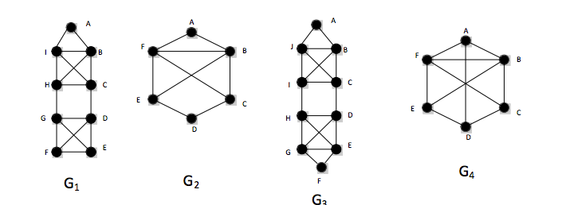
Figure 1
The next step in proving our conjecture was to modify any puzzles we found that were unsolvable in an attempt to find a solution. To do this, we added or subtracted lines from the puzzles where there were an odd number of connecting lines to reduce the amount of odd numbered points to two or less. If we add one more line to puzzle G4, we notice that the number of connection points for C and E changes from an odd to an even number. Then, the G4 puzzle becomes solvable. Also, we subtracted the middle line and observed that the number of connection points for A and D changed from an odd number to an even number (Check out this sketch in Figure 2). Then, we tried the same thing with the bridge connection points. All the bridge connection points are odd numbers, but if we add one more line from A to B, we notice that A and B change to even numbers. By subtracting the line between C and D, we observed that C and D turned into even numbers. As a result, we saw that when we subtract or add, both puzzles become solvable. We tried subtracting and adding with the other couple of puzzles that had more than two odd numbers and found that when we subtract or add, the odd number changes to an even number (Check out this sketch in Figure 3). Figures 2 and 3 are from Jess’s notes which she shared with the group in class.
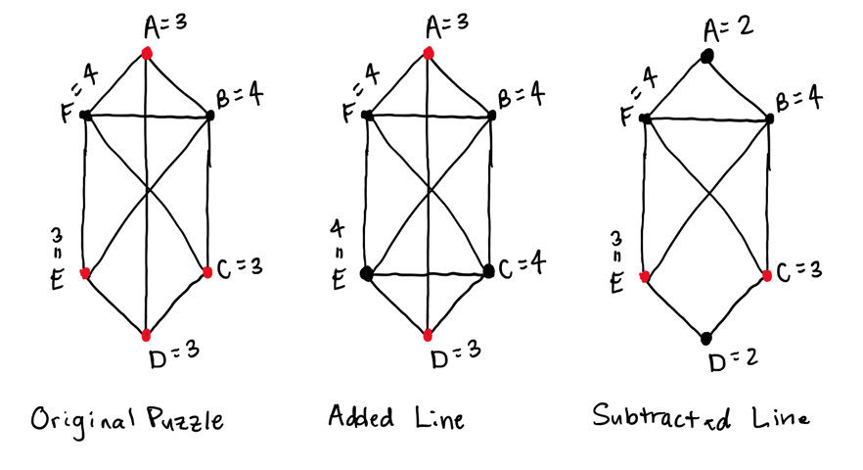
Figure 2
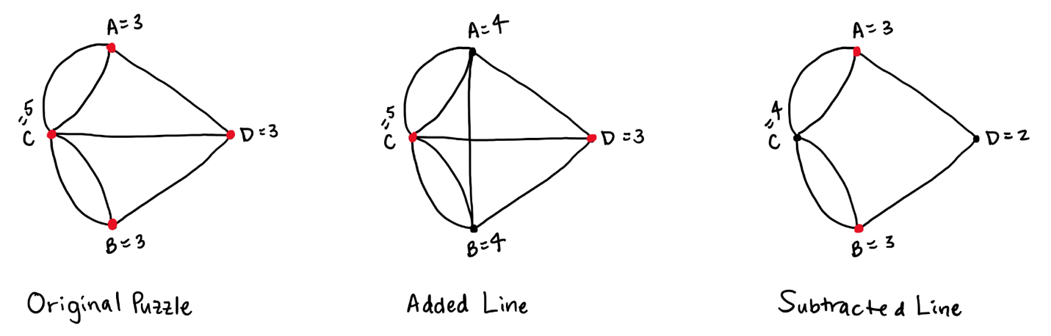
Figure 3
Rachel also decided that it might be worthwhile to try to disprove our conjecture. We thought about what we did in class when a proposition asked us to prove something like 3x/=9, and all we would have to write is “consider the integer 3” in order to disprove the conjecture. Similarly, Rachel tried to come up with a puzzle that would go against our conjecture, thus disproving it. We did this in three ways. The first way was to sit down and attempt to draw a puzzle from scratch that would have more than two points with an odd number of connecting lines that was able to be solved. This was possibly one of the most frustrating stages. It is difficult enough to sit down and create a puzzle such as these out of nothing, but it was even more difficult trying to create an original puzzle under such a specific set of rules. There was a lot of starting a puzzle and erasing, or starting a puzzle then immediately crossing it out. After some time of doing this, it was decided that it was either impossible (which would prove our conjecture) or at least extremely difficult, as Rachel was unable to come up with any that could be solved. The second way to disprove our conjecture was to take an existing puzzle, one that we already knew could be solved, and add enough lines so that there were more than two points with an odd number of connecting lines, and still be able to solve the puzzle. The third way to disprove our conjecture was similar to the third where we used existing solvable puzzles, only instead of adding lines, we tried taking lines away to get more than two points with an odd number of connecting lines and solve the resulting puzzle. Both the second and third ways ended up being just as fruitless as the first, and we were unable to disprove our conjecture based on everything that we tried. The problem we ran into was that while we were unable to come up with our own puzzles that went against our conjecture, we could not say with one hundred percent certainty that such a puzzle did not exist. It was possible that there was a solvable puzzle with more than two points with an odd number of connecting lines that we simply did not think of. While not being able to disprove our conjecture was not in itself a means of proving our conjecture, it helped Rachel to solidify her belief that our statement was in fact true. We discussed this as a group in class and noticed that while we still couldn’t find anything to prove our conjecture, we hadn’t found anything that would point to it not being true.
Overall, we found the process of proving our conjecture to be both interesting and frustrating. Interesting because it required more creativity than the proofs that we had been completing in class. Frustrating for that very same reason. The proofs that we did in class had a set way to be done and a set of definitions that could be used to help, but it was unclear how we could use them in proving our conjecture. We had utilized the definition of odd and even in counting the number of lines in puzzles, but was there a way for us to use the definition of divides? But this, again, is also what made trying to prove our conjecture fun and rewarding. Each time we made progress in proving our statement true was exciting. It was also helpful in understanding all that we were learning in class about proofs, as the puzzles were more visual than a statement such as “if a|4 and b|4, then ab|4.”
While our efforts as a group were unable to definitively prove that our conjecture is true, we strongly believe that any puzzle with more than two points with an odd number of connecting lines cannot be solved. As far as we have been able to tell through sharing our individual work in class, each puzzle with more than two odd numbered points has been unsolvable and each puzzle with two or less has been solvable. If our conjecture is true, it should make solving these puzzles easier in that we wouldn’t have to bother spending time trying to solve a puzzle that we already know is not able to be solved. We are still searching for a new way to go about proving this statement, but believe that the work we have done has helped to show that it is true.

