Math 2071 Introduction to Proofs and Logic, Section D638
Professor Reitz
Group Paper
Samantha Cottoy, Federico Chavez, Yvan Gohourou
November 16, 2018
“Decide whether it is possible to create a walking tour crossing each bridge exactly once”, these are the magic words that started it all. We began with an image of the king’s mountain location (Figure A). There were four landmasses connected through bridges. The problem challenges the reader to try and create a plan that directs them to visit all the points or destinations in the photo while passing over a bridge only one time. This problem looked simple at first. We all tried to solve the puzzle, and the more and more we tried to solve it, the more challenging part of the problem was identified. We all identified that the problem has no solution. As a group we also identified that the puzzle has a line bisecting it which made it very difficult to find a solution.
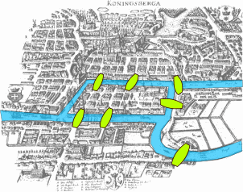Figure A. Is the king’s mountain land scape where 4 landmasses are connected by 7 bridges and came from the Openlab 5 assignment.
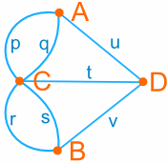Figure B. Is a simplified version of the kings mountain landscape where the points represent the landscape and the lines connecting to the dots represent the bridges. This was taken from the Openlab 5 assignment.

The steps we took to tackle the problem were that we reconstructed the image and made it into a graph to simplify what we were looking at (Figure B). We start at one dot and try to go over all the other solid lines or arcs and see if we can draw the image with only going over each line once. It may look easy, but it’s actually not that easy. Our initial thoughts about the problem were, “Alright just pick a spot, a random spot”, and see if we can come up with a solution. “Maybe the next starting location will work. No doesn’t work either”. There is no solution to this puzzle. Then we were given other puzzles that had solutions those were really fun to solve. That is when we created a conjecture that applied to all puzzles. The A team of, Samantha, Federico and Yvan came up with a few conjectures. Yvan came up with the conjecture 1- “It is impossible to find a solution in the king’s mountain puzzle”. Samantha came up with conjecture 2- “If the puzzle has a straight line going through the middle of it, then the puzzle has no solution”. Federico came up with conjecture 3- “A square in the puzzle makes the puzzle a lot easier unless there is a line bisecting another shape”. We started off by choosing what conjecture we felt we could prove true or false. We then decided on conjecture 2 was going to be the conjecture we worked on. We were absolutely confident about the conjecture and created lots of puzzles. Its actually worked for the puzzles we created. We thought we had a conjecture and we can prove it. Until Federico found a puzzle that has a line going through the middle and it had a solution, but it was difficult to find it. So, now our first conjecture was inaccurate because we found a solution for a puzzle that has a line going through it.
Professor Reitz came to our group and started questioning us about our conjecture. He made a good point when he said it’s unclear what we meant by “A line going through the middle of the puzzle.” Great just what we needed more complications. This is going to be more fun than we expected. So now we have a puzzle that goes against our conjecture by having a solution and we need to be specific about our conjecture. At this point we were laughing. It’s always fun having thought we completely have something all figured out and then realizing it’s not so easy. So we looked at it logically. We have two choices, start from scratch again or work with what we have and make the best out of our progress so far. So, we decided to just try to improve with our conjecture. But instead of making improvements right away we decided to find more puzzles were there was a solution and a line going through the middle. We found a couple of puzzle that didn’t work. What this told us was that our conjecture wasn’t a one-time thing. So that meant the puzzle we had come across wasn’t the one puzzle that disproved our conjecture. Strangely finding more puzzles that went against our conjecture was a relief we had disproven our conjecture, but we had more data to improve our conjecture. Through trial, error, lots of frustration and thinking we found out that all these puzzles we came up with had something in common.
We couldn’t put what we were thinking into words, so we decided to say the puzzles were all more difficult than other puzzles without a line. Instead of working on the conjecture again we decided to work with our puzzles again. We saw that although they had solutions, they also had one specific point where you had to start in order to solve the puzzles. This would be very important later on because it would be one of the things, we use to improve our conjecture. We stayed away from working on the conjecture in fear of it not working out again. Once we heard we didn’t have to prove the conjecture we came up with that was a relief. We relaxed felt more confident and gave it our all. We put our previous puzzles together to improve our conjecture. First off what does it mean to have a line going through the middle? We noticed that the puzzles we came up were difficult! Also we saw that some had no solutions. Putting all that together we came up with our updated version of conjecture 2. Conjecture 2 revised- “If the puzzle has a straight line bisecting the puzzle, then the puzzle is more difficult or has no solution.”
Figure C. Is a puzzle, created by Samantha Cottoy, which supports our conjecture and verifies that it is true.

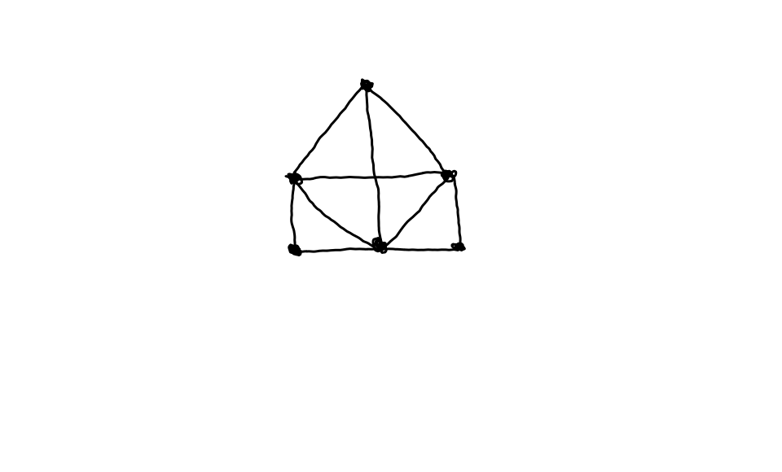
Figure D. Is Puzzle created by Federico Chavez Jr. where the puzzle was created but disproves our conjecture.
The puzzle above (Figure C) is a puzzle Samantha made for one of the open lab homework assignments, as you can see the puzzle has a line bisecting the puzzle. This puzzle has no solution. The puzzle that Federico remembered solving had a line bisecting the puzzle and it had a solution to it, but it was very difficult to find the solution (Figure D). Our first question we asked was how we define the word difficult in our conjecture. Through constant discussion we finally came up with a great definition that seemed to work. When the puzzle is “difficult” to solve that means the puzzle has 1or to 2 key starting points to come up with a solution or no solution at all. Other than having multiple solutions like other puzzles. In other words, it means that you can not start at any given point of the puzzle. In order to solve a difficult puzzle, there must be 2 or 1 key points to start the puzzle or you won’t reach a solution. When we tried to figure out our starting point for the difficult puzzles that have 1to 2 solutions. After the revision of our conjecture and going through trial and error with different puzzles we as a group proven our conjecture to be true. Below (Figure E.) is a puzzle that was drawn from a classmate and we tried to solve it. It was very difficult to solve and as a group we came up with no solutions. This puzzle helps prove our conjecture to be true which is exciting.

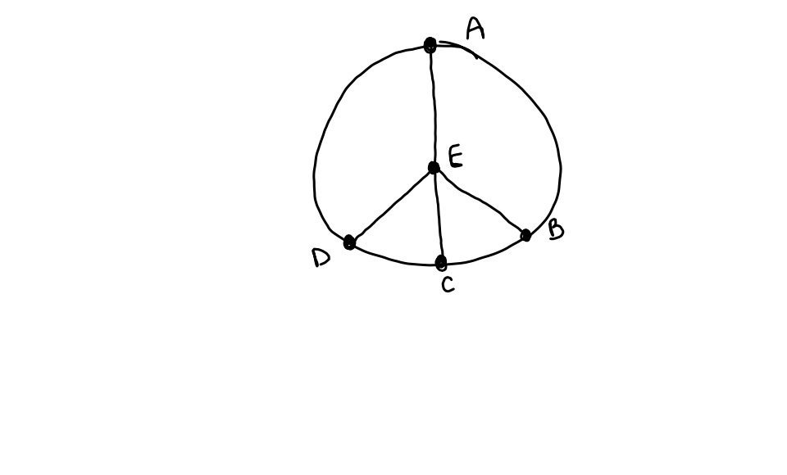
Figure E. Is a puzzle created by Rachel and we used it to help support our definition for difficult.
Now having multiple puzzles that are difficult to solve means we are one step closer to prove our conjecture. That is a lot of weight off our backs. So once we defined the word difficult, we thought that it would be appropriate to make a definition for an easy puzzle. To us an easy puzzle would be a puzzle where you can start from various different points or any point to come up with a solution. A couple of easy puzzles are (Figure F.) As you can see if you start on any place of the puzzle you can find a solution.

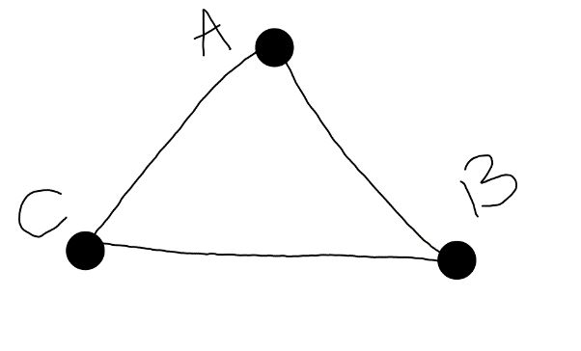
Figure F. Is a puzzle created by our group to support our definition of easy.
There is also the other puzzle we found (Figure G.) In this puzzle you can also start from any point of the puzzle and find a solution.
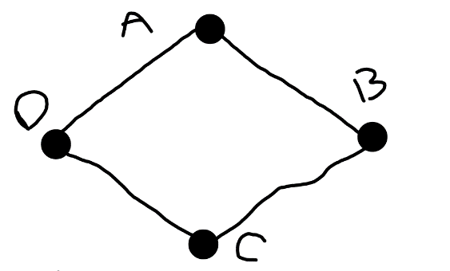
Figure G. Is another puzzle created by our group to support our definition of easy.
Now that we have a definition for both easy and difficult we felt relieved. So now comes the tricky part. Actually proving this conjecture. In class we learned how to construct proof in various ways. But to be honest it’s really difficult to say we are 100% sure this is proven. As a group we discussed whether we can prove our conjecture, “If the puzzle has a straight line bisecting the puzzle, then the puzzle is more difficult, where difficult means the puzzle has 1or to 2 key starting points to come up with a solution or no solution at all, or has no solution.” We came up with an answer for our conjecture and decided that we cannot fully prove this conjecture because there are an infinitely many amount of puzzles, we can come up with in the world and there might be an exception to our conjecture that proves it false. However our group agrees that our conjecture is true. Overall this assignment required a lot of team work and discussion of ideas. Our group has struggled and we have had lots of fun. Playing with the puzzles themselves was definitely the best part. Although we can’t fully prove our conjecture we can take pride and say to us our conjecture stands true from what we have shown.

