Evelyn, Miralia, Josvenia, Sonam
Fall Semester/ November 16, 2017/Proof and logic

Our conjecture is that for some puzzles there is only one specific way to solve it.

After we made our decision for our conjecture, we tried to find puzzles that proved our conjecture. At the beginning, we had some difficulties finding a puzzle that only had one unique solution. So we decided to start off with the puzzles that were given in our OpenLab Assignment #4.
The bridges and walking tour assignment helped us understand our conjecture and come up with a question that made our conjecture provable. This also gave us insight in what made a puzzle possible to solve and what didn’t. We were all given the chance to do these puzzles and to make some of our own puzzles, little did we know that we were going to piggy back off of our puzzles, the walking tour and make our own conjecture and puzzles that proved our conjecture. Sonam shared with us that, “the activity really made my brain muscles worked best as they can! I literally spent one hour to just finish the warm-up examples. I change my answers a few times. For example, I thought that #5, and #7 had no solution, but after I tried many different ways to cross the points. I found out one solution for #5. Then I thought if #5 has a solution then #7 must have a solution too. And finally I was able to solve #7 with the same technique I used for #5. I enjoy the process of solving these puzzles, it a very interesting thing to do. With what we learned so far, I personally think that this activity shows that when we try to solve a problem. If one way is not working, we should try another way to solve it. If still can’t find a solution, then it may have no solution at all. In another word, the goal of this activity is teach us a processes of thinking or reasoning”. Josvenia also mentioned, “I Loved this activity. I sat with my husband and we sketched so many possible puzzles and also try to solve the puzzles given. I think this relates to the class because many times we think there is only one way to prove a math problem but just like a puzzle where you can make a tour a, b, c, d and the same tour b, c, d, a. This is what will happen many times. In some cases, like the puzzles, there is just one way to prove the problems but other times there is endless ways to start the problem to get the same answer.” Lastly Miralia and Evelyn both stated how much they love puzzles and they could of continued working on them if given the chance. Like sonam and Josvenia mentioned in their comments on the walking tour there are sometimes many ways to solve a puzzles sometimes there is none and sometimes there is one possible solution. This assignment helped us continue our love for puzzles and make it into a conjecture but also take into account the puzzles given and the information provided from the assignment to see if we could prove our conjecture.
We continued our proof by trying to find a puzzle that proved our conjecture. We used class time to find puzzles that proved our conjecture. We found a couple of puzzles that proved our conjecture, which is a line, a circle with one point, or a puzzle that can become a line like an S or a V.
Our question for our conjecture was if there was a puzzle that isn’t a line or a circle that can be solved one way. Each one of us took our turns presenting to each other puzzles we were coming up with. One Saturday afternoon Josvenia shared some of the puzzles she had drawn up. 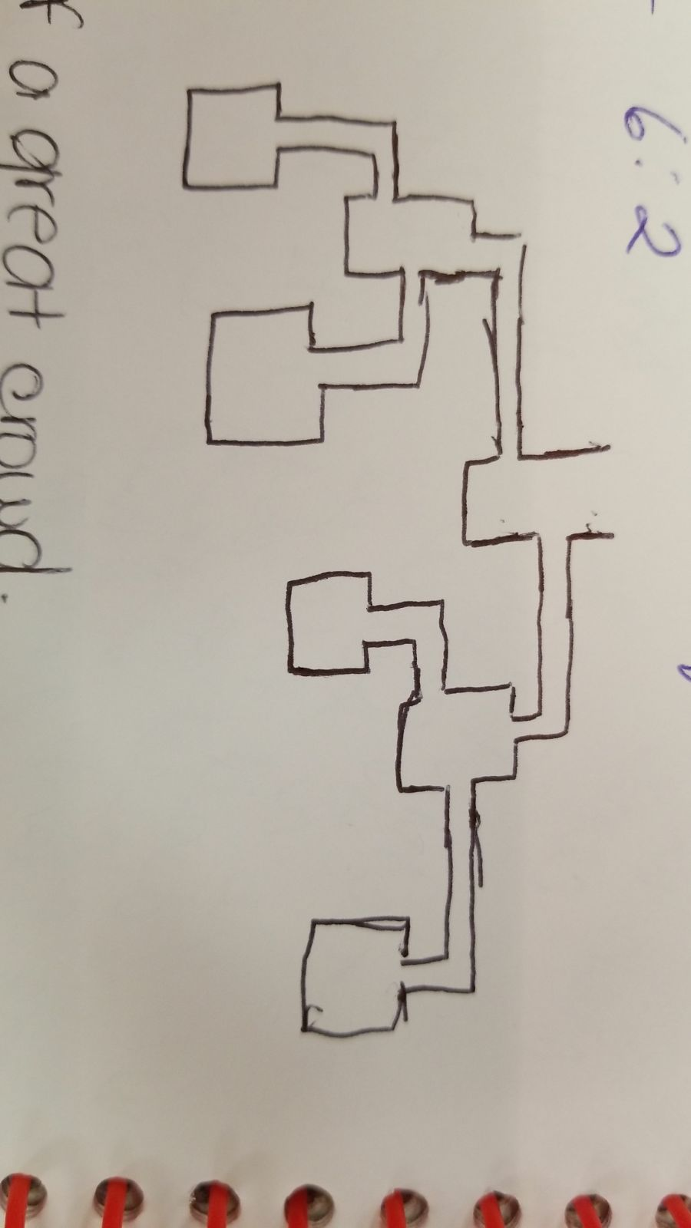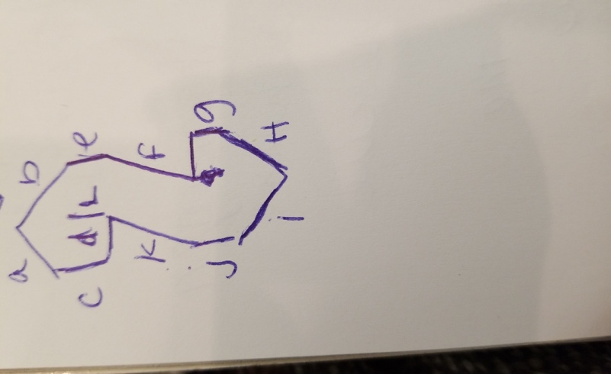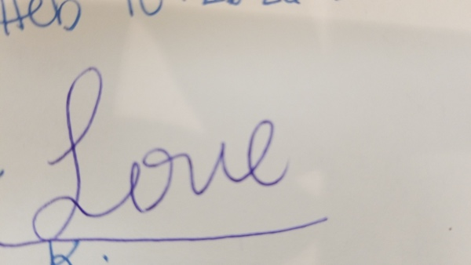
We tried to prove if the puzzles she shared worked. We noticed that 2 out of the 3 puzzles worked but only 2 of the 3 puzzles wasn’t a line. Evelyn also, spent 90 minutes coming up with puzzles that worked and didn’t work and making a list of how many ways the puzzles could work. Her experience coming up with the puzzles explains our experience when drawing and proving if the puzzle supported our conjecture or not. She states: For the 90 minutes, I attempted to make a chart of the different number of bridges and islands. The reason why I said attempted was because I thought I was getting somewhere with the different combinations but little did I know I was back to square one. Well it wasn’t all a failure, I did notice some things from creating different puzzles. On a separate sheet of paper, I created the different puzzles depending on the number of islands and the number of bridges. Everything was running smoothly, I thought I was developing a pattern. At first I thought that if the number of bridges was higher than the number of islands then we can assume that the possible will not be possible to solve. But I decided to go back to the beginning and recreate different puzzles for each row. After creating new puzzles, I realized that some of the new puzzles change my original solutions. Some of them went from impossible to possible and vice versa. So the pattern I thought I was developing quickly crumbled. It was frustrating to have to change my original conclusions but I’m trying to be optimistic about it. Hopefully my work will be useful in proving our conjecture.
We shared our ideas by what’s app which was a great form of communicating because we were able to share our puzzles, questions, conjecture, and prove if the puzzles we were giving worked. Sending pictures to each other helped each one of us understand how our conjecture worked. Since we were always sending photos of puzzles to each other, we were able to discuss hypothesis about our conjecture and answer the question that came about based on our conjecture. One proposition we agreed affected our conjecture and our question for the conjecture was that if you start with a point and are able to return to that point than you have a puzzle that has more than one solution. If we think about it, if we are given a puzzle that has points A, B, C, D from the moment you put your pen down to solve the puzzle, you shouldn’t pass to the point you already passed. So if you can puzzle the puzzle by going from A to C to B to D, then we shouldn’t be able to pass B or C or D again. This was an important proposition for our question because it meant that we no long just talking about bridges but that the points were effecting whether the conjecture had specific solution. So based on this we decided it was important to find puzzles that had points that you couldn’t return to.
During class we used the last 15 – 20 minute to draw as many puzzles as possible. We discovered that in order for us to come up with a puzzle that has only one unique solution, we must limit our choices of point to start with or lines to cross. So, we said how about if we drew a puzzle, in which the puzzle has only one line with two point at end of that line. After we draw that line, we found our first puzzle that proves our conjecture which is two point connected with one line. Then we add many points on that line, we got that it still has only one solution, because you can’t start at any points that not end point of the line. We conclude that if a puzzle has only one line, then this puzzle has only one solution.
Since if a puzzle has only one line then, it has only one solution. We thought we should try if a puzzle has only one point. So, we draw a circle, and on that circle we marked one point. We find out that you always have to come back to that point. Thus, we considered that this puzzle also proves our conjecture. Also we conclude that if a puzzle is just one point, then that puzzle has only one unique solution.
Our conjecture says, “some puzzles have one unique way to solve.” The conjecture is a true because the conjecture states some puzzle not all puzzles. Also as we can notice this proposition is an existential statement and we can prove that there exist some puzzles that have one procedure to solve. We have been working to find what kind of puzzles can prove our statement to be true. Therefore, we discover that are some puzzle that prove our statement which are a line, circle and anything with more than 2 lines not connecting. When we drew a line we realize that no matter how many points it has, it will always have one unique solution or specific way to solve the puzzle. Like-wise for a circle we discovered that a circle with one point has one special way to solve it. Although these two have proven that our statement is true, we also try to see beyond a circle or a line or a scripted words and letters. We drew other puzzles that we thought supported our statement, we discovered that some of those puzzles can be solved using our conjecture. However, there are also some conditions that are associated with our conjecture in order to prove them to be true. One condition is that if we are drawing a puzzle the point we started with, we should not go back to that same point because if we can go back the puzzle has a different way to be solve. The second condition we came up with was that each point should be touched/passed by once because if it this not the case then we can go back to any point more than once causing the puzzle to have more than one way for it to be solved.
Our group’s goal was to identify a puzzle that can only be solved in one unique way. In order to identify if a puzzle has one unique way of solving it, a path (solution) is only counted when the starting point and/or ending point is different. For example, if we have a square with points A, B, C, D. There are four different ways of solving this puzzle because we can start at four different starting points. We can start at A and solve the puzzle. As well as if we start at B, at C and at D. Therefore, this puzzle has four different solutions. We were curious to know if there existed a puzzle that had only one solution. For days, we played around creating different puzzles at home. At first we were simply just creating random puzzles and just attempting to solve them. Unfortunately, we weren’t getting anywhere, we just kept getting puzzles that had more than one way of solving it. We stopped creating puzzles and instead started analyzing each puzzle and taking notes of the different characteristics that each puzzle had.
After we spent some time analyzing the puzzles, we came to two conclusions. Our first conclusion was that if a puzzle was in a straight line, then it will only have one solution. It didn’t matter how many islands (points) or bridges it had, if the puzzle was in a straight line then it will only have one way of solving it. Our second conclusion was that if a circle (of any size) contained only one island then it will only have one way of solving it. After we concluded those statements, we were very eager to see if we can identify another characteristic. So we attempted to make the strangest puzzles that weren’t just a straight line and a circle.
One of the group members attempted to make a chart of the different possible ways of solving a puzzle. The chart consisted of four columns; the number of islands, the number of bridges, possible or not possible, and how many ways? The way she did her work process was by creating puzzles with a combination of different number of islands and different number of bridges. For example, if she was working with three islands, she created puzzles with only three islands but with a different number of bridges. So her puzzles contained only three islands but with either two bridges, or three bridges, or four bridges and so for. For each puzzle she created, she determined if it was possible to solve or not and if so, how many ways did it took to solve it. She continued this process for up to 6 islands. At first, she thought she was developing a pattern but when she went back to remake new puzzles for each row, she discovered that some of her answers were changing. Some of them went from possible to not possible and vice versa. And the number of ways to solve a puzzle was either increasing or decreasing as well. Unfortunately, she couldn’t come up with any pattern. 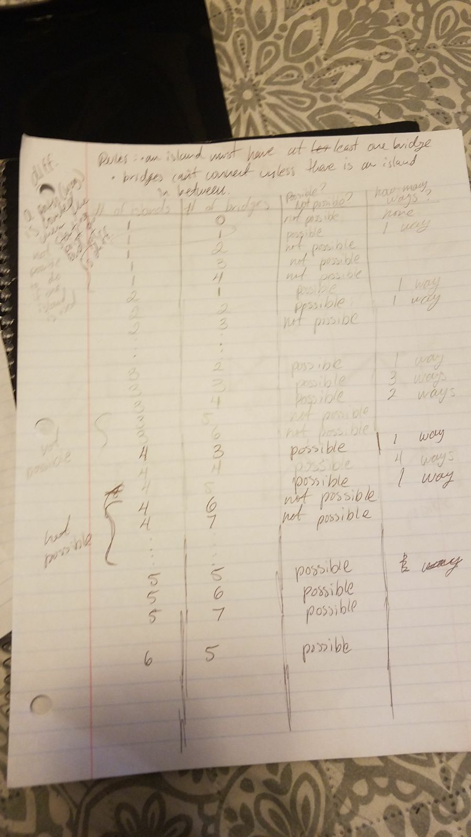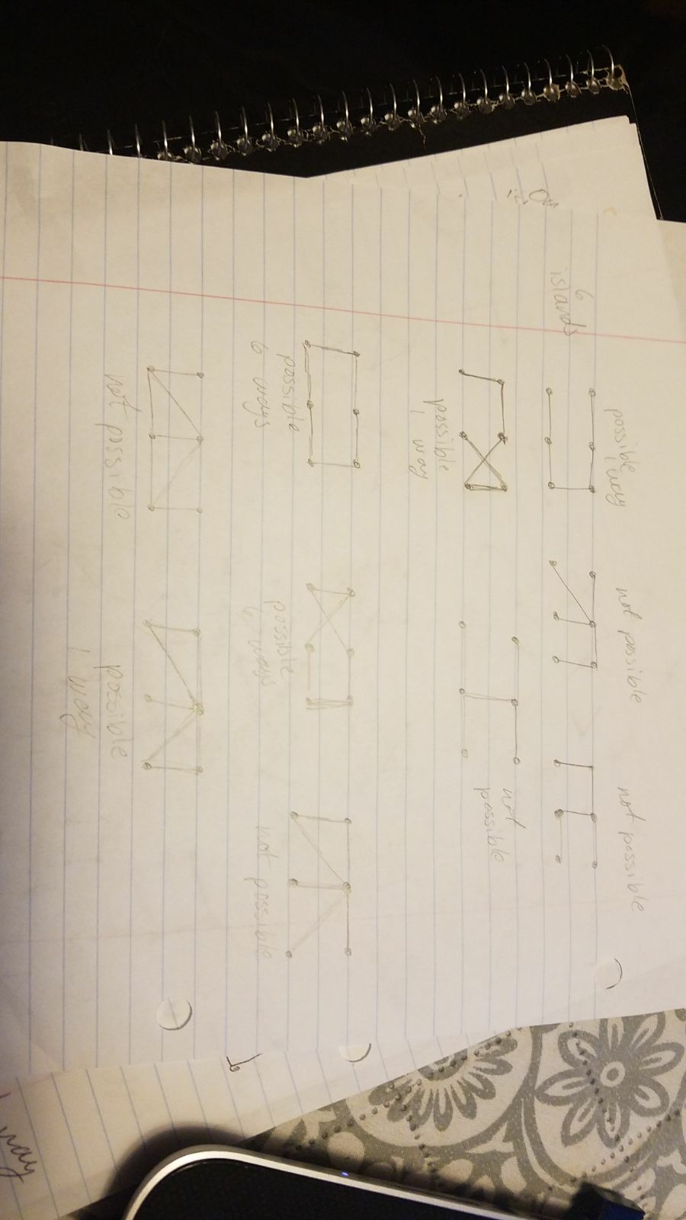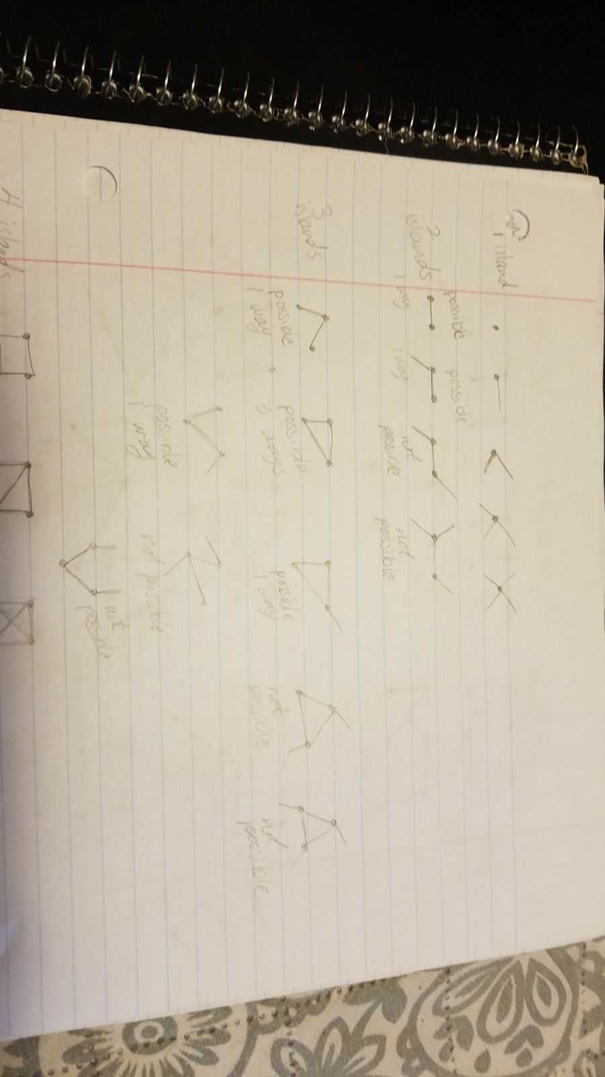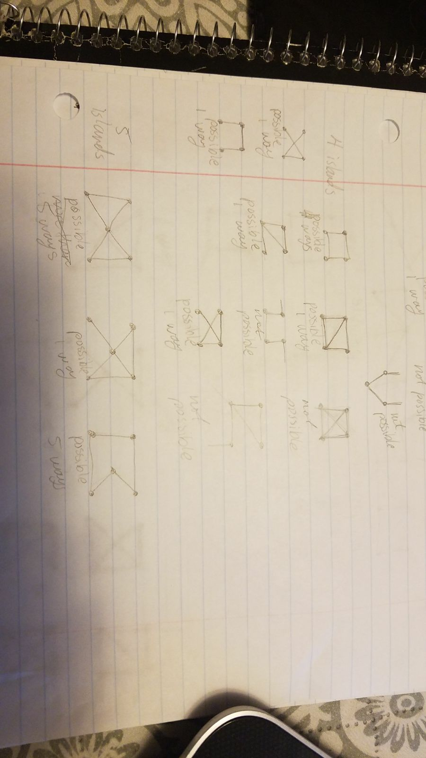
To conclude, the conjecture isn’t only built off of this one proposition but of many different notes, and questions, and other conjectures that help make it true. Making puzzles is fun, they are fun to draw and mess around with to see if they can be solved or not. We all enjoyed checking each other’s puzzles and commenting on them. Sonam worked on coming up with more puzzles that worked, while Evelyn worked on commenting on those puzzles, Miralia explained our conjecture and some of the process we did, and Josvenia put everything together. Doing this we noticed that although it is fun, it is also very difficult and that we still have a long way to go to prove our conjecture.

