Violanda Lubani
Mat2071
Fall2016
Prof .Reitz
12/1/2016
Impossible Graph
Solving Puzzle:
Everything started from “Bridges and Walking Tours” .It was given to me to construct a walking tours for eight graphs and show if walking tour is possible or not.
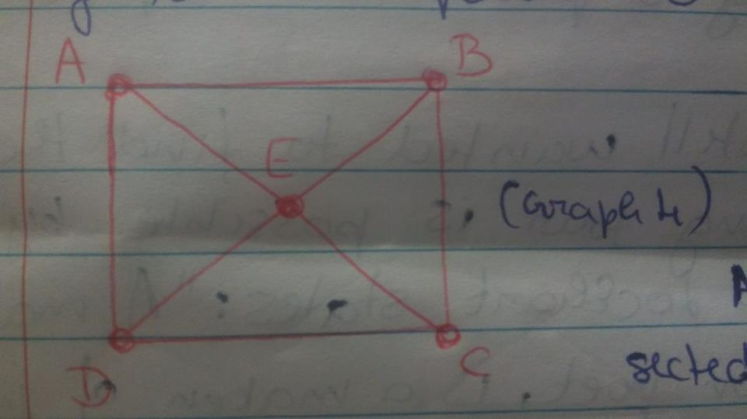
From all of them, graph number 4 was more challenging to me. A square with two intersected diagonals. Each diagonal is a line segment drawn between two opposite vertices(corners) of the square. So, by drawing both of diagonals in opposite vertices, there would appear a point where the diagonals will intersect, and that point will divide diagonals into two equal parts. So, by naming every point by letters A, B, C, D, E I tried to conclude if the walking tour is possible or not. Starting from letter A and going straight to letter B and then there passing through the half of the diagonal to the point E and then form E to C and from C to D again. The walking tour will not pass through segment line BC. Starting the walking tour from every single point didn’t give me a positive answer. Therefore, I concluded that for this puzzle walking your through every edge without lifting a pen ,was impossible.
However, I still wanted to find the way to show that walking tour is possible by using the same graph. As Lockhart states : “ A mathematician, like a painter or poet, is a maker of patterns. If his patterns are more permanent than theirs, it is because they are made with ideas”. Basically, mathematicians like to make patterns with ideas. So, what I did was that I took two graphs:

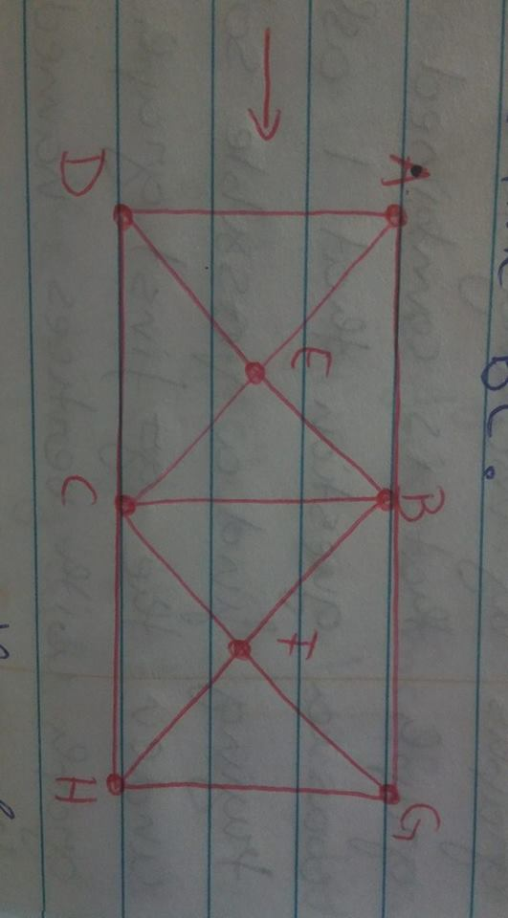
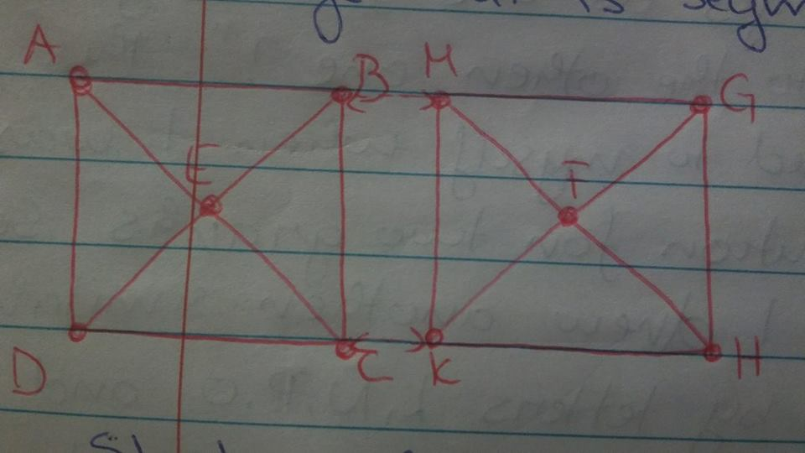
Both were the same, and in both of them the walking tour was impossible. So, I combined them, by making segments BC and MK as a one segment BC. Basically, what I did was that I just doubled the graph 4 from the “Bridges and Walking Tours”, and then two graphs were connected with the same edge that is segment line BC.

Starting from point A and then pass through points B, E, D, A, E, C, B, G, H, F, C, H . I tried to take as a starting point every vertex and still the walking tour was impossible. So, I came a conjecture.
Conjecture:
“Combining two impossible graphs where the walking tours are impossible will give a third graph which will be impossible as well”.
Then I thought that maybe conjecture will be true if I start from any of the points where two diagonals intersect each other. So, I took as a starting point letter E and then I passed through C, F, G, H, C, B, A, D, E, B, F, H . Still the walking tour didn’t pass through segment lines CD, EA, and BG. Therefore it is true that the conjecture is still impossible.
However, what if I combine more than two graphs by making them two edges as one for every graph that is combined to the other one?”. This was a question that I asked myself , when I was trying to find a possible solution for two graphs. So, under the first graph I drew another similar graph with vertices named by letters L,N,P,O and the point that intersect two diagonals named by letter R.
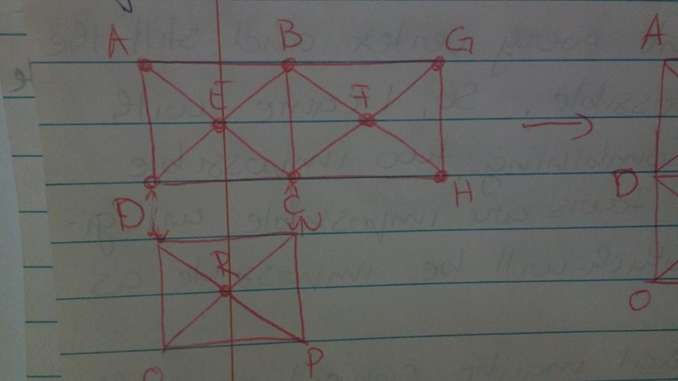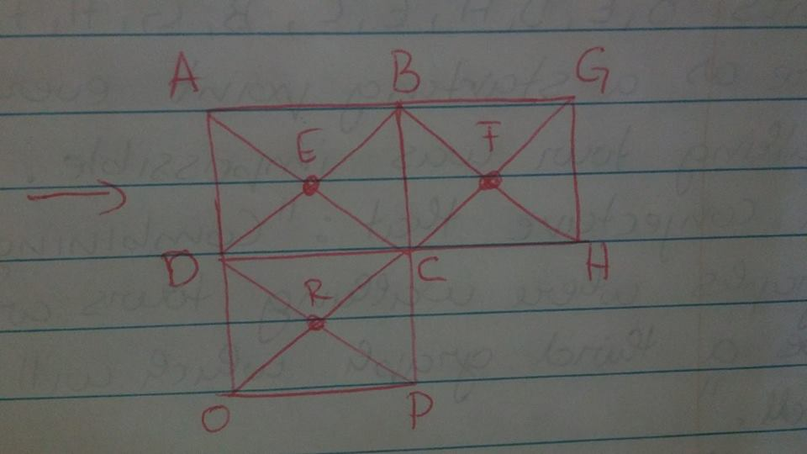
So by making segment lines CD and LN as one edge with two vertices C and D, I combined two similar graphs to one graph. Now, since I put way more letters, it became more difficult for puzzle to be solved. Starting from the point A and passing through E, C, F, G, H, C, P, O, R, C, D, E, B, A, D, R, D will still not pass in every edge without lifting the pen. Therefore, even though I put more than one graph, walking tour still came out to be impossible. But, as a future mathematician, I still didn’t want to give up. I wanted to find the way to come with an answer that my conjecture was wrong. Or either I wanted to proof that it is true. So, I went back to the two graphs,
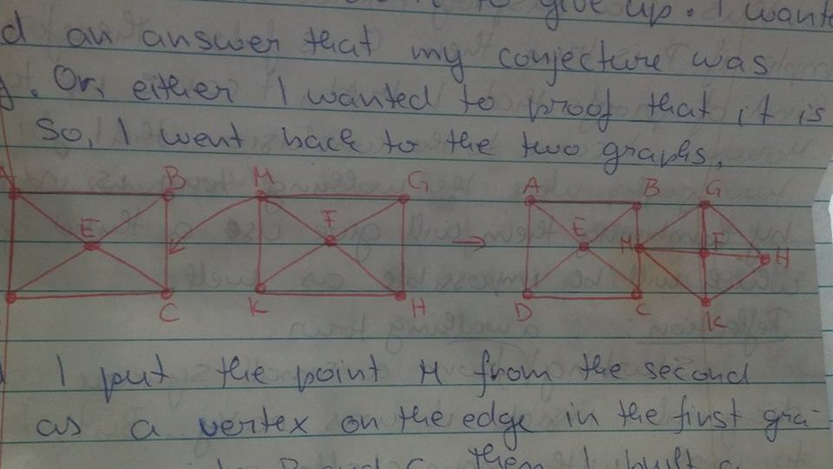
And I put the point M from the second graph as a vertex on the edge in the first graph(as showed in the photo) between points B and C .Then I built a proposition : “ If we put a point from second graph as a vertex on the edge between the points in first graph, then the walking tour in this two combined graphs will be possible.
This statement came out not to be true, and I will show why by bringing a counterexample that shows that. I started the walking tour from the point A and I passed through B, E, A, D, E, C, M, K, H, F, M, G, F, K . And here is the fact that shows me that this statement is not true since I can not pass through line CD and BM and GH. This can proof also that my conjecture is true, since I took a proposition that was the opposite of my conjecture, and I did proof it that the statement was not true. Moreover, for every step that I took to find something against my conjecture, all of them came out to be false. So, I can conclude that my conjecture is true, and I also came to the conclusion that for every two graphs where the walking tour is impossible, by combining them, they will give us a third graph which will be impossible as well.
Reflection:
Starting the walking tour from a small square and its diagonals inside it was very easy. But, trying to work with more challenging in order to come with more beneficial conclusion was very challenging. It was easy just to suppose something, to suppose a conjecture that may be true or not, but after coming with proofs that explain the conjecture was super challenging. However, I found myself to enjoy a work like this because it helped me to express the way I think and create proofs by my own and after by giving counterexamples that show that everything I supposed to be true came out to be false which gave me more assurance that my conjecture was true. Just by combining to impossible graphs, I started to think that If the new graph that I will get will be possible or not. Then, I thought to change the conjecture to more than two graphs. So, I combined three graphs. And, still the new graph that I got was impossible too. After, I supposed that by changing the combination of graphs from edge and edge to edge and vertex, I continued to get a third graph which was impossible. Therefore, for two impossible graphs where the walking tour was impossible ,combination of them will give us another graph which is impossible as well. Furthermore, I proved it not just for two graphs, but also for more than two ones.

