Project Final Draft

The bridges and walking tour is a game in which we translate a map into a graph. We began by talking a created map with a stream of water and a few landmarks and we pose the question; if we as humans cross an x amount of bridges, can we create a tour that lets us visit every part in the city but cross every bridge only once? Answering a question like this is a bit complicated to answer on a map, we use a bit of graph theory. The idea is to simplify the picture of whatever map given by transforming the specific landmarks into vertices and transforming the actual bridges themselves into edges connecting to points corresponding to which landmark it was close to. The goal was, if we can simplify a bigger picture into something consisting of vertices and edges, we can then trace out all edges with a pencil and if we could cross all edges and vertices without lifting our pencil, then we can visit every place and cross every bridge only once.

Once we had some sort of graph or set of graphs, our goal was to create some conjecture, and prove it or disprove it. Conjecture: if a puzzle contains a rectangle with two diagonals and the puzzle is symmetric, then the puzzle can either contain zero or two solutions. The idea behind this arose while we worked vigorously on those puzzles that were examples on the bridges and walking tour assignment on open lab when we assumed that the ones with the diagonals had either zero or one way to do it. We realized that one-way to find a solution began from the right side of that puzzle a majority of the time. One interesting thing about each puzzle was that each one of the puzzles were symmetric so we inferred that if we could start at a particular point on either the left or right side of the line of symmetry, then I can also start at the same point reflected over the line of symmetry on the other side, hence the reason we modified our conjecture to either one or two solutions.

One thing we noticed in this class is that a disproof is so much easier than a proof; so our objective most of the time was to prove ourselves wrong. If we could not do that, we were convinced that our conjecture is true. We started creating as many different figures we could according to our conjecture and tried to prove ourselves wrong. The idea was to write down the path (if it exist) and then without looking at the picture, translate it to the opposite side and see if that pathway leads to a solution as well. For example, (refer to picture 1.1) the line of symmetry cuts in the middle of segments DC and AB respectively, so if you find a path (which we did BDABCDCA) then you can translate it by swapping the letters in that same segment, D for C, C for D, A for B and B for A (ACBADCDB) and it worked out for us.
Picture 1.1 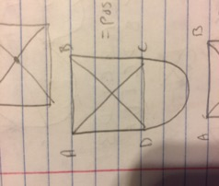

Thinking about the picture and messing around with many examples, we realized it does not work for when you put two simple (and by simple, I mean any example from the open lab assignment) together and form an even bigger path that is still symmetrical. Since we found out that our conjecture is wrong, we tweaked it a bit. Conjecture: if a puzzle contains a rectangle with two diagonals and the puzzle is symmetric with only 1 more travel, then the puzzle can wither contain zero or two solutions. We then tried many examples realizing that now we found to distinct pathways that were not reflections to find the answer. We then changed our conjecture one more time by just replacing the last line with then the puzzle can wither contain zero or four solutions. One of the main problems with a conjecture like this is that there are a lot of different examples you can use to satisfy the requirements of our conjecture, which is why our group keeps trying to edit our conjecture a bit to make it a bit more specific. It’s very hard and time consuming to try to find a solution to any puzzle and honestly, there is times where we don’t notice there is a solution. Now that we have our conjecture the way it is, we believe we should just leave it the way it is and just spend time trying to either prove its wrong or disprove it with an example.
(See picture 1.2 for more examples of harder paths)
Picture 1.2
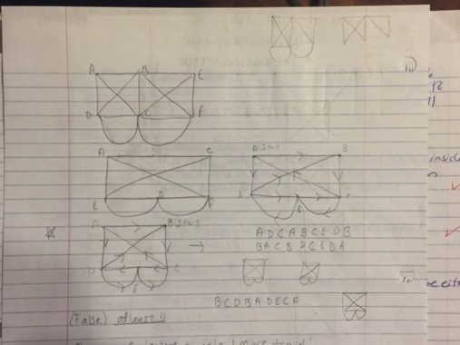

One of the most annoying things about our conjecture was the amount of time it took just to find a solution to a simple one. I believe it took us more than ten minutes to solve just one simple solution. We had the misconception that if we edit it a bit, it would still have the same solution. We were aggravated to say the least. For one of our homework’s, we were told to spend 90 minutes on trying to prove our conjecture. Armando set a few goals for that assignment. 1) Write the conjecture in terms of quantifiers and realize what is being said. 2) Draw as many pictures that satisfy the requirements as you can and try to find a solution to each one. 3) Does the “changing the letters between symmetric segments” trick work? 4) Can you generalize anything about the puzzle? Gary had goals for this assignment as well, 1) Think about the conjecture and think about the types of possible puzzles that can be made. 2) Draw a difficult puzzle and try to solve it and see if there are zero or to solutions. 3) Edit the conjecture if needed. This was really fun and we remember being excited to do this. We set aside about two hours to do this assignment but we still couldn’t get all of our objectives done. Although we did run out of time, we considered our work successful, because of the observations; we realized we had to edit the conjecture a bit to make it less rough on us.

A couple of hiccups we ran in two while sticking to our conjecture. We used the chalkboard (because we love trees) and drew one picture that satisfied our requirements and tried to find a route. If we did or didn’t we would draw another picture and find a solution but sometimes, we may get up to eight solutions. We totally forgot that the picture had to be symmetrical or that it has to have only one additional route. It was aggravating to have to start for scratch at times, but the experience was fun and joyful. I do have to say; we agreed that working in class together on the conjecture is more fun and efficient then working at home. We caught each other’s mistakes, we found solutions faster and overall, both of us have a different way of thinking and seeing things that is very interesting at times.

This process is time consuming hard and very annoying at times, but the actual proving of the conjecture is fun and really gives your brain a workout. We now know we have to analyze each picture before we work on it. Draw each picture out to see what exactly is going on. Figure out a solution or two to the graph and write it down. Translate that according to the rule of segment symmetry. Create an example that is similar to that one by rotating it and see if that affects the picture in any way. Figure out the number of different puzzles we have in our situation and see if we can see a similarity between those pictures. One final note, I constantly refer to a section of the Lockhart’s Lament. I remember (not explicitly) him referring to the beauty of just adding a small segment to the triangle and being able to see the difference that little segment created. I remember stating that math was so much more then just theorems and proofs and that discovering and adapting a picture on your own is truly a beautiful thing and how that is art. Gary and I are essentially creating art every time we mess with a puzzle we create. We began with a small simple picture, added a few line segments and dots and essentially created difficult math problems. This assignment really brings out the best in us because we are forced to critically think in both a math way and a non-math way. What do I mean by that? Well a math way basically describes, what is going on, what is the geometry (if any) in this problem. The non-math way is simple, what is really going on. Is this a real world problem, and as Gary said in his post, Lockhart describes math as being heartbreaking due to teachers being limited to the curriculum, but this project is a nice correlation between math and the real world that really helps us analyze, synthesize and apply skills we learned in other areas and honestly, I think this is one of my favorite projects and I may even use it in my classroom some day.

In conclusion, when it comes to the final conjecture, both Gary and Armando have similar, but different response to weather it’s true or false. Gary stated, I was thinking and I kept thinking that the conjecture was true but I didn’t start to use examples or trying to prove it was true right away. It was until I did start to create examples of different puzzles of the conjecture when I came to the conclusion that the conjecture was correct. Then I was trying to disproof the conjecture by not making a rectangle and not having diagonals and also not being symmetrical. When I did that I saw that the puzzles were easier to solve than the puzzles of the conjecture. Armando stated this conjecture is a true conjecture if we can prove every single case. I believe there are a finite number of cases where this is true and we believe that it’s a small number, though there still are a lot of cases to work through. The easier thing to do is to just find the common denominator of all of then, generalize a rule if possible and work from there to prove it true.
(Picture 1.3 shows some of the examples that were used to prove our conjecture true or false)
Picture 1.3
