Hanan Abuhashish
Ismail Akram
Jeron Pitt
Fall Semester 2016
11/16/2016
Proofs and Logic - MAT 2071
Prof. Reitz
An Puzzling Oddity: Initial Draft
The bridges and walking tour revolves around multiple approaches to a problem.
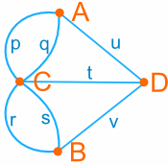
One is unlikely to solve such a puzzle on their first attempt and is put into a situation where they must examine choice scenarios. This methodology mirrors Lockhart's Lament in allowing students to play around with a given task and think for themselves. We began to realize that the initial puzzle given to us was impossible to do, as we slyly added another bridge to fundamentally change the question:
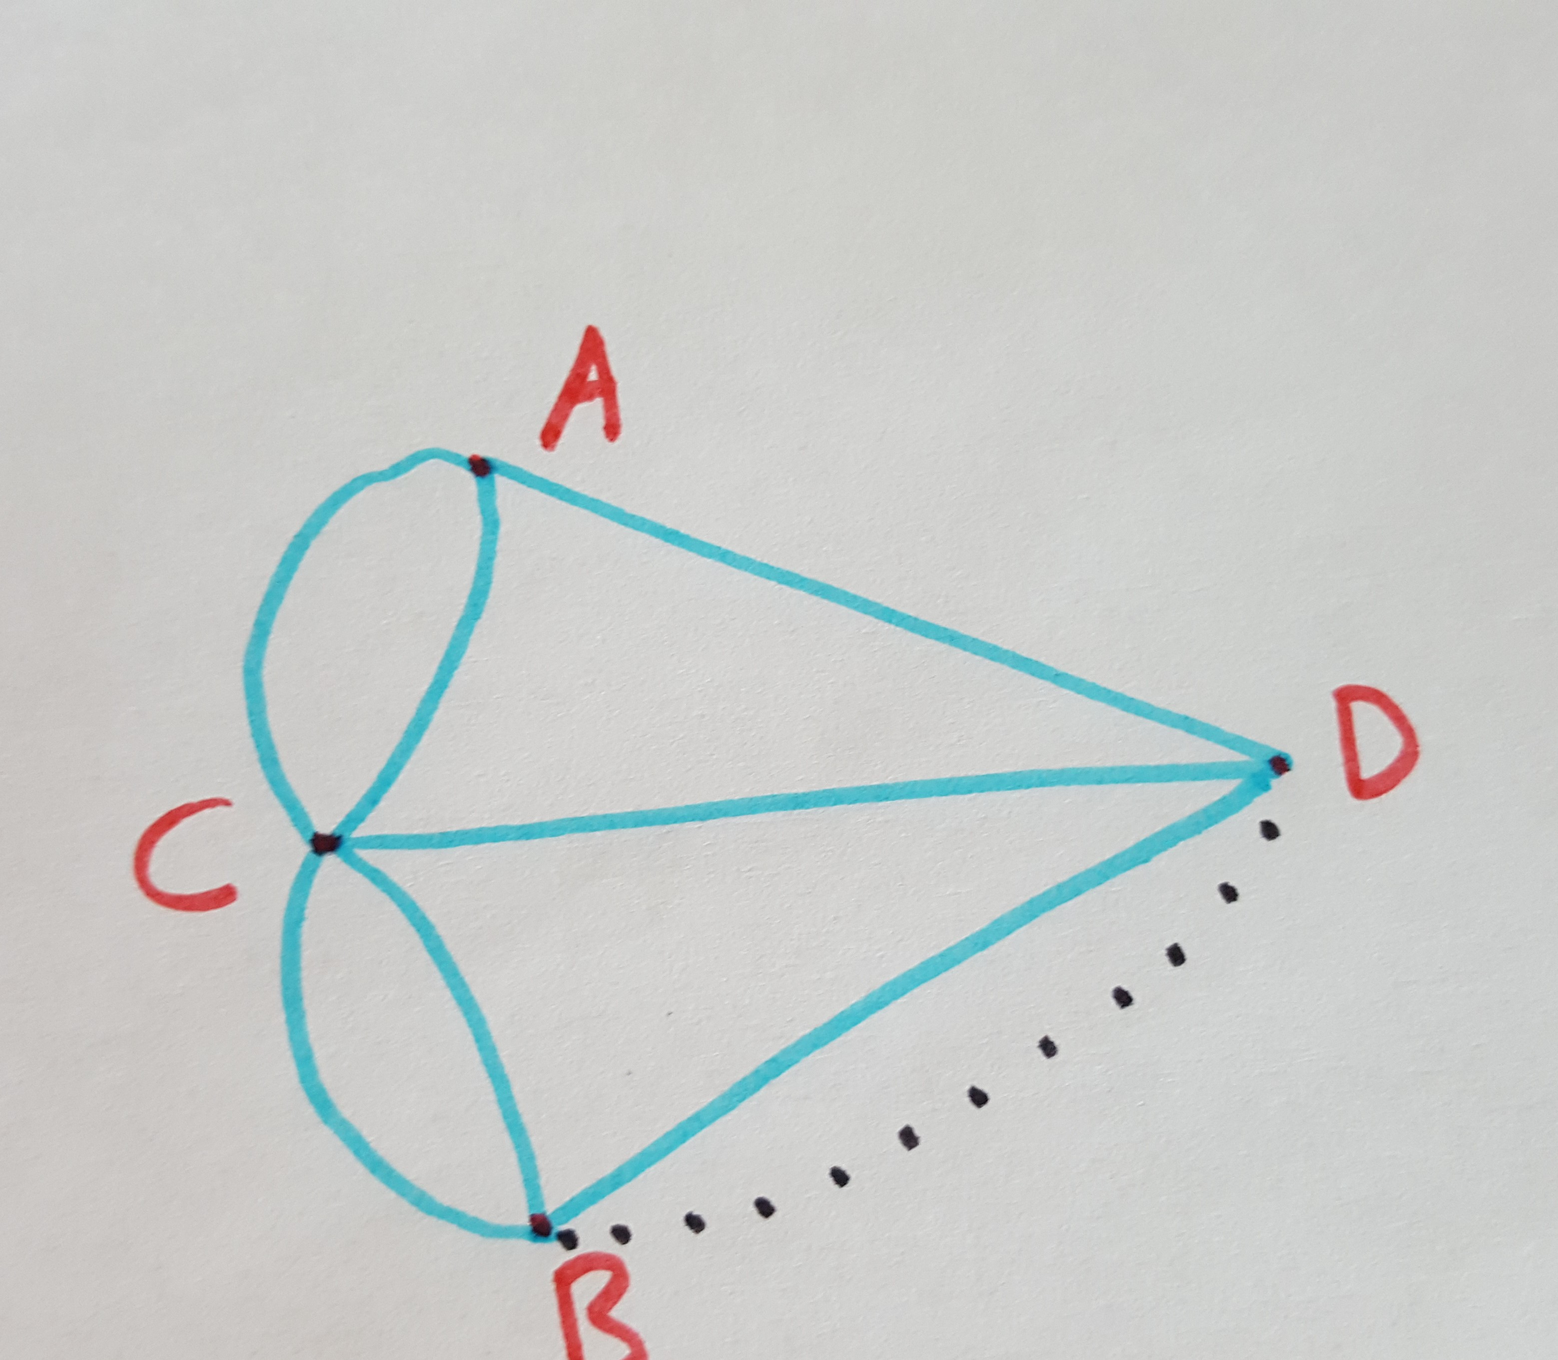
Why did we do that? Perhaps we imitated Lockhart's construction line splitting a rectangle to explain the area of a triangle?
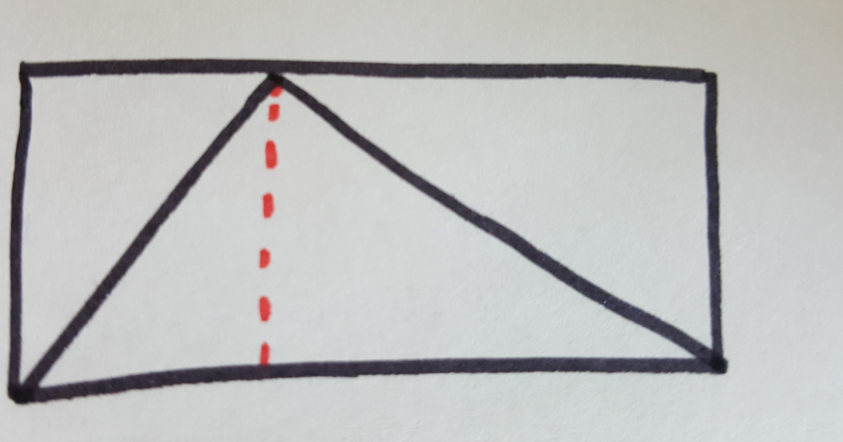
However, these two approaches are not the same, adding another line to "solve" the problem actually changed the problem itself. Again, why did we do that? This leads us to our conjecture:
"If a walking tour puzzle has more than 2 vertices of an odd degree, it is impossible to draw along every path once without lifting your pen".
The vertices A, B, C and D all had an odd degree (3,3,5,3 respectively) in the first version, but after we drew our line, the puzzle changed to having a degree of 3,4,5,4 respectively. Only 2 vertices had an odd degree, thus this new puzzle was now possible (e.g. A->C->B->A->D->B->D->C). Also note that our starting point was A, a vertex of an odd degree. Had we started at D or B the we could not do the puzzle. This led to another speculation:
"If a walking tour puzzle has less than 3 vertices of an odd degree, you must start at either of the 2 odd degree vertices as you will either start at one and end on the other". Developing a tactic into problem solving. Ideally start at an odd degree vertex.
Visually it would look something like this:
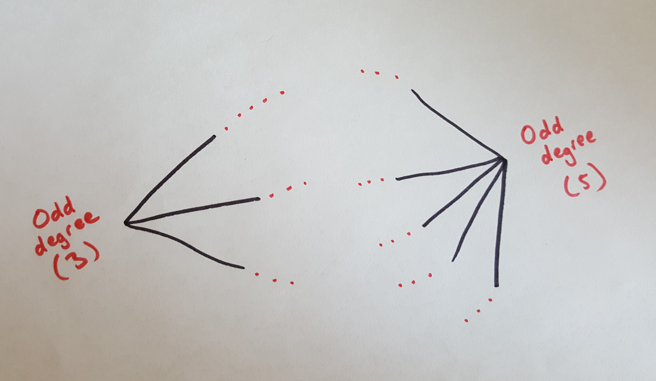
Represents an imaginary abstract puzzle with two vertices of an odd degree. The red dotted lines represents and infinite number of even degree vertices. Pick either odd degree sides as a starting point, let's say the left (degree 3):
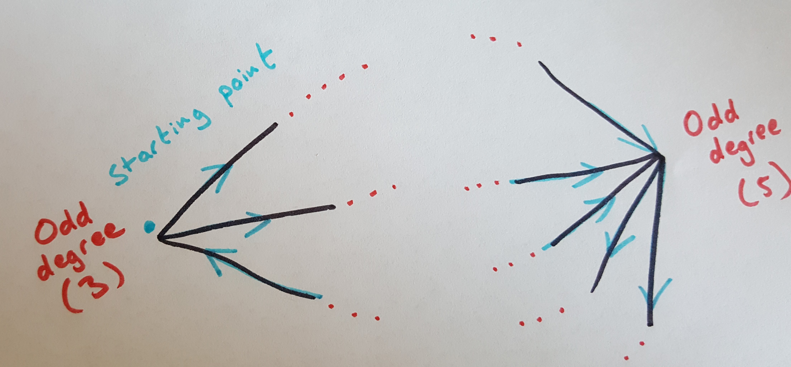
Note that we drew "away" from the left vertex, then "came back", and then "away" again. That's 3 strokes of the pen, we started from the left and ended up away from it as we finished the puzzle. If it's still puzzling: here's a more concrete example:
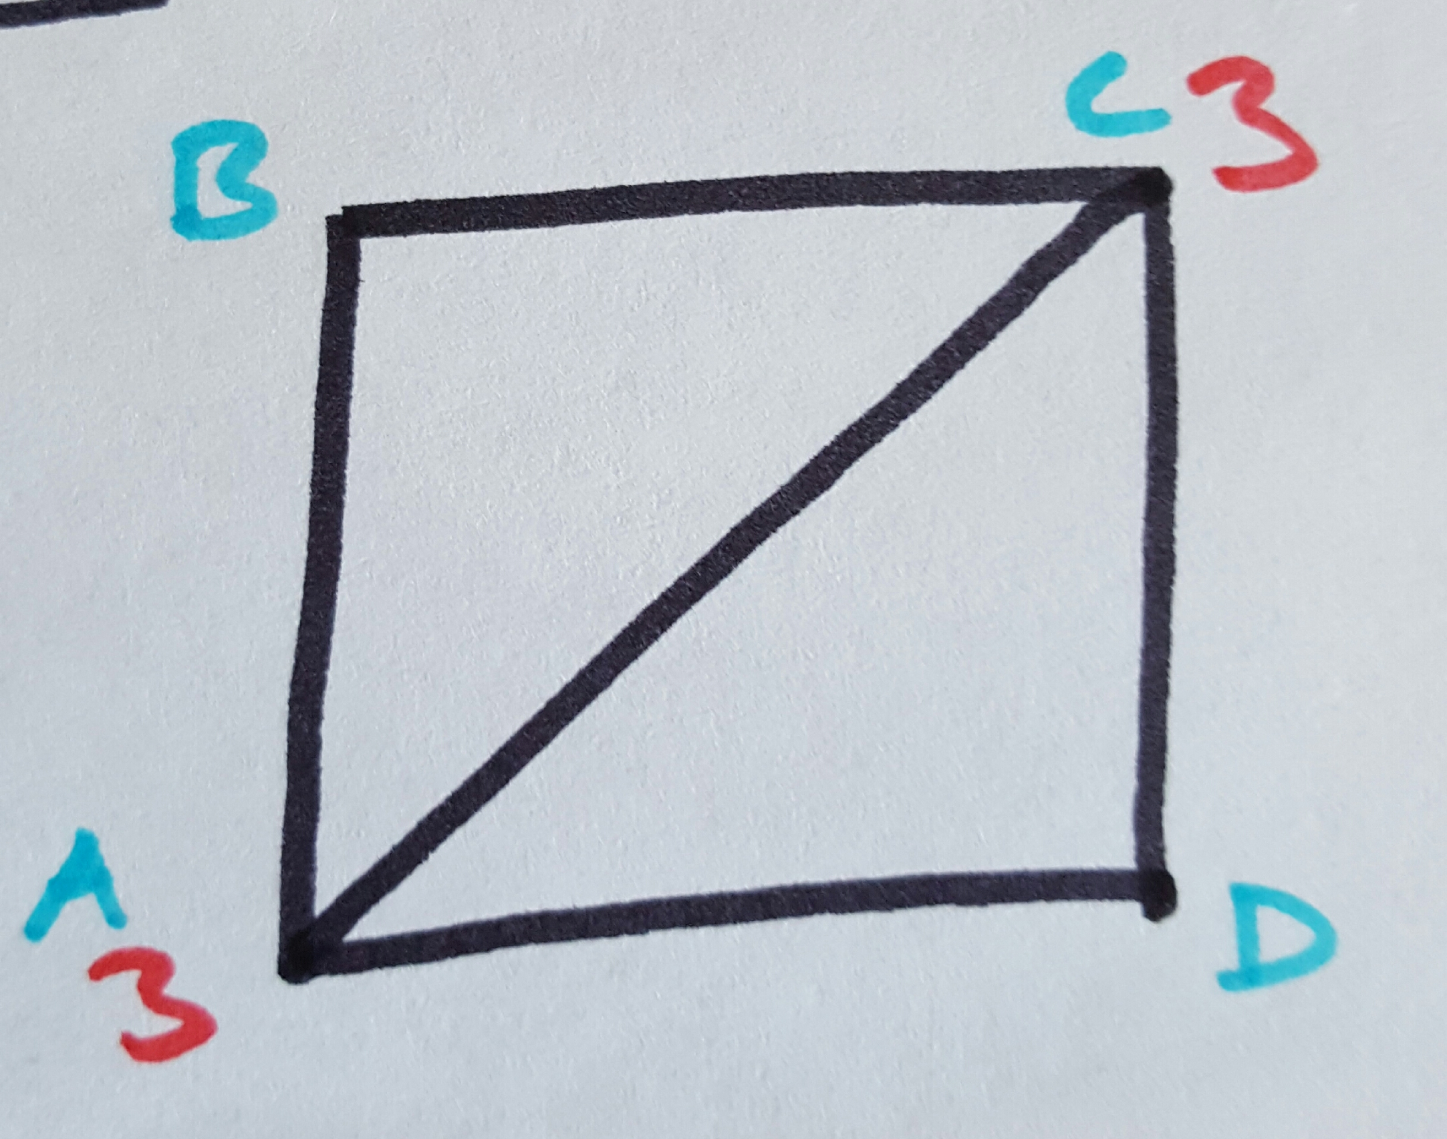
Pick either A or C (they both have a vertex with an odd degree), Say we started at C: Then our path looks like: C->D->A->B->C->A. Note that we started at C and ended up at A. There is no possible combination to start at any of these points an end up on that same exact point as well, as we have 2 odd degree vertices.
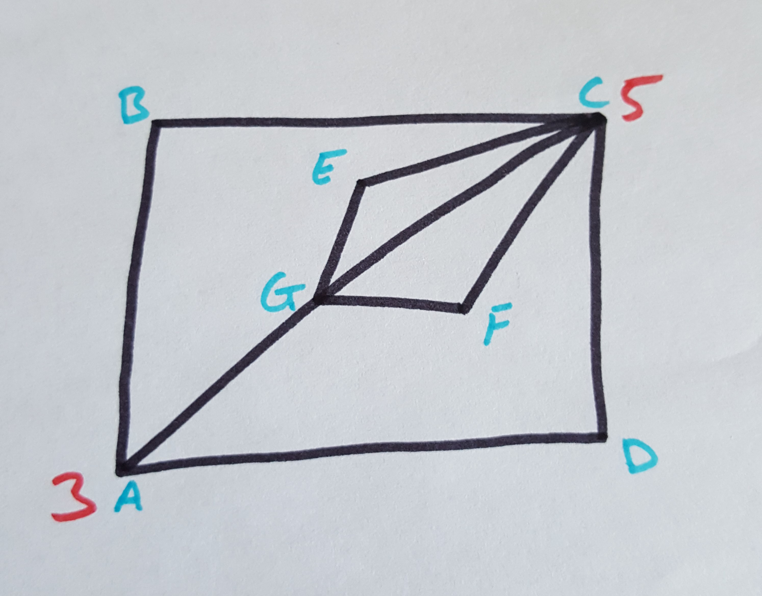
We have another example to show that it doesn't just work with the number 3 but any odd degree vertex. Pick either A or C as a starting point: say A: A->B->C->F->G->E->C->D->A->C. Note that we started at A but ended up at C. That's because we have an odd number of "paths" or "vertices" to go through. We can't start at an odd vertex and end up back at that starting point.

Reflection: Knowing this information helps in quickly discerning whether or not a puzzle is solvable in the first place. It may be that we could delve so much time (like the initial walking tour bridges) only to discover that it is impossible to solve. This helps to reassure the person taking the puzzle, of the validity of the puzzle.

