Marina Felamon
Victor Lee
Leonardo Perez
Farjana Shati

MAT 2071- Introduction to Proofs and Logic Fall 2014
December 2, 2014

The MIU game is an invention Douglas Hofstadter found in his book Gödel, Escher, Bach. The game involves three letters: M, I, and U. There is a goal word which uses all three letters and our objective is to reach the goal word under a certain set of conditions. We always start each game with an initial “axiomatic word” “MI”. We then must follow the following conditions.
Rule 1. Add U to any string ending with the letter I.
Ex. MIUIIIII becomes MIUIIIIIU.
Rule 2. Double any string after M. Mx→Mxx, where x is a string of I’s and U’s.
Ex. MIU becomes MIUIU.
Rule 3. Replace any III with U. That means replace any three consecutive I’s with a U.
Ex. MIUIII becomes MIUU.
Rule 4. Remove any UU. Any two consecutive U’s are removed from the string.
Ex. MIUU becomes MI.
Note: Not an official rule, but “ANY” does not mean “ALL”.
These rules are not absolute; we can be selective in their implementation because no rule has any priority over any other. For example, starting from the axiomatic word MI, we have the option to apply Rule 1 to create MIU or we can apply Rule 2 to create MII. The different choices we make can be summed in the following flowchart:
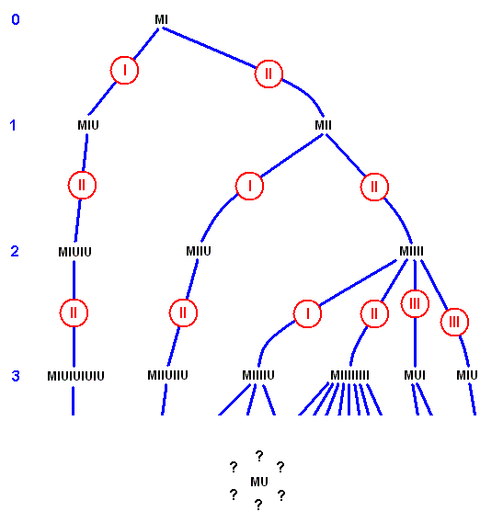 | Source: http://www.metafysica.nl/nature/insect/miu.gif

In order to better grasp the how to play the game, perhaps it is best to solve an example goal word that requires all the rules to be employed. For example, let’s try Professor Reitz’s example MUII.
MI (Axiomatic Word)
MII (Rule 2)
MIIII (Rule 2)
MIIIIIIII (Rule 2)
MIIIIIIIIU (Rule 1)
MUIIUU (Rule 3)
MUII (Rule 4)
After completing the game several times, we can figure that a certain pattern might emerge after several repetitions. After floating around several ideas, we considered attempting one conjecture.
This conjecture focuses on two of the four rules- in particular rules 2 and 3.
Rule 2 states that we can double any string of letters after the M. After playing around with the game, we often use Rule 2 as the first turn and we repeat it continuously. Because the string of letters in the axiomatic word after the M is merely a single I, we are constantly doubling until we have 2^{n} I’s. Yes, we can do so with strings involving U’s also, but for the sake of our conjecture, we tend to ignore this fact.
Rule 3 tells us that we can replace any three consecutive I’s with a U. This can be interpreted as the idea that U has the value of three I’s, so wherever we see a U in the goal word, we can try to reverse-engineer it by substituting III for it. For example, our original goal word might be MIUIIU. We see two U’s, so we can perform the substitution MI(III)II(III). Keep in mind that we are not required to substitute III for every U, but for the sake of our conjecture, we will replace all U’s.
Our group observations resulted in Victor’s conjecture being chosen.
Conjecture. Suppose U = 3 I’s and n= how many times rule 2 is applied. If the goal word is M followed by an equivalent to 2^{n} I’s, then it can be solved in n+1 turns.
In theory, we assumed that the steps to solving a goal word with 2^{n} I’s, we would merely keep apply Rule 2 n times, then on the next turn, apply Rule 3 to get our goal word.
There was some initial confusion among the group members as to how to interpret this statement in spite of Victor’s assurances it was indeed provable. Leonardo in particular was vocal about possible confusion as to why U had to equal 3I. The rest of us had to explain to him how Rule 3 explained this part of the conjecture. This confusion did actually last a while because Victor was absolutely certain it was clear enough and had to be told by Professor Reitz a week before this essay had to be submitted that the conjecture might not have been so obvious.
By looking at our conjecture we as a group thought that it will be hard to prove but we did not lose hope that we might get it proven. There was also the matter of trying to set up the proof as we still didn’t have enough information at the time; we had been leaning toward the idea of using direct proofs at that point. In the week after we submitted our conjecture, we learned about induction proofs and we had thought induction was the best way to go. We had a minor consult with Professor Reitz to find other ideas on how to prove it.
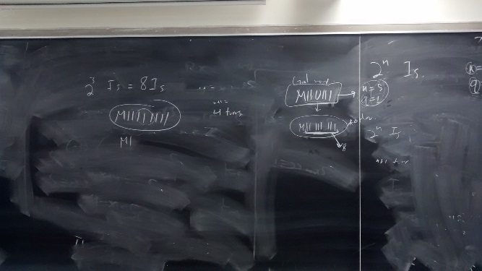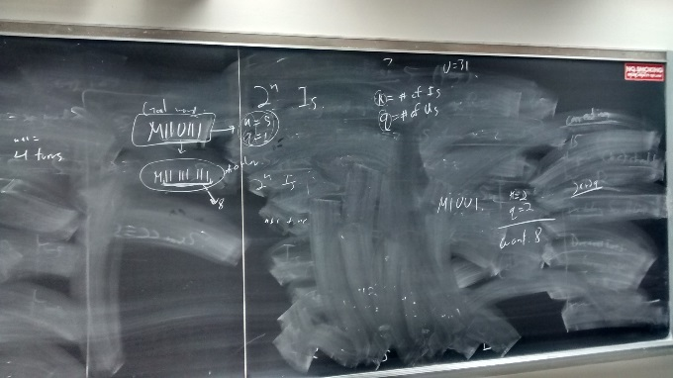
Ideas Professor Reitz floated around.
Immediately after a class session the previous week, Farjana had told Victor that she believed the conjecture was false but was uncertain. Victor dismissed it as he firmly believed in the truth of his conjecture without having tested it himself.
Marina proposed that we meet each other in the library because the deadline was nearing and we had little to show for two weeks after the project was assigned. We met each other at the library and each of us had a paper and a pencil and we tried to do the conjecture alone. After 20 minutes, we all discussed what we got. None of us were able to prove that conjecture, as we were not able to figure out some parts of the conjecture. We kept talking about it and how can we figure out something for it. After 10 minutes Victor had disproven the conjecture. Victor explained his steps to us in disproving the conjecture, and we all agreed that this was the best way to do so.
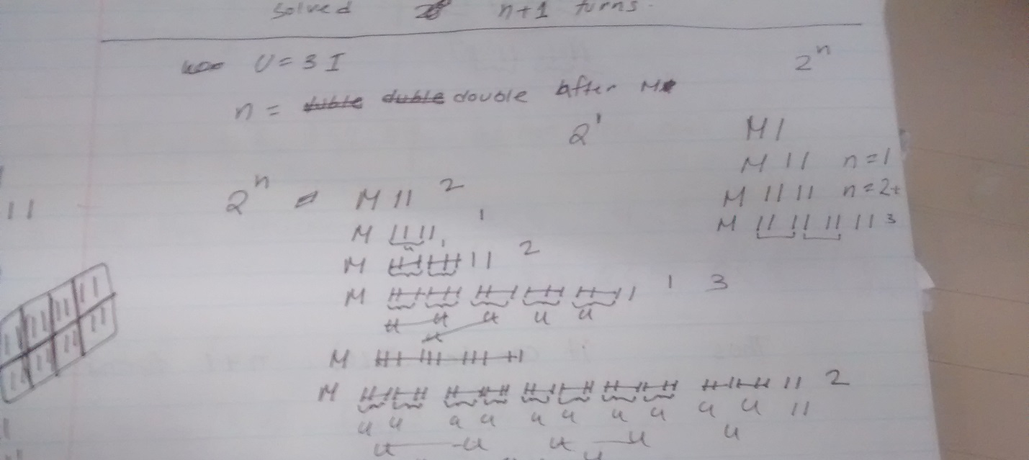
One of Farjana’s attempts to verify the conjecture.
Conjecture. Suppose U = 3 I’s and n= how many times rule 2 is applied. If the goal word is M followed by an equivalent to 2^{n} I’s, then it can be solved in n+1 turns.
Proof by Induction. Disproof by counterexample.
Base Step. Consider goal word is MI. Note: Goal word is axiomatic word. n=0 because Rule 2 has not been used yet. Goal word has 2⁰ I’s. Goal word is solved in 0 turns, not 0+1 turns.
So now we have a disproven conjecture. The problem is the fact that it really seems true. We were working as if the domain we were using was all natural numbers and 0. Unfortunately, we might have overlooked a key element in the conjecture; that U= 3I’s. So the word must have an equivalent value to more than 3 I’s. From our conjecture and Rule 2, we are constantly doubling the string of I’s, so therefore we have to find a high enough natural number value for n so that 2^{n} ≥ 3. 4 = 2² and 4 > 3, so we can say that n must be a natural number greater than or equal to 2. But we guess that’s for further investigation.
Farjana: Working on the conjecture as individual was tough and then trying to solve it was confusing and frustrating. At first I tried to understand the meaning of the conjecture then worked on figuring out if the statement is true or false. My next step was to solve the conjecture with different examples by putting different n values. Looking through my examples made me think of solving the conjecture with proof techniques. But due to my confusion of understanding the last part of the conjecture I gave up on that thought of solving it by proof technique. However working on the conjecture with group was an easier and different experience than working individual. Our group planned to meet up in the library to work together on the conjecture. When I was trying to solve the conjecture myself I started with axiomatic word MI and got stuck and could not able solve it any further at that moment. But after discussing with the group members and getting a clear understanding about the conjecture we were able to figure out that the conjecture is false and we disproved it by taking the value of n equals to zero, therefore then we don’t have an n+1 turn.
Leonardo: When I worked on the conjecture that my group came up with on my own I was confused with what the conjecture was. I wasn’t able to do the conjecture since I didn’t understand it correctly. Regardless of that I still attempted to try and figure out the conjecture. When working on the conjecture I felt helpless since I didn’t understand the conjecture due the fact that I got the wrong conjecture. When I met with my group and we discussed our conjecture I realized that I have misunderstood the conjecture which caused me to be confused and unable to do the conjecture. In working with my group I was able to understand the conjecture since I had support from my group members. Working with my group I was able to see and understand what the conjecture meant this helped me clarify the misunderstanding that I was having. We then were able to come up with a solution for our conjecture which turned out to be disproven. Working with my group helped me realize that I need the support of my group members’ to do the conjecture because on my own I wouldn’t have been able to do it.
Victor: I’m pretty disappointed that our conjecture was proven false so quickly. For all the talk our group had about the conjecture’s wording, it should come to no surprise that it might have been the reason why it was disproved. I guess I should have given more thought to this possibility that another condition had to exist for this conjecture to be true. Although after thinking of this new condition, we may have opened up another can of worms. I think we would have solved many cases, but solving examples wouldn’t constitute a proof. We might be able to do something involving division algorithm where 2^{n} divided by 3 has either remainder 1 or 2, but where to go from there? I guess if given time, we might be able to figure out a method of solving the one. I feel we worked well together to solve the problem, in spite of its unsatisfying end. After spending a while to clarify their questions, I hope we all have a better understanding of the conjecture and how we can best help each other in the future.
Marina: Working to prove this conjecture was frustrating. I never lost hope that I would be able to prove the conjecture. Anyway, I tried my best to prove it but it did not work out with me. I got really sad that I was not able to get it. It is always frustrating to have hope and to spend hours trying to do something and it does not workout at the end. As a group when we went to the library I felt a bit comfortable that I will have my group mates around me to help me through it. As we all tried to prove it and it did not work out with all of us. Victor came up with his idea to disprove the conjecture, I felt confident that we arrived to a solution to this conjecture. As I saw the disproof of the conjecture I felt really happy that we have got to the point we want. I also felt happy and understood the meaning of working in a group and having your mates around you to help you and gathering your ideas together. Working with group was really beneficial to me.

