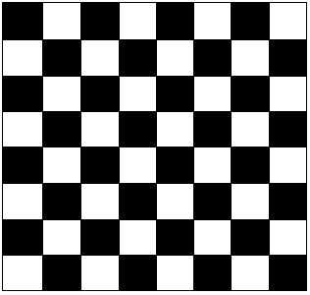 [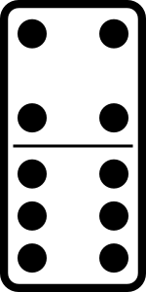](http://www.clker.com/cliparts/4/2/7/e/1197148339275888080molumen_domino_set_24.svg.med.png)

The Mutilated Checkerboard Puzzle

This here is an 8x8 checkerboard (this has 64 squares to be exact). Next to it is a 1x2 domino.

**Example 1** and **Example 2** shows when two squares that are diagonal and next to each other are removed from the checkerboard. The red that outlines the two black diagonal squares and the two white diagonal squares are the square pieces that is removed. As you can see there are two pieces left over concluding that the dominos are not able to cover the checkerboard making this conjecture false.

**Example 1 Example 2**

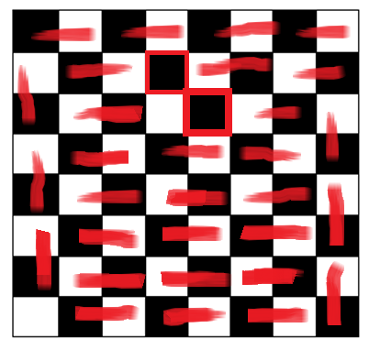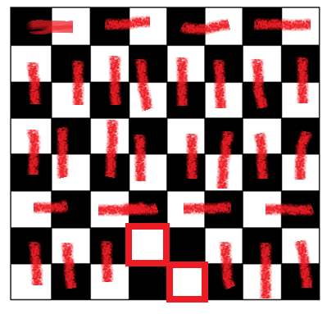

**Example 3** shows when two separated square diagonals with different colors are removed. This showed that the dominos was able to cover the checkerboard. Proving the conjecture to be true if and only if two **different colored** square diagonals are removed.

**Example 4** shows when two separated diagonals with the same color are removed. Unlike in **Example 3,** the dominos was unfortunately unable to cover the checkerboard due to the fact that two of the same color squares were removed.

is removed. As you can see there are two pieces left over concluding that the to cover the checkerboard making this conjecutre

**Example 3 Example 4**

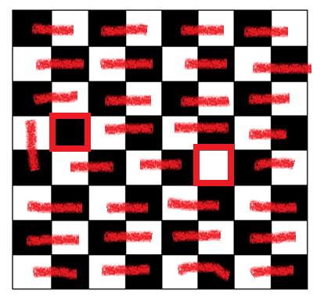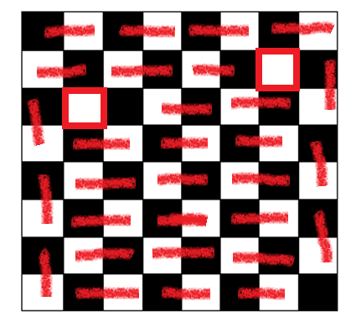

**Example 5** shows when two separated squares that are in the same diagonals are removed. This showed that the dominos was unable to cover the checkerboard. Proving the conjecture to be false.

**Example 5**

