2014 Fall – MAT 2071 Proofs and Logic – Professor Reitz

Semester Project – Group Process Paper (750 words) SINFONG CHIU
Bridges and Walking Tours
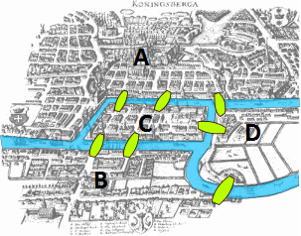=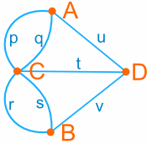
We suppose to create a walking tour of the city that crosses every bridge exactly once. In this case, we simplified a map into numbers and line.
Construct walking tours for each of the following graphs
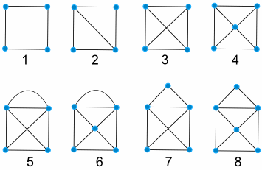
1 | 2 | 3 | 4 | 5 | 6 | 7 | 8
YES | YES | NO | NO | YES | YES | YES | YES

How do we know if a puzzle solvable or not in short time? How to create a solvable and crazy puzzle easily. This is an interesting game. We can create a crazy puzzle that we are not sure how to solve it or it will take a long time to solve it. My idea will help people to master this game by applying Lockhart’s example. Even though I don’t have puzzle like Lockhart’s example, we can transform the bridges and the joint to the place we want because the distance does not matter in this game. In short, we solve or create the puzzle in little by little.
Conjecture: Part A: Suppose Lockhart’s example is solved in bridges and walking tours (crosses every bridge exactly once), it can simplify as a bridge. (Starting point and ending point need to be same as Lockhart’s example)
Part B: Suppose a graph is solved in bridges and walking tours (crosses every bridge exactly once), it can simplify as a bridge. (Starting point and ending point need to be same as original graph). Therefore, we can create a complicate puzzle by combining pre-solve graph.
Part A: Simplify a puzzle
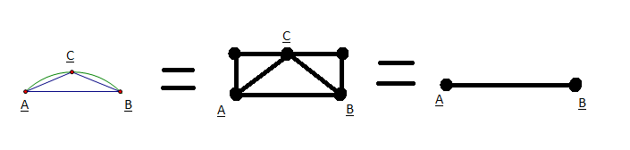
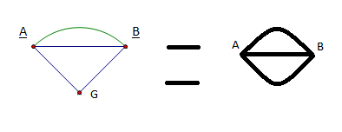
I create a walking tour of the Lockhart’s example that crosses every bridge exactly once if I start at A or B point, and end at B or A point. It is because the distance does not matter in the game. Therefore, the above graph represent the same thing which is solvable.
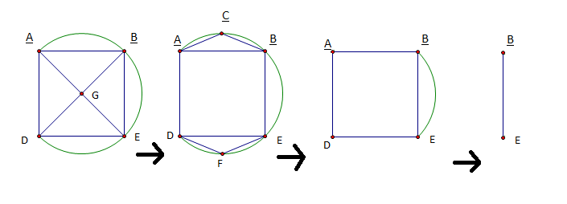
A graph EDAB is simplified to a new graph EB by applying conjecture. First, in graph EDAB, we transfer point AGB to ACB, and DGH to DFE because it is similar to Lockhart’s example. Second, Lockhart’s example is a solved graph, so bridges AB and DE represent ACB and DFE. Third, graph EDAB is solvable, when we start at E and at B point. Fourth, graph EB represent EDAB. Last, graph EB is solved if we start at E point, and ending at B point. It is much earlier to solve from the graph EB in Bridges and Walking Tours.
Part B: Create a complicate puzzle

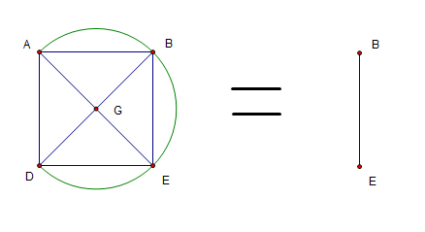
Suppose a graph EDAB is solved in bridges and walking tours (crosses every bridge exactly once), it can simplify as a bridge EB.
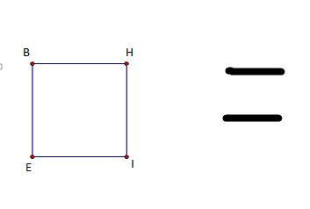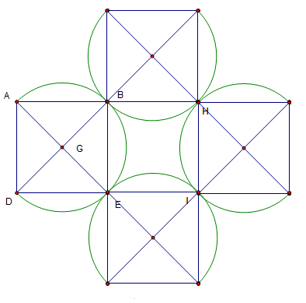
Suppose peter wants to create a complicate puzzle game like Bridges and Walking Tours on his back yard. How can he creates it quickly and correctly?
Bridges EB=BH=HI=IE represent graph EDAB. Therefore, Graph EBHI represent complicate graph by applying conjecture. (Starting point and ending point need to be same as original graph) Therefore, we can create a complicate puzzle by combining pre-solve EDAB graph.
Paul Lockhart says “A good problem is something you don’t know how to solve.” I would like to add something on it. “A good problem is something you don’t know how to solve, but I know how to solve it”. In mathematics, the first person who proof the mathematical formulas or patterns get the all credit. And others people get nothing for attempt. Although a lot of mathematical formulas we found today may not benefit immediately, but we will use it somewhere in future. I feel sad for Mathematician after they spend their life time discover new formula, but there is no Nobel Prize in mathematic. Although there are others prize like Wolf Prize including mathematic, it discourage people to study mathematic.
I found a way to simplify or complicate a graph for the game Bridges and Walking Tours. I draw some of conjecture puzzles in picture above, and it can solve in Walking Tours. I think conjecture is true only if the starting point and ending point in new graph same as original graph. I don’t have idea how to prove the conjecture. I can prove that conjecture works on one of the graph, but I cannot prove it on infinite different graphs. I was enjoy doing my project. because it was first time for me to work on project like this. Although it is not a big discover, it is a small achievement for me.

