Lego Widget: Robo Scarecrow
(My version of Rubber duck debugging)
Description of Parts (Sorted by Colors):
Note: Unless otherwise noted, all parts are rectangular in shape, just like bricks. So, we’ll call those parts- bricks), and number formats such as 2x3 or 1x6, etc., indicate the number of connectors/nodes on top of those bricks. Connectors on top of bricks will also be known as male ends/connectors/nodes while the connectors (with holes) at the bottom/base of the bricks will be known as female ends/inserts. Some bricks (the tall ones) are 2-3 times the height of the regular bricks.
Color | Quantity | Parts Description
White | 2 | Door-like bricks – let’s call these “ears”.
 | 2 | 2x3 triangular “shoes”
 | 3 | 2x6 Bricks
 | 2 | 1x2 Bricks with 3 pointed extensions on one side; let’s call these “triple spikes” bricks
 | 2 | Brick with 2 pointed extensions instead of male-nodes; let’s call these “double spikes” bricks
 | 2 | 1x2 Tall bricks – plain
 | 1 | 1x2 Tall bricks – linings on 2 sides
White (mostly) | 1 | Lego Man figure/character
Yellow | 1 | “Helmet” – odd/unique structure; 2x2 nodes in middle; 1 node on each outer layer; Tall brick
 | 1 | 2x2 – brick with one rounded side with a hole; let’s call this “face plate”
 | 2 | 2x4 bricks
 | 4 | 1x4 bricks
 | 1 | 1x6 brick
 | 2 | 1x2 bricks
Orange | 2 | 2x6 bricks
 | 2 | 1x2 bricks
Blue | 2 | (2x2) male nodes on one side + (1x2) male nodes on adjacent side; L-shaped brick; let’s just call these “blue bricks” since there are no other blue bricks.
Black | 1 | 3 Blades Rotor / Propeller
 | 1 | 4 Armed Rotor with a central hole (looking like a Cross); 2 nodes one each arm
 | 4 | 1x8 Brick
 | 2 | 1x2 Brick
 | 5 | 1x6 Brick
 | 1 | 2x6 Brick
 | 1 | 1x2 Broom-like black brick; let’s call it “palm” of a hand.
 | 1 | Dumbbell
 | 1 | Cross with 5 male nodes
 | 1 | Round brick with holed extension
Gray | 3 | 2x6 Bricks
 | 1 | 2x2 tall bricks, with extending tube
 | 2 | 2x2 bricks
 | 1 | “Stand”: Dual-sided Male bricks – 2x2 on one side, 1x2 on the other side. Let’s call this “Stand”
 | 1 | Half sphere – 1x2 male nodes
 | 1 | Hook
 | 1 | 1x2 brick with semi-circular extended hook holder
 | 1 | Tube / Cylinder
Brown | 3 | The only brown pieces; hand-like structures (meant to be robotic fingers); let’s call these “fingers”
Red | 2 | 1x3 flat-top triangles
 | 5 | 1x2 bricks
 | 1 | 2x8 brick
 | 1 | 2x2 Tall bricks
 | 2 | Single-noded translucent buttons – meant to be red eyes

This Lego project is for creating a robot Scarecrow, and we will be building from top to bottom order, namely head, body, arms, and legs; in the meantime we will also be assembling and attaching the top and back rotors/propellers.

Head
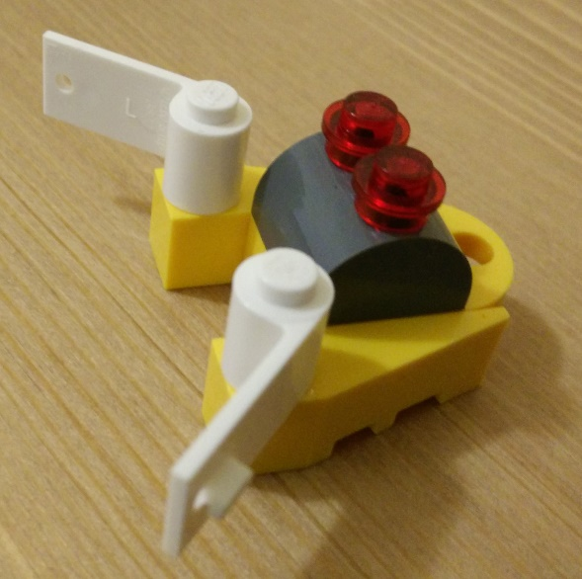
- Take the yellow helmet, and put it on the table, with the narrow edges facing yourself/down.
- Take the 2x2 yellow faceplate, and with the circular side facing down or towards yourself, attach it onto the helmet, the 4 nodes exactly on top of the helmet’s 4 nodes.
- Take the 2 white ears, and attach each to the helmet’s single top node, at about 45 degrees angle and 135 degrees respectively, such that they are pointing away from each other.
- Attach the gray half sphere with 2 nodes onto the 4 noes of the faceplate.
Figure 1: Head with two white ears; and 2 red eyes
- Attach the 2 red translucent circular buttons “eyes” onto the half sphere’s 2 protruding 2 nodes, making 2 read eyes.
- The head is now complete.

Body
- Take one red 2x8 brick and hold it vertically with the male nodes facing yourself, until told otherwise.
- On its third row, attach a 1x2 red brick horizontally.
- Take the head, and attach it to the 2x8 brick’s top 2 rows. The hole of the faceplate should cover the 3rd row of the 2x8 brick (on top of the 1x2 red brick).
- Right after the 1x2 red brick, on the 4th row of the vertically held 2x8 brick, attach 2 gray 2x6 bricks horizontally, covering the 2x8 red brick’s rows 4-7.
- Take 2 red flat-top triangles (1x3) vertically and attach perpendicularly to the center of the 2 sets of the 2x6 gray bricks, covering rows 1-3 of the gray bricks. The narrow end of the 2 attached triangles should be right next to the hole of the faceplate.
- Turn the whole thing around to see the back.
- Take a red 2x2 tall brick and attach it exactly to the center of the 2x8 red brick (on the back) vertically.
- Take a 2x4 yellow brick, and vertically attach it to the bottom 2 rows of the (back of ) 2x8 red brick, such that the half of the yellow brick will appear outside/below the 2x8 red brick.
- Flip the whole thing horizontally. The structure should now be facing you, vertically.
- Take 2 red 1x2 bricks, and attach them to the bottom visible 2 rows of the yellow bricks.
- Take the gray “stand” brick. With the 2x2 side facing upwards, towards the head, attach it to the bottom red brick (1 row).
- Take a 2x6 white brick and attach it vertically to the back of the 2x8 red brick, covering the remaining 3 top rows.
- Attach, horizontally, a 1x2 white lined brick to the visible third/bottom row of the white brick, just above the helmet.
- Take a gray 2x2 tall brick, and attach it to the remaining first 2 rows of the white brick, with the tube showing up on the top.
- Take the black round brick with holed extension, and attach it to the 4 nodes of the 2x2 gray tall brick.
- Take the 3-bladed gray propeller/rotor, and attach it to the top-most gray tube.
- Take the Lego man figure out a black dumbbell into his right hand and attach his feet onto the outermost row of the gray stand.
- Turn around the whole structure to see the back.
- Take the gray cylinder and attach it to the hole of the red 2x2 tall brick.
- Take the 4-bladed-8-nodes rotor and with the nodes facing away from the red brick, insert it onto the gray tube.
- On each of the 4 blades, attach a 1x6 black brick covering the 2 nodes of each blade respectively. The hole will be visible. This becomes the back rotor.
- Take the black “cross with 5 male nodes” and attach it on to the top of the center of the black rotor, covering the central hole.
- The body is now complete.
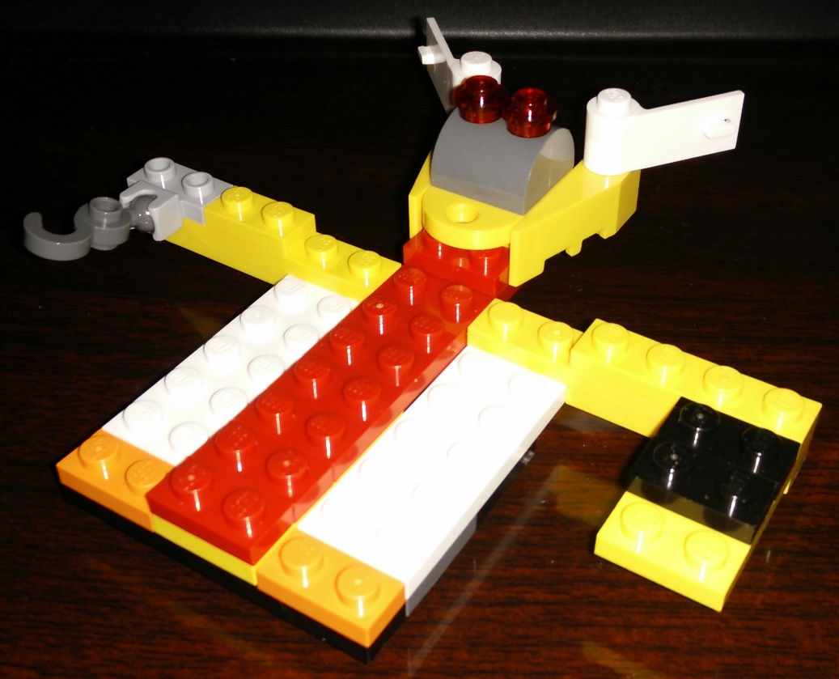

Figure 2: Incomplete body with head and two arms attached

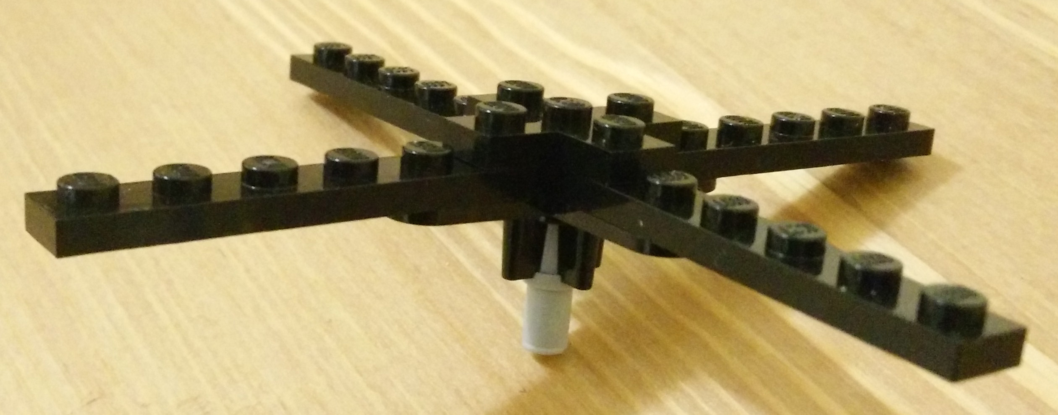
Figure 3: Large back rotor

Arms
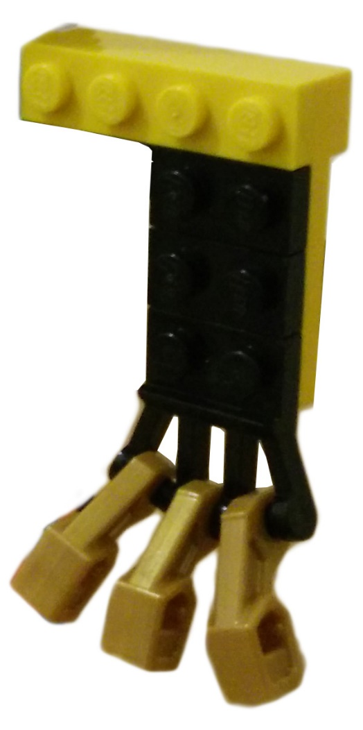
Left Arm:
- Take a 1x4 yellow brick, and attach horizontally onto the top-most row back of the body’s gray bricks. The remaining 2 yellow male nodes should snow be visible.
- Attach horizontally another 1x4 yellow brick on top of the visible 2 nodes of the previous yellow brick.
- Attach a 1x4 yellow brick vertically onto the back of the second 1x4 yellow brick, such that its 3 rows should be visible and hanging down.
- Take 3 black 1x2 bricks and attach horizontally onto the visible 2nd and 3rd rows of the yellow hanging brick. The bottom yellow row should visible.
- Take the 1x2 Broom-like black brick “palm”, and horizontally attach it to the bottom visible yellow row.
- Take the 3 brown “fingers” and attach to the 3 horizontal connectors of the palm respectively. The “palm” and the “fingers” now become a “robotic hand”.
- Attach 1x4 yellow brick horizontally behind the top row of the 2x4 yellow brick.
Figure 4: Left arm with 3 brown fingers
- The right arm is now complete.

Right Arm:
- Take a 1x6 yellow brick, and attach it horizontally onto the topmost row of the back of the body’s gray bricks. There should be 4 nodes visible.
- Take a 1z2 yellow brick and attach it to the first 2 yellow nodes from the body.
- Take a 1x4 yellow brick, and horizontally attach it to the back of the 1x6 yellow brick, from the outermost node, leaving the first two nodes from the body visible.
- Take the 1x2 gray hook holder and attach it to the outermost frontal 2 yellow nodes; attach the gray hook onto the holder with the hook facing downwards.
- The left arm is now complete.
Note: At the end, attach one 2x6 black, one 2x6 gray and one 1x6 black bricks horizontally right below the back portion’s 2x2 tall red brick respectively to make the structure stronger.

Legs
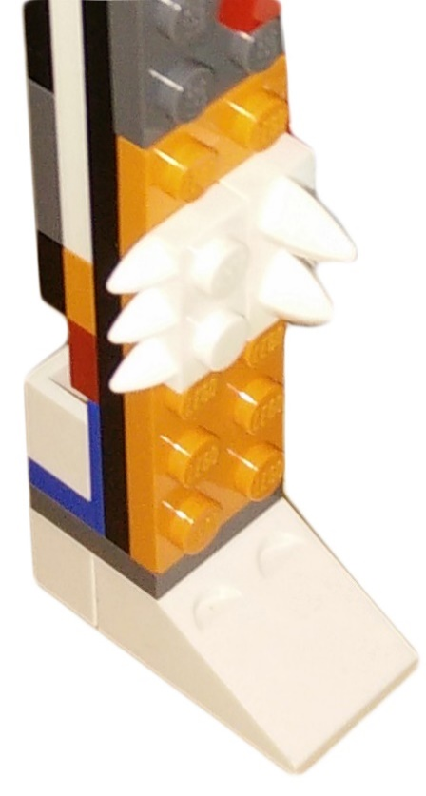
- Take 2 black 1x8 bricks and vertically attach to the back of the body’s bottom 2 gray row, keeping the 6 nodes of each black brick visible.
Figure 5: Leg with white knee spikes
- Take a 2x6 orange brick and attach it on top of the 2 black bricks’ visible make nodes, covering all black nodes.
- Take a white 1x2 brick with pointed “double spikes”, and vertically attach it onto the orange 2x6 brick’s 2nd and 3rd rows, on the side of the gray stand.
- Take a 1x2 white brick with 3 pointed spikes “triple spikes”, and vertically attach it right next to the previous white brick, covering orange brick’s 2nd and 3rd rows.
- Turn the widget around to see the back portion.
- Take a white 2x6 brick and attach it vertically on top the gray body, starting from the yellow arm’s 2 female ends.
- Take one orange 1x2 brick, one red 1x2 brick, and attach horizontally to the visible black female nodes, respectively, right below the white brick.
- Take the blue “L-shaped” brick and attach the wider side onto the remaining 2 black rows (near the bottom).
- Add a tall 1x2 white brick onto the female end of the blue brick.
- Turn the widget around, facing you, still holding vertically.
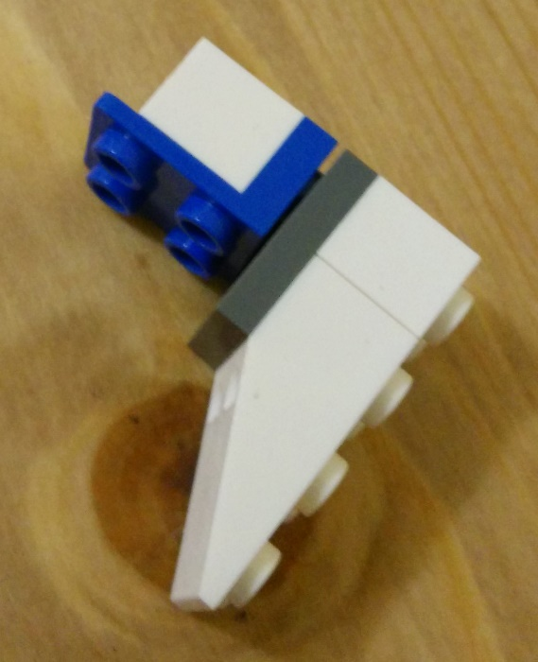
- Take a 2x2 gray brick, and with the male nodes facing down, attach it to the bottom facing 2 nodes of the blue brick, such that the gray brick covers the bottom of the frontal orange and the back’s blue and white bricks.
Figure 6: Shoe
- Take a 1x2 tall white brick, and with the male nodes facing down, attach it horizontally to the back row of the bottom 2x2 gray brick.
- Take a white triangular shoes. With the male nodes facing down, attach its female hole onto the frontal bottom row of the 2x2 gray brick, covering up all remaining gray bottom nodes. That completes the shoes.
- Repeat all the steps (1-13 to assemble the other leg).

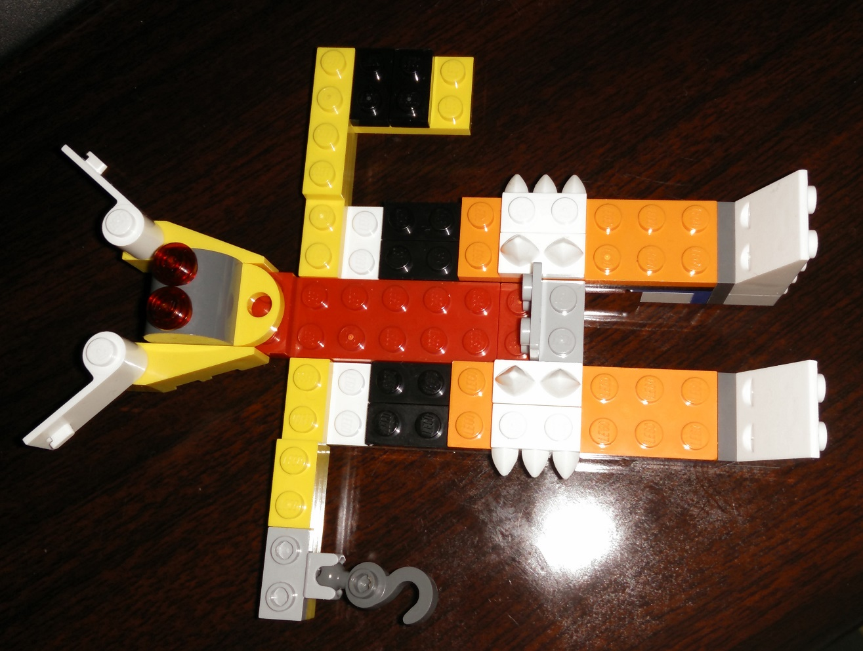
The Lego Robo Scarecrow is now complete and should look like the images below:
Figure 7: Almost complete, need to attach the Lego Man figure onto the gray stand.
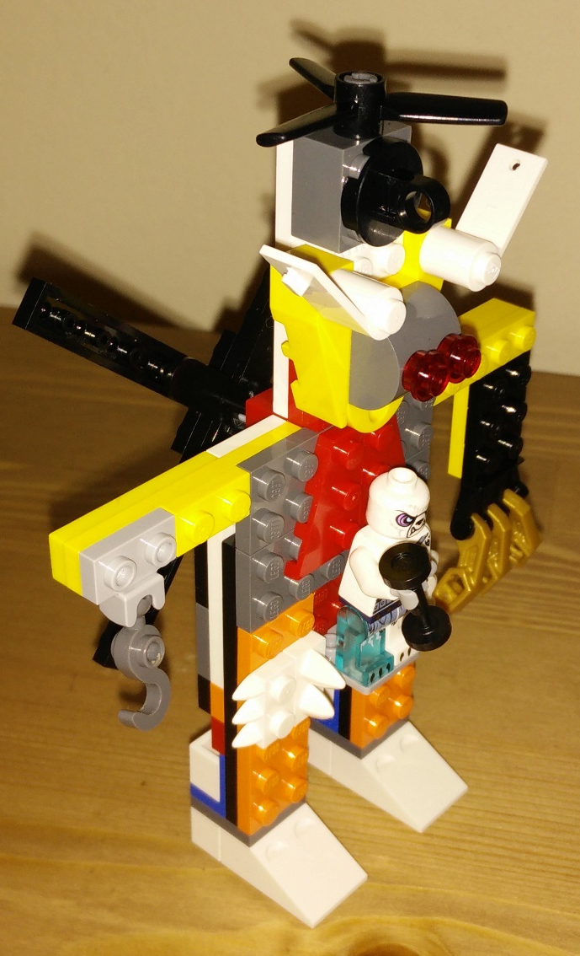
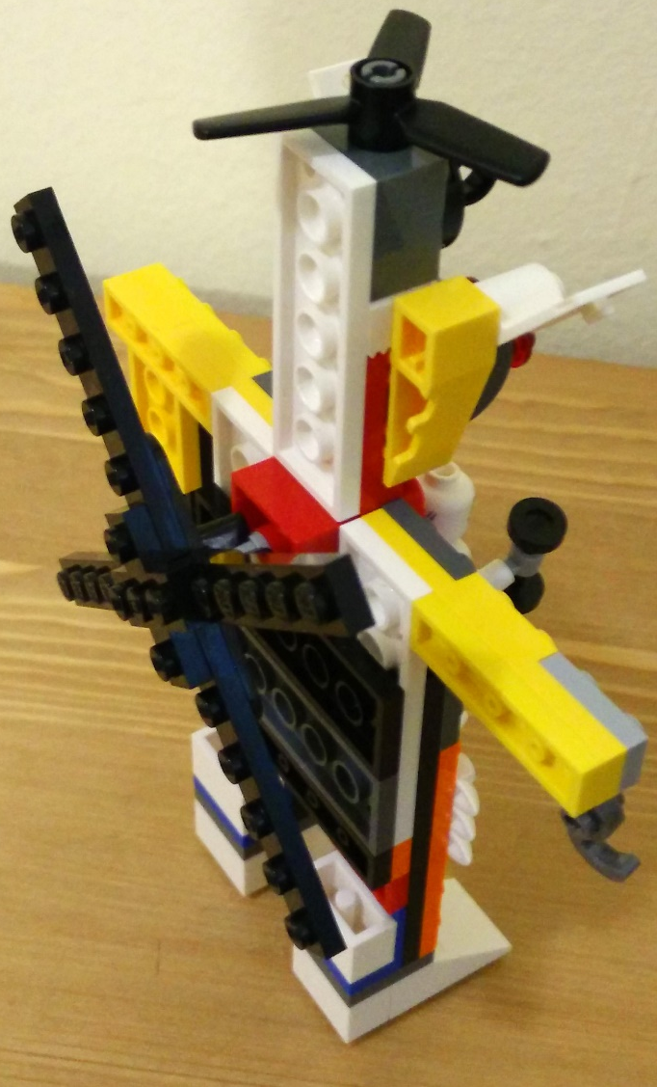
Figure 8: Completed Widget - Font View
Figure 9: Completed Widget - Back View

