Percents

- Suppose that the local sales tax rate is 7.5% and you purchase a bicycle for $394.
  - How much tax is paid?
  - What is the bicycle’s total cost?

- A computer with an original price of $1460 is on sale at 15% off.
  - What is the discount amount?
  - What is the computer’s sale price?

Percents II
HINT: $\text{Percent increase/decrease=}\frac{\text{amount of increase/decrease}}{\text{original amount}}$

1. In 2000, the world population was approximately 6 billion. Figure 8.2 shows world population projections through the year 2150. The data are from the United Nations Family Planning Program and are based on optimistic or pessimistic expectations for successful control of human population growth.
- Find the percent increase in world population from 2000 to 2150 using the high projection data
- Find the percent decrease in world population from 2000 to 2150 using the low projection data.
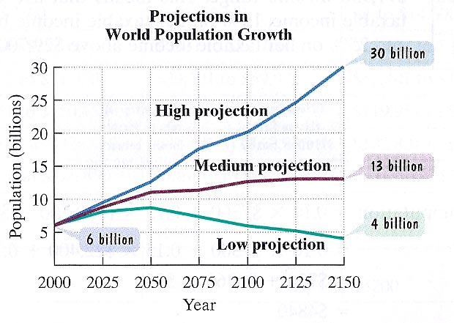

2. A jacket regularly sells for $135.00. The sale price is $60.75. Find the percent decrease of the sale price from the regular price.

3. John Tesh, while he was still coanchoring Entertainment Tonight, reported that the PBS series The Civil War had an audience of 13% versus the usual 4% PBS audience, “an increase of more than 300%”. Did Tesh report the percent increase correctly?

4. A politician states “If you elect me to office, I promise to cut your taxes each of my first three years in office by 10% each year, for a total reduction of 30%.” Evaluate the accuracy of the politician’s statement.

Interest

1. You deposit $2000 in a savings account at Hometown Bank, which has an interest rate of 6%. Find the interest at the end of the first year.

2. A student took out a simple interest loan for $1800 for two years at a rate of 8% to purchase a used car. What is the interest on the loan?

3. A loan of $1600 has been made at 6.5% for three months. Find the loan’s future value.

HINT: The future value of a loan consists of the principle plus any interest that accrues over the life of the loan. The formula for future value is:
$$A=P(1+\text{rt})$$

