Systems of Linear Equations Graphically
Consider the system of linear equations $\begin{matrix}x+2y=2 \\ x−2y=6\end{matrix}$
- Graph the first equation by finding the intercepts.
- Graph the second equation on the same coordinate grid.
- Find the coordinates of the point where they cross.
- Do these coordinates give a solution to the system of equations? Doublecheck by plugging in.

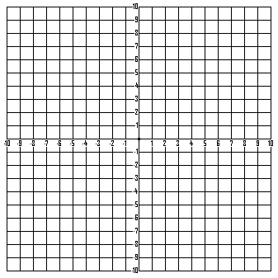

Linear Inequalities in Two Variables
Graph the linear inequalities.
a. $3x−5y³\text{15}$

b. $y\text{>-}\frac{2}{3}x$

c. $x>2$

Systems of Linear Inequalities
Graph the system of linear inequalities.
$$\begin{matrix}x−y<1 \\ 2x+3y³\text{12}\end{matrix}$$

HINT: Graph each inequality separately, then find the area where the graphs overlap. This gives the solution.

