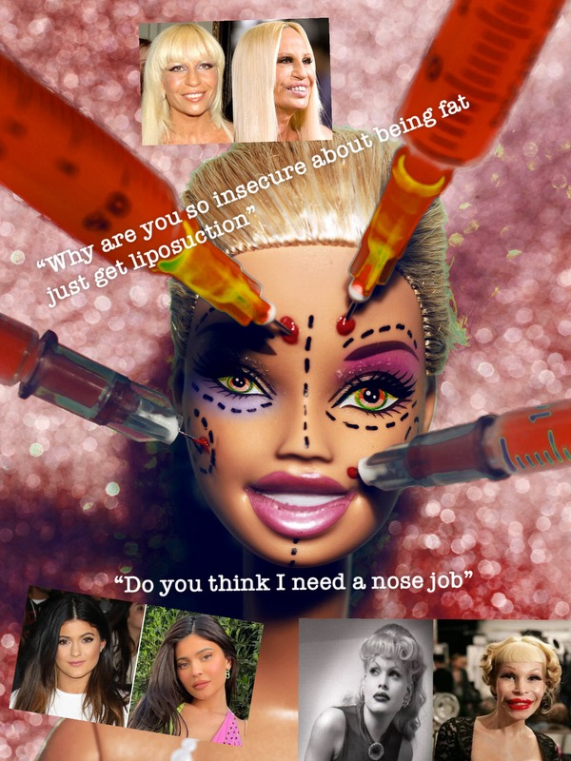

For my culture jam one of the topics, I am doing is beauty standards and social media. Social media can persuade unrealistic beauty standards. The constant exposure to carefully curate and often edits images may create pressure for people to conform to a narrow definition of beauty. This can have negative effects on mental health, self-esteem, and body image, particularly people around our age 20’s-30’s. It also creates anxiety making people ask themselves “Do I look good” “Do I need things done to my face” making them feel insecure about themselves. A lot of younger generation now start to get things done. I know boob jobs at 19 and 20 are a thing now and to me that is very young. Same thing with lip fillers ages 17 and 18. It is a positive and negative thing, being it could make the person feel better about themselves, more confident but also maybe not liking it afterwards or regret just because they wanted something done. In this image I showed before and after of celebrities who have gotten botched. Also lines I’ve heard people say before.

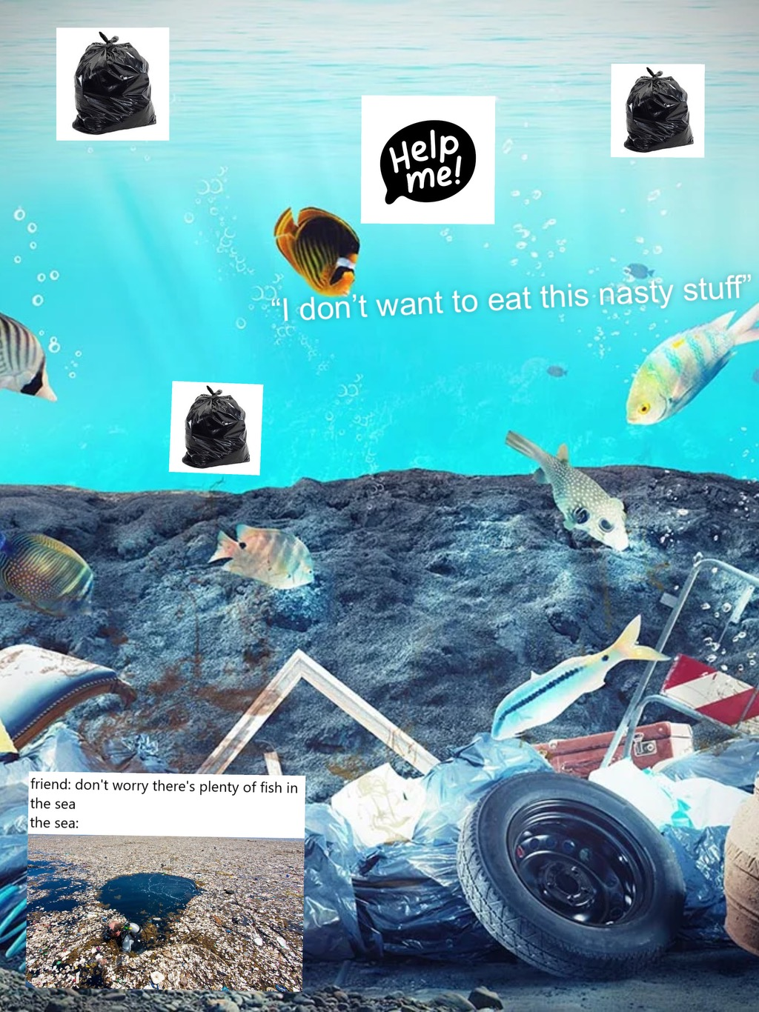

For my second topic, I wanted to do something with garbage landfills, the effects of littering, why pollution is so bad for the environment. Plastics, bottles, and other non-biodegradable materials not only mar the aesthetics of our surroundings but also contribute significantly to landfill overflow. Additionally, litter can find its way into the ocean, and can kill marine life. I created an image that would be best for what I was talking about. How garbage dumps and where our garbage goes can effect our marine life and animals in general.

