Parmbir Singh 12/4/2023
ENG 1710ID HD10

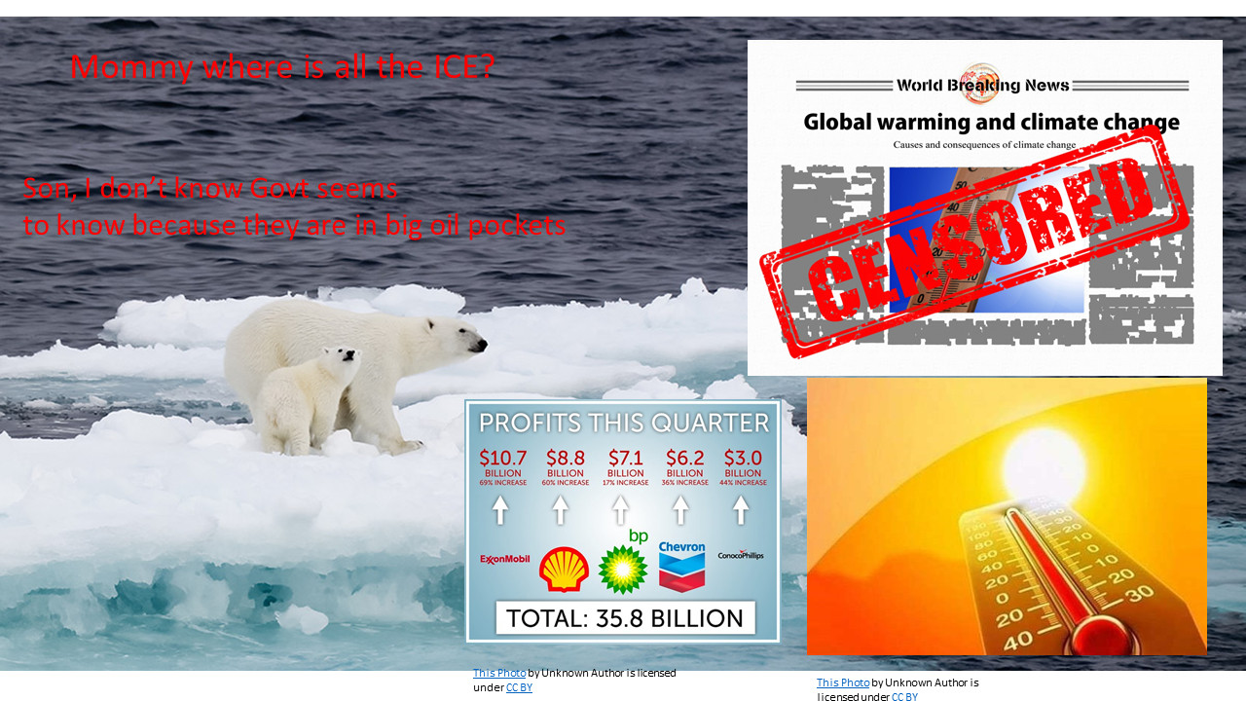

In this image of a culture jam I did climate change and showed the effects of how big oil the politicians ignored the effects of Climate change for far too long. In this image it shows a polar bear and her cubs with a melting rapidly melting ice cap. I also put texts for the bears such as the cub asking his mom why the ice is melting, and she responds by saying ask the govt officials who in big oils pocket. I improved on this part of the culture jam by using PowerPoint to make my jam due how much easier was to navigate through it. It also explains that rising global temperatures yearly is the reason ice caps melt rapidly.

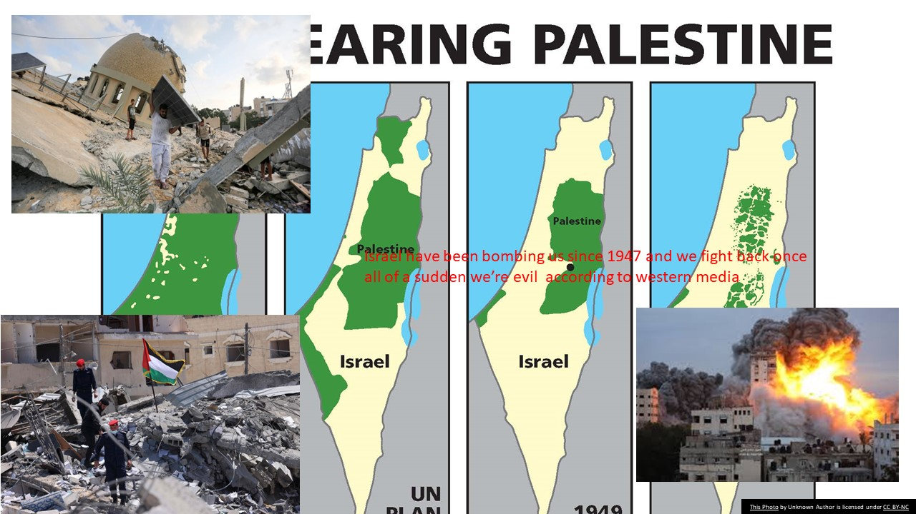

In this culture jam, I did an image off the ongoing Palestine Israel conflict. The culture explains that Israel have been bombing innocent Palestinians since 1947 and nobody in major western media said anything but when Palestine struck back recently all the western media appointed them as terrorists. However, the Palestinians fighting back are just trying to live and are tired in living in oppression by the Israeli government. It also shows how much land Israel stole from Palestine since 1947. The Israeli government also have displaced many Palestinians due to finding from their allies in the west such as the US. I improved on this part of the culture jam by using PowerPoint to make my jam due how much easier was to navigate through it.

