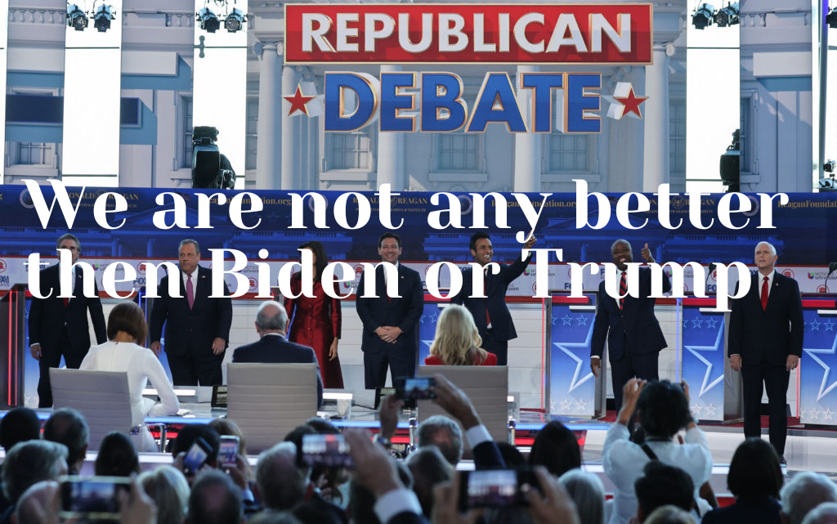

For the first topic, I got an image of the 2024 RNC candidates during a debate. The point is that they aren't any good candidates at all for 2024 US Elections. I feel like they aren't any better due to all of them in favor of Israel.

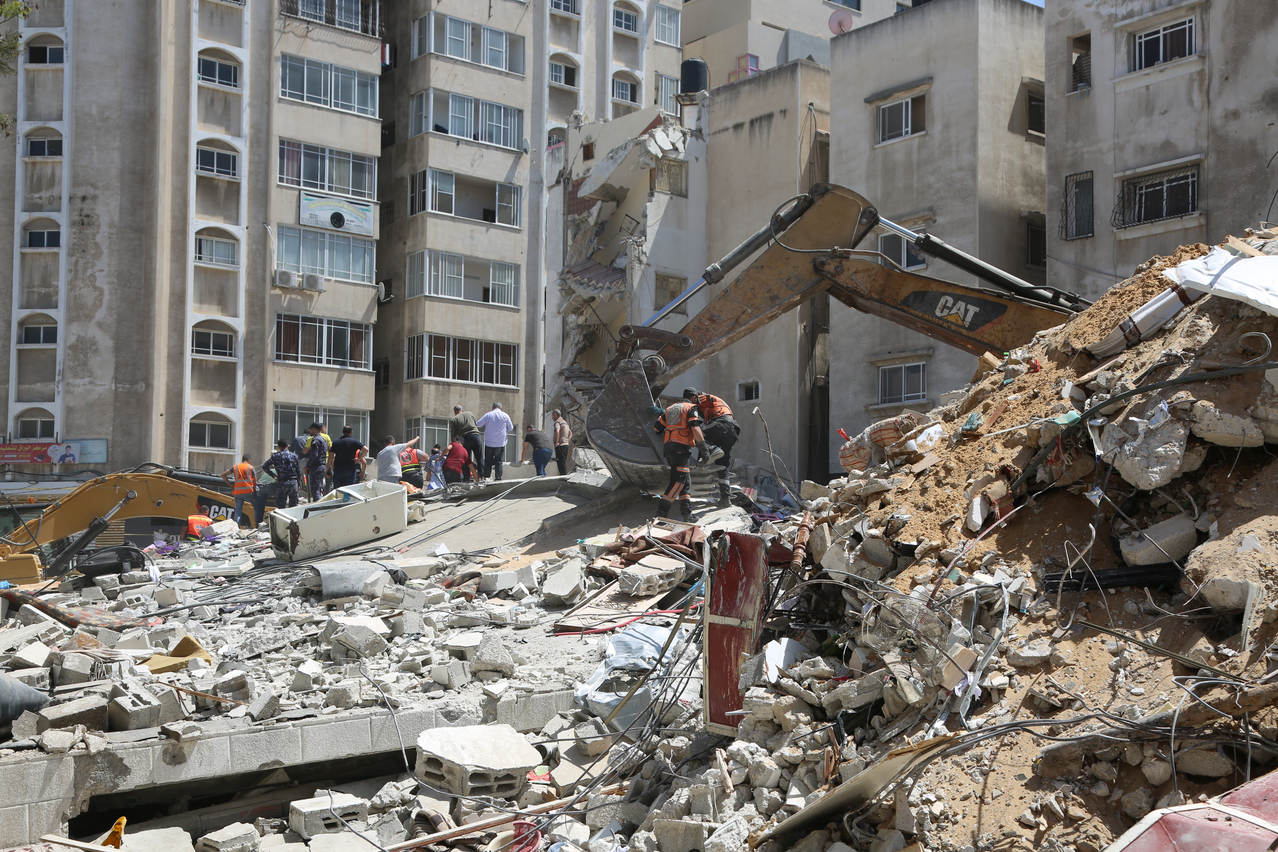For the second topic I chose the Israel and Palestine conflict, the reason I chose this topic and chose this is because of the destruction Israel have done to Palestine and the media favoring Israel for their war crimes. The image which I also got from Canva shows a damaged building Gaza.

In this image I got from Canva it is a protest sign about climate change. The sign stated that is s getting very hot on earth, it is implying that it is getting warmer and warmer on planet earth each year and most politicians around the world are ignoring it. This is due to being in pockets with oil pushing the agenda of denying it.

Works Cited

Press, Associated. “Live Updates: 2nd GOP Debate in the 2024 Presidential Race.” *PBS*, Public Broadcasting Service, 27 Sept. 2023, www.pbs.org/newshour/politics/live-updates-2nd-gop-debate-in-the-2024-presidential-race.