Technology/media exploratory paper
Antonino Giordano
10/6/23

McLuhan was a Canadian theorist of media and technology who rose to prominence in the 1960s following the publication of Understanding Media: The Extensions of Man, in which McLuhan argued that most previous works which explored media effectively missed the point. McLuhan argued that media and technologies in general were used by humans to extend their bodily capabilities into the environment, with different technologies augmenting the capacities of different sensory organs.

My topics/ what I will be talking about is Apple, Bluetooth, and robots. Let’s start off with the world-famous Apple. Apple designs, manufactures, and markets smartphones, personal computers, tablets, wearables, and accessories and sells a range of related services. The Company's products include iPhone, Mac, iPad, Air Pods, Apple TV, Apple Watch, Beats products, Home Pod, iPod touch and accessories. The company was founded in 1976 and the first product that was successful was the 1998 iMac it got rid of a drive and replaced with a USB port. Apple is a company that is known to put ease-of-use as the main goal when designing a product. And as technology continues to advance, Apple still manages to create a product that works for absolutely anyone using it, with therefore researchers have found that elderly people lean more towards Apple than Samsung.

Moving onto to the person who invented it all, Steve Jobs he redefined technology and made a huge impact to this world by creating products and services. As Jobs says, “Apple is about people who think 'outside the box,' people who want to use computers to help them change the world, to help them create things that make a difference, and not just to get a job done.”

I ask myself till this day how will technology affect us in another 10 years? So, looking into Apple here is what they have to say, “The company is exploring emerging technologies including augmented reality (AR) through its AR developer platform Ark it, and there are rumblings of the release of the new Apple Glasses.” The Apple Glasses are coming out at the end of 2023 with a retail price of $3,500 which is insane and what it is basically VR glasses but 10x fancier, you can use your hands to control everything, etc.

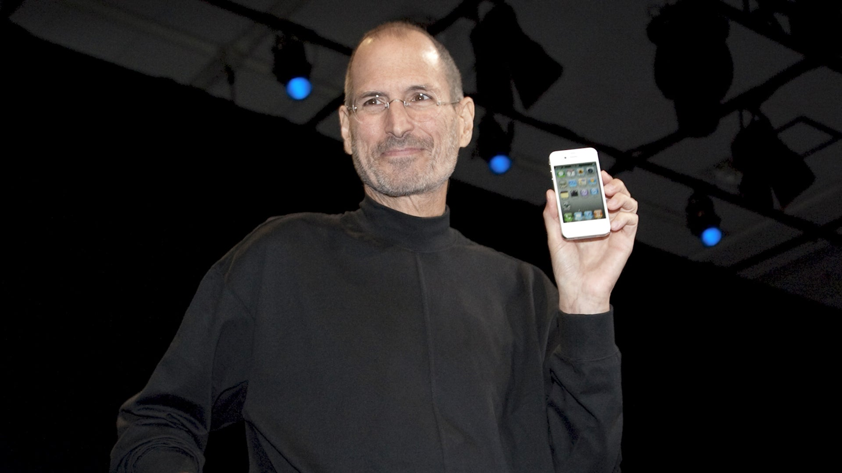

Work Cited:
https://www.uschamber.com/co/start/strategy/steve-jobs-quotes-for-business-owners
https://www.wired.com/2016/04/apple-40th-birthday/#:~:text=His%20first%20major%20product%20was,Its%20designer%3F
https://en.wikipedia.org/wiki/Apple_Inc.

Now onto my second topic which is… Robots. Starting off with one of McLuhan’s quotes I cited where he says, “First we build the tools, then they build us.” Meaning technology could get so advanced it could take over our world. These hyper-intelligent entities are well positioned to shape our future. Of course, “shape” is a loaded term. It teases questions such as: “how much,” whether the shape/paradigm, new epistemic reality will be reflected on as being “good” or “bad,” will us humans even survive if they took over?
At my local supermarket Stop&Shop we have robots that come around and ask if you need help finding anything. Also, it has huge eyes to see if something spilled in the aisle and checks for in stock things to see if the store needs more of it. Crazy how technology works these days huh… even at your local grocery store! A lot of people are 50/50 about it saying that they love it or hate it because of how it could get in the way and loving it, so you don’t always have to call for a real store assistance.
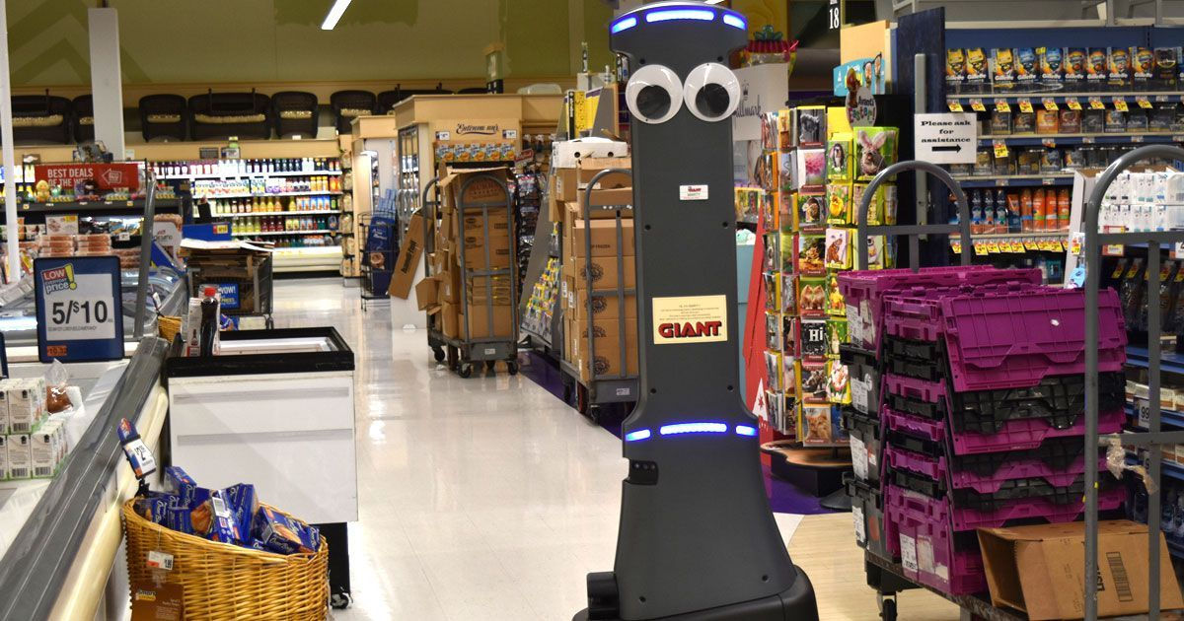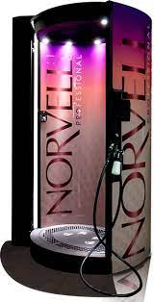

Now continuing with robots where I go to tan, we have a Norvell Spray booth which is a handheld spray machine or a robot tells you what to do and basically commands you how to move for example “keep your arms up for 5 seconds 1,2,3,4,5 complete”. They never had that in the past, there would always be a technician doing it.
Going even further what do you think about robot dating? Yes, there is such thing. Inventors are creating apps like Tinder but robot version. There are videos on YouTube about it and even Will Smith has tried it. Could this be the new future?

Work Cited:
https://law.stanford.edu/2014/09/18/first-build-tools-build-us-marshall-mcluhan/
https://techxplore.com/news/2023-05-robots-life.html
https://thecounter.org/supermarket-robot-automation-ai-organized-labor-stop-and-shop/

Moving onto Bluetooth, by experimenting with multiple different factors and assets, Haartsen finally was able to create a technology that used UHF radio waves at 2.4 GHz. He was able to make this protocol consume a low amount of energy while operating properly at a shorter range. Like McLuhan says as a medium makes one thing easy, it makes other things hard. If you’re reading on a laptop or a phone or an eBook reader, each of these devices will also change how you engage with the content. Reading on an eBook reader while lying alone on your couch is different than listening on a subway surrounded by people or listening on a Bluetooth speaker while cooking dinner.

