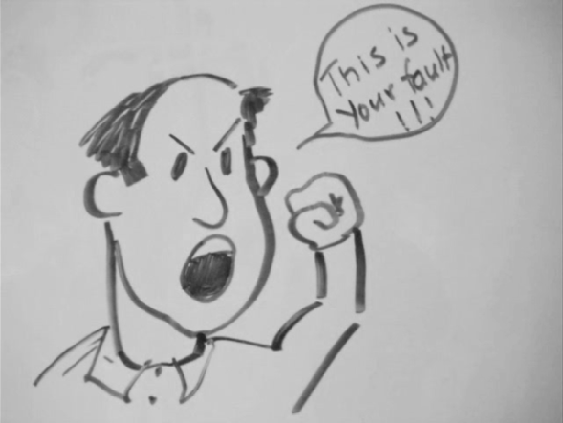

I drew this picture because of Pg 145 McLuhan saying, “Ask ourselves more questions”. In a way it relates to me because since I am shy, I don't speak up enough. Now that I am getting older, I try my best to. The picture is describing a scenario whether if you don't say something it might lead to something good or bad.

