Diana Rivera
October 2022
Professor Leston
ENG 1710
When one thinks of technology, you think of the electrical stuff. Our phones, our laptops, our television; you know the basics. But surprisingly technology can categorize a plethora of things. One being our handy-dandy metro cards. These flimsy cards are what most of New York City relies on, whether that’s to go home or go to school or even to go to a hangout with friends. It’s a thing that has a bigger impact in our lives because that’s what allows us to travel in an efficient manner. Whether that travel be through the subways or the public buses. The technology that the MTA uses hasn’t always been the MetroCard; and surprisingly it’s not always going to be either. In about 2 years, us New Yorkers are going to have to get used to paying our fares in a different way. The OMNY way. But is change always a good thing? Do we really need to change our way of payment to make it fair for everyone or is it just a cash grab for the MTA?
The train token was something introduced to New Yorkers back in 1953. They were only 15 cents, but since we live in New York it was only 13 years till the price went up to 20 cents. The original token is the Small Y token. Prior to the token, a train ride was only 5 cents, the reason for the token was because of the price raise. It was hard for them to change the change slots to fit two cents of two different sizes, that being the nickel and the dime to accommodate the 10 cents difference they were making to the price for a train ride. Train currency was made not only because of the struggles of making a slot to fit two coins or different sizes, but also, typical government style, it was a lot cheaper than having to change every slot in these train stations. Hence why the tokens were made, they were made to fit the size of the slots originally intended for a nickel. The token took on many changes, not only in its currency but in its physical look as well. When it comes To the look, the size of the token went from being the size of a nickel, to the size of a quarter. As the price increased, so did the size of the physical token. The change in size wasn’t an issue for people, in fact the change of the token wasn’t that hard, it just created an issue of people forgetting that they need a token, not an actual coin. The issue that many had with the token was the issue that they had in previous struggles pre-token. The struggle of having their token be lost in their pocket or purse. We all know the struggles that one person can have when looking for change in their wallet or bag. Their size doesn’t help us find them when needed, and they definitely had that problem in the 50’s. 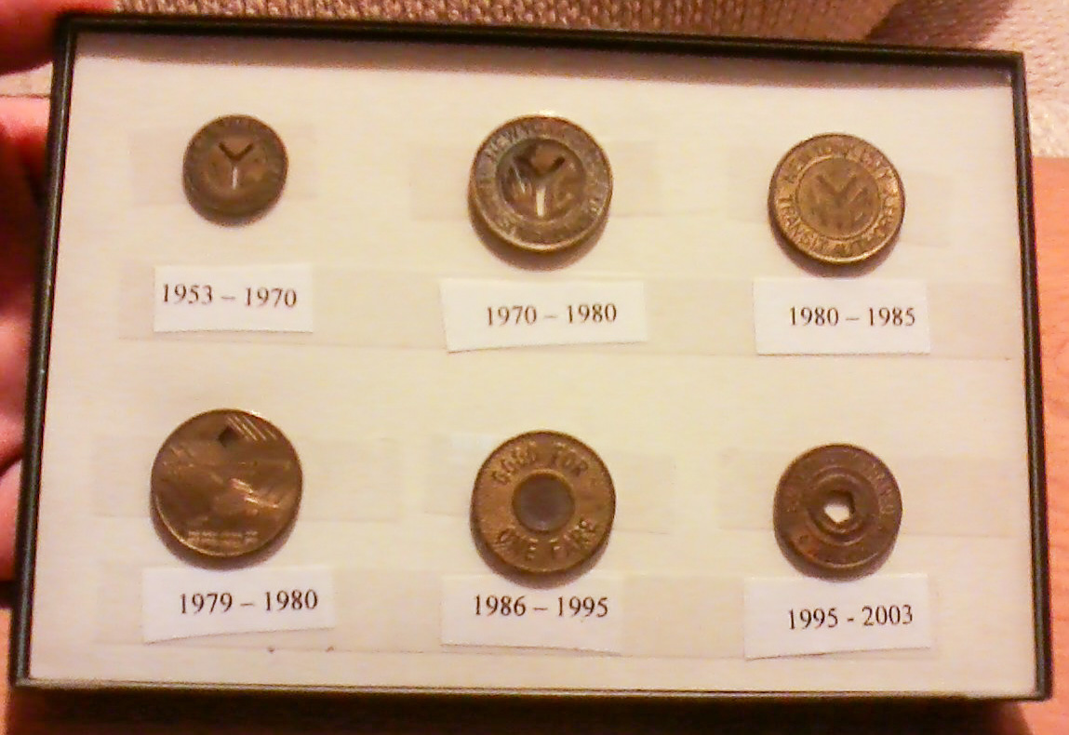
This issue then leads to the making of the Token Holder. Was a metal contraption made to make finding your subway tokens in an easier way in your bag. The token holder had three token slots, being made to carry 9 tokens, three tokens in each slot. Although it made finding tokens a lot easier for them to find them from their bags and pockets, they would have the issue of leaving their token holders, along with their tokens at home. When that would happen, people figured that they can easily find a different way of paying for the subway. Slogs. The token was made from a special type of metal, a metal that made them magnetic. The reason for this being that they were trying to make the token impossible to copy. This way people couldn’t just make a token at home from any sort of metal the way that people make money out of any sort of paper. So what about slogs? Well slogs were different items, all the same size and width of a subway token, but had no value. And although they didn’t have value, the token slot wouldn’t keep track of currency, rather that being the size of the item can get through the turn signal to turn and allow the person through.
Another issue of the token-era was token-sucking. Nowadays, due to Covid, a person wouldn’t put their mouth on anything public transportation related. But that wasn’t a thought in a person’s mind in the 80’s and 90’s. Token-sucking was when a person would put their mouth on the token slot of the machine and inhale, or suck up air. Why? Because that way if there was a token near the entrance of the slot, they can suck up a free token and pay to enter like that. And the reason why it was so easy for someone to do this was because most, if not the majority, of token slots would be clogged up. The reason for these clogged up token slots, the tokens were collecting lint in the bags and pockets of the people of New York City. This made an impact and even played an impact in the transition into the metro card, these issues causing the MTA to lose money. If someone was using slogs or token-sucking it creates an issue of either a plateau of money gain for the MTA or even a decrease in the amount they will gain weekly, perhaps even daily because of the loopholes people were finding to get a way out of paying for their subway rides.
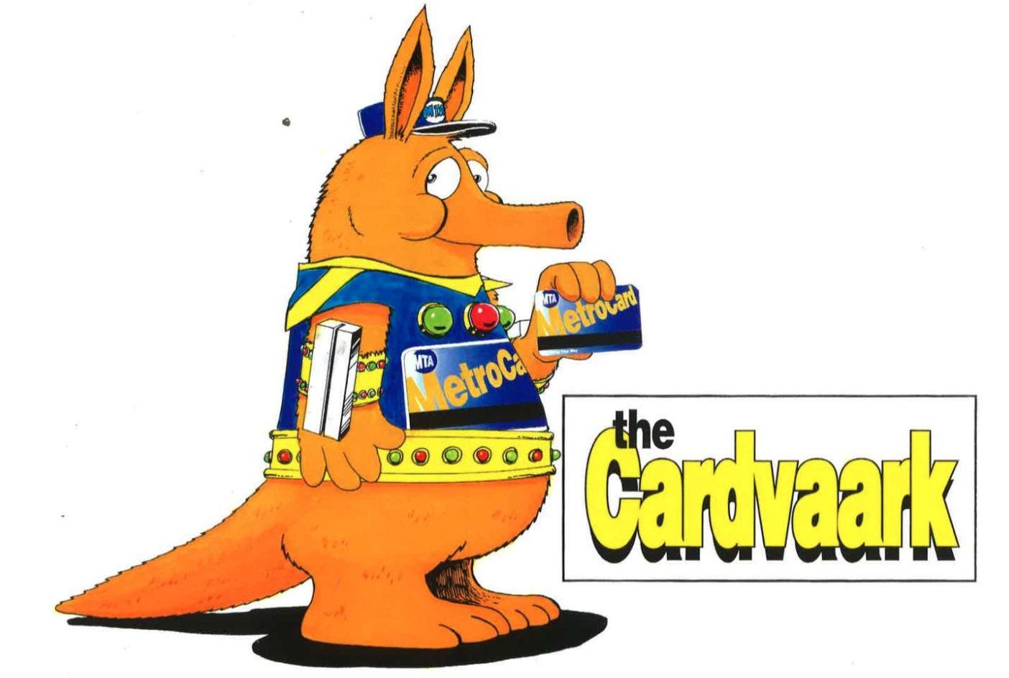
The well-known and well-loved metro card was introduced for the first time January 6, 1994. A person would no longer need to pay for a Timesaver pack, a pack of 8 subway tokens, they will now need to go to a subway booth to buy a MetroCard. The MetroCard came in three options, the way that it still is, a 30-day MetroCard for $63, a 7-day MetroCard for $17, and a one-day MetroCard for $4. The reason behind the making of the MetroCard, officially, is to make mass transit easy for New Yorkers who need to take a train and bus to get to their destination. How? Well, the MetroCard offered something that the token didn’t. A free bus-transfer after swiping your MetroCard for a train ride. But many New Yorkers believed that the reason for making the MetroCard and replacing token slots with MetroCard turnstiles was to be able to make the price of a subway ride more expensive. By the time that the token ended, which was April 13, 2003, it was at the price of $2. Now with the MetroCard being introduced, it was an increase of $2 for a simple one-day MetroCard. But many argue that the one-day MetroCard gave the same price as a two token when you go on the train and transfer to the bus. Another issue being that many found the 18-minute wait to use another swipe, you know classic New Yorker impatience.
MetroCard’s were to show the rider that they have more options rather than just taking the train or the bus. The introduction of the MetroCard shows the spike in riders almost six percent more than the amount of riders there was while the token was still in town. They were giving the ability for riders to get to their destination faster than it was before. During 1996, the MTA got a huge break when it came to tax season, giving them a green light to offer people discounts for riding. The unlimited MetroCard was introduced in 1998, giving working people and kids in middle and high school unlimited MetroCard’s for periods at a time for free. Needless to say MetroCard’s became a hit to every New Yorker. From the easy way to hold and carry it around to the unlimited free transfers, what was there not to like about the MetroCard?
The MTA was gaining about $3,170,774 a day with the increase in popularity for the MetroCard. Which then gave the MetroCard the nickname ‘MetroCard Gold’. When the MetroCard was made, it wasn’t the yellow we are so used to nowadays, it was blue with yellow writing for ‘MetroCard’ written across the blue background. Basically, the way that it looks now, just with a blue background and yellow writing. They decided to change the look when the nickname came to light, ‘MetroCard Gold’. The MTA also had enough space to give advertisements on the back of the MetroCard since 1995. It wasn’t until 2012 where the MTA took advertisement to the next level. They began to offer front advertisements to the front of the MetroCard to TV shows and to brands as well. The bigger the amount of cards the brands bought, the cheaper it got to label per card. A popular example being the famous supreme MetroCard’s being sold at train station booths in 2018. After supreme, followed the equally famous David Bowie MetroCard’s.
Issues began to rise when people started to refuse to pay for their subway rides, again. In 2018, the MTA began to see an increase in what they call ‘farebeaters’, people who refused to pay their subway fares. They release a video showing the amount of people they catch on camera footage that either jump over the turnsite, crawl under it, or walk through the door when people leave or open to let their carts, walkers, and wheelchairs in. Some pretend to swipe and jump over, others just straight up jump. During this time they went on to estimate the amount of money they would lose if they continue to allow people to skip the fare charge, and that number being $215 million dollars. This situation had been going on long before 2018, in 2015 they were losing $110 million to the 319,000 people skipping the fare on buses and subway combined. That number then increased to 556,000 in 2018. This issue had an easy solution to the MTA, cops.
The NYPD became the MTA’s best friend when they began to increase the amount of cops in subway stations because of the amount of people jumping the fare. Creating an issue of the people of New York feeling negative feelings towards the police giving people a ticket of $100 when the police caught you jumping, crawling under, or entering through the door without paying for the fare. Another solution to this became the future to our transportation; the OMNY card.
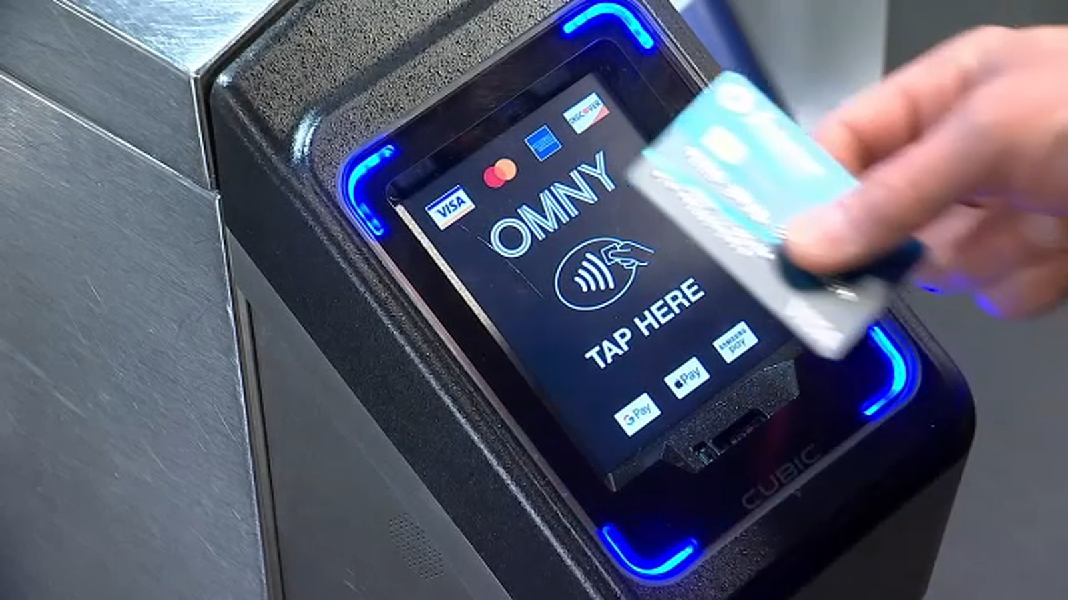
The OMNY card is the future of the MTA. This began to come to flourishion during 2019, when it began to pop up at certain stations to be tested. The OMNY way allows someone to pay for their fare by simply tapping their credit, debit, or pre-paid card or digital wallet on the screen shown above to pay for their $2.75 fare. The goal of OMNY is to equal the amount of each fare that everyone pays. You can also buy an OMNY card, which does include a free-transfer. OMNY even allows a person to put in their previous information that they would put into a discounted program like fair fares, a program that gives people of a certain financial level the ability to pay half price for a monthly unlimited, to continue to pay for an OMNY card for half price. The OMNY card can also be refilled at any store such as Walgreens, CVS, or even a 7-Eleven. The cost of an OMNY card is $5 with a minimum of $1 in the card or a fare price.
Another goal for OMNY is being to be able to connect riders to not only the bus or the train, but to other transportation such as the LIRR. OMNY also gives people a benefit of fare capping. Fare capping being when you ride the train for 12 rides in a row, you will get the rest of that week free Monday through Sunday. But the catch is that you need to use the same way of payment, whether that be a phone, a digital watch, credit or debit or prepaid card, or an OMNY card. The issue coming up with the OMNY card from what is being heard, is the issue of if someone would like to buy an OMNY card, they will have to pay about $7.75, a $5 for the card itself and then $2.75 for the fare. Yes, if you go on to apply for a card you can be able to pay half price if you were eligible to pay for a metrocard at half price. Not only is that an issue, but let's say you don’t have an OMNY card and your device that has your digital wallet is damaged, you can’t pay for the fare. And there is also a possibility of the OMNY double charging your device for two rides, and if that happens to you, you have to go to your OMNY account and dispute it. But if you don’t have an OMNY account you would have to dispute that problem with your bank.
With the introduction of the OMNY card, where does this leave the metrocard? Well coming 2023, the metrocard turnstiles will be no longer. Just the way that they did with the transition from the subway token and to the metrocard, they are going to get rid of the metrocard machines. And by 2024 the MTA is hoping that the metrocard will be no more. They are still working out the kinks when it comes to OMNY, but the future of the MTA is the OMNY way. OMNY is working on being able to provide railroad ticketing, student fares, special programs, and reduced fares for eligible riders and riders who are willing to pay for these type of OMNY programs.
The future of paying for the MTA may be changing, but one thing is for sure; New Yorkers will forever rely and be grateful for the MTA. Whether we were paying with a dime, a token, a MetroCard, or in recent times, our phones for a tap and pay, the subway and buses have been our community. Getting us to where we need and want to be. Offer us a place to stay dry when it rains or snows. And a place where we fall asleep when we get out of class or work. It’s something that has impacted our lives forever. But New Yorkers will always find a way to save, whether that be jumping over a turnstile or even token sucking, we will find a way to get on our train or our bus without paying a dime.

References:
Subway Tokens
DeCesare , Jason R, et al. “New York City Subway Tokens.” Nycsubway.org: New York City Subway Tokens, www.nycsubway.org/wiki/New_York_City_Subway_Tokens.
Saraniero, Nicole, and Monique Zamir. “Remember NYC's Subway Tokens?” Untapped New York, 29 Aug. 2022, untappedcities.com/2022/01/14/nyc-subway-tokens/.
Carlson, Jen, and Kerry Shaw. “A Brief History of How New Yorkers Have Paid for the Subway.” Gothamist, 6 Jan. 2022, gothamist.com/arts-entertainment/brief-history-how-new-yorkers-have-paid-subway.
Metrocard
Carlson, Jen, and Kerry Shaw. “A Brief History of How New Yorkers Have Paid for the Subway.” Gothamist, 6 Jan. 2022, gothamist.com/arts-entertainment/brief-history-how-new-yorkers-have-paid-subway.
John, et al. “How the Unlimited MetroCard Revolutionized Transit.” Second Ave. Sagas, 1 Apr. 2010, secondavenuesagas.com/2010/03/31/how-the-unlimited-metrocard-revolutionized-transit/.
Jen ChungPublished Dec 5, 2018Modified Dec 6, and 2022 at 3:59 p.m. Matt KatzPublished Oct 13. “Video: NYC's Wide Variety of Subway Turnstile Jumping Techniques.” Gothamist, gothamist.com/news/video-nycs-wide-variety-of-subway-turnstile-jumping-techniques.
Nonko, Emily. “The History of the New York City Metrocard.” 6sqft, 8 Nov. 2017, www.6sqft.com/the-history-of-the-new-york-city-metrocard/.
OMNY
Carlson, Jen, and Kerry Shaw. “A Brief History of How New Yorkers Have Paid for the Subway.” Gothamist, 6 Jan. 2022, gothamist.com/arts-entertainment/brief-history-how-new-yorkers-have-paid-subway.
“Account Management.” Account Management, omny.info/faq/account-management.
“How Omny Works.” How OMNY Works, omny.info/how-omny-works.
“How Does Fare Capping Work with Omny?” YouTube, 24 Feb. 2022, youtu.be/J59P1UbHswY.

