Aaron Nieves
Professor Leston
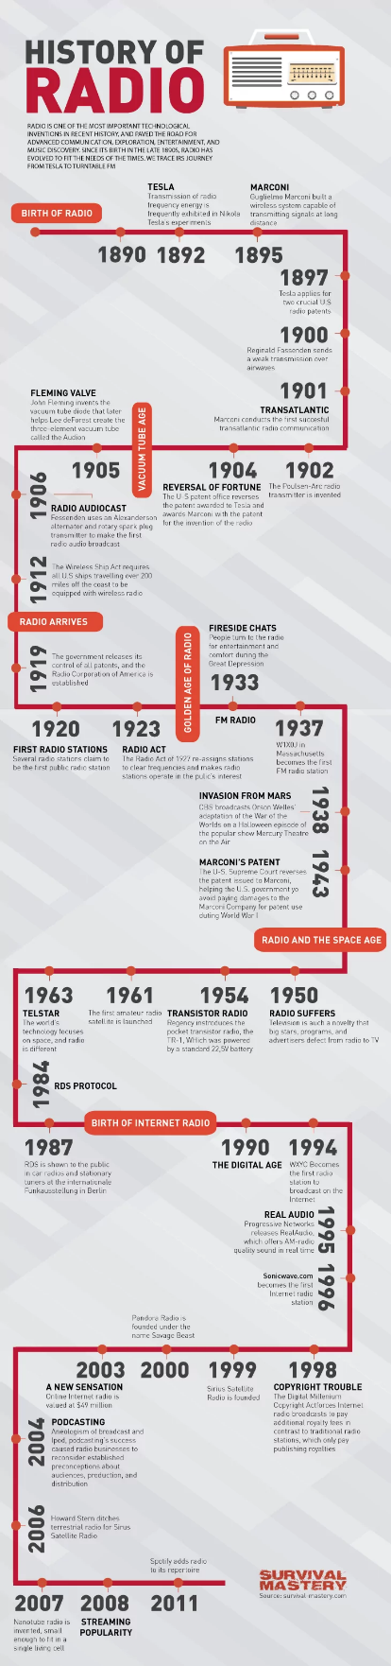
October 11, 2022
ENG 1710

Impactful Pieces of Technology
Technology takes many forms. It elevates efficiency and lowers the workload for people. Some are more impactful than others. Technology makes life easier for people. Instead of reading a book, you can listen to the radio. Instead of listening to the radio you can watch the television. The radio, artificial intelligence and virtual reality all have had or will have a strong impact on society. Although there is a cost to making life easier.
The radio is a type of sound communication that allows broadcast stations to transmit music, news, and other programs to its listeners. This is possible through radio waves and the listener's radio receivers. The international use of the radio started in the early 20th century, it became primarily known for its fast transmission of news and entertainment.
The inventors of the radio proved that wireless communication was plausible via the radio waves. Its invention was first used by the U.S. Navy through the 1912 Wireless Ship Act which allowed them to communicate offshore and be the only ones to have access to it. In 1919, the government released its control of the radio use which allowed people to explore its uses. The radio became mostly popular during the great depression in 1933, as many people started to use it as a distraction and remain informed.
One of the radio’s outcomes was how it influenced the public’s opinion. An example of this was when “the easy-to-listen-to speeches of Franklin D. Roosevelt unquestionably brought out more voters than the same speeches would have brought out if they had only been read” (Bartlett, 1947, p. 91). Bartlett (1947) goes on to say that the radio was most likely to influence its listeners and that most of them switched from Republican candidate to Democrat candidate because of it.
Artificial intelligence has been emerging more and more over the past couple decades. We see the influence of artificial intelligence even in our forms of entertainment, such as movies. The Terminator (1984) and Ex Machina (2014) are great examples of the fear that arises with the thought of artificial intelligence. A piece of technology being able to have its own thought process and function without assistance is something that can be a little scary.
Technology that can almost “think and act” on its own. Artificial intelligence is most referred to computers and machines and their creation to act “independently”. The computers or machines are created to translate data given to it and use it loosely to achieve a certain outcome. Some AI’s functions can be narrowed down to simple tasks, such as Siri or Alexa performing searches for you through the internet. Another example of artificial intelligence are the smart cars we are starting to see throughout our streets. It can be argued that Tesla's whole platform in the auto industry can show how their cars have a sense of intelligence (and that they are electric).
There are currently developments for stronger AI that can simulate the human mind. Ex Machina is a movie that was inspired, but these developments. Can a machine become human and have the same properties we carry or is it just code we create to create the perception of an actual human. Alan Turing asked the simple question “Can machines think?” at the start of his piece Computing Machinery and Intelligence. Turing introduced a test to see if we can differentiate a human from a machine, where there is a questioner and two respondents. One respondent was human and the other was a computer. This test would later mold the ideas for artificial intelligence.
The outcomes of artificial intelligence can be seen as both a positive and a negative. Enhancing the “intelligence” of technology can vastly improve the amount of work that can be done for a company. Artificial intelligence adds efficiency and makes life easier, but at a cost. This can influence employment in certain areas. Unlike humans, a machine doesn’t need to take breaks. All you’d have to do is monitor the machine from time to time. We can see examples from a couple of Porsche’s factories in Germany. Today we see less and less people working the assembly line in comparison to fifty years ago. A member of Porsche’s executive board, Albrecht Reimold said “[we] will become the first vehicle manufacturer to use driverless transport systems in a continuous series production process.”
Artificial intelligence can even affect how we communicate with one another. Creating a machine to act and solve problems on its own can eliminate the need to have discourse amongst us. We no longer need to talk and think to find answers to things if we have an intelligent piece of technology processing all the databases for answers. We see earpiece translators being used during the general assembly of the United Nations. People don’t have a need to try to learn new languages.
Virtual reality is another form of technology that has been opening doors to new worlds and opportunities. Virtual reality is an artificial environment created to simulate a three-dimensional plane. These artificial environments and images are created through computer software allowing us to enter new worlds. Typically, when one enters these new planes, they wear a headpiece covering their vision from any outside distractions. Virtual Reality can be found in many different industries, the most common are video games and health care.
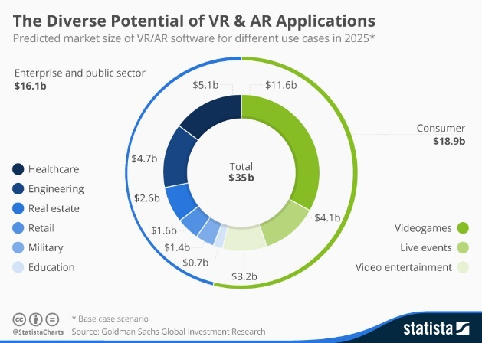
The average person will think of video games when the words “virtual reality” enters their minds. In Star Wars: Squadrons you can enter a different universe entirely and become a pilot in space. You sit in a cockpit and experience this world through “your own eyes”. You turn your head up and maybe you see the stars or maybe a massive space station above you. You turn your head down and you see the controls of your ships “in your hands”. Maybe you don’t want to be a pilot dogfighting in space. You can enter a medieval world where elves and dragons exist. In The Elder Scrolls V: Skyrim VR, you can travel around the fantasy world of Skyrim. Trekking through mountains and small villages. Encounter Dragons burning the grounds in front of your “feet”. The developers of the game have almost fully engulfed you into the world they have created for you to experience.
Virtual reality still has its limitations. Outside of the video games industry this technology has had minor feats. We currently are seeing the use of virtual reality in the biomedical space for the purposes of research and study. “David Vining, a radiologist at the Bowman Gray School of Medicine at Wake Forest University in Winston-Salem, North Carolina, has developed what he calls a ‘virtual colonoscopy.’” (Stevens, 436). Here David Vining was able to transform CT scans into a three-dimensional space. Observers were able to move around the colon to find any abnormalities. Vining developed this process back in 1993 and since then the technology has been used all over the industry from virtually conducting procedures, such as heart transplants, to even just marketing purposes.
With the growing popularity of virtual reality, the increase in medical drawbacks begin to rise as well. Virtual reality has been known to disrupt one’s sensory system causing several side effects, such as motion sickness and loss of balance to name a couple. Now most of the medical drawbacks are short term. A scientific coordinator for ANSES, Dina Attia, recommends taking time to rest after a session on virtual reality. She says, "The body makes a great effort to adapt to the virtual world it interacts with, which can lead to fatigue. It is therefore important to allow an hour or two of rest before resuming an activity that requires a high level of concentration, such as driving a car,".
Some may consider virtual reality as a “niche” technology. It’s not a piece of technology that can be socketed into every outlet. Especially, due to the limitations and accessibility of this technology now. In its infancy, if you wanted to play a virtual reality game the number of wires you had to set up was a hassle. Now you can just buy a headset and hand pieces. Still, the piece of technology has its expenses, as well as technical and medical drawbacks.
From enhancing our communication to one another to traveling into new worlds, technology has grown considerably in the past couple centuries. Technology has shaped society and our way of life. We can address key issues from basic communication to healthcare through technology. Thanks to technology we can perform heart surgery with out needing a real heart. We can also talk to someone on the other side of the world within seconds. Technology continues to amaze and aid us into the future.

References:
Sterling, Christopher H, and Randy Skretvedt. “The Golden Age of American Radio.” Encyclopædia Britannica, Encyclopædia Britannica, Inc., 27 July 2021, www.britannica.com/topic/radio/The-Golden-Age-of-American-radio.
Bartlett, Kenneth G. “Social Impact of the Radio.” The Annals of the American Academy of Political and Social Science, vol. 250, Mar. 1947, pp. 89–97.
Roose, Kevin. “This Should Be V.R.'s Moment. Why Is It Still so Niche?” The New York Times, The New York Times, 30 Apr. 2020, https://www.nytimes.com/2020/04/30/technology/virtual-reality.html.
Stevens, Jane Ellen. “The Growing Reality of Virtual Reality.” BioScience, vol. 45, no. 7, 1995, pp. 435–439., https://doi.org/10.2307/1312785.
Thompson, Sophie. “VR Applications: 23 Industries Using Virtual Reality.” VirtualSpeech, VirtualSpeech, 1 Mar. 2022, https://virtualspeech.com/blog/vr-applications.
Venkatesan, Mythreye, et al. “Virtual and Augmented Reality for Biomedical Applications.” Cell Reports Medicine, Cell Press, 21 July 2021, https://www.sciencedirect.com/science/article/pii/S266637912100197X.
“What Are the Risks of Virtual Reality and Augmented Reality, and What Good Practices Does Anses Recommend?” Anses, Anses, 29 June 2022, https://www.anses.fr/en/content/what-are-risks-virtual-reality-and-augmented-reality-and-what-good-practices-does-anses.
“Porsche Rethinks Traditional Automotive Assembly Lines.” ASSEMBLY RSS, ASSEMBLY, 31 Oct. 2018, https://www.assemblymag.com/articles/94537-porsche-rethinks-traditional-automotive-assembly-lines.
“Risks from Artificial Intelligence - CSER.” Centre for the Study of Existential Risk, University of Cambridge, https://www.cser.ac.uk/research/risks-from-artificial-intelligence/.
Tai, Michael Cheng-Tek. “The Impact of Artificial Intelligence on Human Society and Bioethics.” Tzu Chi Medical Journal, Wolters Kluwer - Medknow, 14 Aug. 2020, https://www.ncbi.nlm.nih.gov/pmc/articles/PMC7605294/.
Turing, A M. Mind, vol. 59, no. 236, Oct. 1950, pp. 433–460.
Images:
Dawson, David. “History of Radio Infographic.” Visual.ly, https://visual.ly/community/Infographics/technology/history-radio-infographic.
Richter, Felix. “Infographic: The Diverse Potential of VR & Ar Applications.” Statista Infographics, 6 Apr. 2016, https://www.statista.com/chart/4602/virtual-and-augmented-reality-software-revenue/.

